Eclipse setup for Blackjack. There are multiple ways to do this--here is one:

1) Create a new Eclipse project: File->New->Java Project. Enter your desired name and take all defaults.

2) Select the new project name you just created, right-click and select "Properties", click on “Java Build Path” and then "Libraries" tab. Now, select "Add External JARS...":
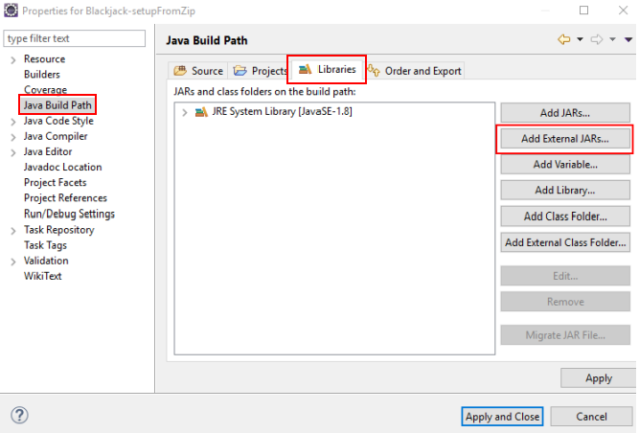
Navigate to where you unzipped the student-v1.x.zip file and go to .../blackjack_2019/lib. Select all jars and click open/OK.
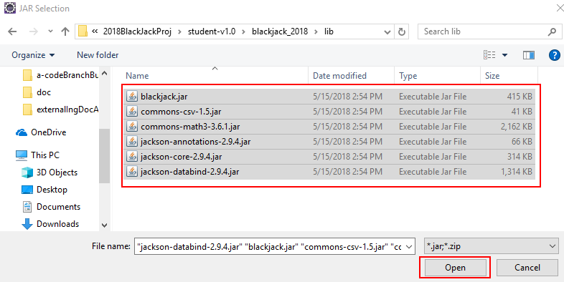
Once back at the Eclipse properties screen, click "Apply and Close".

3) Just one more thing: Copy the MyPlayer package and file to your new Eclipse project "src" directory. One way to do this:

** 3.a) Navigate to where you unzipped the project file and copy the "student" directory:
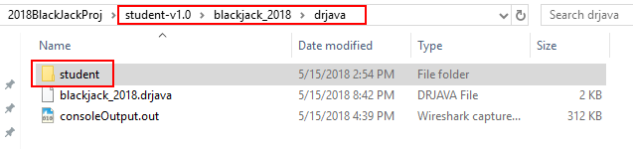
** 3.b) Paste the copied directory in your Eclipse project's src directory (select "src", right-click and select "paste"):

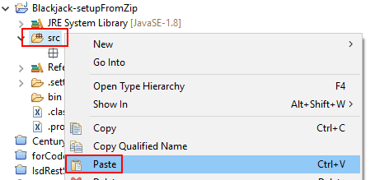
After the package and class file have been copied/created, you should see:
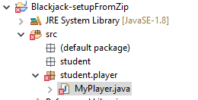
Fix the compile error. Once fixed, run your player by right-clicking on MyPlayer.java and select "Run As->Java Application"

