2019 AP Computer Science Programming Competition

Welcome to AP Computer Science Battle of the Schools V, otherwise known as “May Mayhem”!!!

The volunteers from IBM are excited to work with the students at Century and Mayo High Schools for a cross-school competition to determine bragging rights amongst the cyber techies of the Rochester School District high school hallways. Winning school gains control of the The Belt.
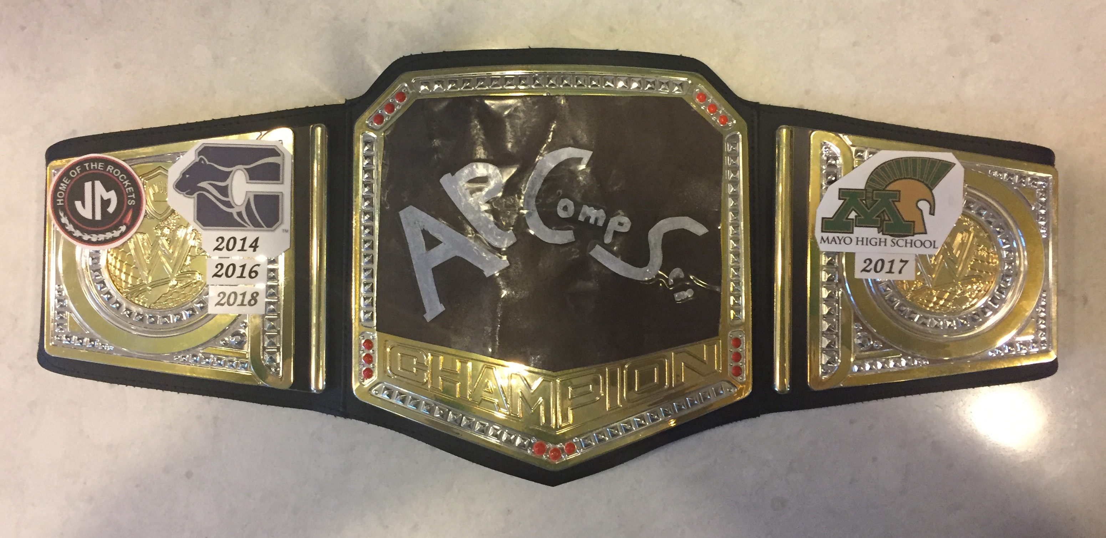
This coveted prize has been won three times by Century, including last year, and once by Mayo. Will Mayo notch a second victory this year and prevent Century’s defense of their title?

We are extremely excited to announce an update of last year’s popular competition based on the playing of Blackjack, also known as “21”. If you are not familiar with this popular card game, you might want to find a free version to play on your phone or from your home computer.

The rules of Blackjack are quite simple: draw cards until you get as close to 21 without going over, and if you have a higher count than the dealer, you win. But just like chess and other games, the rules may be simple but the optimal strategy is very complex.

For our competition, you will be writing a “computer” player for Blackjack that determines:
- how much money to bid (at the beginning of the round),
- what card actions to take—hit, stand, double-down, or split (during the round),
- and whether or not to walk away from the table (at the end of each round).

Each student will be implementing their own strategy for playing the game at a “table”.

Each table has
- a starting amount of money for the player,
- between one and six decks decks of cards,
- a minimum and maximum bet amount,
- and a maximum number of rounds which can be played.

To make matters exciting, players have the opportunity to walk away at any time.

The competition will consist of suite of “tables” which include the 10 provided tables and at least 10 additional tables against which everyone will play. The amount of money acquired by the player will be their score. Scoring for the competition will be accumulated at the school level as defined later.

Some key differences between our game and other versions are:
- Blackjack pays 2-1 (said “two to one”). If you bid $2 and get a blackjack, you get $6 back – the original $2 plus a profit of $4.
- Push pays 1-2. If you bid $2 and tie the dealer, you get $3 back – the original $2, plus a profit of $1.
- Dealer stands on a “Soft 17” (an Ace and a 6).
- Splits are allowed only on an exact pair (a not matching score), e.g. two Queens can be split, but a Queen and a Ten cannot.
- Cards do not get reshuffled until all of the available cards are completely gone. Only the cards in the discard tray are reshuffled.
Please note that these rules are modified from commonly used rules at casinos. Several of our rules have been explicitly selected to tilt the odds in the favor for the student player. Real casinos ensure the odds are in their favor by paying 3-2 for a Blackjack and holding your money on a push!

You can find a very detailed description of the rules in the JavaDoc at …/blackjack_2019/doc/javadoc/index.html. The game rules are also defined in the run-time by and accessible through the TableRules and CasinoRules classes. The accessor routines are described in the JavaDoc.

Project Setup
Everything you need to complete the project is provide in the student-v1.0.zip file:

- A document on how to setup the project, build a JAR for submission, and a Java class overview of the game framework (…/blackjack_2019/doc/BlackjackProjectGuide.pdf).
- A DrJava project to simplify setup (…/blackjack_2019)/drjava/blackjack_2019.drjava).
After you download and extract the zip file, you should begin by opening this project file explicitly in DrJava as detailed in BlackjackProjectGuide.pdf.
- A simple player class file (…/blackjack_2019/drjava/student/player/MyPlayer.java) to facilitate getting started with the competition.
This file contains a VERY basic player that hits until it reaches 21 or busts. All of your code should go in this file. You will submit your version of MyPlayer.java in a JAR at the end of the competition using instructions in BlackjackProjectGuide.pdf.
- 10 pre-configured tables and an integrated table editor for testing.
Make sure to test your solution against all of these. If you get more time, create your own tables.
- JavaDoc for framework APIs available to the player.
You should start your learning about the framework in the “Overview” section of JavaDoc. This excellent writeup can be found by opening .../blackjack_2019/doc/javadoc/index.html and clicking on “Overview” at the top of the main frame.
- A run-time framework (JAR) that includes a GUI with which to run the game.
You should not need to do anything with this file if you use the DrJava project file listed above in #2.
- And, if you’re really bored, confused, or just plain geeky about reading code, you can find all project source in …/misc/src/com/ibm/vie/blackjack/... .

Follow these steps to get started:
- Download student-v1.0.zip and unzip the package.
- In your extracted directories from step #1, locate, read, and follow the directions on how to get started in the document named …/blackjack_2019/doc/BlackjackProductGuide.pdf.

Project Goals
The goal for the competition is to provide experience with using code you have not written, while introducing the concept of Artificial Intelligence (AI). If one chooses to make a career as a computer programmer, you will quickly learn that the ability to read, understand, and interact with code and classes not written by you are key skills.

Additionally, if you select computer programming as a career path, the areas of Artificial Intelligence and Machine Learning may be ones which interest you. These specialties attempt to create algorithms that either model or improve upon human behavior to solve common everyday problems.

Historically, computers have played games to demonstrate their reasoning ability. In 1954, a team of scientists ran millions of simulated hands of Blackjack using an IBM machine, in an attempt to determine the best playing decision of every combination of cards. (See http://www-03.ibm.com/ibm/history/ibm100/us/en/icons/ibm700series/impacts/). IBM has made further contributions to this area with systems like Deep Blue (see http://en.wikipedia.org/wiki/Deep_Blue_%28chess_computer%29) which beat Gary Kasparov at chess in 1996 and Watson who won Jeopardy over the most successful player of all time, Ken Jennings, in 2011 (see http://en.wikipedia.org/wiki/Watson_%28computer%29). Today, Watson systems and algorithms are being employed by the health care industry in initiatives such as attempting to cure cancer.

Project Schedule
The competition will occur on the following schedule:

- Monday, May 20
Problem sets posted to Moodle by 7AM. IBM Tutors will be in the classroom to kick-off the competition.
- During competition
Tutors will be in the class daily to answer questions and provide guidance. Help will also be available on-line under the Moodle discussion topic “Programming Competition 2019”. Comments and answers will be private to the school that asked.
- Friday, May 24 at 12:00 PM
Projects must be submitted to your teachers (per their directions). Late submissions will not be accepted. Your teacher will validate submission times.
- Tuesday, May 28
IBM representatives will be in the classroom to present the results. Information will be posted to Moodle for all classes to see at the same time.

Competition Rules
- Students will work independently and submit their own code.
- Discussions among students on playing algorithms are STRONGLY encouraged to eliminate duplicity of solutions.
- Students will submit one implementation of the MyPlayer class. See the detailed instructions in BlackjackProductGuide.pdf for submission packaging.
- Solutions must be in Java.
- Projects will be evaluated using the criteria defined in the section below.

Competition Scoring
Individuals will compete for their school. Six points per table will be award to the respected schools for each table based upon the students performance as follows:

Most money: 3 points
Second most money: 2 points
Third most: 1 point

The three highest earning players will earn points for their schools. Ties will “split” the accumulated points. For example, if 3 students from 3 different schools all tie with the highest score, then each school is awarded 2 points (6 / 3). The school with the most number of points at the end will be declared the winner.

Note: The evaluation will include a predefined set of table configurations, 10 of which were provided to the students for testing.

Individual Awards
In addition to the priceless team award, individual awards will be provided:

- Top Scorer: The individual whose algorithm scores the most points for their team.
- Top Money: The individual whose algorithm earned the cumulative highest amount of money for the competition.
- Most Advanced Algorithm: The individual whose algorithm successfully uses the combination of double-down and split options the most number of times across all tables in the competition.
- Best Program Structure: Each student's MyPlayer class will be reviewed for organization of internal methods/functions, use of variables, use of data structures, flow of the code, and source code documentation.
Any questions about evaluation criteria for this round should be posted to Moodle. Answers for this type of question will be cross-posted to all classes.

Technical Tips for a Successful Project
The reason that Blackjack game-play is a useful programming exercise is because there are multiple areas in which logic and strategy can be applied.

If you are unfamiliar with the game, you may want to begin by familiarizing yourself with the game by playing either a Blackjack app for your phone or on-line at a free place such as https://www.casino.org/blackjack/free/. Note: this URL may need to be accessed from home or a non-school network.

The default algorithm which has been provided simply plays until you reach 21 or bust. Obviously there are better algorithms. We suggest you begin by implementing the following basic strategies:

- Play so that you never break, i.e. hold on anything greater than 11.
- Play so that you have a reasonable chance of winning by holding on 17.
With this basic change to the strategy, your player should now be winning some money on our sample tables. Please note that this is not the case using the rules at most casinos where payouts are not as generous. When you get to this point, ask us about the “Easter Egg” to change to more realistic rules.

Once you have mastered the most basic strategies of the game, here are some things to consider as you formulate your strategy:

- Exploit the card the dealer is showing.
This is the single most important factor in making your decision. If you do any research at all into Blackjack strategy, you will find that the dealers “up card” completely changes your actions. If they have a 6 showing, for instance, that makes the dealer most likely to bust, and therefore the players strategy is simply “don’t bust” and therefore do not draw another card if your total is 12 or above. On the other hand, if the dealer has a 10 showing, the best strategy would be to draw a card until the player reaches at least 17.
- Decide when to double down.
This strategy, when applied correctly, can significantly improve your winnings. Doubling down gives the player a chance to double their bet after seeing two cards. So, if your first two cards total 11 (an 8 and a 3, for instance) you have the best chance of getting to a total of 21, so you should almost always double your bet in this scenario. Keep in mind that 4 different card ranks (10, Jack, Queen, King) all have a numeric value of 10 in the game of Blackjack, which is why having a total of 11 after two cards gives you a good chance of getting to 21 after 3 cards.
- Decide when to split cards.
The rules of Blackjack allow you to split a pair into two hands and play them as separate hands. This should only be done in certain scenarios, and can greatly improve your winnings. For instance, if the dealer is showing a 6, which we explained above is the most favorable to the player, and the player has a pair of Aces, they can split them into two hands, and have a very good chance of winning both hands. Conversely, if you have a pair of Jacks, this is already strong hand, and you generally should not split them.
- Implement card counting.
A good Blackjack player is keeping a running tally of all the cards that have been played. This is important because as certain cards are played, the cards remaining in the deck may be favorable or unfavorable to the player, and you can adjust your strategy accordingly. A good strategy will count the cards, and make some adjustments to the betting strategy based on the count.
The most commonly used counting strategy is called Hi-Lo, and is explained at http://www.blackjackage.com/the-hi-lo-strategy.php. The basic idea is to understand when the remaining cards in the deck are most favorable to the player, and to increase your bet size when that happens. When the remaining cards are unfavorable, you can either make the minimum bet, or walk away from the table.
One critical item should be considered when implementing card counting for your player: the design of the framework is such that keeping a count of a card as they are dealt is challenging. The recommended strategy is to extract the relevant information from gameinfo on each call to MyPlayer::decideHowToPlayHand(), MyPlayer::decideToWalkAway()and MyPlayer::placeInitialBet() and then dynamically build all card count information.
- Finally, consider your betting strategy.
Common questions about betting to consider include:
  - How many consecutive times could you lose while betting the maximum?
  - What’s the probability that the cards are more or less in your favor given your position in the deck?

Please consider some of these strategies, and consider that the most successful projects will use them all. These can be combined together to be very successful in your strategy.

Here is an example of using multiple strategies together:
- The dealer is showing a 6, this is a favorable scenario for the player, so the player decides not to bust no matter what, as explained in point #1 above.
- The player gets an 8 and a 2. This total of 10, combined with the dealer showing a 6, leads the player to double down as explained in point #2 above. The next card they get after doubling down is a 5, so they now have a total of 15. While this is not a great total, they are in the “do not bust” strategy due to the dealers up card, so they stand.

If you search on-line, there is plenty of information about Blackjack strategies. Some of the useful URLs we found are:
- https://www.familyeducation.com/fun/card-games/blackjack
- https://en.wikipedia.org/wiki/Card_counting
- https://newswatchtv.com/2018/10/09/the-history-of-blackjack/
- https://wizardofodds.com/games/blackjack/strategy/4-decks/
- https://blackjackarmy.com/basic-blackjack-strategy.php

Good luck and have fun!

