2022 AP Computer Science Programming Competition

Welcome to this year’s AP Computer Science Battle of the Schools! This competition we are calling “May Mayhem”!!!

The volunteers from IBM are excited to work with the AP Computer Science students at Century, John Marshall, and Mayo for a multi-school competition to determine bragging rights amongst the cyber techies of the Rochester School District high school hallways.

This year's project is Treasure Hunt – a treasure seeking, environment traversal game. Your goal is to program a player to collect all of the treasures with the fewest number of steps across a wide variety of levels (called “boards”).

Boards may have different types of terrain to navigate and traversing different terrain may cost you more steps then others. Watch out though! If you run into a wall, your adventure for a board will end.

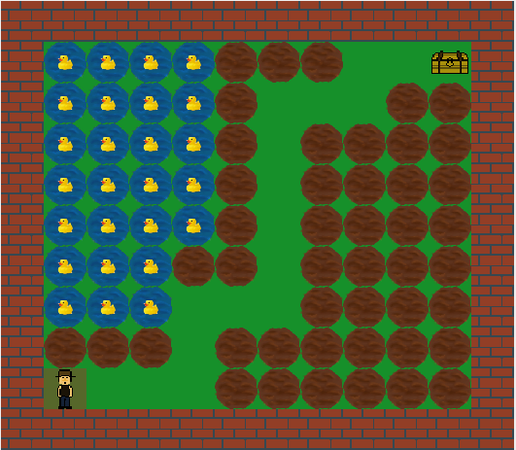

Project Details
Each board consists of a two dimensional array (grid) comprised of:
- A single player
- Different types of squares (terrain) to navigate
- One or more treasures
- A maximum number of steps the player can take

The different types of squares a board may have are

Terrain Name | Step Cost
Space | 1
Treasure | 1
Mud | 5
Water | 13
Bushes | 23
Trees | 37
Mountain | 47
Lava | 61
Wall | All

Each board will be allotted a maximum number of steps in which the treasure(s) should be acquired.

The score a player can get for a board is based on several factors including the number of treasure obtained and the number of unused steps. Specifically, each board will be scored as follows:

Points per each acquired treasure: 100 points
Bonus per each unused step: 1 point / step
Bonus for completing a board (getting all treasures): 500 points

For example, a board with one treasure and a maximum of 50 steps, but solved in 20 steps, will get a score of: (1 * 100) + (50-20) + 500 = 630.

Competition Details
The competition will be evaluated in two phases.

The first phase will be a team competition where each class competes to navigate a set of boards. Some boards used in the competition will be provided to the students, but not all. Individuals can score points for their class, and the class with the highest score will be declared the winner and bestowed the official AP Computer Science Championship Belt traveling trophy!
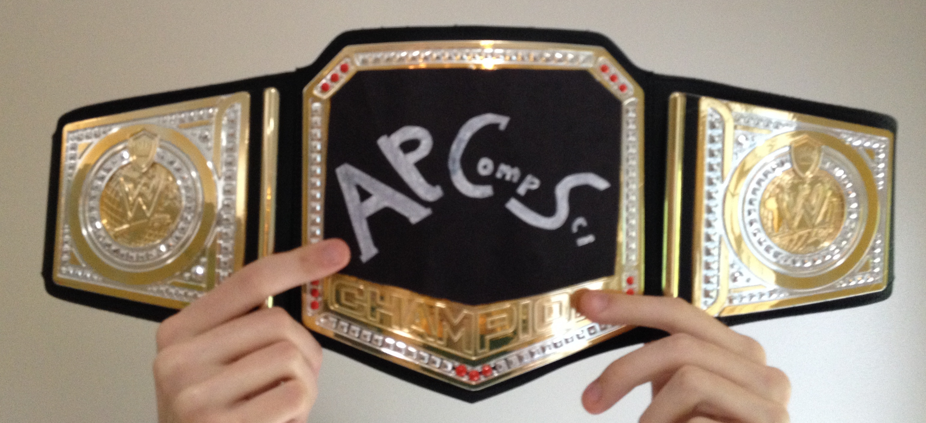
In addition to the team competition, IBM will evaluate each individual’s solution to determine special awards. Individual prizes will be awarded in the following categories:

- Top Performer
- Best Program Structure
- Most Elegant Solution

Schedule

- Monday, May 16
The competition project will be posted for students by the teacher. IBM tutors will be in the classroom to kick-off the competition.

- During competition
IBM helpers will be available in class to help answer any questions about programming or the competition. Any questions outside of class should be sent to your teacher.

- Wednesday, May 25
Projects must be submitted to your teacher by end of the class period. Late submissions will not be accepted. Your teacher will validate submission times.

- Friday, May 27
IBM volunteers will be in the classroom to present the results.

Rules
- Students will work independently and submit their own code.
- Discussions among students on playing algorithms are STRONGLY encouraged to eliminate duplicity of solutions.
- Students will submit one implementation of the MyPlayer class for the competition. For instructions on how to submit your solution, see the docs/SubmissionGuide.pdf document.
- Solutions must be in Java.

Judging

Team Competition
Individuals will compete for their class. Six points per board will be awarded to respective classes based on the student’s performance. The points for a board will be distributed as follows:
Highest score: 3 points
Second highest score: 2 points
Third highest score: 1 point

The three highest scoring players for a board will earn points for their class. Ties will “split” the accumulated points. For example, if 2 students from 2 classes tie for the highest score, then each class is awarded 2.5 pts ((3 + 2) / 2). The class with the highest number of points will be the winner.
Note: The evaluation will include a predefined set of boards. Due to the Engineering altruism that all designs have a trade-off, one can naturally conclude that having a single algorithm which wins every time will likely be impossible. Therefore, the team which ultimately wins will likely have the most diverse set of algorithms.

Individual Honors
In addition to the team competition as described above, the following categories will be judged on an individual basis in the following categories:

- Top Performer: Each program will be run against the solution boards (and a few more devious additions) and re-scored using the same methodology used to score the Team Competition. The highest score to complete all of the boards will be declared the “Top Performer”.
- Best Program Structure: Each student's MyPlayer class will be reviewed for organization of internal methods/functions, use of variables, use of data structures, flow of the code, and source code documentation. The student's code judged as most extensible and support by another person will be the “Best Program Structure” winner.
- Most Elegant Solution: Each game algorithm will be reviewed looking for the algorithm which has an innovative design that balances code complexity (quantity) and movement decision effectiveness (score). The search algorithm which accomplishes the most success in a reasonably small amount of source code will be deemed the “Most Elegant Solution”.
Any additional questions about evaluation criteria for these awards should be asked in class or ask your teacher to email the IBMers. Answers for this type of question will be communicated to all classes.

Special Notes
The judges reserve the right to disqualify implementations that require an excessive amount of resources to run (e.g. time, memory, etc), or that do unscrupulous things.

Getting Started

The project is provided in a zip file, student-v2.0.zip. Inside the zip file, you will find:

- This overview document (doc/2022APProgrammingProjectOverview.pdf)

- A DrJava project file (drjava/treasure_hunt_2022.drjava),
- JavaDoc for information and framework APIs available to the player (doc/javadoc/index.html)
- Your solution Java file (drjava/MyPlayer.java) which implements the traversal algorithm. This file contains comments within it, marked “TODO:” which you should follow at the beginning of the project.
- A description of the board levels and a guide on how to make your own boards (doc/BoardDesigns.pdf),

See the GettingStarted.pdf file to get started downloading and opening the project zip file (student-v2.0.zip).

Good luck and have fun!

