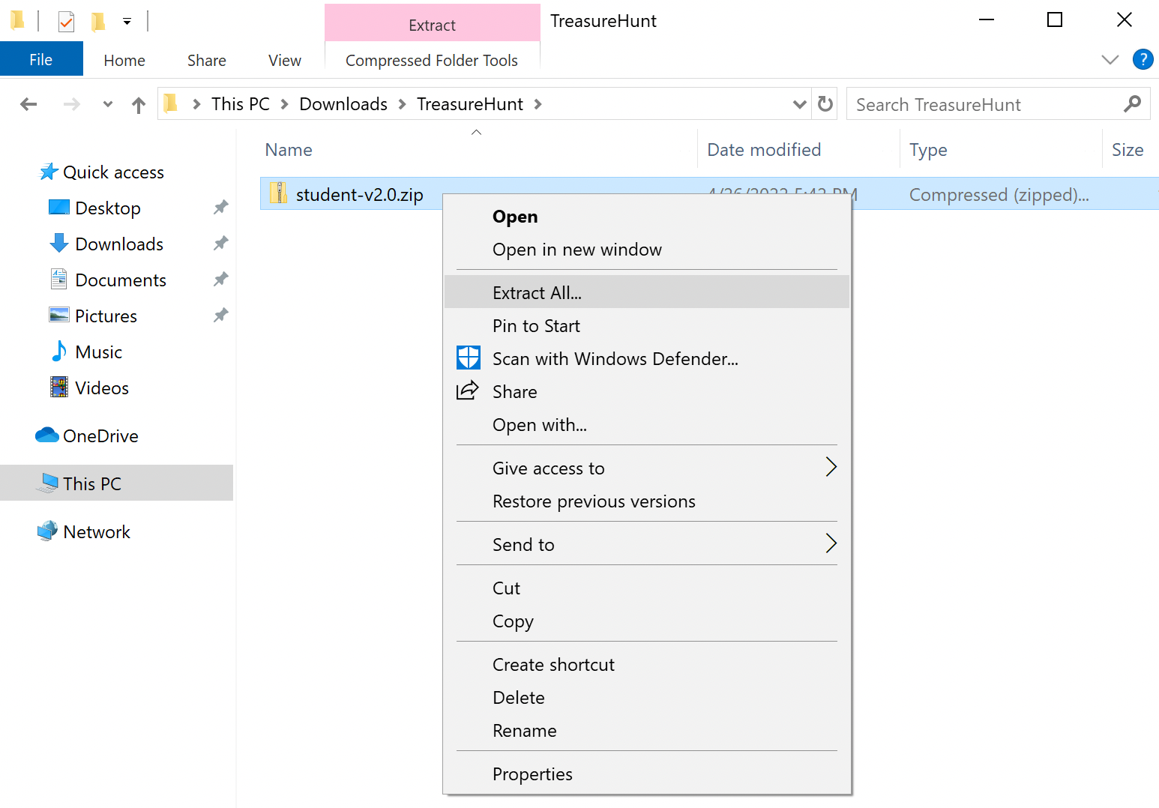
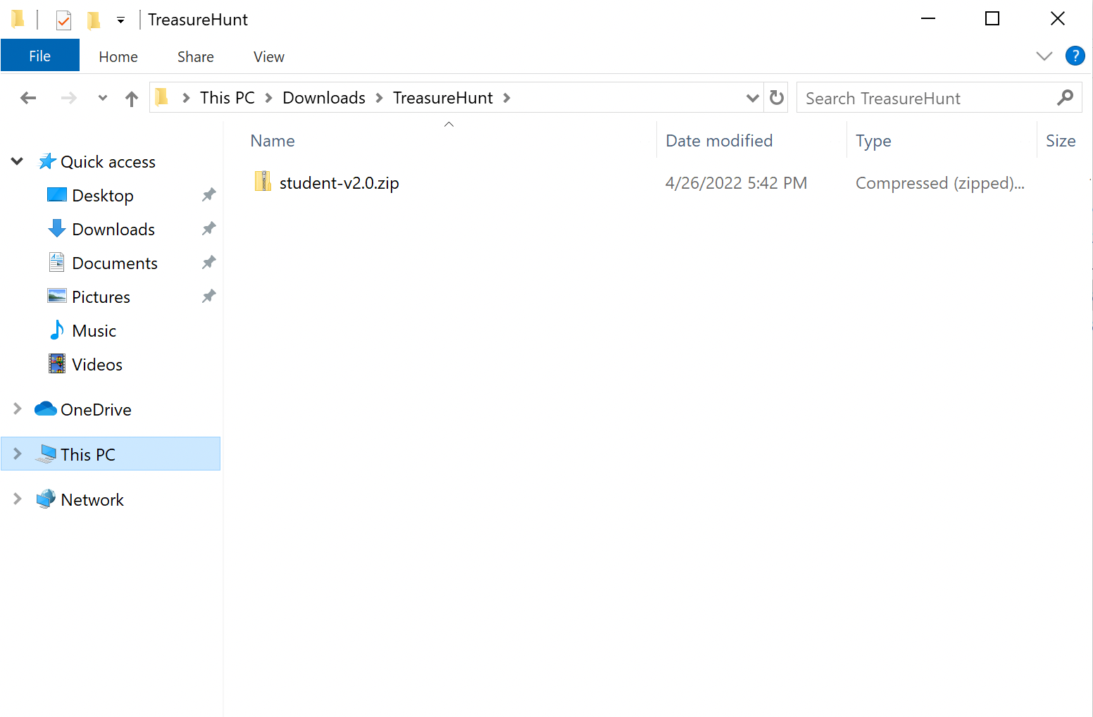
Treasure Hunt – Getting Started Guide

Download
- Download the student-v2.0.zip file from your teacher.
  - Save it to a location like the Downloads folder or to your personal drive.

Extract Files
- Find the student-v2.0.zip file in Windows Explorer.

- Right-click the file, and select ‘Extract All…’

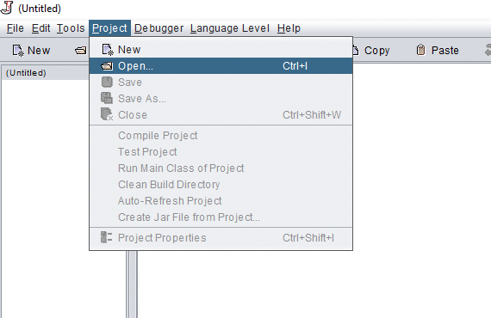
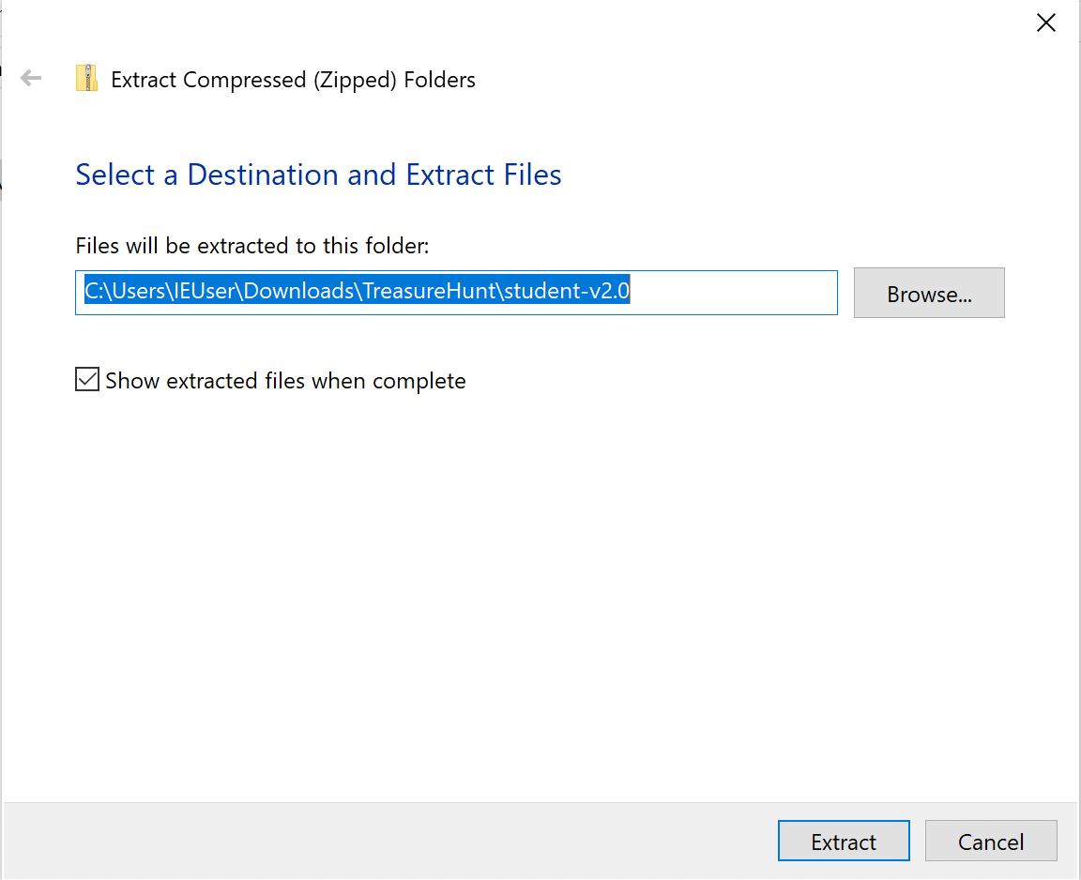
- A dialog box (shown below) will appear asking where to extract the files.
  - Click ‘Extract’. Remember this location!

DrJava
- Open DrJava.
- Under Project, click ‘Open…’ to get the following dialog box:

- Navigate to your remembered location where you extracted the files.

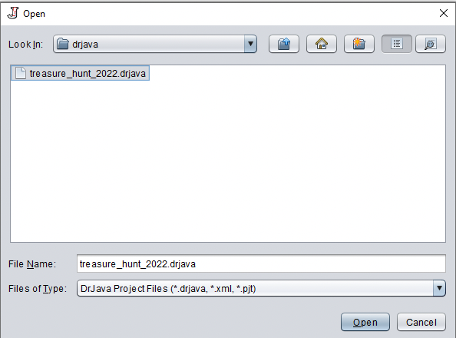
- Enter the treasure_hunt_2022 folder and then the drjava folder.

- Select the treasure_hunt_2022.drjava file and click ‘Open’.

- The project should now be in your DrJava workspace with the MyPlayer ready for you to code.

Compile and Run
- Compile the project by clicking ‘Compile Project’.

- Click ‘Run’ once your project is compiled to test that the application works.

- Happy coding!!!!

