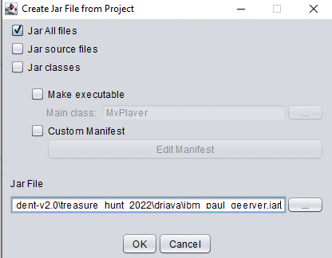
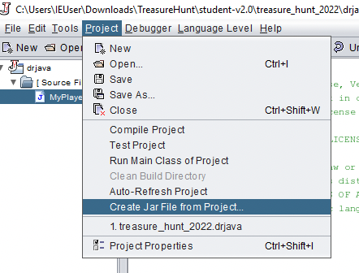
Treasure Hunt – Submission Guide

Create a Jar
- In DrJava under Project, click Create Jar File from Project…

- A dialog box (shown below) will open.

- Ensure the Jar All files box is selected!

- Edit the Jar File line to be ‘...\treasure_hunt_2022\drjava\schoolname_first_lastname.jar’
  - Ensure you use the underscore character '_' between fields (hard to see in the dialog box)

- Click OK.
  - A window should pop up saying the jar creation was successful. Click OK.

- The JAR should be located at the <YourLocation>\treasure_hunt_2022\drjava\ folder.

- Submit the JAR file to your teacher as instructed by them.

