Project Submission Report: Progress Update

Introduction:

This report provides an update on the progress of the laundry service website project, which is currently at 50% completion. The completed portion of the project primarily focuses on the frontend development.

Project Overview:

The laundry service website aims to provide a convenient platform for users to schedule laundry services online. Users will be able to register, login, schedule pickup and delivery times, select laundry preferences, and make payments through the website. The website will offer a user-friendly interface, ensuring a seamless experience for both customers and administrators.

Current Situation:

As of now, the frontend development of the project is almost complete. The frontend encompasses the visual and interactive elements of the website that users interact with directly. Key components of the frontend include:

Homepage: Designed to provide an overview of the laundry services offered and encourage users to explore further.

User Registration/Login: Implemented to allow new users to create accounts and existing users to log in securely.

Service Selection: Users can choose from a range of laundry services based on their preferences and requirements.

Scheduling Interface: An intuitive interface for users to schedule pickup and delivery times that suit their convenience.

Payment Gateway Integration: Integration of a secure payment gateway to facilitate online payments for laundry services.

Here are some visuals from what we have completed of the website.

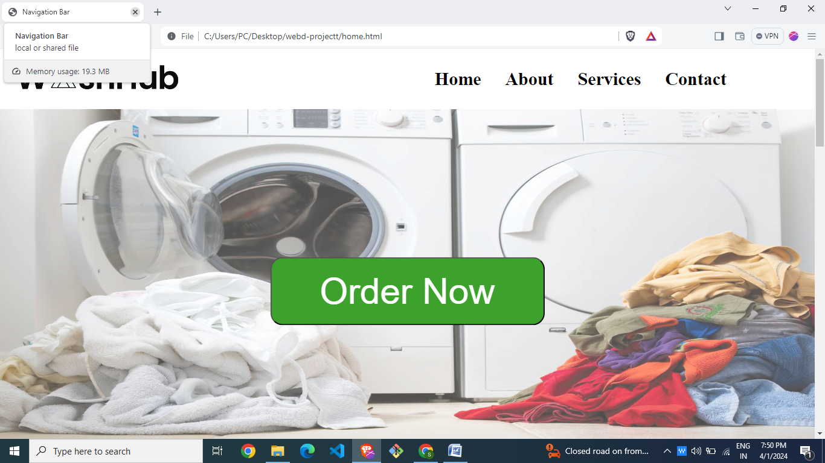

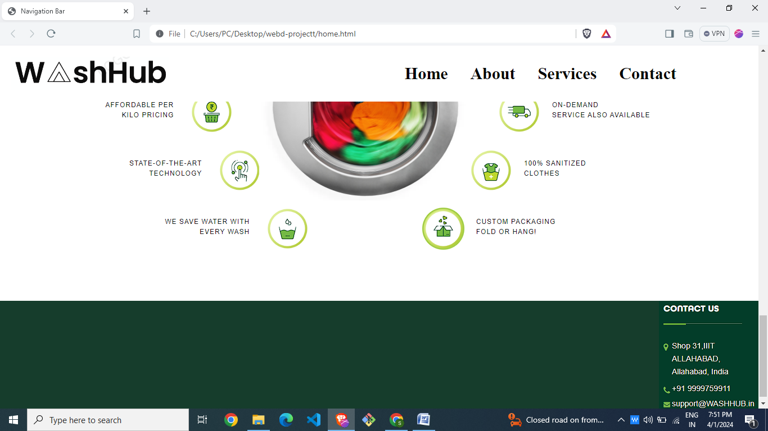

Next Steps:

While the frontend development is halfway complete, there are several tasks remaining to finalize the project:

Backend Development: Develop the backend functionalities to support user registration/login, scheduling, payment processing, and data management.

Database Integration: Integrate a database to store user information, service preferences, scheduling details, and transaction records securely.

Admin Dashboard: Create an administrative dashboard to manage user accounts, view orders, track payments, and generate reports.

Testing and Debugging: Conduct comprehensive testing to identify and rectify any bugs or issues in the system to ensure smooth functionality.

Deployment: Deploy the website on a hosting platform to make it accessible to users and ensure reliability and scalability.

In addition to providing updates on the project progress, it's essential to recognize and appreciate the efforts put forth by each member of the project team. The success of the project is a result of the collective contributions and dedication of team members. Here's a brief appreciation for the efforts made by each member:

Rochi Sri & Agraj Singh: Services/Order Page

Hridyansh Gupta: Home Page and Contact Us Page

Shaurya Singh: Profile Page and About Page

Their hard work, dedication, and collaborative spirit are deeply appreciated and instrumental in achieving our goals. Together, we look forward to delivering a high-quality and user-friendly platform that meets the needs and expectations of our customers.

Conclusion:

The project has made significant progress with the frontend development part almost being complete, marking the halfway point towards achieving the goals of the laundry service website. With continued effort and focus on backend development, database integration, testing, and deployment, we aim to deliver a high-quality and user-friendly platform that meets the needs of our customers effectively. We remain committed to meeting project deadlines and ensuring successful project completion.