- Cake.php, codeignider, Yii, laravel are php frameworks
- There are 4 releases of Angular JS so far. The latest being angular4 also called Ionic.
- Var myApp = angular.module(“myModule”, []);
- Incase the module name is spelled wrong duringg initialization the following error can be detected in the console.
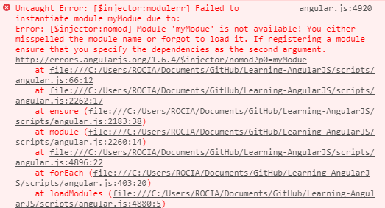
- Use code myApp.controller(“myController”,myController)

