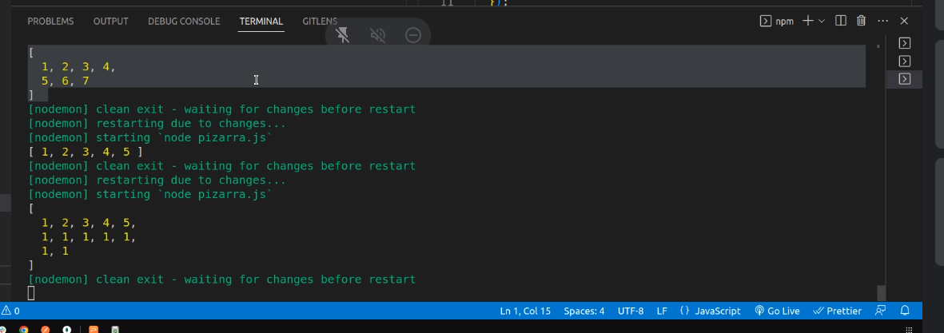
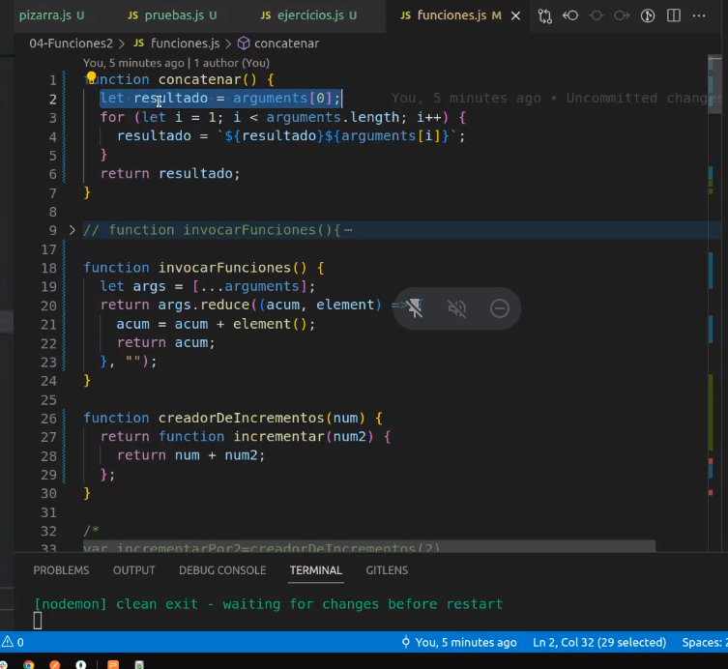
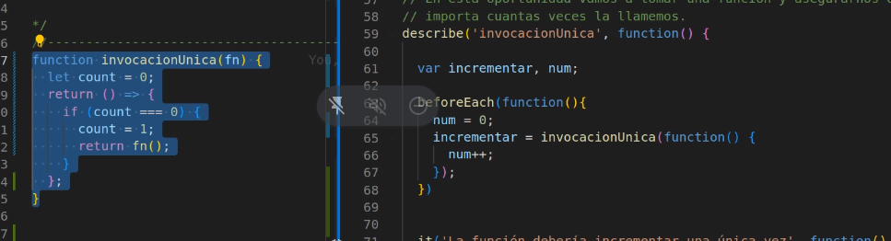
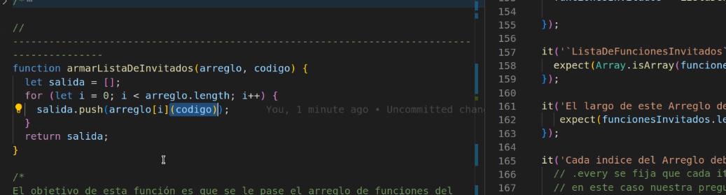
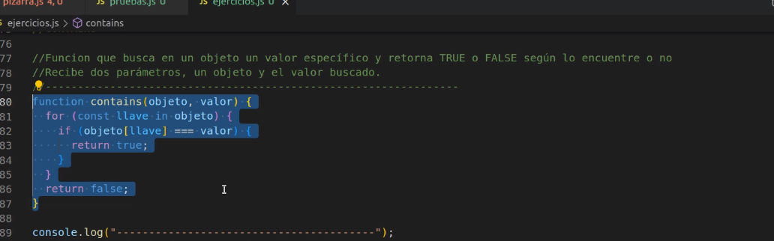
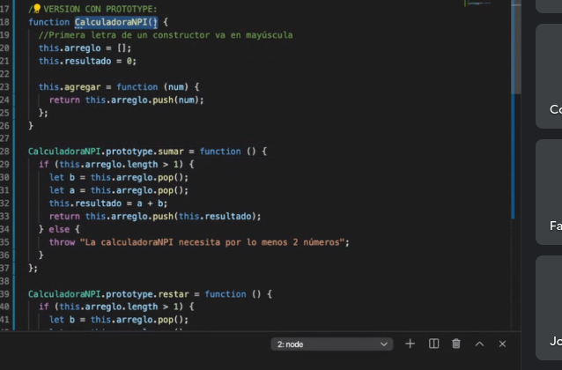
Martes

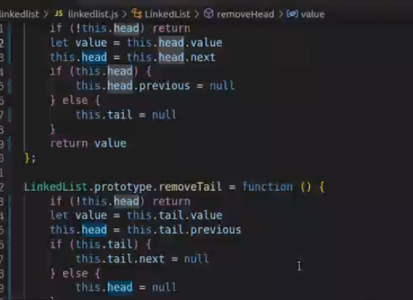
function LinkedList() {
this.head = null;
this.tail = null;
}

LinkedList.prototype.addToHead = function (value) {
let node = new Node(value);
if (!this.tail) {
this.tail = node;
this.head = node;
} else {
this.head.previous = node;
node.next = this.head;
this.head = node;
}
};

LinkedList.prototype.addToTail = function (value) {
let node = new Node(value);
if (!this.tail) {
this.tail = node;
this.head = node;
} else {
this.tail.next = node;
node.previous = this.tail;
this.tail = node;
}
};

LinkedList.prototype.removeHead = function () {
if (!this.head) return;
let value = this.head.value;
this.head = this.head.next;
if (this.head) {
this.head.previous = null;
} else {
this.tail = null;
}
return value;
};

LinkedList.prototype.removeTail = function () {
if (!this.head) return;
let value = this.tail.value;
this.tail = this.tail.previous;
if (this.tail) {
this.tail.next = null;
} else {
this.head = null;
}
return value;
};

LinkedList.prototype.search = function (value) {
let node = this.head;
let found = null;
while (node && found == null) {
if (typeof value === "string") {
if (node.value === value) {
found = node.value;
}
} else {
if (value(node.value)) found = node.value;
}
node = node.next;
}
return found;
};

function Node(value) {
this.value = value;
this.next = null;
this.previous = null;
}

function LinkedList() {
this.head = null;
this.tail = null;
}

LinkedList.prototype.addToHead = function (value) {
let node = new Node(value);
if (!this.tail) {
this.tail = node;
this.head = node;
} else {
this.head.previous = node;
node.next = this.head;
this.head = node;
}
};

LinkedList.prototype.addToTail = function (value) {
let node = new Node(value);
if (!this.tail) {
this.tail = node;
this.head = node;
} else {
this.tail.next = node;
node.previous = this.tail;
this.tail = node;
}
};

LinkedList.prototype.removeHead = function () {
if (!this.head) return;
let value = this.head.value;
this.head = this.head.next;
if (this.head) {
this.head.previous = null;
} else {
this.tail = null;
}
return value;
};

LinkedList.prototype.removeTail = function () {
if (!this.head) return;
let value = this.tail.value;
this.tail = this.tail.previous;
if (this.tail) {
this.tail.next = null;
} else {
this.head = null;
}
return value;
};

LinkedList.prototype.search = function (value) {
let node = this.head;
let found = null;
while (node && found == null) {
if (typeof value === "string") {
if (node.value === value) {
found = node.value;
}
} else {
if (value(node.value)) found = node.value;
}
node = node.next;
}
return found;
};

function Node(value) {
this.value = value;
this.next = null;
this.previous = null;
}

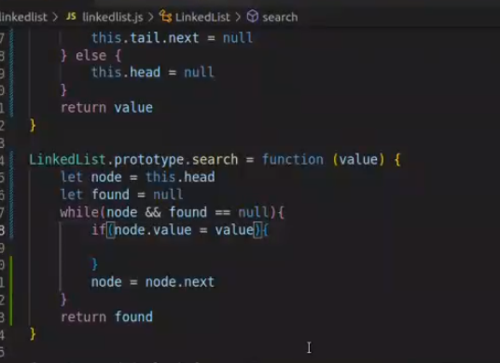
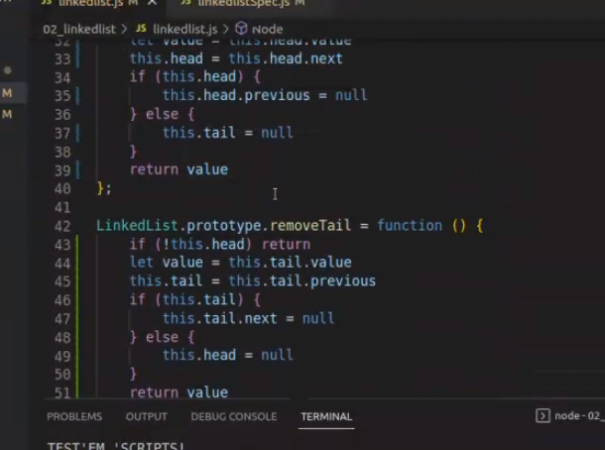
resolcucion por video llamada cn meet



