Задание 1
CREATE OR REPLACE PROCEDURE sp_subscription_type_upsert(
p_id INTEGER,
p_type_name VARCHAR(100)
) LANGUAGE plpgsql AS $$
BEGIN
IF p_id IS NULL THEN
INSERT INTO subscription_type (type_name) VALUES (p_type_name);
ELSE
UPDATE subscription_type SET type_name = p_type_name WHERE id_subscription_type = p_id;
END IF;
END
$$;

CREATE OR REPLACE PROCEDURE sp_subscription_type_delete(p_id INTEGER) LANGUAGE plpgsql AS $$
BEGIN
DELETE FROM subscription_type WHERE id_subscription_type = p_id;
END
$$;

CREATE OR REPLACE PROCEDURE sp_subscriptions_upsert(
p_id INTEGER,
p_price NUMERIC(10,2),
p_duration_month INTEGER,
p_type_id INTEGER
) LANGUAGE plpgsql AS $$
BEGIN
IF p_id IS NULL THEN
INSERT INTO subscriptions (price, duration_month, type_id) VALUES (p_price, p_duration_month, p_type_id);
ELSE
UPDATE subscriptions SET price = p_price, duration_month = p_duration_month, type_id = p_type_id
WHERE id_subscriptions = p_id;
END IF;
END
$$;

CREATE OR REPLACE PROCEDURE sp_subscriptions_delete(p_id INTEGER) LANGUAGE plpgsql AS $$
BEGIN
DELETE FROM subscriptions WHERE id_subscriptions = p_id;
END
$$;

CREATE OR REPLACE PROCEDURE sp_client_upsert(
p_id INTEGER,
p_last_name VARCHAR(100),
p_first_name VARCHAR(100),
p_middle_name VARCHAR(100),
p_birth_date DATE,
p_phone VARCHAR(20)
) LANGUAGE plpgsql AS $$
BEGIN
IF p_id IS NULL THEN
INSERT INTO client (last_name, first_name, middle_name, birth_date, phone)
VALUES (p_last_name, p_first_name, p_middle_name, p_birth_date, p_phone);
ELSE
UPDATE client SET last_name = p_last_name, first_name = p_first_name,
middle_name = p_middle_name, birth_date = p_birth_date, phone = p_phone
WHERE id_client = p_id;
END IF;
END
$$;

CREATE OR REPLACE PROCEDURE sp_client_delete(p_id INTEGER) LANGUAGE plpgsql AS $$
BEGIN
DELETE FROM client WHERE id_client = p_id;
END
$$;

CREATE OR REPLACE PROCEDURE sp_client_subscription_upsert(
p_id INTEGER,
p_client_id INTEGER,
p_subscription_id INTEGER
) LANGUAGE plpgsql AS $$
BEGIN
IF p_id IS NULL THEN
INSERT INTO client_statuscription (client_id, subscription_id) VALUES (p_client_id, p_subscription_id);
ELSE
UPDATE client_statuscription SET client_id = p_client_id, subscription_id = p_subscription_id
WHERE id_client_subscription = p_id;
END IF;
END
$$;

CREATE OR REPLACE PROCEDURE sp_client_subscription_delete(p_id INTEGER) LANGUAGE plpgsql AS $$
BEGIN
DELETE FROM client_statuscription WHERE id_client_subscription = p_id;
END
$$;

CREATE OR REPLACE PROCEDURE sp_client_trainer_upsert(
p_id INTEGER,
p_client_id INTEGER,
p_trainer_id INTEGER
) LANGUAGE plpgsql AS $$
BEGIN
IF p_id IS NULL THEN
INSERT INTO client_trainer (client_id, trainer_id) VALUES (p_client_id, p_trainer_id);
ELSE
UPDATE client_trainer SET client_id = p_client_id, trainer_id = p_trainer_id
WHERE id_client_trainer = p_id;
END IF;
END
$$;

CREATE OR REPLACE PROCEDURE sp_client_trainer_delete(p_id INTEGER) LANGUAGE plpgsql AS $$
BEGIN
DELETE FROM client_trainer WHERE id_client_trainer = p_id;
END
$$;

CREATE OR REPLACE PROCEDURE sp_equipment_upsert(
p_id INTEGER,
p_name VARCHAR(100),
p_receipt_date DATE,
p_quantity INTEGER
) LANGUAGE plpgsql AS $$
BEGIN
IF p_id IS NULL THEN
INSERT INTO customer (name_equipm, receipt_date, quantity) VALUES (p_name, p_receipt_date, p_quantity);
ELSE
UPDATE customer SET name_equipm = p_name, receipt_date = p_receipt_date, quantity = p_quantity
WHERE id_equipment = p_id;
END IF;
END
$$;

CREATE OR REPLACE PROCEDURE sp_equipment_delete(p_id INTEGER) LANGUAGE plpgsql AS $$
BEGIN
DELETE FROM customer WHERE id_equipment = p_id;
END
$$;

CREATE OR REPLACE PROCEDURE sp_client_group_class_upsert(
p_id INTEGER,
p_client_id INTEGER,
p_group_class_id INTEGER
) LANGUAGE plpgsql AS $$
BEGIN
IF p_id IS NULL THEN
INSERT INTO client_group_class (client_id, group_class_id) VALUES (p_client_id, p_group_class_id);
ELSE
UPDATE client_group_class SET client_id = p_client_id, group_class_id = p_group_class_id
WHERE id_client_group_class = p_id;
END IF;
END
$$;

CREATE OR REPLACE PROCEDURE sp_client_group_class_delete(p_id INTEGER) LANGUAGE plpgsql AS $$
BEGIN
DELETE FROM client_group_class WHERE id_client_group_class = p_id;
END
$$;

CREATE OR REPLACE PROCEDURE sp_trainer_upsert(
p_id INTEGER,
p_last_name VARCHAR(100),
p_first_name VARCHAR(100),
p_middle_name VARCHAR(100),
p_experience INTEGER,
p_salary NUMERIC(10,2)
) LANGUAGE plpgsql AS $$
BEGIN
IF p_id IS NULL THEN
INSERT INTO trainer (last_name, first_name, middle_name, experience_years, salary)
VALUES (p_last_name, p_first_name, p_middle_name, p_experience, p_salary);
ELSE
UPDATE trainer SET last_name = p_last_name, first_name = p_first_name,
middle_name = p_middle_name, experience_years = p_experience, salary = p_salary
WHERE id_trainer = p_id;
END IF;
END
$$;

CREATE OR REPLACE PROCEDURE sp_trainer_delete(p_id INTEGER) LANGUAGE plpgsql AS $$
BEGIN
DELETE FROM trainer WHERE id_trainer = p_id;
END
$$;

CREATE OR REPLACE PROCEDURE sp_group_class_upsert(
p_id INTEGER,
p_workout_type VARCHAR(100),
p_people_count INTEGER,
p_class_date DATE,
p_trainer_id INTEGER
) LANGUAGE plpgsql AS $$
BEGIN
IF p_id IS NULL THEN
INSERT INTO group_class (workout_type, people_count, class_date, trainer_id)
VALUES (p_workout_type, p_people_count, p_class_date, p_trainer_id);
ELSE
UPDATE group_class SET workout_type = p_workout_type, people_count = p_people_count,
class_date = p_class_date, trainer_id = p_trainer_id WHERE id_group_class = p_id;
END IF;
END
$$;

CREATE OR REPLACE PROCEDURE sp_group_class_delete(p_id INTEGER) LANGUAGE plpgsql AS $$
BEGIN
DELETE FROM group_class WHERE id_group_class = p_id;
END
$$;

CREATE OR REPLACE PROCEDURE sp_group_class_equipment_upsert(
p_id INTEGER,
p_group_class_id INTEGER,
p_equipment_id INTEGER
) LANGUAGE plpgsql AS $$
BEGIN
IF p_id IS NULL THEN
INSERT INTO group_class_equipment (group_class_id, equipment_id) VALUES (p_group_class_id, p_equipment_id);
ELSE
UPDATE group_class_equipment SET group_class_id = p_group_class_id, equipment_id = p_equipment_id
WHERE id_group_class_equipment = p_id;
END IF;
END
$$;

CREATE OR REPLACE PROCEDURE sp_group_class_equipment_delete(p_id INTEGER) LANGUAGE plpgsql AS $$
BEGIN
DELETE FROM group_class_equipment WHERE id_group_class_equipment = p_id;
END
$$;
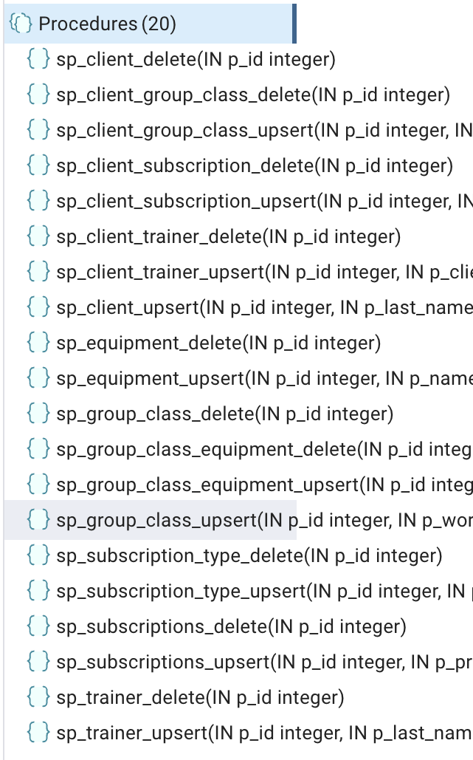
Задание 2
CREATE OR REPLACE FUNCTION fn_total_clients()
RETURNS INTEGER
LANGUAGE plpgsql
AS $$
DECLARE
total INTEGER;
BEGIN
SELECT COUNT(*) INTO total FROM client;
RETURN total;
END
$$;

CREATE OR REPLACE FUNCTION fn_check_client(p_id INTEGER)
RETURNS BOOLEAN
LANGUAGE plpgsql
AS $$
BEGIN
RETURN EXISTS (SELECT 1 FROM client WHERE id_client = p_id);
END
$$;

CREATE OR REPLACE FUNCTION fn_trainer_stats(
OUT total_trainers INTEGER,
OUT avg_experience INTEGER,
OUT avg_salary NUMERIC(10,2)
)
LANGUAGE plpgsql
AS $$
BEGIN
SELECT COUNT(*), AVG(experience_years), AVG(salary)
INTO total_trainers, avg_experience, avg_salary
FROM trainer;
END
$$;
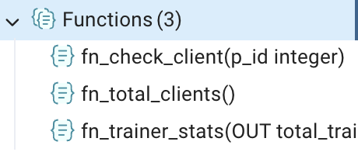
Задание 3
