Nutanix Version 1.0 Documentation Script ReadMe

NOTE: This script requires PowerShell V3 or later.
NOTE: Best performance is obtained by using PowerShell V5.
NOTE: Word 2007 is not supported.

Support for non-English Versions of Microsoft Word
The script supports the following languages:
- Catalan
- Danish
- Dutch
- English
- Finnish
- French
- German
- Norwegian
- Portuguese
- Spanish
- Swedish

Functionality v1
New Script Features
- New table function that now utilizes native word tables. Looks a lot better and is way faster
- Better support for multi language Word versions. Will now always utilize cover page and TOC

Bugfixes
- First release
This version of the script will gather and format the following information:
- Cluster Overview
- Licensing
- Node Information
- Storage Pool(s)
- Containers
- vDisks
- VMs
- Protection Domain(s)

Prerequisites
Before we can start using PowerShell to document a Nutanix environment, let us ensure we have the necessary requirements.
  - Install the PowerShell cmdlets from the PRISM interface as shown in Figure 1.
Figure 1
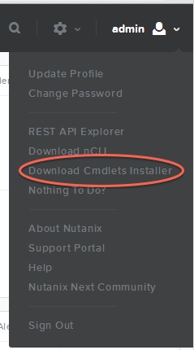

Script Usage
How to use this script?
  - Save the script as Nutanix_Script_v1_0.ps1 in your PowerShell scripts folder.
  - Run Nutanix_Script_v1_0.ps1-nxIP 1.1.1.1 -nxUser Admin -nxPassword **** and press Enter.
  - Run Nutanix_Script_v1_0.ps1-nxIP 1.1.1.1 -nxUser Admin -nxPassword **** -full and press Enter if you want a full report of your Nutanix Cluster.
  - By default, a Microsoft Word document is created named Nutanix Documentation Script.docx.
  - If you use the –PDF option, a PDF file is created named Nutanix Documentation Script.pdf.

Full help text is available.

Get-Help .\ Nutanix_Script_v1_0.ps1 –full

The help text explains all the parameters the script accepts.

