Sarah Rock

Lab 9

04/18/2019

BioE-210

Lab 9 Report

Abstract:

Curve fitting is the process of constructing a curve, or mathematical function that has the best fit to a series of data points, possibly subject to constraints. Function discovery is the process of finding a mathematical equation that describes a set of empirical data. These were obtained by the Matlab functions polyfit, polyval, interpolation, and spline. Polyfit was used to find the coefficients for the polynomial fits and polyval was used to evaluate those fits. Also the regression and interpolation were compared. Regression analyzes best fit but not at every point, while interpolation creates piece-wise curves that fit between every data point.

Methods:

The following were calculated on Matlab R2018B.

Problems 1 through 3 were done using the same code. The only variation between the 3 was the data.

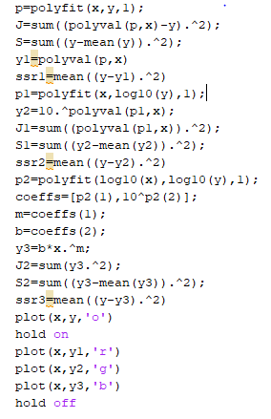

Problem 1:

Data:



Problem2:

Data:



Problem3:

Data:



Problem4: Problem 4 was done by using the data given and examining the residuals to determine whether the reaction was a first, second or third order reaction. Also to find the constant k. For the problem, the equations for the orders were given as well as the data.

Equations:

First order: 

Second order:

Third order:

Data: 

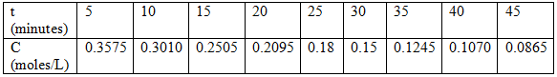

Problem5: Problem 5 was done by graphing sin(x) and x then using Matlab to find the max value of x where the error between the two functions was less than 5% and less than 1%. Then the functions were plotted and the ‘Basic Fit’ feature was used to find the best fit line and the coefficients for the two functions.

Problem6: Problem 6 was done by plotting the three different arrays with their corresponding arrays for y. Then the interpolation was found using the interpl () function at the values pi/2 and 3pi/2, then to find the error. The last part of this problem asked for the same values but to this time plot the cubic spline which was done using the spline function, then to find the error. The error for both the interpolation and the spline was found as shown.

Part B

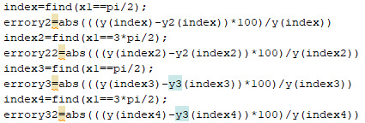

Part C

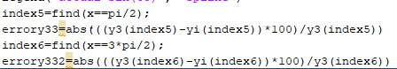

Results:

For problems 1 through 3 the requirement was to decide whether linear, exponential, or power fit best represent the data given the calculated SSR. The one the best fits gives the lowest SSR value.

Problem 1: The best fit for this problem was the linear fit with the SSR value of 1173

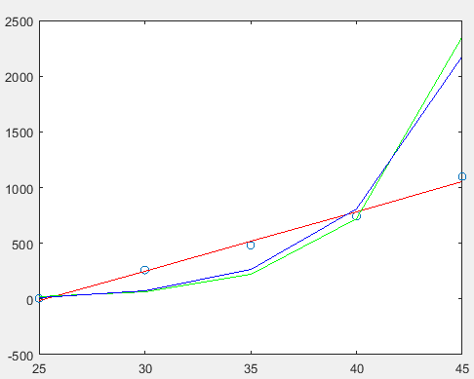

Problem2: The best fit for this problem was the power fit with the SSR value of 197.8677

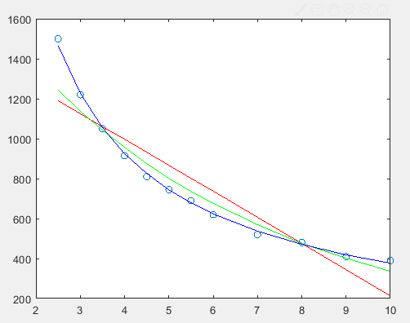

Problem3: The best fit for this problem was the exponential fit with the SSR value of .0457

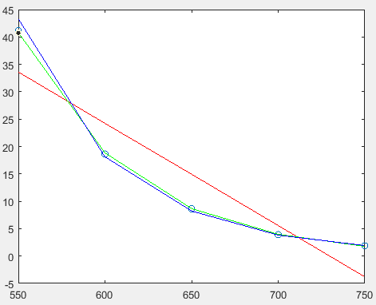

Problem4: From the results, the best fit was the first order reaction with a calculated k value of 0.0350

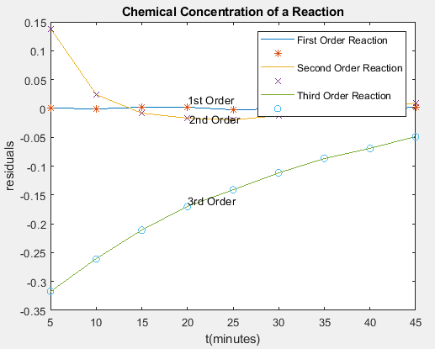

Problem5: For the error between sinx and x to be less than 5%, x needs to be less than 0.5385. For the error to be less than 1%, the x value needs to be less than 0.2441. The top graph is a plot of sinx and x vs x ranging from 0 to pi/2. The middle has x ranging from 0 to .5385, and the bottom is x ranging from 0 to .2441.

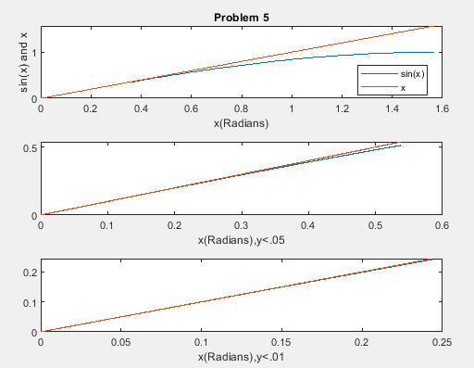

The coefficients and line of best fit is as shown:

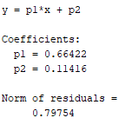

Problem6: The error calculated for both part b and c was 0. Below are the 6 graphs required for problem 6 going in order from top to bottom. The top is t1 vs y1, then t2 vs y2, next t3 vs y3, then interpolation, and last the cubic spline.

