
IUC COMPUTER EDUCATION
IUC Admin Analytics Dashboard
Complete User & Digital Marketing Guide
Live-system reference, metric dictionary, operating workflow and troubleshooting handbook
DOCUMENT SCOPE
Prepared from the authenticated live IUC Admin Analytics dashboard and the verified local implementation. Screenshot data uses the fixed reporting period 2 September–2 October 2026. Personal contact fields and admin notes are masked.

Version 1.0
Prepared 3 October 2026 · Asia/Kolkata
Classification: Internal operational guide
No live website files, settings, records, or credentials were changed while preparing this guide.

Table of Contents
This table is generated from the numbered chapter headings. In Microsoft Word, use Update Table if pagination changes after editing.
Table of Contents 2
1. Purpose, Audience and Measurement Boundary 4
1.1 What the dashboard measures 4
1.2 What the dashboard does not measure 4
2. System Architecture and Data Flow 4
2.1 Main database tables 4
3. Secure Access and Navigation 5
3.1 Login procedure 5
3.2 Main navigation 5
4. Dashboard Overview and Live Snapshot 6
4.1 Verified live KPI snapshot 7
5. Date Range, Acquisition Filters and Exports 7
5.1 Date range 7
5.2 Acquisition filters 8
5.3 Reports 8
6. Visitor, Session and Engagement Metrics 8
6.1 Device, browser, operating system and geography 10
6.2 Recent Visitors table 10
7. User Journeys 11
7.1 How to read a journey 12
8. Campaign Attribution and Social Website Traffic 12
8.1 Required campaign URL fields 12
8.2 Supported click identifiers 12
8.3 Session behavior when campaign attribution changes 12
8.4 Cost and note fields 14
8.5 Social website traffic 14
9. Pages, Landing Pages and Exit Pages 15
9.1 Practical analysis 15
10. Interaction Events and Engagement 15
11. Conversions 16
11.1 Formula 17
12. Enquiries and Lead Operations 17
12.1 Live enquiry snapshot 18
12.2 Lead workflow 18
12.3 WhatsApp status 18
13. SEO Monitor and Google Search Console 19
13.1 Verified Search Console snapshot 20
13.2 Metric definitions 20
13.3 Search Console vs website attribution 21
13.4 Connection security 21
14. Daily, Weekly and Campaign Reporting Workflows 21
14.1 Daily admissions/marketing check 21
14.2 Weekly campaign review 21
14.3 Month-end report 21
15. Troubleshooting 21
15.1 Production error checklist 22
16. Known Limits, Privacy and Data Quality 22
16.1 Privacy handling 22
Appendix A — Quick Metric Formula Reference 23
Appendix B — Campaign Naming Checklist 23
Appendix C — Screenshot and Verification Record 23
Appendix D — Ownership and Change Control 23

1. Purpose, Audience and Measurement Boundary
This guide explains how to operate, interpret, validate and troubleshoot the IUC Admin Analytics Dashboard. It is written for IUC management, digital-marketing teams, admissions staff and technical administrators.

1.1 What the dashboard measures
- Activity completed on the IUC website: anonymous visitors, sessions, pageviews, acquisition attribution, interaction events, enquiries and conversion actions.
- Google Search Console aggregate search performance when a valid connection is available.
- Enquiry records saved by the website and the WhatsApp delivery status stored for each enquiry.

1.2 What the dashboard does not measure
- Meta or YouTube platform impressions, reach, video views, engagements, ad clicks or advertising spend unless those values are separately imported. No such platform import exists in the current dashboard.
- A person's identity across devices or browsers. Website visitors are represented by an anonymous browser identifier.
- Individual organic-search queries for a named visitor. Search Console query data is aggregate.
- CRITICAL INTERPRETATION RULE
- Website sessions and website pageviews must never be compared as if they were equal to ad-platform impressions, reach or video views. The normal funnel is: impression or video view → link click → completed landing-page load → tracked website session → interaction → enquiry/conversion.

2. System Architecture and Data Flow
The dashboard is the reporting end of a first-party website analytics pipeline. The following flow shows where each value originates.
WEBSITE ANALYTICS FLOW
Visitor browser → assets/js/tracker.js → POST /track.php → analytics database tables → admin/api.php → admin/admin.js → Admin Analytics Dashboard

ENQUIRY AND CONVERSION FLOW
Course/contact page → enquiry form → index.php → enquiries + analytics_events → WhatsApp message log → Admin Enquiries and Conversions

Component | Responsibility | Important output
tracker.js | Creates/reuses the anonymous visitor and 30-minute session, reads URL/referrer attribution, sends pageviews, heartbeats and interaction events. | visitor_id, session_id, UTMs, click IDs, page/event payloads
track.php | Validates the payload and writes visitors, sessions, pageviews, campaigns, events and live activity. | Normalized first-party analytics records
Database | Stores the source-of-truth website measurements. | analytics_visitors, analytics_sessions, analytics_pageviews, analytics_campaigns, analytics_events, enquiries
admin/api.php | Applies the selected period/acquisition scope and calculates dashboard metrics. | Authenticated JSON response
admin/admin.js | Requests API data and renders KPIs, charts, tables, filters, journeys and exports. | Visible Admin Analytics UI
Search Console client | Requests aggregate Google search performance for the selected period. | Clicks, impressions, CTR, position, queries and dimensions

2.1 Main database tables
Table | Purpose
analytics_visitors | One anonymous browser visitor with lifetime totals and latest-seen information.
analytics_sessions | One visit/session with attribution, landing/exit pages, device, geography, page count and duration.
analytics_pageviews | Individual page loads and recorded time on page.
analytics_campaigns | Campaign-attributed session details, unique by session.
analytics_events | Interaction and conversion events.
analytics_live_activity | Recent per-session activity used for live-presence reporting.
analytics_campaign_meta | Manually maintained campaign cost and note metadata.
enquiries | Successful contact/course enquiries plus attribution and workflow status.
whatsapp_enquiry_messages | WhatsApp send/delivery attempt status linked to enquiries.

3. Secure Access and Navigation

3.1 Login procedure
- Open the IUC Admin Analytics login page over HTTPS.
- Enter the authorised administrator username and password. Never share credentials in campaign sheets, screenshots or chat.
- Select Login to Dashboard. After five failed attempts within 15 minutes, the current login session is temporarily rate-limited.
- Use Logout in the left navigation when finished, especially on a shared computer.
- SCREENSHOT PRIVACY
- Figure 1 uses a sample username and a masked sample password. It does not contain a live credential.

- 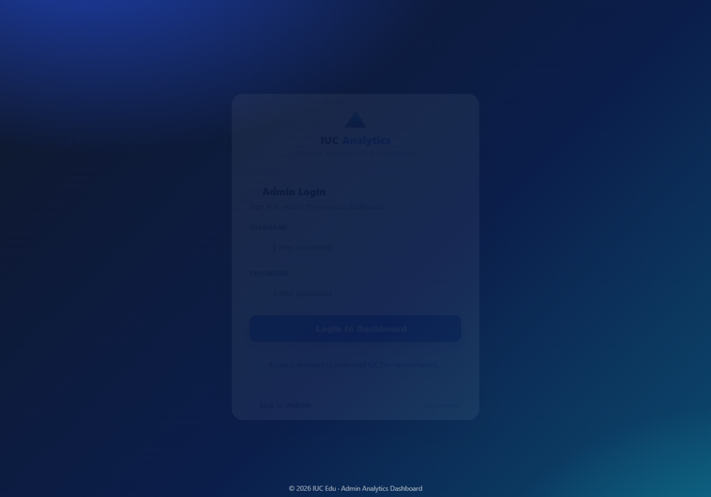
Figure 1 — IUC Admin Analytics login screen (sample credentials only)
The login screen provides username/password authentication, password visibility control and a secure route into the dashboard.

3.2 Main navigation
Section | Use
Overview | Executive KPIs, trends, sources, device/browser and landing-page summaries.
Visitors | Visitor composition, device/OS/geography and the most recent sessions.
User Journeys | Ordered page and event path for recent matching sessions.
Campaigns | Source/medium/campaign performance, social website traffic, cost and notes.
Pages | Top pages, landing pages, exit pages and the combined page table.
SEO Monitor | Search Console plus session-level search/utm_term analysis.
Enquiries | Saved enquiries, attribution, WhatsApp status and lead workflow status.
Conversions | Conversion actions, converting sessions, rate and action mix.
Live Visitors | Visitors active recently, using the configured live source/fallback.
Reports | Download summary PDF or raw session CSV for the selected period.

4. Dashboard Overview and Live Snapshot
Figure 2 shows the authenticated dashboard for the fixed period used throughout this guide. The interface has a persistent left navigation, date/export controls, acquisition filters, KPI cards, database health and charts.
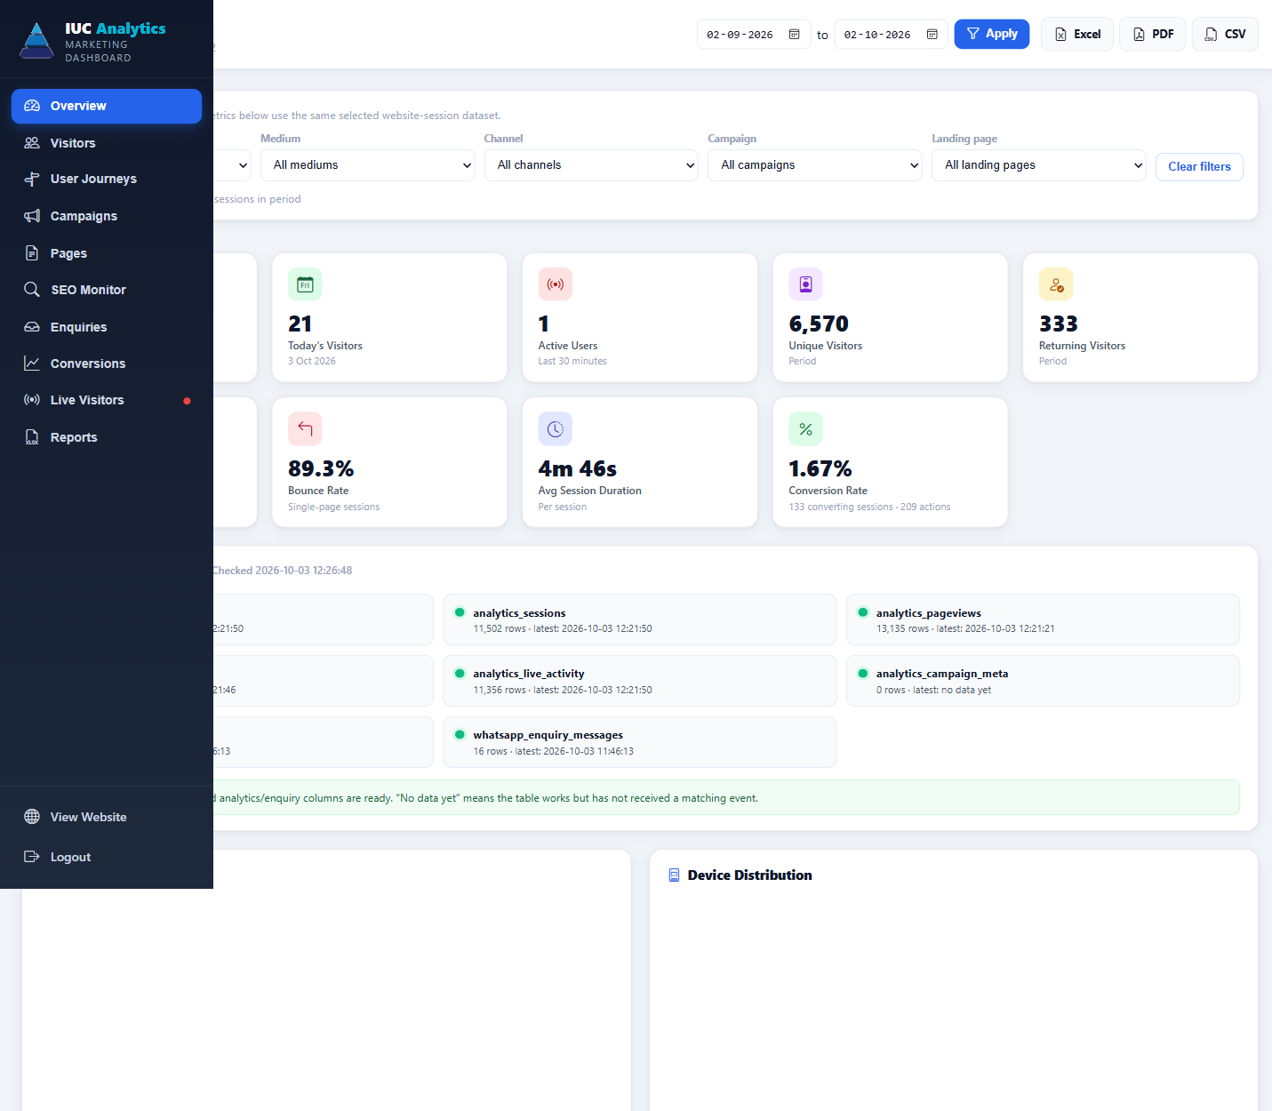
Figure 2 — Dashboard overview for 2 September–2 October 2026 (part 1 of 2)
The dashboard health message reported the database and required analytics/enquiry columns ready. "No data yet" means that the collector/table is operational but has not received a matching event.
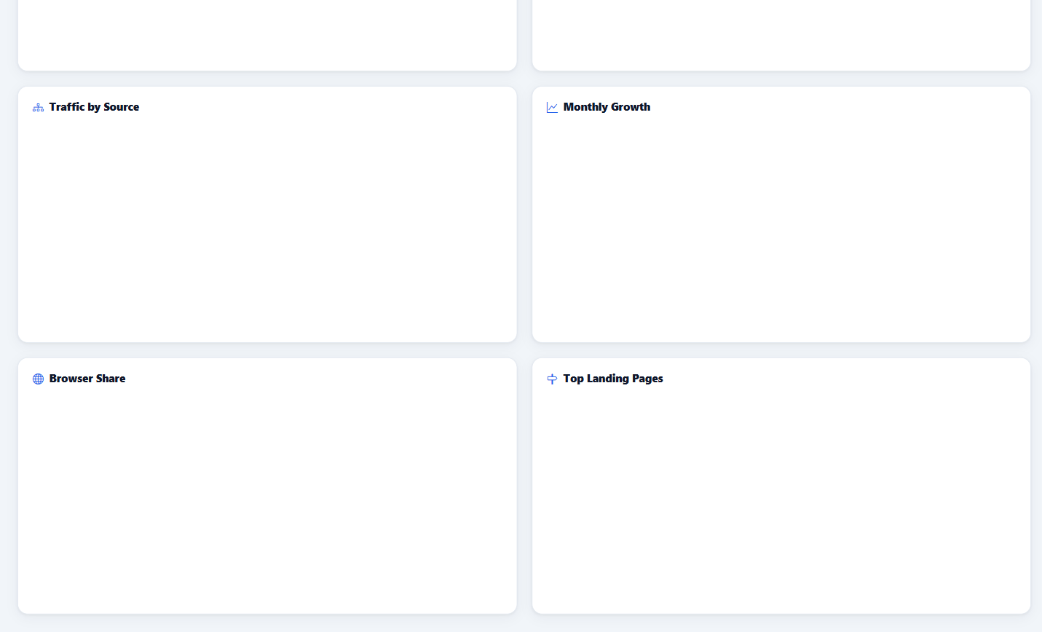
Figure 2 — Dashboard overview for 2 September–2 October 2026 (part 2 of 2)

4.1 Verified live KPI snapshot
Metric | Live value | Scope
Total Visitors | 9,108 | All time
Today's Visitors | 21 | 3 October 2026
Active Users | 1 | Last 30 minutes
Unique Visitors | 6,570 | Selected period and acquisition scope
Returning Visitors | 333 | Selected period visitors with a session before the period
Sessions | 7,953 | Selected period and acquisition scope
Total Pageviews | 9,029 | Matching pageviews during the period
Bounce Rate | 89.3% | Sessions with one or zero matching pageviews
Average Session Duration | 4m 46s | Average stored session duration
Conversion Actions | 209 | Configured conversion events
Converting Sessions | 133 | Distinct sessions with at least one conversion action
Conversion Rate | 1.67% | 133 ÷ 7,953 × 100

DYNAMIC DATA NOTICE
The values above are a dated snapshot, not permanent targets. The live dashboard will change as new sessions and events arrive. Always compare reports using the same date range, timezone and filter set.

5. Date Range, Acquisition Filters and Exports

5.1 Date range
Figure 3 — Date range and export controls
Choose inclusive From and To dates, then select Apply. The server evaluates from 00:00:00 on the first day through 23:59:59 on the last day in Asia/Kolkata.
- Use a fixed range for month-end or campaign reports so every team member compares the same data.
- Do not compare a partial current day with a complete prior day without labelling the difference.
- The top controls provide Excel, PDF and CSV export shortcuts; the Reports tab also provides PDF and CSV downloads.

5.2 Acquisition filters
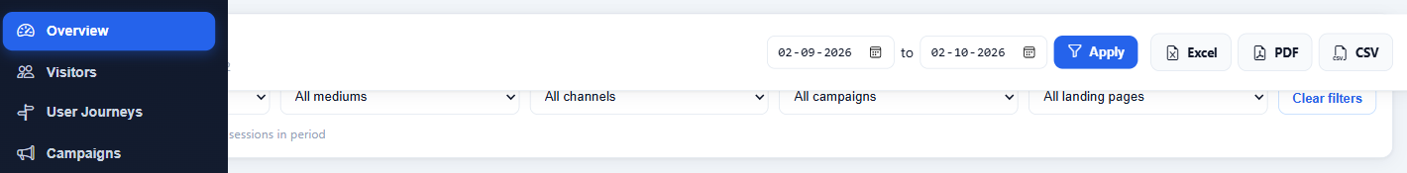
Figure 4 — Acquisition filter bar
Source, medium, channel, campaign and landing-page filters are exact matches. They create one shared session dataset used by the period KPIs, charts and tables.
Filter | Meaning | Example
Source | Origin named by UTM/referrer/click detection. | google, facebook, instagram, youtube
Medium | Marketing mechanism. | cpc, paid_social, paid_video, organic_social
Channel | Normalized reporting group. | Google Ads, Facebook Ads, YouTube Ads, Direct
Campaign | utm_campaign or supported campaign ID. | python_chennai_sep
Landing page | First page path, normalized without the query string. | /course/python

- Select the date range and Apply first.
- Choose one or more acquisition filters.
- Confirm the status line shows the expected matching session count.
- Use Clear filters before starting a different analysis.

5.3 Reports
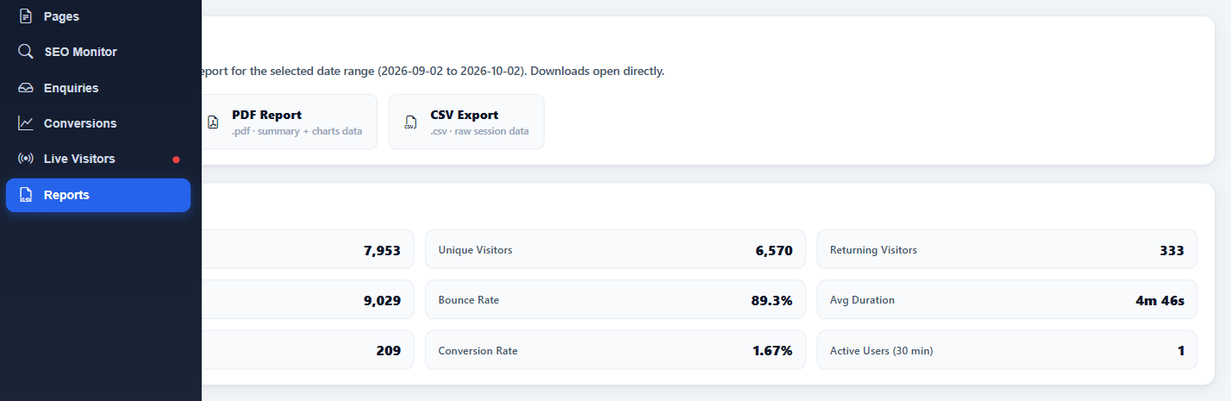
Figure 13 — Reports tab and period summary
The report summary repeats the selected-period KPIs. PDF is intended for presentation; CSV is intended for raw session analysis.

6. Visitor, Session and Engagement Metrics
Metric | Exact interpretation | Calculation / caveat
Total Visitors | All anonymous visitor records ever stored. | All-time and not restricted by the selected period.
Today's Visitors | Visitor records whose last_seen is today. | Operational today metric; not acquisition-filter scoped.
Active Users | Distinct visitors active in the last 30 minutes. | Operational live metric; not selected-period scoped.
Unique Visitors | Distinct visitor IDs with a matching session. | Filtered period metric.
Returning Visitors | Matching visitors who had any earlier session before the range start. | Historical returning logic; not simply a lifetime flag.
Sessions | Matching analytics_sessions records started in the selected period. | A browser session expires after 30 minutes of inactivity.
Pageviews | Matching analytics_pageviews rows created in the period. | Multiple pageviews can belong to one session.
Bounce Rate | Matching sessions with one or zero pageviews ÷ sessions × 100. | This is page-count based, not GA4 engaged-session bounce.
Average Duration | Average stored duration_sec across sessions. | Duration depends on heartbeat/activity signals and can be zero.
New Visitors | Unique visitors minus returning visitors. | Period classification, not a permanent identity claim.

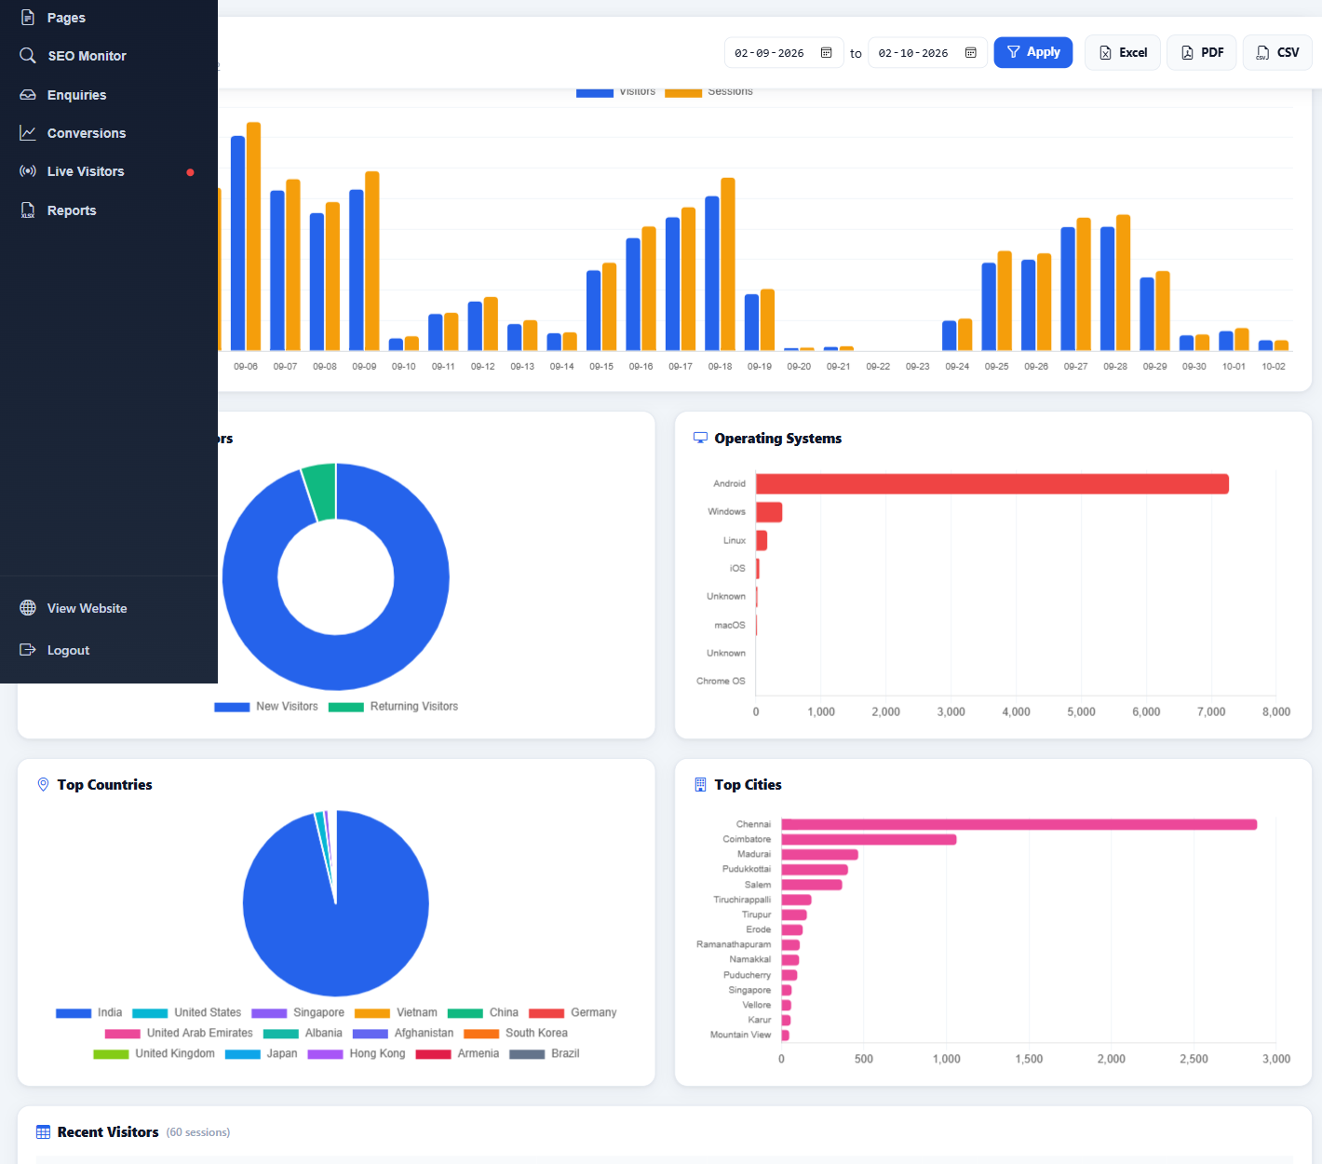
Figure 5 — Visitor analysis and Recent Visitors (phone values masked) (part 1 of 2)
The visitor section combines trend, new/returning mix, device, operating system and geography. Recent Visitors shows the latest 60 matching sessions.
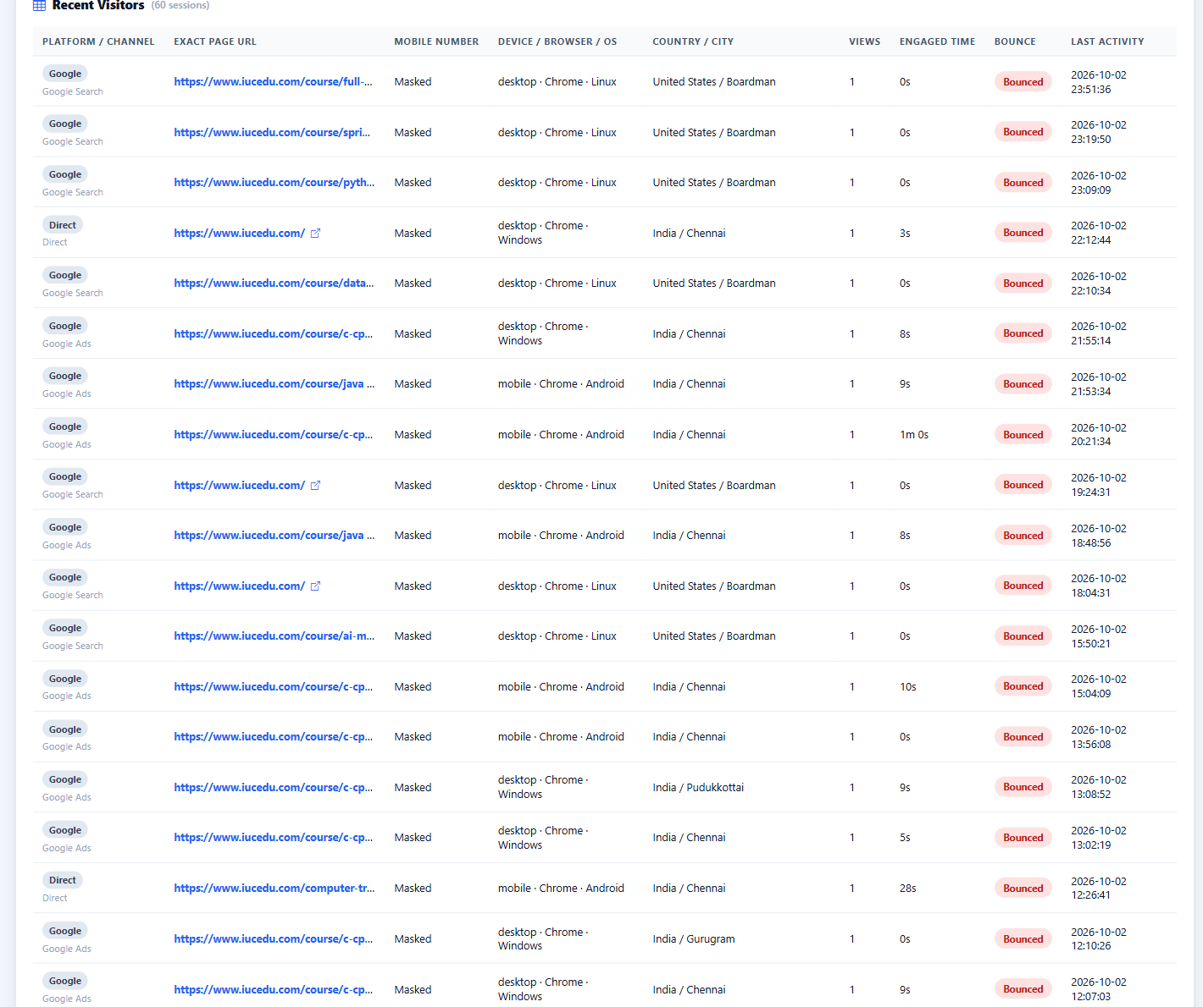
Figure 5 — Visitor analysis and Recent Visitors (phone values masked) (part 2 of 2)

6.1 Device, browser, operating system and geography
- Device/browser/OS counts group matching sessions, not unique people.
- Country, state and city depend on IP-based lookup and may show Unknown or a network/VPN location.
- Use these breakdowns for responsive-design and regional campaign decisions, not precise personal-location claims.

6.2 Recent Visitors table
- Fields: platform/channel, exact latest/exit URL, optional known phone, device/browser/OS, country/city, pageviews, engaged time, bounce status and last activity.
- The table is limited to the 60 latest sessions within the chosen range and filters.
- Contact fields are personal data. Export or share them only with authorised admissions personnel.

7. User Journeys
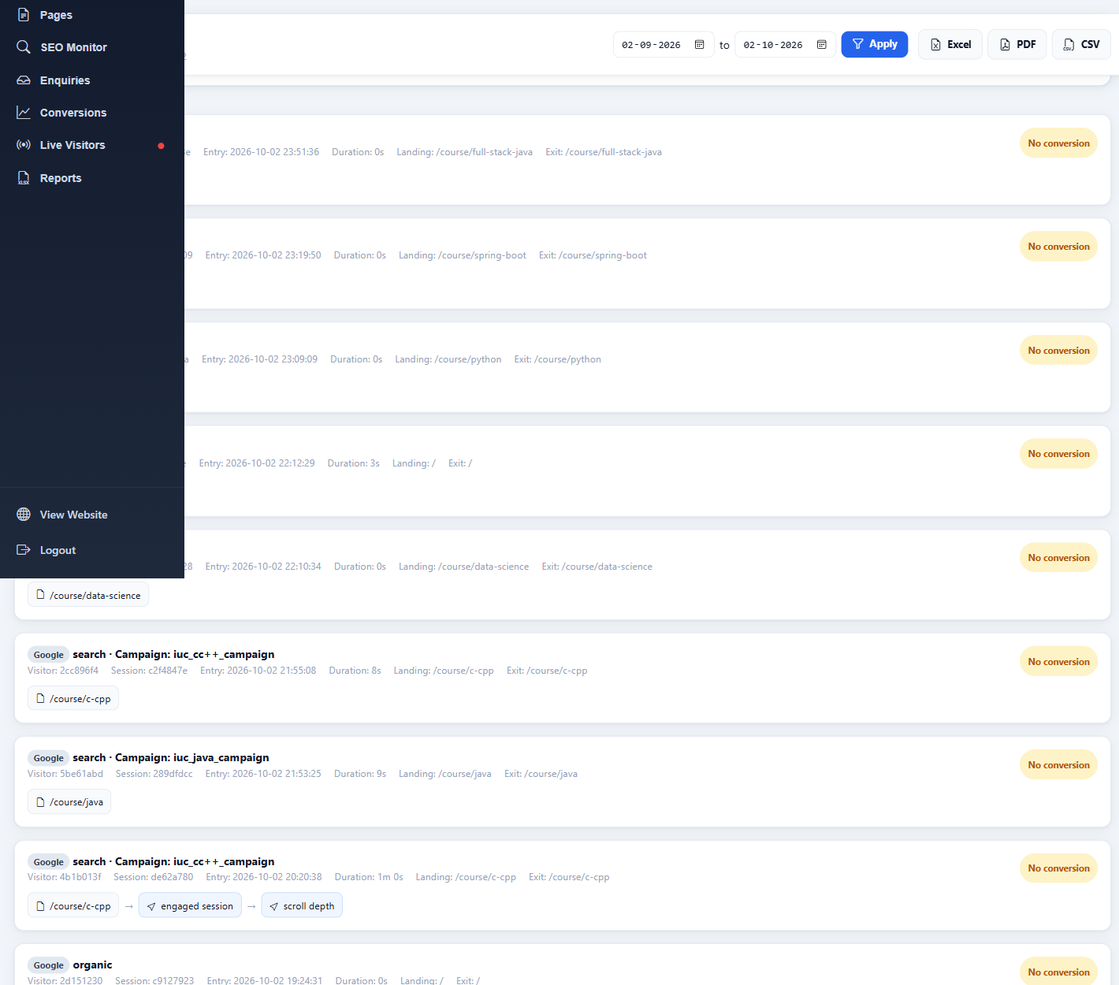
Figure 6 — Ordered anonymous session journeys (part 1 of 2)
Each journey lists the acquisition label, shortened anonymous visitor/session IDs, entry time, duration, landing and exit pages, followed by ordered page and event steps. Up to 40 recent matching sessions are shown.
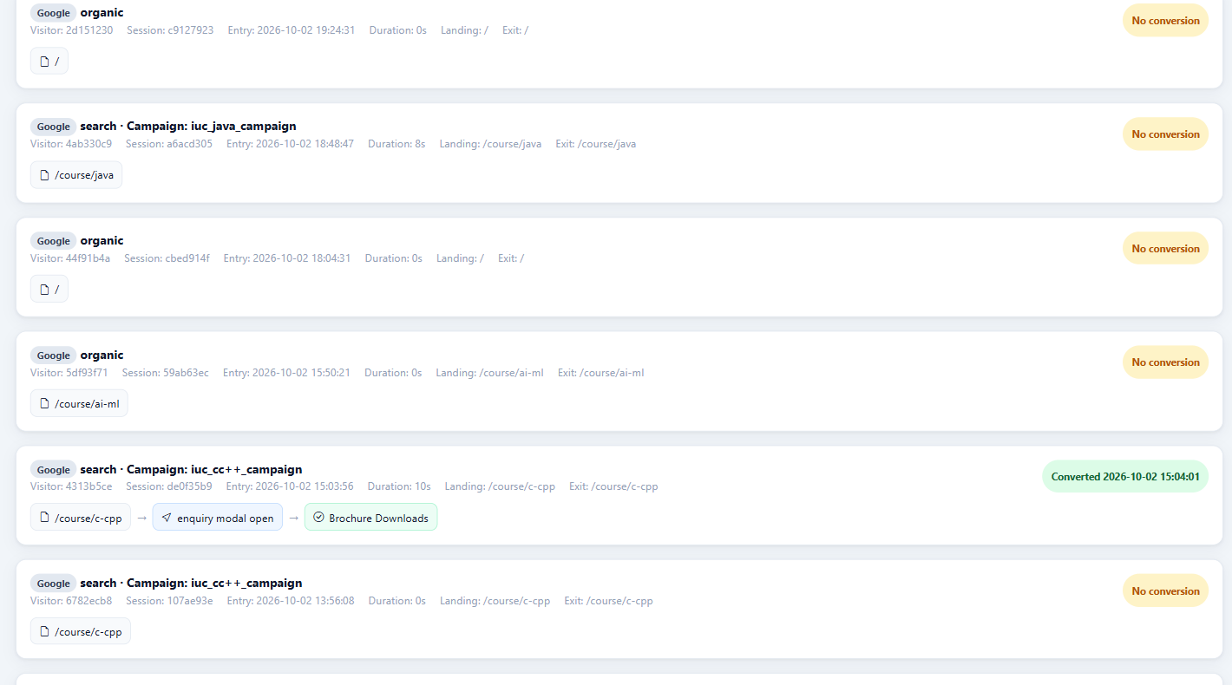
Figure 6 — Ordered anonymous session journeys (part 2 of 2)

7.1 How to read a journey
- Read the source, medium and campaign in the journey header.
- Compare landing and exit pages to understand where the session began and ended.
- Follow page nodes and interaction-event nodes from left to right.
- Use the green converted marker to identify a session with at least one configured conversion action.
- ANONYMOUS BY DESIGN
- Journey IDs are shortened anonymous identifiers. They are useful for debugging a session path but should not be presented as a named person unless a separately authorised enquiry record provides that relationship.

8. Campaign Attribution and Social Website Traffic

8.1 Required campaign URL fields
Parameter | Purpose | Recommended value
utm_source | Platform or referrer source. | youtube, facebook, instagram, google
utm_medium | Traffic mechanism. | paid_video, paid_social, cpc, organic_social
utm_campaign | Campaign grouping. | python_chennai_oct
utm_content | Creative/ad distinction. | video_ad_01, carousel_02
utm_term | Paid keyword or managed targeting term. | python course chennai
utm_id / campaign ID | External campaign identifier. | Platform campaign identifier

TAGGED URL EXAMPLE
https://www.iucedu.com/course/python?utm_source=youtube&utm_medium=paid_video&utm_campaign=python_chennai_oct&utm_content=video_ad_01

8.2 Supported click identifiers
The tracker recognizes gclid, dclid, gbraid, wbraid, fbclid, msclkid, ttclid, twclid, li_fat_id, gad_source and gad_campaignid. Click identifiers supplement UTMs; they do not replace a clear campaign naming standard.
- fbclid alone cannot reliably distinguish Facebook from Instagram. Use utm_source=instagram on Instagram links.
- gclid alone cannot identify whether the click came from YouTube, Search or another Google inventory. Use utm_source and utm_medium.

8.3 Session behavior when campaign attribution changes
- Opening the same campaign again or reloading the page reuses the active session.
- A genuinely different campaign/source during the current 30-minute session starts a new analytics session so the new attribution is not overwritten.
- Normal direct/internal navigation during an active campaign session retains that session and does not create duplicates.
- 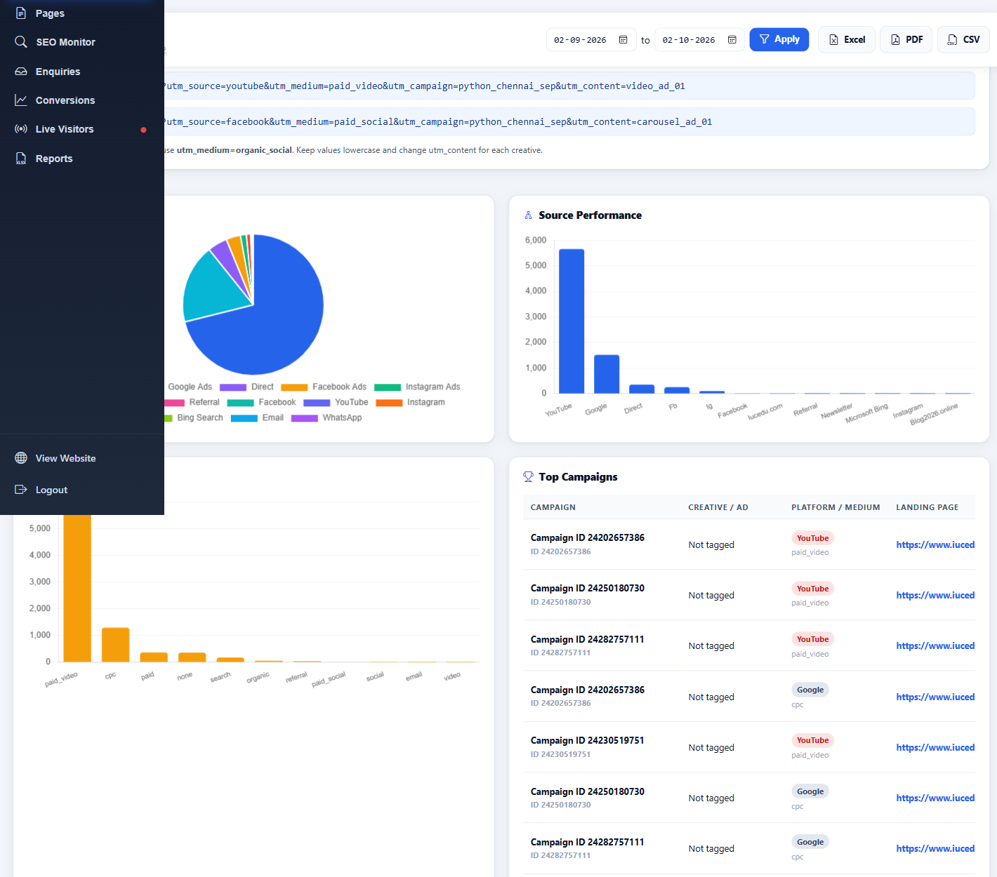
Figure 7 — Campaign performance (part 1 of 2)
The campaign view groups tagged sessions by campaign, campaign ID, creative/content, source, medium and click-ID type. It reports first/last visit, sessions, website pageviews and conversion actions; the visible table is limited to 50 grouped rows.
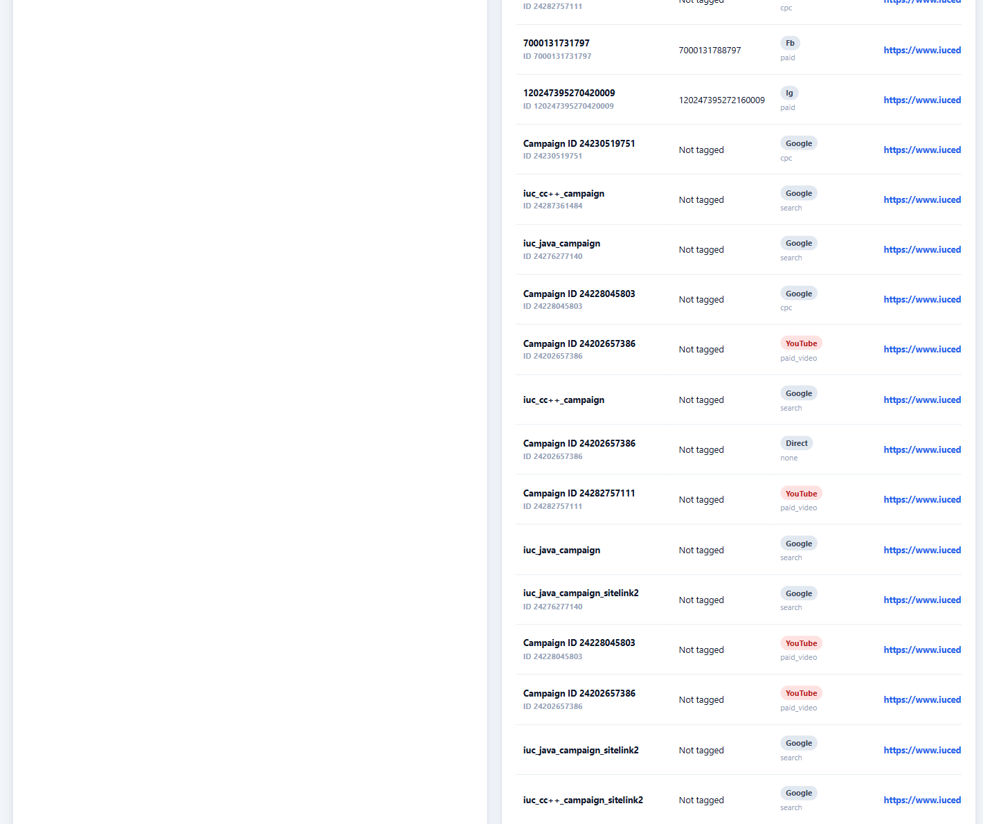
Figure 7 — Campaign performance (part 2 of 2)

8.4 Cost and note fields
Campaign cost and note fields are manual metadata stored in analytics_campaign_meta. They are not automatically imported from Meta, Google Ads or YouTube. Treat them as operational annotations and verify the currency/time range before using them in ROI analysis.

8.5 Social website traffic
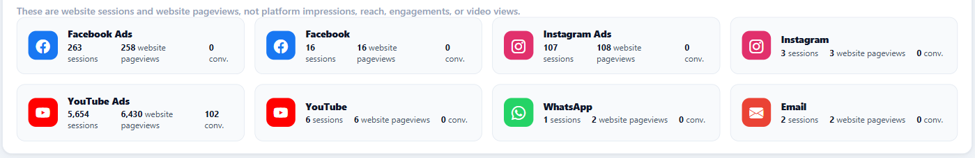
Figure 8 — Social website sessions, pageviews and conversions
These cards report website activity attributed to the named social channel. They do not report platform impressions, reach, engagements or video views.
Channel | Sessions | Website pageviews | Conversion actions
Facebook Ads | 263 | 258 | 0
Facebook | 16 | 16 | 0
Instagram Ads | 107 | 108 | 0
Instagram | 3 | 3 | 0
YouTube Ads | 5,654 | 6,430 | 102
YouTube | 6 | 6 | 0
WhatsApp | 1 | 2 | 0
Email | 2 | 2 | 0

9. Pages, Landing Pages and Exit Pages
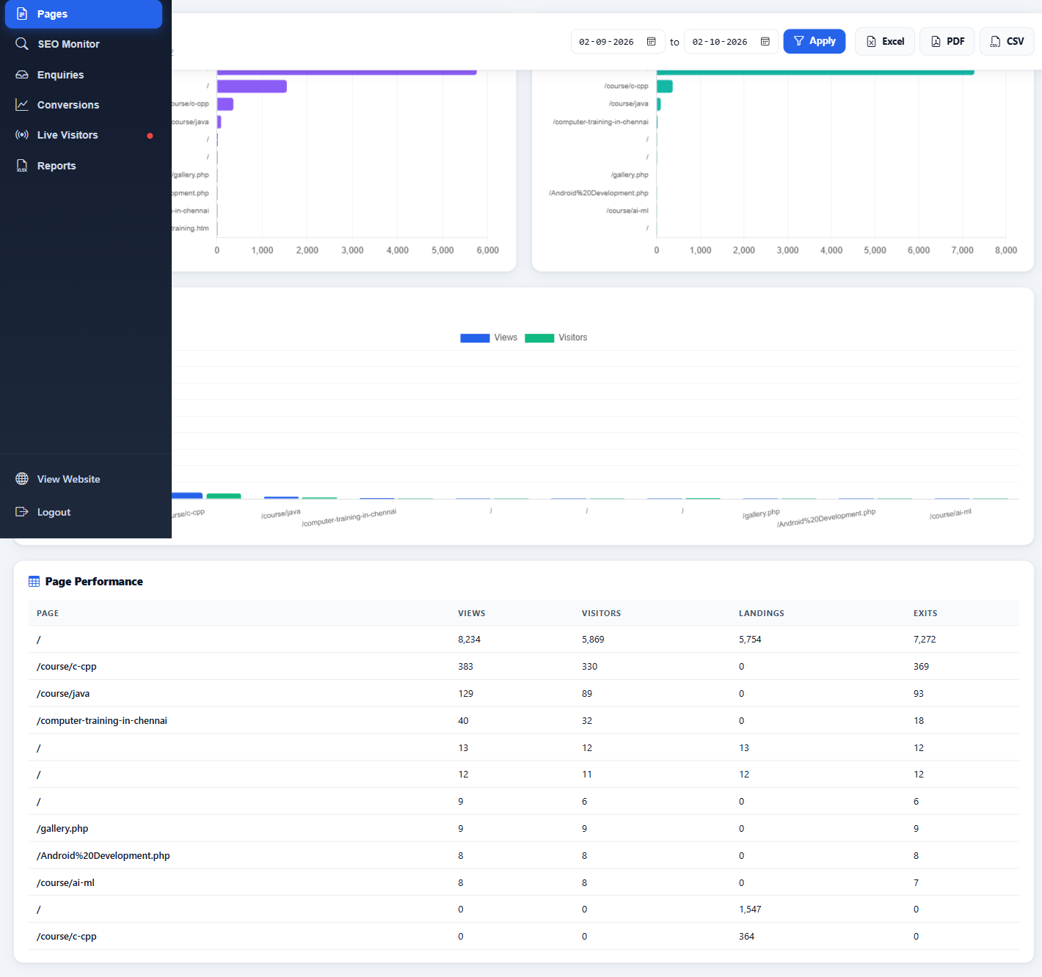
Figure 9 — Page performance
Page Performance merges top pageviews, landing-session counts and exit-session counts by normalized page path.
Column | Meaning
Page | Normalized website path; query strings are removed for grouping.
Views | Matching pageview records for that path.
Visitors | Distinct anonymous visitor IDs that viewed the path.
Landings | Sessions whose first/landing page is the path.
Exits | Sessions whose recorded exit page is the path.

9.1 Practical analysis
- High landings with high bounce: review message match, load speed, mobile layout and CTA clarity.
- High views with low conversions: inspect the next-step CTA and form visibility.
- High exits are not automatically bad; confirmation/contact-completion pages are natural exits.

10. Interaction Events and Engagement
The tracker sends allowed interaction events to analytics_events. Some events are diagnostic engagement signals; six event types are counted as conversion actions.
Event | Category | Meaning
pageview | Core measurement | A tracked page load.
heartbeat | Core measurement | Updates time-on-page and session duration.
scroll_depth | Engagement | Configured scroll milestone reached.
engaged_session | Engagement | Page remained visible for 10 seconds.
course_card_click | Engagement | Course card selected.
enquiry_modal_open | Funnel | Enquiry modal opened.
enquiry_form_start | Funnel | First interaction with the enquiry/contact form.
contact_form_attempt | Funnel | Form submission attempted.
form_validation_failure | Funnel | Browser validation prevented submission.
thank_you_shown | Funnel verification | Thank-you message observed after successful flow.
cta_click / outbound_click | Navigation | Marked CTA or external link selected.
contact_form | Conversion | Successful enquiry/contact form recorded.
call_click | Conversion | Telephone link selected.
whatsapp_click | Conversion | WhatsApp link selected.
brochure_download | Conversion | Brochure/PDF link selected.
admission | Conversion | Marked admission action.
registration | Conversion | Registration/newsletter action.

EVENT COUNTING
An event count is a number of actions, not a number of people. One session can generate several conversion actions. This is why the dashboard separately reports Conversion Actions and Converting Sessions.

11. Conversions
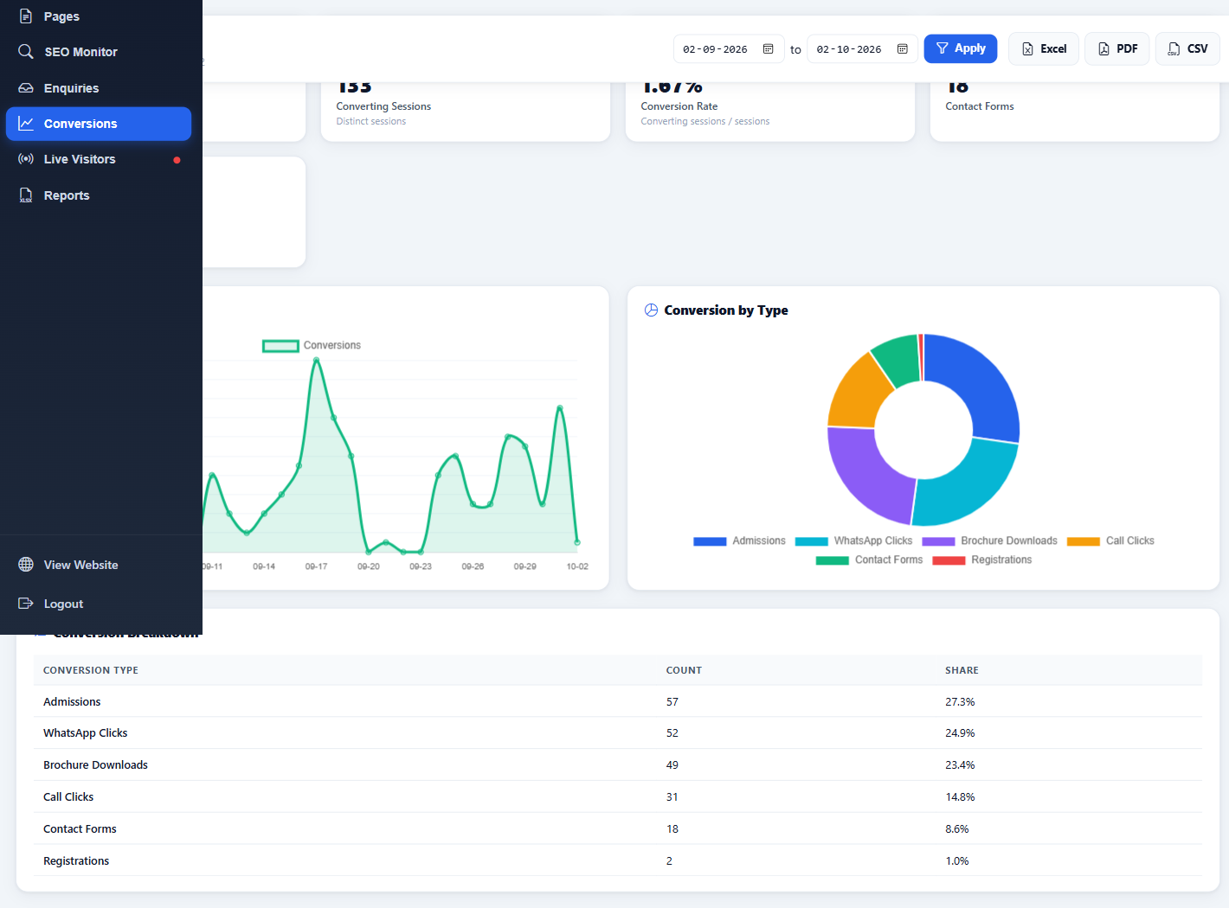
Figure 12 — Conversion KPIs, trend and action mix
The selected period recorded 209 conversion actions in 133 distinct sessions. Conversion rate is based on converting sessions, preventing multiple actions in one session from inflating the rate.

11.1 Formula
CONVERSION RATE
Distinct sessions with at least one configured conversion action ÷ all matching sessions × 100. Live example: 133 ÷ 7,953 × 100 = 1.67%.

Conversion action | Count | Share of 209 actions
Admissions | 57 | 27.3%
WhatsApp Clicks | 52 | 24.9%
Brochure Downloads | 49 | 23.4%
Call Clicks | 31 | 14.8%
Contact Forms | 18 | 8.6%
Registrations | 2 | 1.0%

12. Enquiries and Lead Operations
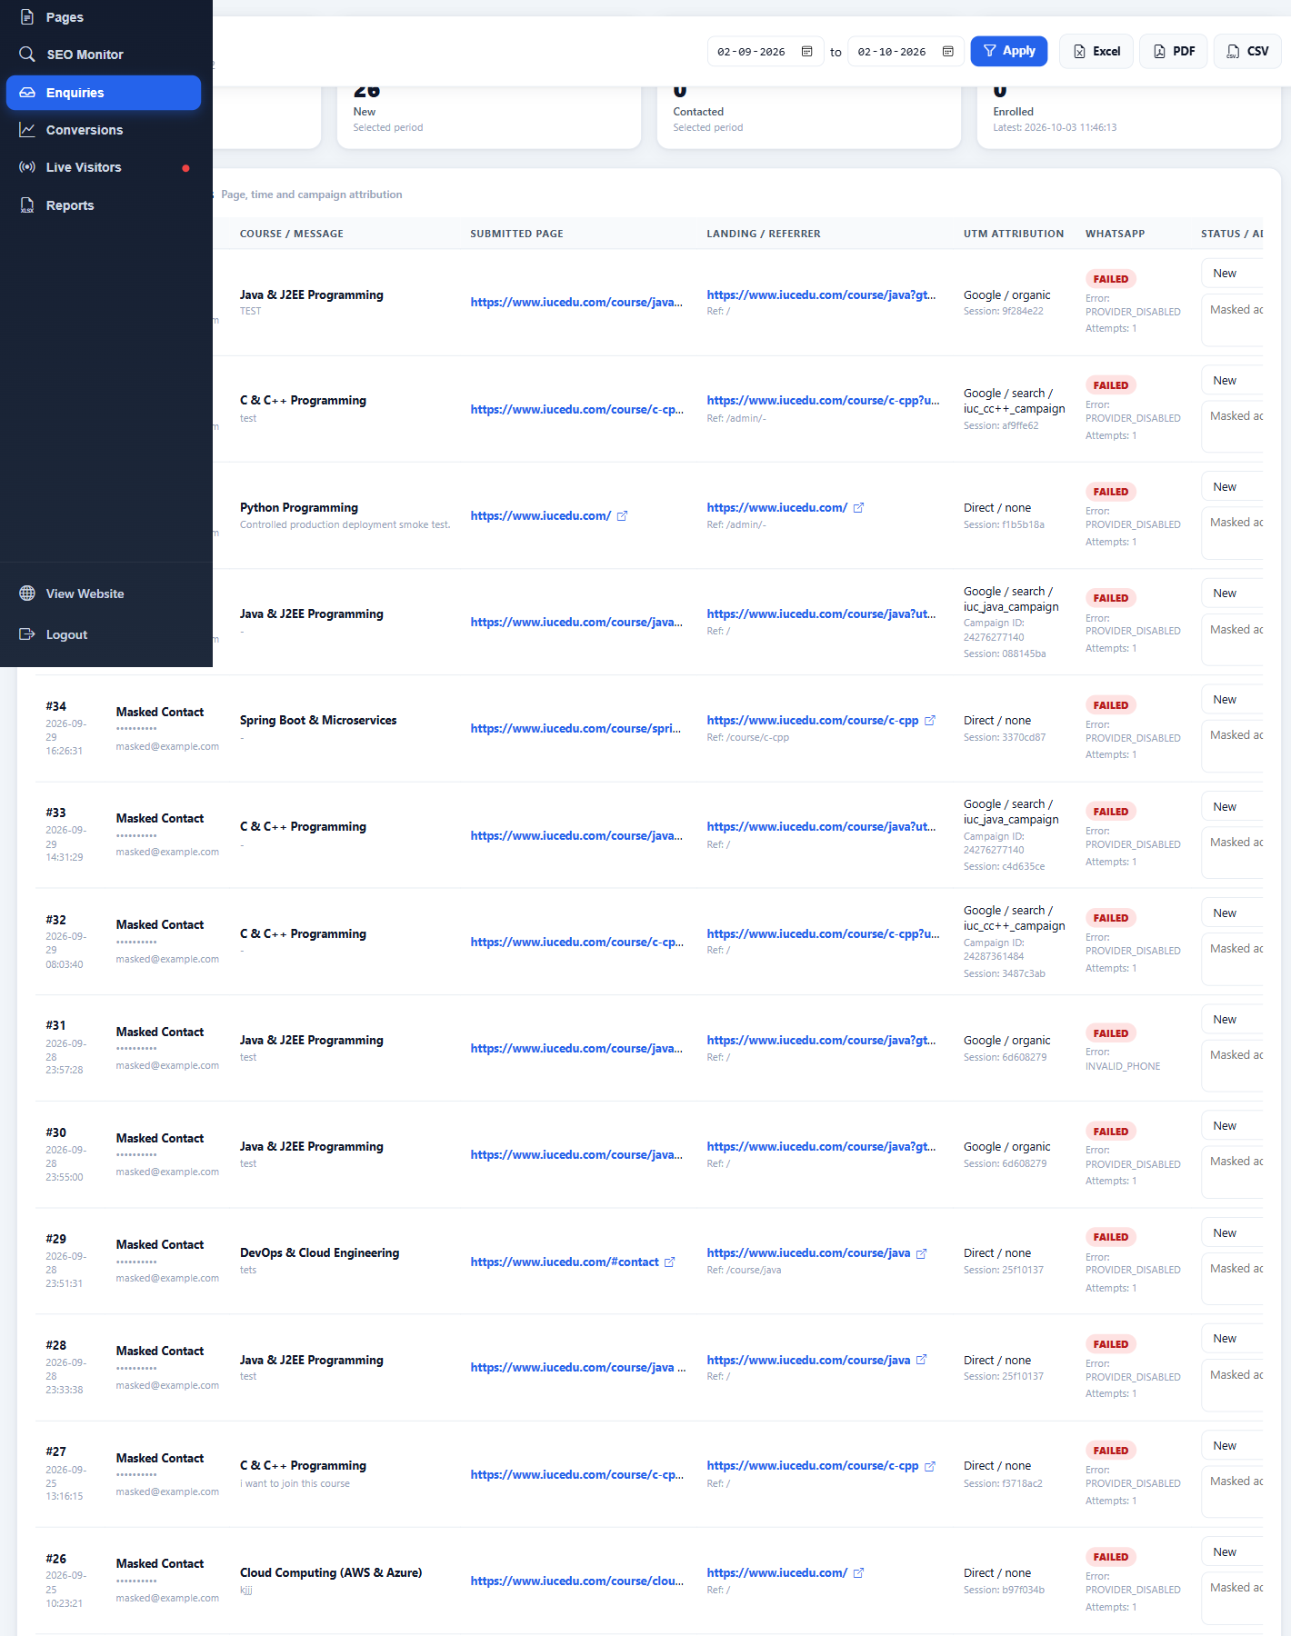
Figure 11 — Saved enquiries (contact details and admin notes masked)
The table links each enquiry to course/message, submitted page, landing/referrer, UTM attribution, WhatsApp status and the admissions workflow status.

12.1 Live enquiry snapshot
Metric | Value | Meaning
All Enquiries | 39 | All-time database total; not restricted to the selected period.
New | 26 | Enquiries in the selected period currently marked New.
Contacted | 0 | Selected-period enquiries marked Contacted.
Enrolled | 0 | Selected-period enquiries marked Enrolled.
Displayed rows | 26 | Enquiries matching the selected period; API maximum is 200 rows.

12.2 Lead workflow
- Review the newest enquiry first and confirm the course/message context.
- Check submitted page, landing/referrer and UTM attribution before assigning campaign credit.
- Contact the lead using an authorised business channel.
- Change the status to Contacted, Enrolled, Closed or Spam and add a concise operational note.
- Select Save and verify the row confirms the update.

12.3 WhatsApp status
The captured live rows show WhatsApp failures such as PROVIDER_DISABLED and, for one record, INVALID_PHONE. These statuses do not mean the enquiry was lost: the enquiry record and contact_form conversion can still be saved. They mean the WhatsApp auto-reply was not accepted for that attempt.
CURRENT LIMITATION
At capture time the WhatsApp provider was disabled for many displayed enquiries. This guide does not change the provider configuration. Re-enable or repair it only through the separately approved WhatsApp/Meta workflow, then perform a controlled API and enquiry test.

The existing thank-you tracking hook remains enquiry-thank-you-message. The browser tracker can also record thank_you_shown; successful contact_form conversion is recorded independently in the server-side enquiry flow.

13. SEO Monitor and Google Search Console
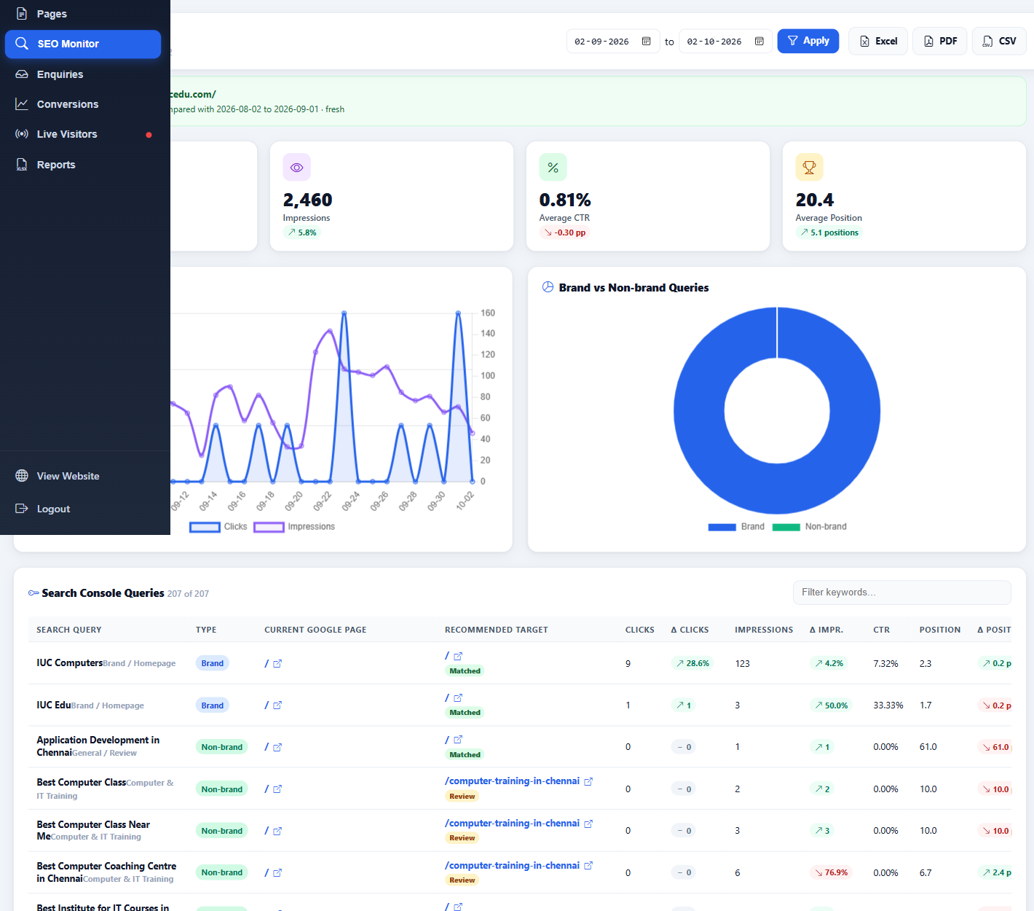
Figure 10 — Connected Google Search Console performance (part 1 of 3)
The live dashboard was connected to https://www.iucedu.com/ for 2 September–2 October 2026 and compared the equal previous period 2 August–1 September 2026. The query table contained 207 rows before keyword filtering.
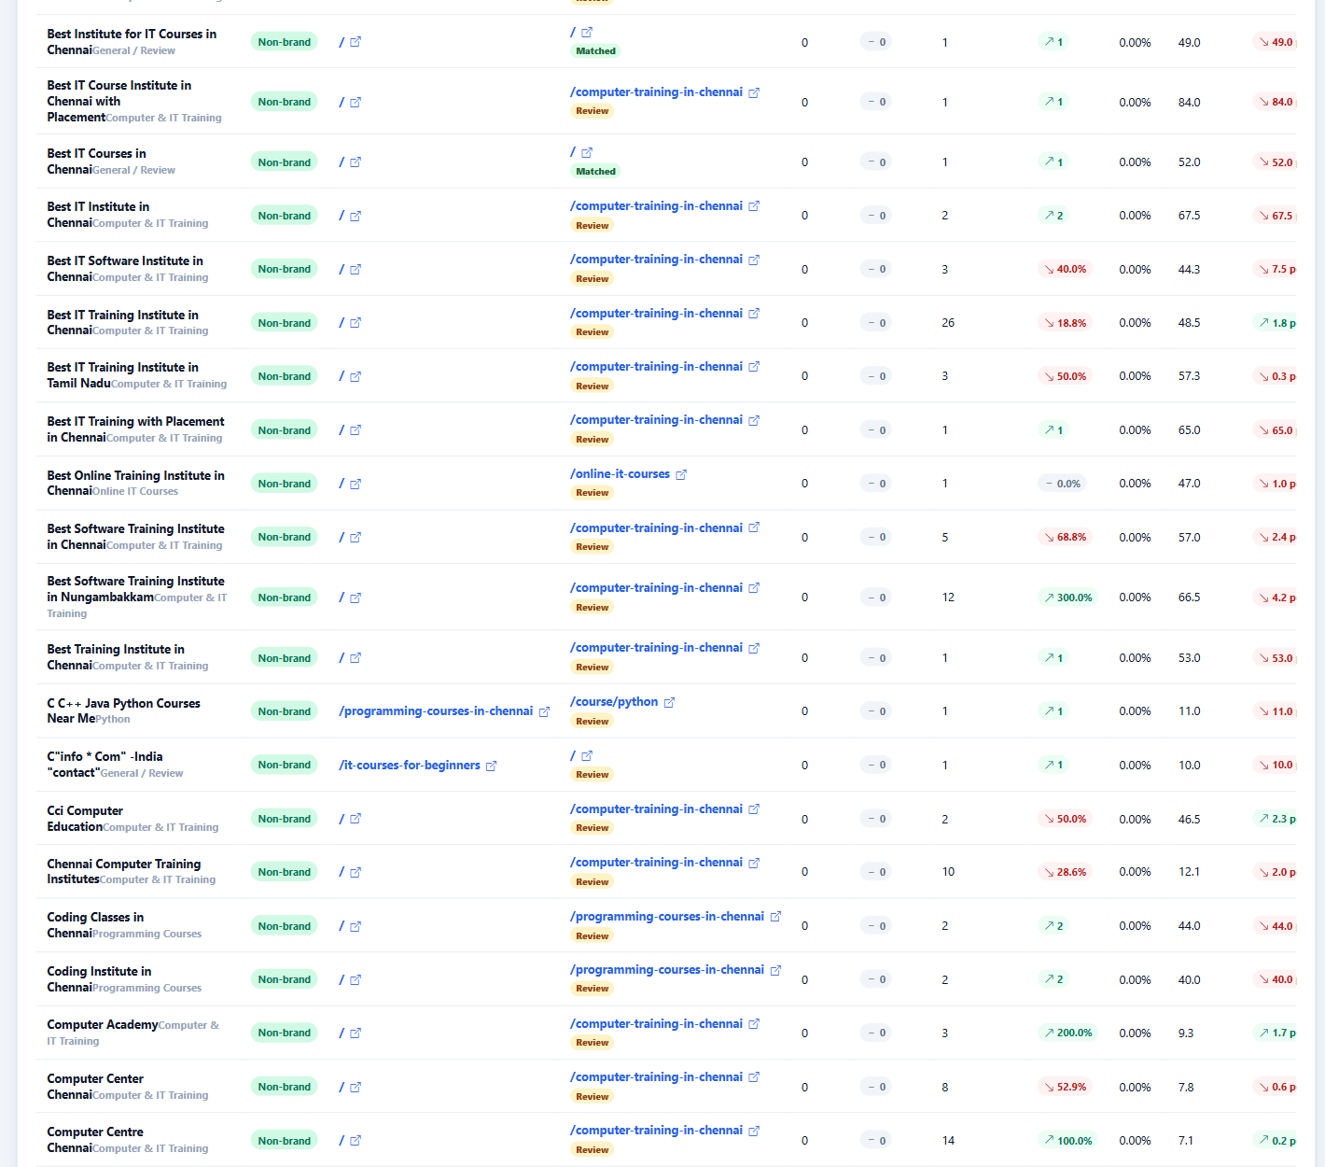
Figure 10 — Connected Google Search Console performance (part 2 of 3)
Figure 10 — Connected Google Search Console performance (part 3 of 3)

13.1 Verified Search Console snapshot
Metric | Current period | Change versus previous period
Google Clicks | 20 | +23.1%
Impressions | 2,460 | +5.8%
Average CTR | 0.81% | −0.30 percentage points
Average Position | 20.4 | Improved by 5.1 positions

13.2 Metric definitions
Metric | Meaning
Clicks | Clicks from Google Search results to the selected Search Console property.
Impressions | Times a property result was shown under Search Console rules.
CTR | Clicks ÷ impressions × 100.
Average Position | Impression-weighted average top result position; lower is generally better.
Brand vs Non-brand | Query classification used for strategic grouping, not individual-user attribution.
Recommended Target | Operational mapping between a query and the most relevant website page.

13.3 Search Console vs website attribution
- Search Console is aggregated and privacy-protected; it cannot identify which named enquiry searched a particular organic query.
- Session-level keywords are available only when a referrer exposes a term or a managed campaign supplies utm_term.
- Search Console and website analytics can differ because they use different measurement definitions, time processing and filtering.

13.4 Connection security
If a service-account JSON key is uploaded through the connection form, the implementation keeps it in the authenticated admin session and does not write it to project files or the database. Use Forget credential/Logout when finished and never include the JSON key in screenshots or reports.

14. Daily, Weekly and Campaign Reporting Workflows

14.1 Daily admissions/marketing check
- Open a short recent range and confirm database health is ready.
- Review Active Users, today's visitors and the newest enquiries.
- Check WhatsApp status and follow up failed auto-replies manually when authorised.
- Review Recent Visitors and User Journeys for abnormal landing-page or validation patterns.

14.2 Weekly campaign review
- Select a complete seven-day range and clear filters.
- Record sessions, unique visitors, pageviews, converting sessions and conversion rate.
- Filter one source/campaign at a time and compare landing pages and conversion actions.
- Check campaign naming consistency and creative-level utm_content coverage.
- Compare website sessions with platform landing-page views/clicks—not platform impressions.

14.3 Month-end report
- Use fixed calendar dates and note Asia/Kolkata as the reporting timezone.
- Export PDF for the management summary and CSV for validation/pivot analysis.
- State whether filters were applied and include the exact metric definitions.
- Keep ad-platform and website metrics in separate columns before calculating funnel rates.
- Funnel level | - Example metric | - Source
- Delivery | - Impressions / reach / video views | - Advertising platform
- Response | - Link clicks / platform landing-page views | - Advertising platform
- Website acquisition | - Sessions / unique visitors | - IUC website analytics
- Website engagement | - Pageviews / duration / journey events | - IUC website analytics
- Outcome | - Enquiries / converting sessions / actions | - IUC website and enquiry database

15. Troubleshooting
Symptom | Checks | Action
Dashboard appears empty or stuck | Confirm login, date range, filters, Network status and database-health message. A large live range may take time. | Wait for the single request; avoid repeated Apply/reload clicks. Clear filters and retry a smaller range. Escalate HTTP 500, invalid JSON, timeout or SQL errors.
No campaign attribution | Inspect the final landing URL after redirects; confirm UTMs/click IDs remain present and use consistent lowercase values. | Fix the campaign URL/redirect in a separately approved change. Do not rewrite historical data without approval.
Campaign appears as Direct | App/browser may have removed the referrer and the link lacked UTMs. | Use explicit utm_source, utm_medium, utm_campaign and utm_content on every managed link.
Social totals differ from Meta/YouTube | Check whether the platform number is impressions, video views or clicks. | Compare platform landing-page views/clicks with website sessions using the same dates/timezone.
Conversion actions exceed converting sessions | One session generated several actions. | Use converting sessions for conversion rate; retain actions as engagement volume.
Search Console unavailable | Check connection status, property access, selected dates and session credential state. | Reconnect with the approved service account; never store the key in source control.
WhatsApp shows PROVIDER_DISABLED | Enquiry saved but outbound provider is disabled. | Follow up manually and use the separate approved Meta/WhatsApp setup process.
WhatsApp shows INVALID_PHONE | Recipient number could not be normalized/accepted. | Correct the contact number through the authorised lead workflow and retest safely.
Recent table has fewer rows | Fewer than 60 sessions match the chosen scope. | Expand the date range or clear acquisition filters.
Journey missing expected event | Event may be blocked, not implemented on that element, or outside the latest 40 sessions. | Reproduce in a controlled test and inspect Network/API/event table without changing production data.

15.1 Production error checklist
- Browser Network: API HTTP status, response time, response body and JSON validity.
- Browser Console: JavaScript exceptions and failed resource requests.
- API health payload: query_errors must be empty and schema_ready should be true.
- Server error log: PHP fatal/warning, timeout, memory and SQL errors such as "Can't reopen table".
- Database freshness: latest timestamps in visitor, session, pageview, event and enquiry tables.

16. Known Limits, Privacy and Data Quality
Area | Current limit / caveat
Session window | 30 minutes of inactivity. A changed campaign can deliberately start a new session within that window.
Anonymous identity | localStorage visitor ID; clearing storage, incognito mode or switching browser/device creates a new anonymous visitor.
Blocking | JavaScript blockers, failed loads or blocked requests can prevent first-party website tracking.
Referrer loss | Mobile apps and privacy controls may remove referrer information; explicit UTMs are essential.
Recent Visitors | Maximum 60 sessions in the UI response.
User Journeys | Maximum 40 recent matching sessions.
Campaign table | Maximum 50 grouped campaign rows.
Enquiries | Maximum 200 selected-period rows; All Enquiries remains an all-time total.
Source charts | Top source/medium charts are limited to 12 groups.
Geography | IP-derived and approximate; VPNs/proxies can change the apparent location.
Duration | Depends on heartbeats and can be understated when a tab closes before the next update.
Today / Active / Total | Operational/all-time cards are not all constrained by acquisition filters; read each card subtitle.
Ad platform metrics | No automatic Meta/YouTube/Google Ads impression, reach, click or cost import.
Campaign cost/notes | Manual metadata; verify date/currency and the separately tracked metadata issue before financial conclusions.
Search Console | Aggregate and may be delayed; it cannot identify a specific searcher or enquiry.
WhatsApp | Provider status is separate from enquiry saving; the captured state includes provider-disabled failures.

16.1 Privacy handling
- Treat names, phone numbers, email addresses, messages, admin notes and full click IDs as restricted operational data.
- Mask personal data before sharing screenshots outside the authorised admissions/technical group.
- Do not expose passwords, OTPs, cookies, CSRF values, access tokens, service-account keys or Meta credentials.
- Use aggregate campaign reports whenever individual lead details are not required.

Appendix A — Quick Metric Formula Reference
Metric | Formula
Unique Visitors | COUNT(DISTINCT visitor_id) across matching sessions
Returning Visitors | Distinct matching visitors with a session before the selected start timestamp
Pageviews | COUNT matching analytics_pageviews records
Bounce Rate | Sessions with ≤1 pageview ÷ sessions × 100
Average Duration | AVG analytics_sessions.duration_sec
Conversion Actions | SUM configured conversion-event counts
Converting Sessions | COUNT distinct matching sessions with ≥1 configured conversion event
Conversion Rate | Converting Sessions ÷ Sessions × 100
Search CTR | Google Search clicks ÷ impressions × 100

Appendix B — Campaign Naming Checklist
- Use lowercase, stable values; prefer underscores over spaces.
- Use the real platform in utm_source and the delivery mechanism in utm_medium.
- Keep one campaign name consistent across all creatives in the same campaign.
- Give each creative/ad/post a unique utm_content.
- Use utm_term only for a real keyword or a documented managed targeting term.
- Test the final URL through every redirect before publishing.
- Open the URL in a clean browser and confirm the dashboard receives the expected source/campaign.

Appendix C — Screenshot and Verification Record
Figure | Live section | Privacy treatment
1 | Admin Login | Sample username and masked sample password.
2 | Overview | Aggregate metrics only.
3 | Date/Exports | No sensitive values.
4 | Acquisition Filters | No sensitive values.
5 | Visitors / Recent Visitors | Mobile-number column replaced with Masked.
6 | User Journeys | Anonymous IDs shown only in shortened form.
7 | Campaigns | Manual note inputs cleared for capture.
8 | Social Traffic | Aggregate website metrics only.
9 | Pages | Aggregate paths and counts only.
10 | SEO / Search Console | Aggregate queries and performance only; no credential shown.
11 | Enquiries | Names, phones, emails and admin notes masked.
12 | Conversions | Aggregate counts only.
13 | Reports | Aggregate period summary only.

Verification basis: authenticated live UI capture on 3 October 2026, fixed period 2 September–2 October 2026, plus source review of the local analytics implementation. No live mutation was performed.

Appendix D — Ownership and Change Control
This guide documents the system as verified on the preparation date. Update it after any material change to attribution logic, conversion definitions, dashboard filters, Search Console integration, enquiry workflow, WhatsApp provider, database schema or report limits.
Role | Recommended responsibility
Digital Marketing | Campaign URL standards, platform-vs-website reconciliation and weekly analysis.
Admissions | Enquiry follow-up, lead status updates and authorised notes.
Technical Administrator | Collector/API health, secure access, error-log review and controlled deployments.
Management | Metric definitions, reporting-period approval and interpretation of outcomes.

END OF GUIDE
For a discrepancy, always preserve the exact date range, acquisition filters, dashboard screenshot, API response status and metric definition before escalating.

