Winegrape Maturity Enhancement via Reverse Osmosis

Clark Smith and Ken Fugelsang
Vinovation, Inc., Sebastopol California and
Dept. of Enology, California State University, Fresno, California.

Introduction
The reproductive strategy of the genus Vitis centers around dissemination of mature seeds by animals, principally birds. Berries attract avian vectors by surrounding seeds with nutrient- and flavor-rich pericarpal flesh encased in black or golden epidermal tissue which enhances visibility against green foliage. To prevent premature consumption by animals prior to seed viability, immature berries which are formed from primordial during cycle 1 are, by contrast, camouflaged and undesirable: small, hard, low in flavor (except vegetal flavors), low in sugar and high in acid.

During cycle 2, which comprises about 100 days, berries transform vigorously. The required time for completion of cycle 2 appears, for a given variety, to be nearly independent of climate. Since the secondary artifacts of cycle 2 (color, flavor, phenolics) are the essential materials necessary to the evolution of rich flavor and distinctive character of wines, optimum maturity is a critical prerequisite to wine quality.

Primary metabolic effects such as malic acid degradation and sugar accumulation, on the other hand, proceed at differing rates in different climates and are greatly subject to heat and rain. Harvest at optimum maturity is hampered in cool climates by rain (resulting in diluted sugar and flavor) and in warm climates by high sugar, resulting in excessive alcohol content in resulting wines. In both climates, extending maturation may result in bird damage and, occasionally, in elevated volatile acidity.
Reverse osmosis applications to enhance maturity by concentrating juice, reducing volatile acidity, and adjustment of alcohol content have been developed and commercialized in recent years. This paper will discuss details of alcohol adjustment, for which several strategies exist in commercial practice.

For immature fruit, these applications are less desirable than traditional methods such as chaptalization, since concentration of acids and green tannins reduces quality. For ripe fruit, however, the removal of diluting rainwater in cool climates and of excessive alcohol in warmer climates may permit balanced wines of mature varietal expression and distinctive appellation-derived characteristics to be achieved more consistently.

Alcohol Adjustment Applications
I. Non-alcoholic wine production.
Methods for the production of non-alcoholic wine bear little relationship to those employed for adjustment of premium table wine. While United States federal labeling regulations for wine do not permit the introduction of foreign water, non-alcoholic wine is not subject to this restriction.

Reverse osmosis filtration produces a permeate product which, depending on precise membranes characteristics, is substantially free of flavor and color but contains 40 to 80% of the ethanol percentage of the wine retentate. Permeate may be simply discarded and replaced by purified water. This practice results in non-standard wine and may also strip mouthfeel components, depending on the porosity of the membrane employed. Wines in this category generally require addition of re-flavoring systems to achieve palatability.

II. Recombinatory strategies for alcohol reduction for table wines.
In U.S. table wines, permeate must be stripped of its alcohol and its de-alcoholized portion recombined back into the original wine to prevent the introduction of foreign water which may occur in dialysis systems. Since the goal of the process is to preserve the volume, composition and character of the wine, critical factors for the process include membrane porosity, purity of extracted ethanol, and microbial stability of treated lot. If too small a percentage is treated so that the resulting component is below 8% alcohol, the treated portion may be subject to spoilage and should be blended expeditiously.
Advantages over vacuum distillation are:
- Reverse osmosis is incapable of separating wine flavor and aroma constituents, which remain together in the retentate.
- Minimum wine concentration and product loss.
- Purity of removed spirit, not subject to operator’s whim.
- Economy, portability and ease of operation.

In the system utilized by the author, treatment is generally performed on a 10 to 25% portion and back-blended to achieve the desired level based on tasting trials.

Permeate is introduced into a packed column continuous distillation system containing 15 stripping plates and 15 rectifying plates. Ethanol of the composition shown in Table 1 is removed. It will be noted that although higher alcohol content is low in this distillate, methanol content, for which reverse osmosis does not present a barrier, is atypically elevated in comparison to wine spirit. Further refinement of high proof spirits might be easily accomplished by installation of additional draw points for heads and tails cuts.

Table 1:
Typical high proof ethanol composition from wine permeate generated by reverse osmosis
U.S. Proof | 181.2
Ethyl alcohol | 90.6 % v/v
Fusel oils:  Iso-amyl alcohol  n-Butanol | 189 ppm  92 ppm
Aldehydes | 3 ppm
Methanol | 208 ppm

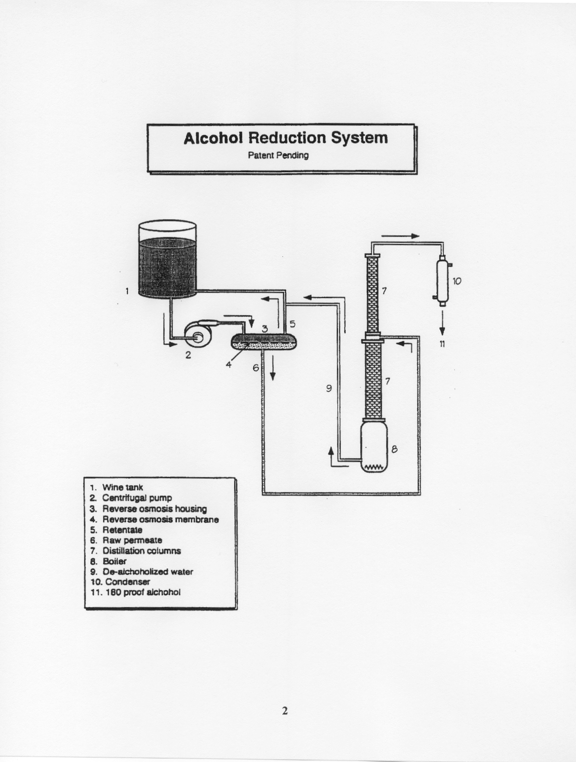
Figure 2
Recombinatory alcohol adjustment process diagram

Sensory Sweet Spot Determination
In contrast to chaptalization, alcohol adjustment at the wine stage is technologically challenging and thus has only recently become feasible. An inherent advantage, however, of adjustment to wines rather than musts is the ability to fine-tune alcohol balance through empirical taste trials. In the author’s experience on hundreds of such trials, consensus is generally obtained on one or more points of harmonious balance sometimes called “sweet spots,” usually surrounded by wines of slightly greater or lesser alcohol which are substantially less balanced.

1999 Fresno Syrah was harvested at 31 brix (measured after a two-day cold soak) and vinified for 17 days at 60ºF using Prise de Mousse yeast. Fermentation ceased at 6 gm/L residual sugar and 17.8% v/v alcohol, and eventually completed at 18.0% alcohol at dryness. In January 2000, 26% of the wine was subjected to reverse osmosis separation for “sweet spot” tasting in 0.1% alcohol increments, resulting in 31 wines between 15.5% and 12.5% v/v which were examined by 22 judges. Free choice preference frequencies are shown in Figure 1, resulting in four points of harmonious balance. For ² analysis of observed vs. expected,  < 0.1 % (very highly significant).
Wines of distinctly different styles were obtained as described in the free associations listed in Table 2.

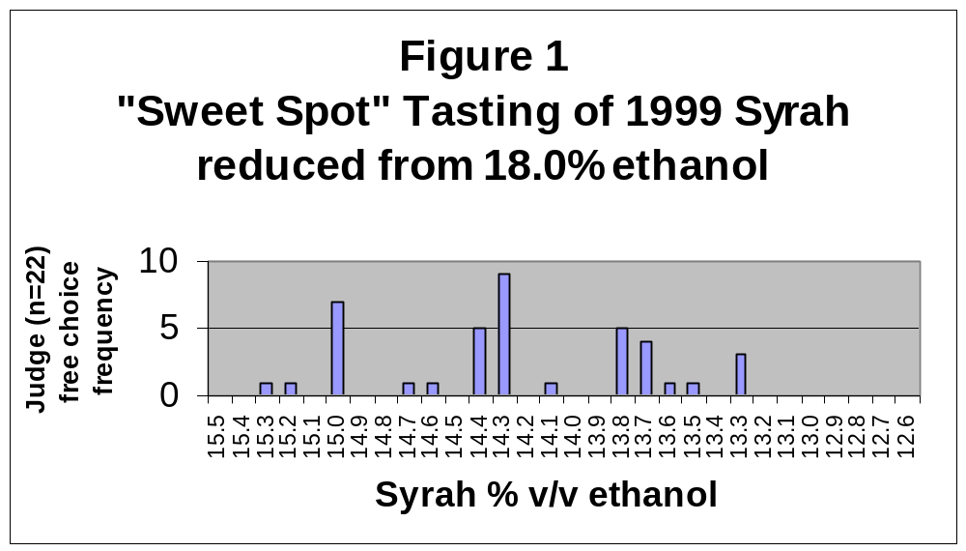
*** for ² analysis of observed vs. expected,  < 0.1 % (very highly significant)

Table 2
Judge descriptors for Syrah “sweet spots”
18.0% (untreated) | Hot, astringent
15.0 | Rich, alcoholic, leathery, complex, Chateauneuf-du-Pape
14.35 | Jammy, black pepper, smooth
13.75 | Elegant, balanced, long finish
13.3 | Clean, blueberry, tart

Although this extreme example still had good fruit characteristics, the author cautions against the use of this technique to promote extreme ripeness. Techniques are needed to assess optimum grape maturity in support of traditional fruit tasting assessment.

- Recombinatory strategies for rain-diluted wines for alcohol enhancement

In the case of cool region fruit or rainy vintage conditions, it may be desirable to remove rain dilution after vinification. Identical equipment is utilized, and permeate is distilled as before, but in this case, alcohol is recombined and pot bottoms water is discarded, resulting in alcohol increase and wine concentration to pre-rain levels.

The overall result is analogous to must concentration, but permits “sweet spot” tasting to determine precisely optimum balance. In addition, the author speculates that red wine fermentation at lower alcohol and thus higher dielectric constant may enhance phenolic stacking colloid stability and improve co-pigmentation equilibrium extraction effects.

Suggested directions for research
- Microbiological stability of reduced-alcohol components.
- Methods to assess maturity in grapes of secondary metabolites.
- Methods to assess excessive, deleterious maturity of winegrapes.

