Rocket Scheduler

# Introduction

The Rocket platform has a DNN scheduler interface. This is then used to run scheduled events.

# Rocket Interface

Each system that want to run the scheduler will need an interface to the scheduler. This defines which class and assembly will be run by the rocket scheduler link.

Enter the Rocket System interface.

[/DesktopModules/DNNrocket/adminsystem.html](http://dev.dnnrocket.com/DesktopModules/DNNrocket/adminsystem.html)

Define the scheduler provider in the system data.

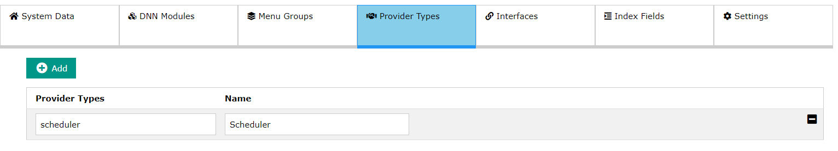

Create a Rocket Interface

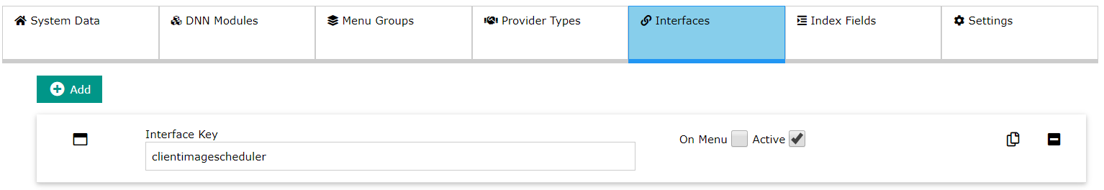

*Expanded..*

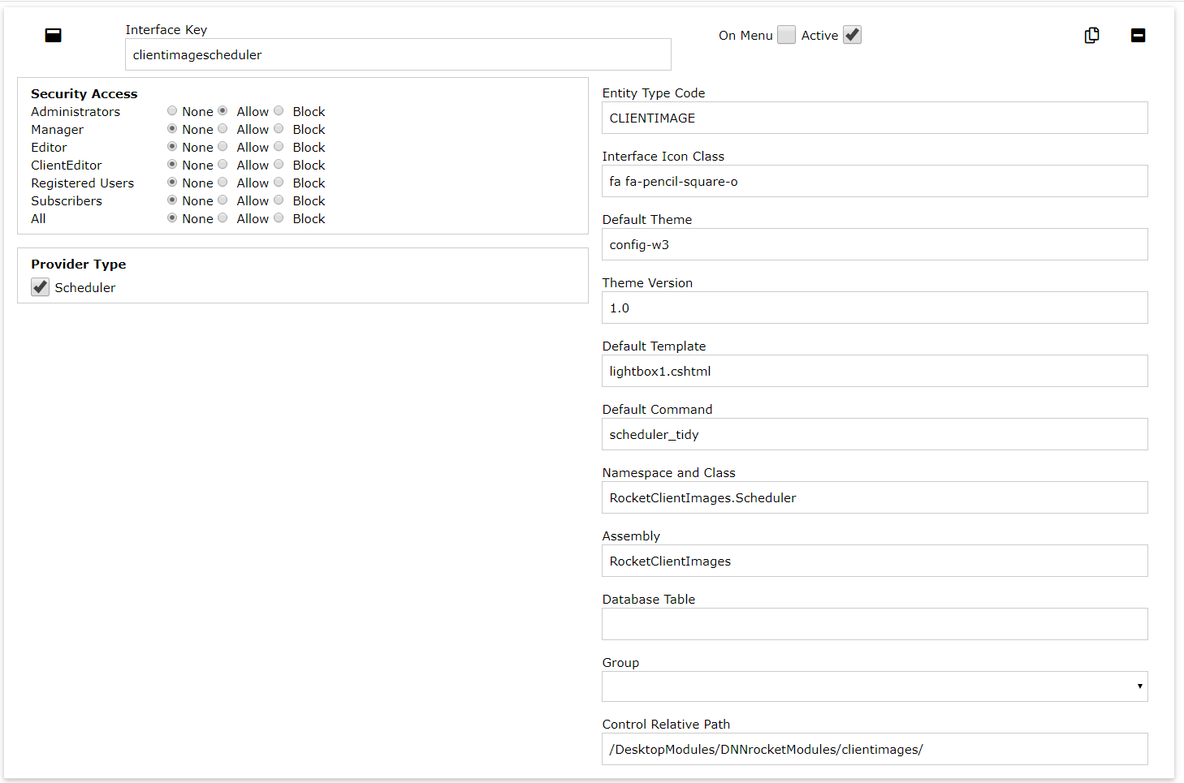

The Scheduler interface code can then be defined. Inheriting the “SchedulerInterface”

using System;

using System.Collections.Generic;

using System.Text;

using DNNrocketAPI;

namespace RocketClientImages

{

public class Scheduler : SchedulerInterface

{

public override void DoWork(SystemData systemData, DNNrocketInterface rocketInterface)

{

// do Scheduler work here..

}

}

}

The we need to turn on the scheduler, this can be done from DNN for from the Rocket System > Global Settings

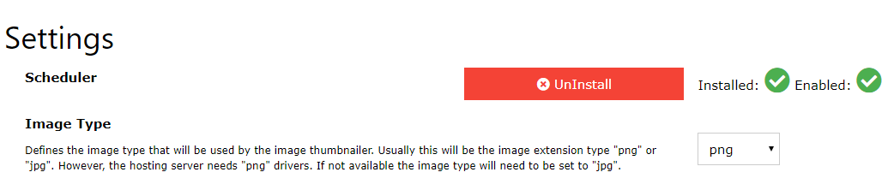

Activating this will create the scheduler in DNN

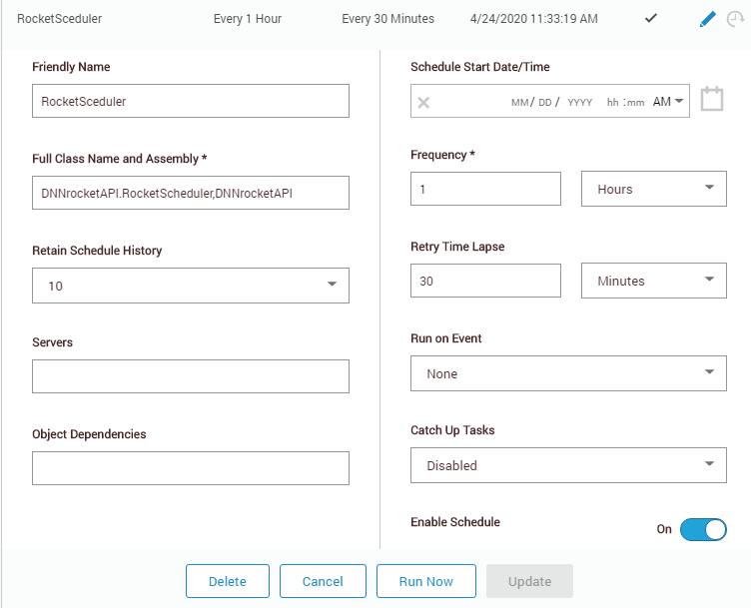

# Conclusion

The rocket scheduler code will be processed when the scheduler is processed. There is only 1 DNN scheduler entry which runs every hour (This can be changed is required).

The Rocket Scheduler will process ALL the defined scheduler rocket interface in the DNN install.