RMCS ANALYZER
User Guide
Rocket Motor Characterization System Data Analysis Software
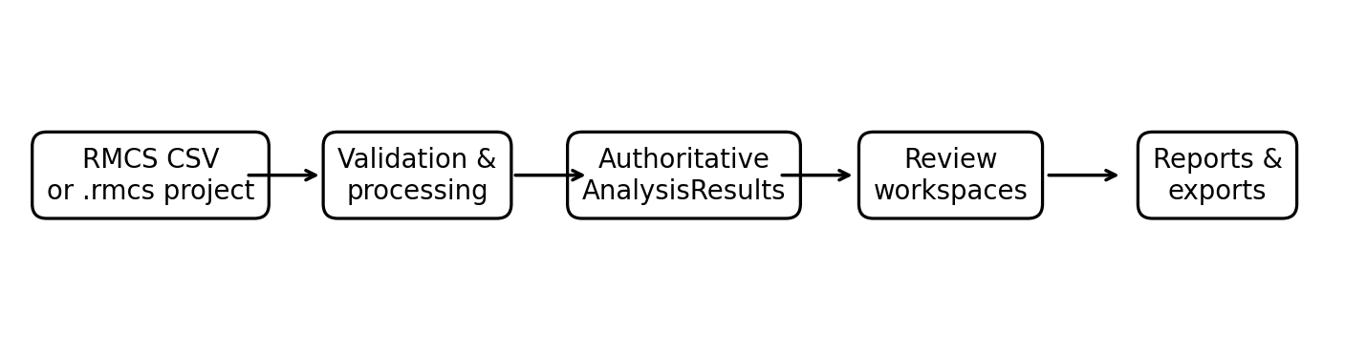
Version 1.0.0 • September 2026
Complete instructions for importing, analyzing, comparing, documenting, and exporting static-test results.
Safety
RMCS Analyzer is an analysis/documentation tool. It does not replace test-stand safety procedures, applicable laws/codes, certified test methods, or engineering judgment. Conduct motor testing using appropriate remote operation, exclusion distances, protective measures, and site procedures.

Document Purpose
This guide is the primary end-user manual for RMCS Analyzer v1.0.0. It explains the complete workflow from raw RMCS test data through engineering analysis, comparison, simulation review, video synchronization, campaign analysis, and export.
Item | Value
Application | RMCS Analyzer
Release | v1.0.0
Platform | Windows desktop
Project file | `.rmcs`, format 3
Reference CSV | RMCS CSV 1.0
Authoritative results | AnalysisResults / PerformanceReducer
Release regression baseline | 48 automated tests passing

Recommended Workflow
Import → verify metadata → inspect data → analyze → review Key Results and Analysis → optionally compare simulation → synchronize video → save project → export.
Tip
Keep the original test CSV and video files as part of the permanent test record. The `.rmcs` file stores project state but should not be treated as a replacement for your raw acquisition archive.

Contents
Right-click and choose Update Field.
After opening in Word, right-click the table of contents and choose Update Field → Update entire table.

1. Understanding RMCS Analyzer

1.1 What It Does
RMCS Analyzer converts standardized static-test measurements into traceable motor-performance results. It separates data preparation, engineering reduction, presentation, and export so that the same authoritative results feed the GUI, PDF reports, and analysis exports.

1.2 Authoritative Analysis Path
- Imported CSV/project data becomes the TestData/TestModel representation.
- Processing performs validation, timeline selection, cleaning/trimming, baseline correction, event detection, and time alignment as applicable.
- Performance reduction calculates the authoritative thrust/impulse metrics and classification.
- Performance extensions calculate Isp and C* when the required inputs are available.
- AnalysisResults is the engineering source of truth for the application.
- Workspaces and exporters consume those authoritative results rather than duplicating engineering calculations.
Why this matters
A value shown in Key Results, Analysis CSV, or a PDF report should trace back to the same analysis result rather than a separate GUI-only calculation.

2. Getting Started

2.1 First Launch
- Launch RMCS Analyzer.
- Open Settings if you want to select the Light or Dark theme.
- Import one or more RMCS CSV test files.
- Select a test in the Test Files panel.
- Review Test Information and correct metadata with Edit Metadata… if necessary.
- Run or refresh analysis using the normal application workflow.
- Save an `.rmcs` project if you want persistent test/session, campaign, simulation, and video state.

2.2 Main Workspaces
Workspace | Purpose
Thrust Curve | Measured thrust vs. time, events, playback, and optional simulation thrust.
Pressure Curve | Measured pressure vs. time, events, playback, and optional simulation pressure.
Compare | Multi-test thrust/pressure comparison and synchronized review.
Campaign | Population metrics, distributions, and campaign thrust-curve comparison.
Analysis | Detailed engineering metrics and baseline/statistical information.
Data Table | Tabular inspection of loaded data.
Video area | Playback and synchronized measured/simulation overlays.
Export area | BurnSim, RASP/.ENG, Analysis CSV, PDF, and V2 placeholders.

2.3 Active Test vs Campaign Selection
The active individual test controls the individual-test workspaces. Campaign and Compare selections are independent populations. Always verify both before generating a multi-test export.
Important
Changing the active test does not automatically mean the Compare or Campaign selection changed.

3. Importing Test Data

3.1 RMCS CSV Input
The primary measured-data input is the standardized RMCS CSV format. The reader validates the file and normalizes it into the internal TestData representation.
Input | Meaning | Engineering unit
Time(s) | Original acquisition timeline | s
Time Cal (s) | Optional calibrated analysis timeline | s
Thrust | Load-cell-derived motor thrust | N
Pressure | Chamber pressure when available | psi
State | RMCS state information when available | text
Metadata | Test and motor information | mixed

3.2 Multiple-Test Import
- Open the RMCS test-data import workflow.
- Select one or more `.csv` files.
- Review the import summary and any rejected files.
- Select each test and verify metadata before interpreting results.

3.3 Metadata You Should Verify
- Test number
- Motor designation
- Test date
- Propellant type
- Motor diameter and length
- Nozzle throat diameter
- Propellant mass
Derived metrics depend on metadata
Propellant mass is required for Isp and C*. Nozzle throat diameter is required for C*. Incorrect metadata can produce numerically valid but physically misleading derived results.

4. Preparing and Analyzing a Test

4.1 Data Preparation
- Valid calibrated Time Cal (s) is preferred for engineering reduction; otherwise Time(s) is used.
- Non-finite time/thrust samples are excluded from the performance reduction.
- Data is sorted by time and duplicate timestamps are reduced.
- Negative thrust is not interpreted as negative motor thrust during impulse integration.
- Processing and analysis are kept separate from GUI presentation.

4.2 Physical Events vs Standardized Boundaries
Concept | Purpose
Ignition event | Timeline/event context; state-based when RMCS state information exists.
Physical burnout | Timeline/event context based on state or threshold detection.
5% burn start | Standardized performance boundary.
5% burn end | Standardized performance boundary.
Complete valid curve | Source region for total impulse.

Physical burnout and standardized 5% burnout are intentionally separate. A physical event marker should not be assumed to be the same thing as the standardized performance endpoint.

5. Engineering Methodology

5.1 The 5% Standardized Burn Method
RMCS Analyzer uses a 5%-of-peak-thrust threshold to define standardized burn time and standardized average thrust. This follows the NFPA 1125 convention historically documented in public NFPA material and summarized by ThrustCurve.
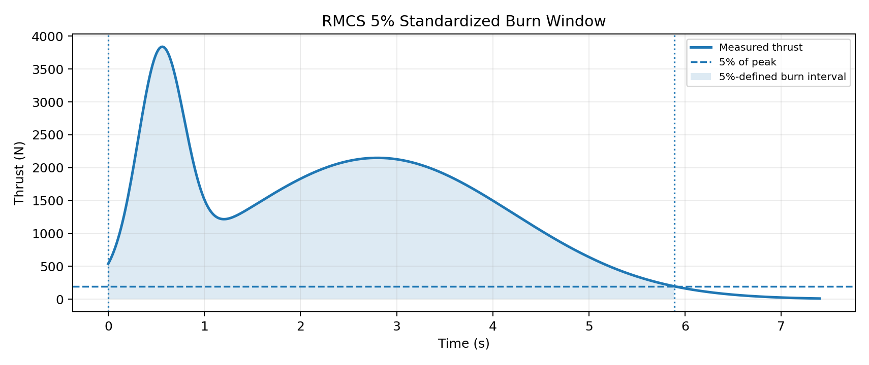
- Find the maximum positive finite thrust: Peak Thrust.
- Calculate the threshold as 0.05 × Peak Thrust.
- Find the first rising crossing before the peak.
- Linearly interpolate between the surrounding samples to determine the exact 5% start time.
- Find the final falling crossing after the peak.
- Linearly interpolate to determine the exact 5% end time.
- Compute standardized burn time as end − start.
- Integrate thrust between the exact boundaries.
- Compute standardized average thrust as standardized-window impulse ÷ standardized burn time.

5.2 Why Interpolation Is Used
A sampled curve will rarely contain a point exactly at 5% of peak. Selecting the nearest sample would make the result depend on sample spacing. Linear interpolation estimates the crossing between adjacent points and gives a repeatable boundary.

5.3 Total Impulse vs 5% Impulse
RMCS Analyzer calculates total impulse over the complete valid recorded thrust curve. Negative thrust values are clipped to zero before integration because a negative load-cell reading does not represent negative motor thrust. The standardized average thrust instead uses only the exact 5% interval.
Metric | Curve region
Peak thrust | Maximum positive finite sample.
Total impulse | Complete valid recorded curve; negative thrust contributes zero.
5% standardized impulse | Exact 5%-start to 5%-end interval.
Standardized average thrust | 5% standardized impulse ÷ standardized burn time.
Initial thrust average | First 0.5 s after standardized 5% start.

Common mistake
Do not calculate the reported standardized average thrust as Total Impulse ÷ standardized burn time. RMCS intentionally keeps whole-curve total impulse separate from the 5%-window impulse.

6. Understanding the Results

6.1 Key Results
Result | Definition
Peak Thrust | Maximum positive measured thrust.
Standardized Average Thrust | Average thrust from the 5% burn window.
Total Impulse | Area under the complete valid positive thrust curve, N·s.
Burn Time | 5%-defined standardized burn time.
Time to Peak | Peak time relative to the prepared curve start.
Isp | Specific impulse derived from total impulse and propellant mass.
Peak Pressure | Maximum finite measured pressure.

6.2 Motor Class and Calculated Designation
Motor class is determined from total impulse, not peak thrust. The calculated designation is the impulse-class letter followed by the rounded standardized average thrust; for example, an N-class result with approximately 2031 N standardized average thrust becomes N2031.
Class | Total impulse (N·s)
A | 1.26–2.50
B | 2.51–5.00
C | 5.01–10.00
D | 10.01–20.00
E | 20.01–40.00
F | 40.01–80.00
G | 80.01–160.00
H | 160.01–320.00
I | 320.01–640.00
J | 640.01–1,280.00
K | 1,280.01–2,560.00
L | 2,560.01–5,120.00
M | 5,120.01–10,240.00
N | 10,240.01–20,480.00
O | 20,480.01–40,960.00

Classification note
Impulse class is a performance classification reference. Certification, labeling, manufacturing, and regulatory determinations may involve additional requirements and should be checked against the applicable current standards and authority.

6.3 Specific Impulse (Isp)
When propellant mass is valid, RMCS calculates:
Isp = Total Impulse / (Propellant Mass × g₀)
The implementation uses g₀ = 9.80665 m/s² and converts propellant mass from grams to kilograms. Isp is reported in seconds.

6.4 Characteristic Velocity (C*)
When pressure, propellant mass, throat diameter, and a valid standardized burn interval are available, RMCS calculates average C* using:
C* = P̄c × At / ṁ̄
Pressure is time-averaged over the standardized 5% interval. Throat area is πd²/4. Average mass flow is estimated as propellant mass divided by standardized burn time. This makes C* a derived engineering metric, not a direct thrust-stand measurement.

6.5 Rise and Decay Rates
The thrust curve is smoothed with a centered moving-average window of approximately 0.10 s before differentiation. Rise rate is the maximum positive derivative on the rising side of peak thrust. Decay rate is the most negative derivative on the falling side. Edge samples without a complete smoothing window are excluded.

6.6 Baseline Statistics
Baseline mean and baseline standard deviation help identify load-cell offset and noise before ignition. Review them when a test shows unexpected drift, negative pre-burn values, or unusually noisy results.

7. Reading the Plots

7.1 Thrust Curve
- Measured thrust vs time.
- Event annotations for ignition, burnout, and peak thrust.
- Show Simulation overlay when project simulation is loaded.
- Playback controls synchronized with the video workflow when video is present.

7.2 Pressure Curve
- Measured pressure vs time.
- Peak pressure derived from finite measured pressure samples.
- Show Simulation for imported simulation pressure.
- Shared playback timeline behavior with the Thrust Curve.

7.3 Event Markers
Event markers provide context. State-based event detection is preferred when useful RMCS state information exists; otherwise threshold detection is used. The 5% standardized boundaries are calculated separately.

8. Compare and Campaign

8.1 Compare
- Load the desired tests.
- Open Compare.
- Select any number of loaded tests required for the comparison.
- Review thrust and pressure curves and comparison metrics.
- Use synchronized playback when applicable.
- Change selection to refresh the comparison population.
Compare selection is independent of the active individual test. The workspace supports multi-test visualization rather than imposing a two-test limit.

8.2 Campaign
Campaign Analysis treats selected tests as a population. Use it to inspect distributions, population statistics, and thrust-curve variation. Campaign exports preserve each selected firing as its own result rather than averaging curves together.
Feature | Purpose
Metric Distribution | Inspect the spread of a chosen metric.
Population statistics | Review mean and variation.
Campaign Thrust Curve | Compare individual curves as a population.
Persistent selection | Maintain a defined campaign population.
Campaign `.eng` export | One motor entry per selected test.

9. Simulation Import and Comparison

9.1 Import
- Obtain a BurnSim/OpenMotor-style simulation CSV.
- Use Settings → General → Appearance to download the blank template if needed.
- Import the simulation at the project level.
- Review the imported state.
- Use Show Simulation on Thrust Curve and/or Pressure Curve.
- Optionally enable simulation on video graph overlays.
- Save the `.rmcs` project to persist simulation state.

9.2 Supported Normalization
Quantity | Accepted examples | Internal unit
Time | s, ms, us | s
Thrust | N, lbf, kgf | N
Pressure | psi, Pa, kPa, MPa, bar, atm | psi

9.3 Interpreting Differences
Use measured-versus-simulation comparison to examine timing, peak magnitude, curve shape, pressure behavior, and burn duration. The measured test remains the experimental record. Simulation is a model/comparison dataset.

10. Video Analysis

10.1 Synchronization
- Associate the source video with the test.
- Identify the video moment corresponding to the RMCS synchronization reference.
- Set Sync Start.
- Use synchronized playback to inspect the event against thrust and pressure.
- Adjust overlay visibility in Video Overlay settings.

10.2 Overlay Options
- Measured thrust and pressure overlays can be controlled independently.
- Results/events can be shown on graph overlays.
- Imported simulation curves can be shown on the corresponding video graph.
- Overlay presentation state can persist in the `.rmcs` project.

10.3 Selecting a PDF Frame
- Play or scrub to the desired moment.
- Click Use Current Frame.
- Confirm the selected video timestamp.
- Save the project if the selection should persist.
- Generate the PDF report.
Frame behavior
Clearing the selected frame returns the report to automatic representative-frame behavior. The selected timestamp is stored as video state and does not alter the engineering analysis timeline.

11. Projects and Persistence
The `.rmcs` project is the persistent container for session state, test metadata, campaign selection, simulation state, video state, overlay presentation, and selected PDF-frame information.
- Save the project after meaningful changes.
- Keep the project in a stable location.
- Reopen it later with Open Project.
- After reopening, verify the active test, campaign selection, simulation, and video source before exporting.
Source-file reminder
Project state can remember an external video association, but it cannot guarantee that a video or source CSV still exists at its original path. Maintain stable source locations and backups.

12. Reports and Exports
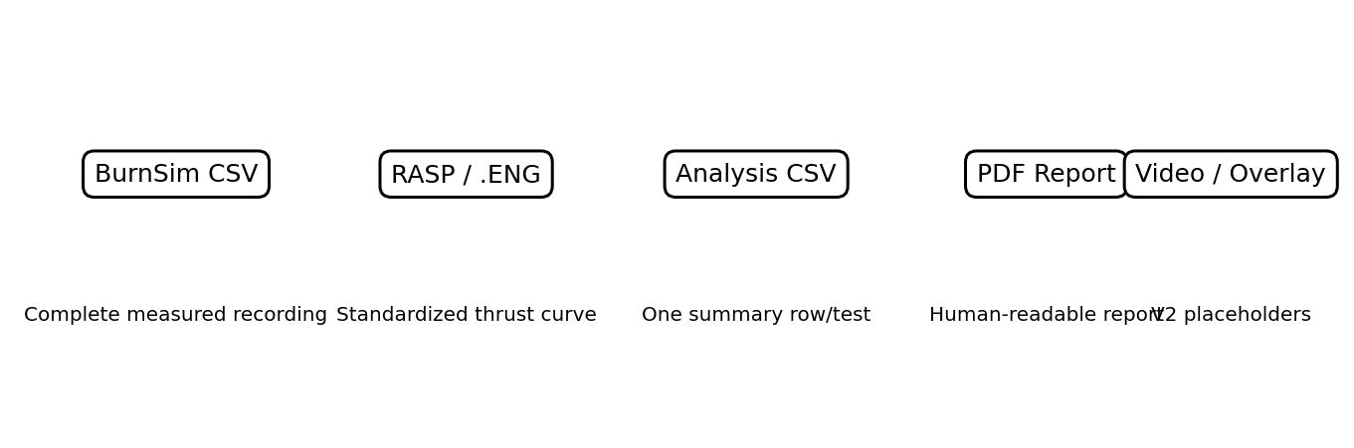

12.1 BurnSim CSV
BurnSim export contains Time, Pressure, and Thrust in seconds, psi, and newtons. It preserves the complete measured recording, including pre-ignition and post-burnout data. This is intentionally different from the standardized RASP curve.

12.2 RASP / `.ENG`
- Uses the authoritative standardized measured thrust curve.
- Single test → one motor entry.
- Campaign → one motor entry per selected test.
- Curves are not averaged together.
- Static-test entries use `P` in the delay/ejection field.
- Output is the RASP `.eng` interchange format, not an OpenRocket/RockSim project.

12.3 Analysis CSV
Produces one engineering-summary row per selected analyzed test. It is intended for spreadsheets, databases, dashboards, and downstream analysis.

12.4 PDF Report
Produces single-test and campaign reports with conditional pressure, simulation, video, and notes sections when the corresponding information is available. The report consumes authoritative analysis results.

12.5 Video and Overlay Export
These controls are explicit v2 placeholders. They are active UI buttons but do not currently create video files; they present a future-feature message.

13. Settings, Themes, and Templates

13.1 Appearance
- Select Light or Dark theme.
- Theme changes preview immediately and persist when confirmed.
- Download blank RMCS Test Data, BurnSim Simulation, and OpenMotor Simulation templates.

13.2 Video Overlay
- Configure overlay visibility and presentation.
- Adjust graph/title preferences available in the Video Overlay settings.
- OK persists the changes; Cancel reverts the in-progress Settings changes.

13.3 Templates
The templates document the CSV structures RMCS Analyzer can import. BurnSim and OpenMotor normally generate their own native simulation files; these templates are RMCS-side import examples.

14. Troubleshooting
Problem | What to check
CSV will not import | Use the RMCS CSV format/template; check numeric time/thrust data and file integrity.
Analysis is blank | Confirm successful import and finite time/thrust data; inspect Analysis for unavailable-data messages.
Isp unavailable | Enter valid positive propellant mass.
C* unavailable | Provide pressure data, propellant mass, throat diameter, and a valid standardized burn interval.
Simulation will not import | Check recognizable time + thrust/pressure columns, numeric data, and non-decreasing time.
Simulation imported but hidden | Use Show Simulation on the relevant curve; it is enabled when project simulation data exists.
Video is out of sync | Recheck Sync Start; video time and RMCS analysis time are separate.
Wrong PDF video frame | Use Use Current Frame at the desired moment and save the project before export.
PDF export fails | Check ReportLab/Pillow dependencies and destination-file locks.
RASP export fails | Confirm the test is analyzed and has a valid standardized burn interval.
48 tests fail after deleting fixture folders | Restore `test_data/` and `sim_data/`; they are intentional regression fixtures.
`.pytest_cache` returns | Normal; pytest regenerates it and Git ignores it.
`__pycache__` returns | Normal; Python regenerates it and Git ignores it.
Project video missing after reopen | Verify the original external video still exists at its stored path.

15. Quality and Reproducibility

15.1 Regression Testing
Release preparation validated RMCS Analyzer with a 48-test automated regression suite. The suite covers core analysis, motor classification, performance reduction, exports, simulation import, project persistence, video-related behavior, and reference/edge cases.

15.2 Regression Fixtures
The repository intentionally retains `test_data/` and `sim_data/`. These deterministic fixtures are required for the automated tests and make a fresh checkout reproducible.

15.3 Generated Test Artifacts
`.pytest_cache/`, `__pycache__/`, and Python bytecode may reappear after testing or running the program. They are generated artifacts and are intentionally ignored by Git.

15.4 Reference Dataset
The Zerox reference dataset is used for repeated validation of expected engineering behavior. When a regression test fails, compare the failing metric against the reference expectations before changing analysis code.

16. Engineering Reference

16.1 Units
Quantity | RMCS unit
Time | s
Thrust | N
Pressure | psi
Impulse | N·s
Propellant mass | g in metadata; kg internally where needed
Nozzle throat | in in metadata; m internally for C*
Isp | s
C* | m/s
Thrust rate | N/s

16.2 Key Equations
Metric | RMCS method
5% threshold | 0.05 × Peak Thrust
Standardized burn time | t₅% end − t₅% start
Standardized impulse | ∫ thrust dt between exact 5% boundaries
Standardized average thrust | Standardized impulse ÷ standardized burn time
Total impulse | ∫ max(thrust, 0) dt over complete valid curve
Isp | Total impulse ÷ (propellant mass × g₀)
Throat area | πd²/4
C* | Average chamber pressure × throat area ÷ average mass flow
Average mass flow for C* | Propellant mass ÷ standardized burn time

16.3 What RMCS Does Not Assume
- Motor class is not inferred from peak thrust.
- Total impulse is not replaced by 5%-window impulse.
- Simulation does not replace measured results.
- Physical burnout is not automatically treated as the 5% standardized endpoint.
- PDF reports do not independently recalculate the engineering metrics.

17. Standards, References, and Further Reading
Standards evolve. For certification, manufacturing, regulatory, or compliance work, consult the current edition and applicable authority rather than relying solely on this guide.
NFPA 1125 — Code for the Manufacture of Model Rocket and High-Power Rocket Motors
Current NFPA 1125:2026 is the latest edition. Historical public NFPA material was used to document the 5%-of-peak convention implemented by RMCS Analyzer.
https://www.nfpa.org/codes-and-standards/nfpa-1125-standard-development/1125
NFPA 1125:2017 public preview
Public preview used to verify the historical 5% burn-time and total-impulse measurement language.
https://previewnorm.com/nfpa/NFPA%201125-2017%20PDF.pdf
ThrustCurve — Motor Statistics
Practical explanation of the NFPA-based 5% burn-time, average-thrust, and whole-curve total-impulse convention.
https://www.thrustcurve.org/info/motorstats.html
National Association of Rocketry — Rocket Motor Resources
Background on motor codes, impulse classes, average thrust, and certified motor data.
https://www.nar.org/content.aspx?club_id=114127&module_id=669253&page_id=22
Standards note
The 5% method in this guide describes the methodology implemented by RMCS Analyzer and documented from historical NFPA 1125 material. This guide is not a compliance determination or substitute for the current NFPA edition or certification authority requirements.

18. Quick Reference
Need | Go to
Inspect measured thrust | Thrust Curve
Inspect measured pressure | Pressure Curve
Compare several tests | Compare
Analyze a campaign | Campaign
Review detailed metrics | Analysis
Inspect raw samples | Data Table
Import simulation | Project / Simulation import
Show simulation | Thrust Curve / Pressure Curve → Show Simulation
Synchronize video | Video Analysis → Sync Start
Choose PDF frame | Video Analysis → Use Current Frame
Change theme | Settings → General / Appearance
Configure overlays | Settings → Video Overlay
Export measured recording | BurnSim
Export motor curve | RASP / `.ENG`
Export summary data | Analysis CSV
Create formal report | PDF Report

Appendix A — Recommended Test Review Checklist
- ☐ Confirm the correct source CSV is loaded.
- ☐ Verify test metadata and propellant mass.
- ☐ Inspect baseline mean and noise.
- ☐ Inspect thrust curve for clipping, dropouts, offsets, or mechanical artifacts.
- ☐ Inspect pressure when available.
- ☐ Confirm ignition, burnout, and peak event markers are plausible.
- ☐ Review 5% start/end boundaries.
- ☐ Review Peak Thrust, Standardized Average Thrust, Total Impulse, Burn Time, and Time to Peak.
- ☐ Review Isp/C* only when their inputs are valid.
- ☐ If using simulation, compare magnitude, timing, and shape.
- ☐ If using video, verify Sync Start and PDF frame selection.
- ☐ Save the `.rmcs` project.
- ☐ Generate the required exports.
- ☐ Archive source CSV, project, and report together.

RMCS ANALYZER v1.0.0
User Guide
ROCI Motor Characterization System
Engineering Analysis Software
Recommended repository path
`docs/RMCS_Analyzer_User_Guide_v1.0.0.docx`

