Sounding Rocket Allowable Differential Pressure
Ashlee Espinoza, Berton Vite,
Raul Rios, and Charles Hoult
California State University, Long Beach, CA, 90840, USA
During the 2011 Intercollegiate Rocket Engineering Competition ( I.R.E.C.) one of the California State University Long Beach (CSULB) rocket’s payload bay doors failed by prematurely separating during the early part of the flight causing excessive drag. The door failure root cause was determined to be excessive differential pressure. This problem can be corrected by increasing the vent hole size to reduce the differential pressure. Simulation can be used to establish the relation between vent hole size and maximum flight differential pressure. However, the allowable differential pressure must be estimated experimentally. Our experimental apparatus consisted of a portion of the rocket payload bay made of the same tubing as the original rocket. End caps and a bicycle tire Presta valve were attached, doors cut and attached, and the assembly sealed water tight. Pressurization was with a bicycle tire pump, and the differential pressure was measured with a commercial sphygmomanometer pressure gauge. The maximum differential pressure for no leakage was estimated by slowly pumping air into the submerged apparatus while measuring differential pressure. Leaks were detected by doing a visual check for escaping air. The maximum differential pressure for the rocket without door failure was then recorded in dry conditions. Future CSULB IREC rockets will use this data to preclude premature payload door separation.

Nomenclature
= Door area, sq in,
= Differential pressure, psi
L = Door peripheral length, in, and
= Peel strength, lb/in.

Introduction
IN 2010 and in 2011 the California State University, Long Beach (CSULB) rocket did not reach the apogee predicted by our precision trajectory code, SKYAERO. This analysis was based on measured weights, extensive motor static firings and a mature aerodynamic drag code. Failure review highlighted the drag estimate as the most likely cause of the failures, but no physical explanation for this was immediately forthcoming.
In last year’s competition, soon after CSULB Experimental Sounding Rocket Association (ESRA) Rocket was launched, the Embry- Riddle team found a Plexiglas window about 700 feet from the launch site. This window covered our optical payload. With the knowledge the window failed very near our burnout location (which was not visually observed because it was within a low cloud), we discovered that the cause of the extra drag was the freshly exposed payload and structure.
To preclude future door failures we need to increase the ventilation of the rocket. To know how much larger to make our ventilation holes we need to first determine the maximum differential pressure the rocket doors can handle. With this information we can use the BLOWDOWN program to help determine the vent size. To find the allowable differential pressure, we used the experiment reported here to measure the lowest differential pressure at which door failure occurs.

Experimental Apparatus
The CSULB sounding rocket used for the ESRA competition has a fuselage made from a 6-inch diameter cardboard mailer tube. All precautions were taken to ensure that the apparatus was not only an accurate representation of an actual rocket payload bay, but also inexpensive. In order to mimic the design of the rocket during pressurization the same type of mailer tube was also used. The tube was cut down to a length of 4 feet. Two doors of size 12 in. x 5.19 in. and 11.88 in. x 4.25 in. were cut from the tube to act as the payload doors for testing. Plastic end caps were set in place with epoxy on each open end of the tube to seal it shut.
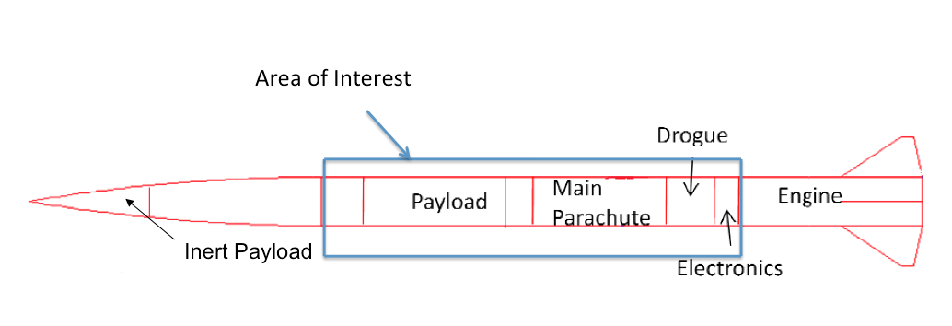

Figure 1. Testing Apparatus with Respect to the Actual Rocket.

A hole was drilled into the side of the tube and a Presta valve (basic bicycle tire valve) was put into place so that a bicycle tire pump could be used to pressurize the apparatus; a gauge on the bicycle pump measured the pressure. After attempting to pressurize the tube it became apparent that air was escaping. Further inspection proved that the air was coming through the tubing spiral seams. Although this leaking also occurred during actual flight of the rocket, in this experiment it became a problem because the tube was becoming pressurized at a much slower rate than during actual flight. This led to a significantly larger portion of air lost, deeming the results inconclusive.
The next step was to seal the seam. Plumber’s caulk was used as an inexpensive and simple way to do this. It was applied to the seams on the main tube and the doors. From the first trial it was also determined that the gauge on the bike pump would not be accurate enough to measure such small pressures. A sphygmomanometer gauge was used in its place. This was attached to the tube in the same manner as the Presta valve. To keep it in place and leak-proof the gauge was sealed with epoxy. A way to ensure the test article was leak proof was also needed. It was determined that this would best be done by submerging the apparatus in water. Once submerged it was possible to do a visual check for leaks by looking for escaping air bubbles.
In preparation for performing the actual experiment the final steps were sealing the edges of the doors and attaching them to the mailer tube. The doors were sealed to be somewhat water/air tight by applying lithium grease to the edges. The doors were then attached using aluminum tape. This was applied in a 3-layer system as it was actually flown on the rocket.

Sphygmomanometer Pressure Gage
Aluminum Tape

Mailer Tube (Sealed)
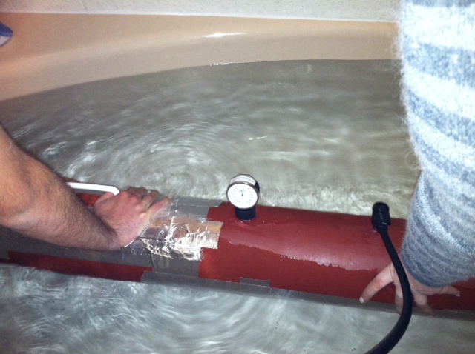
Bicycle Tire Presta Valve

Figure 2. Experiment Underway
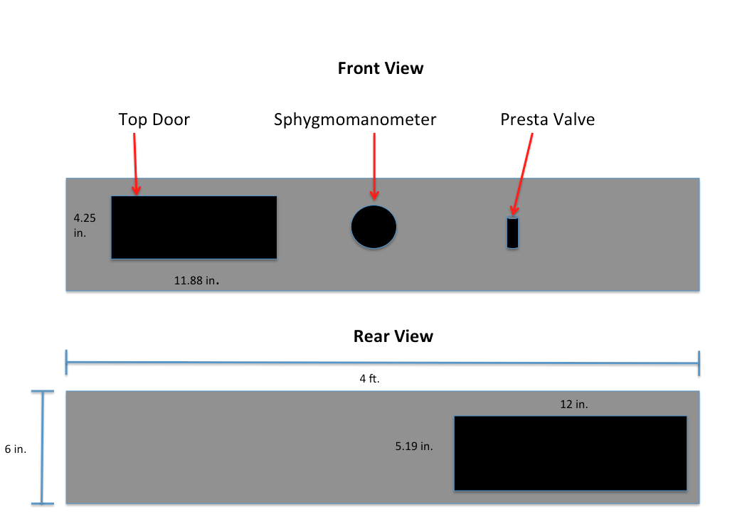

Figure 3. Test Article Sketch.

Experimental Results
The apparatus was assembled by taping both doors on with three layers of adhesive-backed aluminum tape in the same way as the flight doors & windows were attached. Skin-to-door gaps were filled with a soft lithium grease to ensure an air-tight joint. When fully assembled, the unpressurized apparatus was immersed in the bathtub to check for leaks. None were detected.
The bicycle pump was then mated to the apparatus bicycle tire valve, and the apparatus again immersed in the bath tub as shown in Fig2. Next, the pressure inside the apparatus was slowly increased using the bicycle pump. No change was observed until the differential pressure reached 10-12 mm Hg at which point leaking was first observed. The pressure was increased further to about 20 mm Hg when the leakage outflow matched the maximum inflow achievable with the bicycle pump.
Initially two doors were cut expecting that the leakiest of the two would fail first as pressure was increased. However, the bottom door experienced a hydrostatic pressure about 12 mm Hg higher than that acting on that acting on the top door. Since 10-12 mm Hg was found to be the maximum without leakage, it’s almost certain that the top door always fails first.

Comparison with Theory
Reference 1 provides a theoretical model for door failure by tape peeling from the rocket skin. It basically describes the failure as peeling of the tape from the tube. See Fig. 4 for a sketch of this failure mechanism.
Reference 1 also provides a crude mathematical model of the process:

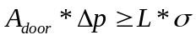, (1)

where 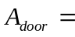 The door area = Length * Chord, in² ,
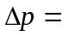 The differential pressure acting on the door, lb/in²,
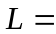 The door peripheral distance, in , and

Ultimate peel strength of the tape-to-tube joint, lb/in

The experiment described here had a top door area of 50.47 sq. in, a periphery of 32.25 in, and a pressure at door failure of about 0.2 psi. From this, we find that the peel strength is about 0.3 lb/in
Door
Rocket Skin
Peeling Failure
Duct Tape
Excessive Internal Pressure
Figure 4. Peeling Failure Sketch

Conclusions and Recommendations
We encountered a large reduction in apogee altitude at the ESRA-sponsored 5th Intercollegiate Rocket Engineering Competition (IREC) in June 2010. Excessive drag was found to be the likely culprit, but no physical mechanism for this could be found. In the 6th IREC in June 2011 our payload optical window was found alone near our launcher. It clearly separated from the rocket near burnout, most likely from excessive differential pressure. The extremely “dirty” exposed payload and structure easily account for the extra drag and reduced apogee.
It is straightforward to estimate the differential pressure in a payload bay as a function of the size of the holes venting the bay. The problem is, what’s the allowable differential pressure? Since this will depend on the hole size and shape, the allowable peel load is the determining factor. We found that a peel load of about 0.3 lb/in is the most that taped-on doors can hold. It is recommended that a peel load of 0.2 lb/in be used to size the venting holes.
Through this experiment, we have had the opportunity to develop unique research applicable to sounding rockets. We now have one less factor to worry about that could cause mission failure. From a theoretical standpoint, if all other systems work well now that the differential pressure has been accounted for, great success shall be achieved at various IREC’s to come.

References
¹Hoult, C. P., “Pressure Strength of Taped-On Doors,” RST Memo, 01 December 2011.

Student, AIAA Student Member
Student, AIAA Student Member
Student, AIAA Student Member
Adjunct Professor, AIAA Lifetime Senior Member

