A New Wind Sensor for Rocket Launches

Mohamed Samir
Mohideen F. Buharie
Oscar Mejia
Anusha Prabhakar

February 14, 2008

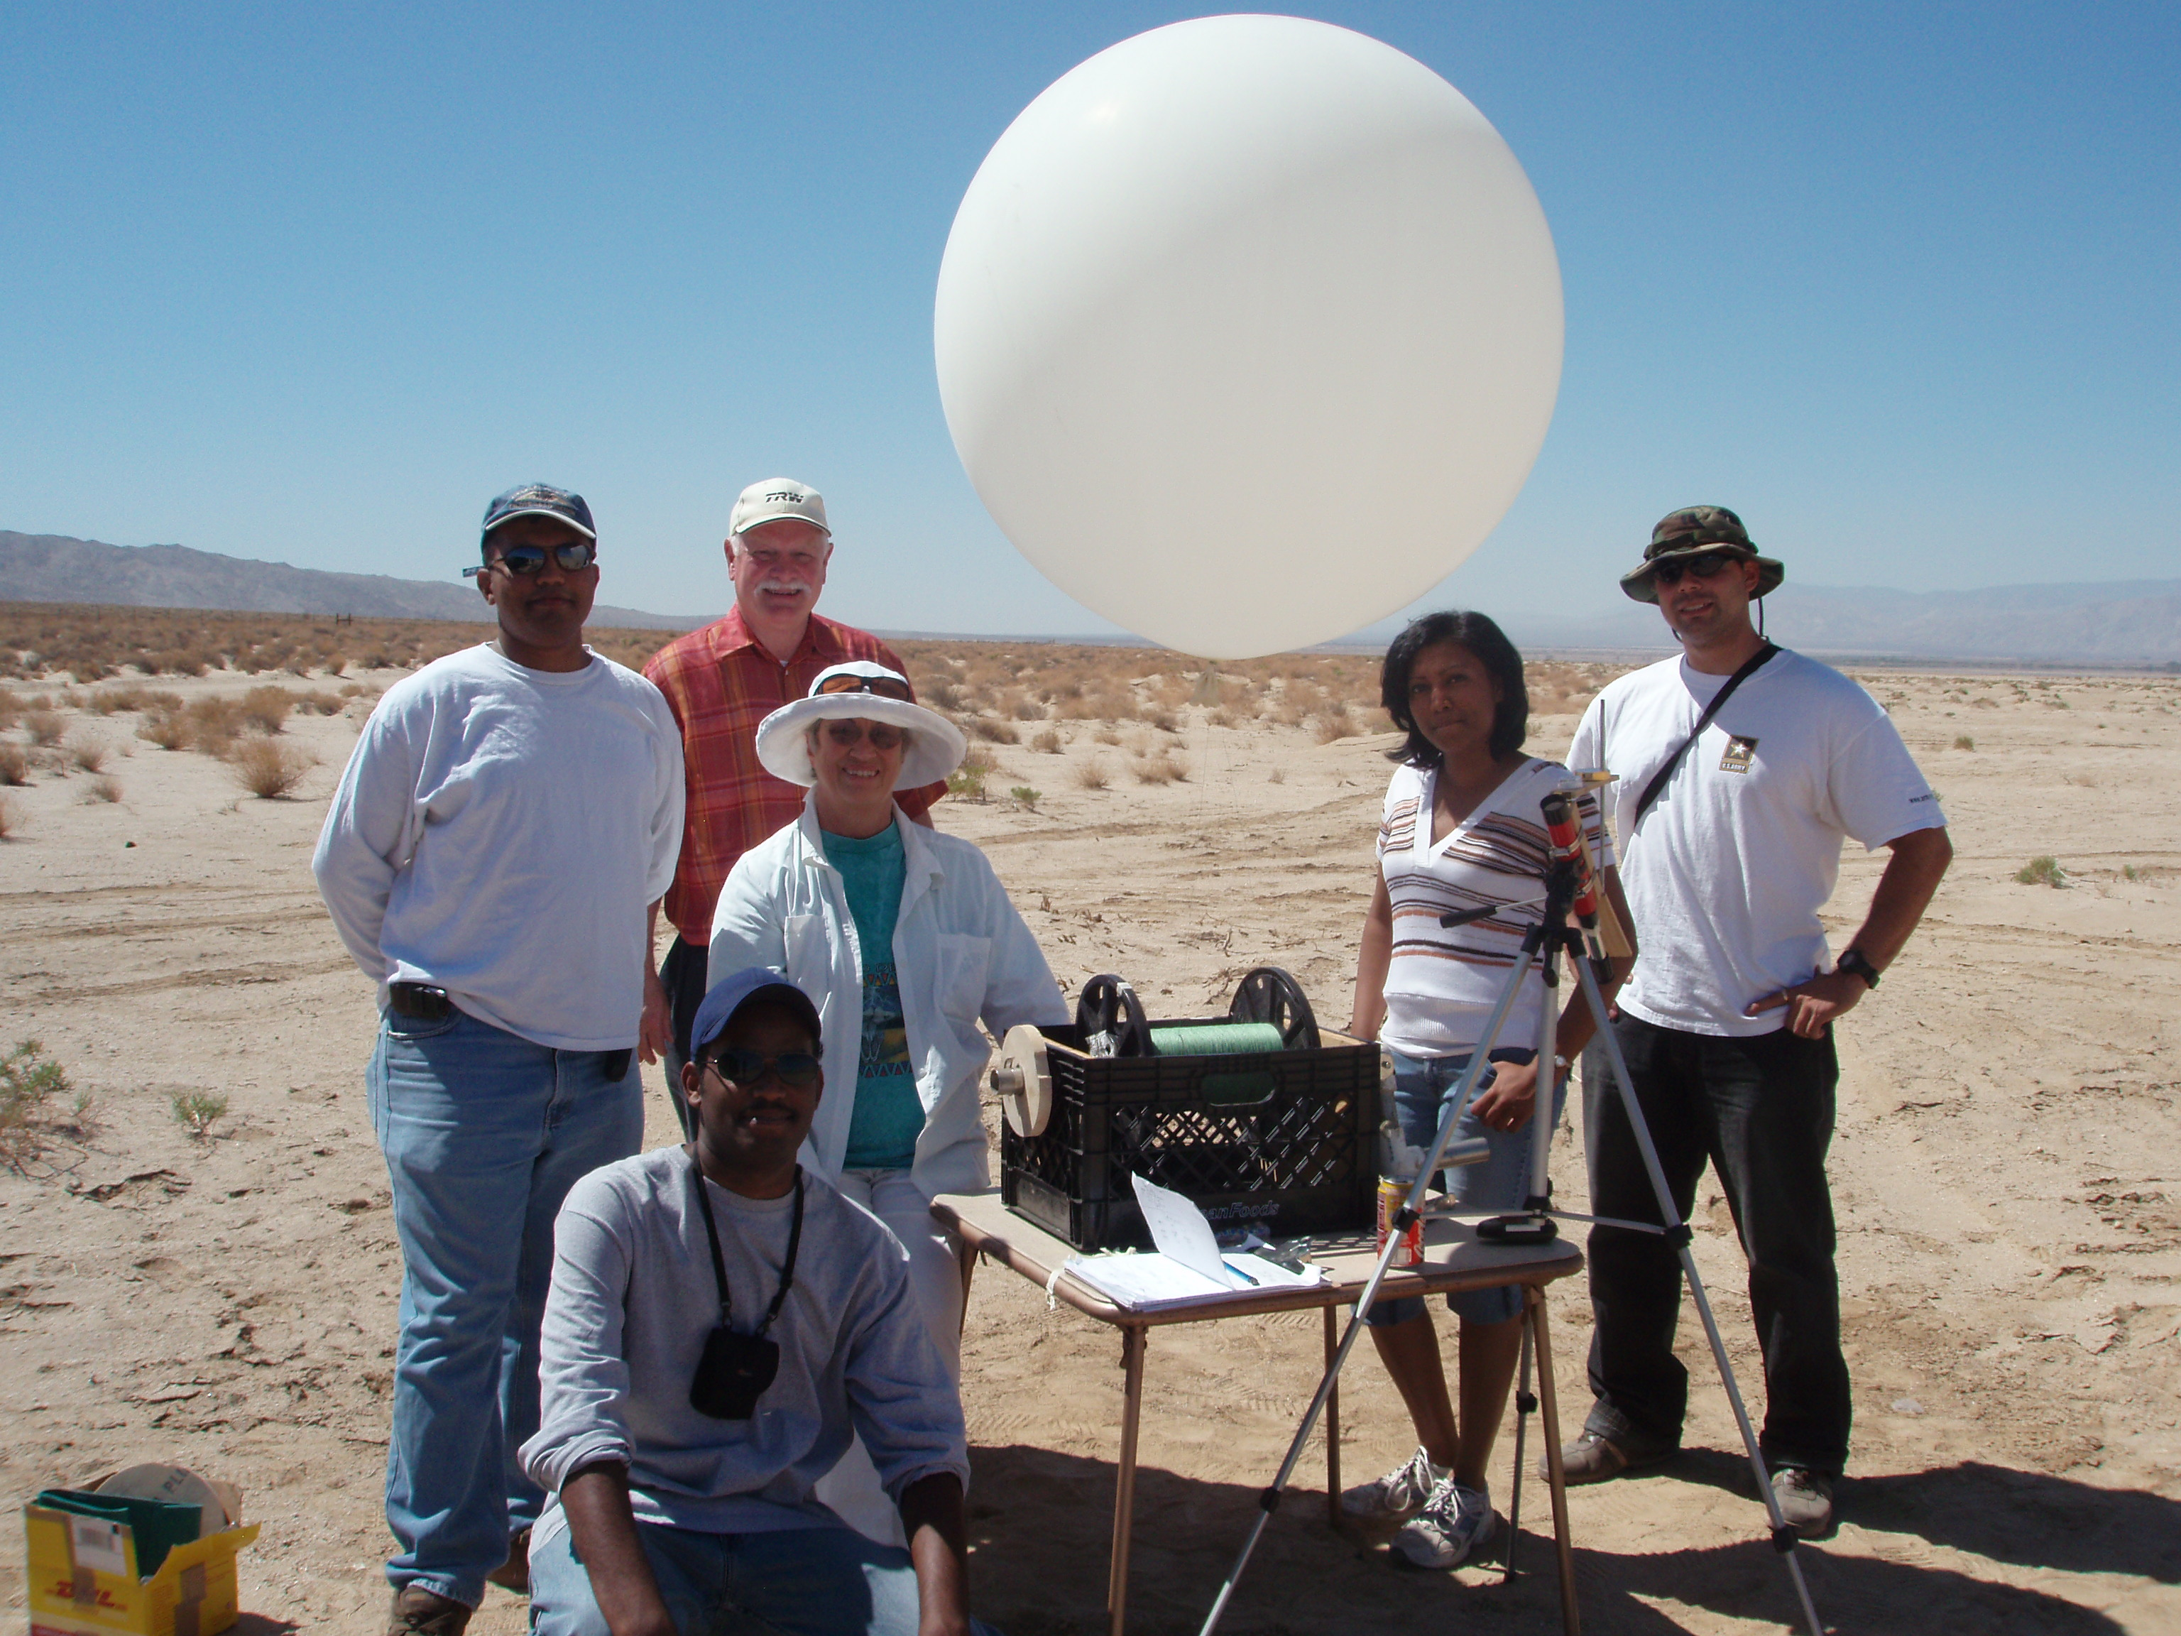

MECHANICAL & AEROSPACE ENGINEERING DEPARTMENT
CALIFORNIA STATE UNIVERSITY LONG BEACH
1250 BELLFLOWER BLVD.
LONG BEACH, CA 90840


Abstract: The purpose of this research was to design and develop a low cost wind measurement device using a tethered pilot balloon, tracked with an observing telescope. A telescope-mounted commercial SkyScout™ sensor provides line of sight elevation and azimuth angles using a GPS receiver, and triaxial accelerometers and magnetometers. This equipment proved to be inexpensive, practical and suitable for wind compensation of academic sounding rockets.
Introduction: Unmodeled errors in the wind profile traversed by a rocket are by far the largest single cause of trajectory prediction error. Safe operations imply control of rocket impact points by measurement of the winds and compensation via changes in launch rail azimuth and quadrant elevation angles. The objective of this project was to develop a functional wind measurement system (hardware & software) suitable for wind compensation of CSULB Prospector rockets.
This research explores a new wind measurement concept. Many techniques for wind measurement exist. At the low altitudes attainable with a tower or mast, the classical Robinson cup anemometer with azimuth vane is a good approach. For higher altitudes, Doppler lasers and a network of whistles and audio microphones have both been satisfactorily developed. Finally, most sounding rocket wind measurements have used a sequence of free flying weather balloons observed with stereo theodolites. All these existing techniques are either too expensive (by a factor of ~10) or generate data at altitudes too low to be useful. University launch vehicle programs need an inexpensive technique to measure winds below about 2 km altitude. Above 2 km, aviation weather winds from FAA can be used.
To solve this problem we chose to measure the deflection of a tethered pilot balloon (TPB). Only one balloon is used per launch, and a single telescope with

attached SkyScout™ sensor measures pilot balloon (pibal) azimuth and elevation angles. Balloon altitude is controlled by measurements on tether length.
Wind
Catenary Tether
Pibal
LOS
Sensor Optics
Drag
Elevation Angle
In service the telescope is pointed at the pibal while the tether length is adjusted to place it at the desired altitude. Only then are the final elevation and azimuth angles read from the SkyScout™.
Development Philosophy: Because this technique has not previously been used, we adopted a two-phase approach to reduce development risks and increase student confidence. First, we built a very crude, inexpensive prototype to learn as much as possible. Then, after assimilating the lessons learned in testing, an operational sensor was designed and built from commercial off the shelf components. Also, we compared various ways to implement each sensor function; for example, we selected a magnetic compass to measure balloon azimuth after comparing it with using a landscape feature as a fiducial reference and measuring from that with a protractor.
Sensor Design - Balloon Sizing: The Tethered Pilot Balloon (TPB) concept will work as long as the balloon drag increases monotonically with wind speed. However, the existing sphere drag data¹ can be used to prepare Fig. 1. The boundary layer on the sphere near its equator transitions from laminar (smooth, orderly) flow to turbulent (chaotic, disorderly) flow near where the low speed drag is greatest, causing a pronounced nonlinearity.
Turbulence causes the outer, inviscid flow to remain attached to the sphere for a greater extent which increases back-side pressure recovery and reduces drag. The laminar/turbulent transition depends on Reynolds Number (= wind speed * balloon diameter / kinematic viscosity). Since kinematic viscosity, a fluid property, does not change for our design problem, the balloon diameter must be selected to provide a wind speed range appropriate for our application. Knowing that rockets would not normally be launched into winds greater than about 20-25 ft/sec, Fig. 1 shows that a balloon radius of about 1.5 feet is a good choice. In service, balloon size is controlled by inflating the balloon until it just fits inside a 36” hole in a cardboard template.

Sensor Design - Spectra 2000³: Spectra 2000™ is the trade name of a special polyethylene fiber recently brought to market by Honeywell, and is one of the world's strongest and lightest fibers. It is truly remarkable material, abrasion resistant, much stronger than steel yet light enough to float on water. For our tether, we used commercial Spectra 2000™ fishing line 0.011” diameter with an advertised ultimate strength of 30 lb. We know of only one catch, it is so smooth that most knots are no more than ⅔ as strong as the parent material.
Sensor Design - Telescope and Azimuth/Elevation Measurements: Our inexpensive (< $100) prototype telescope used a bubble level and protractor to measure elevation angle and a pocket compass to measure azimuth. Prototype testing revealed many operational deficiencies. It had no spotting scope so the pibal was difficult to track. The telescope mounting had a dead zone near zenith, and needed a right angle eyepiece. Next, the magnetic compass was subject to interference, especially from the threaded steel rod used to adjust the elevation protractor. Finally, the elevation angle protractor itself was difficult to mount and read.
The operational sensor uses a Celestron⁴ SkyScout™ mounted on a 90 mm telescope sold together for about $600. SkyScout™ is, in effect, a high-tech “hand-held planetarium” first sold in 2006. SkyScout™ uses an internal GPS receiver for geolocation. Knowing location, triaxial magnetometers are used to measure the telescope barrel azimuth. Elevation angle is found from triaxial accelerometers in the SkyScout™. Both prototype and operational devices are shown in Photo 1.
Sensor Design - Winch and Tether Length Measurement: The prototype winch was made from a strong plastic milk crate with a hand cranked axle made from scrap aluminum pipe. To estimate the tether length deployed, a stock clerk’s tally counter was rigged to measure drum revolutions.
The requirements for the operational sensor reflect experience with the prototype. The awkward hand crank was replaced with a cordless electric drill. A more robust means of measuring deployed tether length is provided by a commercial bicycle odometer, and calibrated with a traffic wheel odometer. Both winches are shown in Photo 2.
Sensor Design – Software: There are four forces acting on the pibal, tether tension, balloon weight, buoyancy and drag. Since the balloon is in static equilibrium, Newton’s third law can be solved for the drag as a function of elevation angle. Because drag varies as wind speed squared, a measurement on the elevation angle leads to a wind speed estimate as shown in Fig. 2. Measured azimuth angles correspond directly to the wind direction. The TPB software ingests telescope elevation and azimuth angles from the SkyScout™. Software output is estimated wind velocity. The software also generates the required tether length for the pibal altitude required by prelaunch planning. This is used to adjust the deployed tether length prior to taking the final azimuth and elevation readings.
The calibration curve in the software is shown in Fig. 4. As the zenith angle increases, the wind velocity also increases up to approximately 30 fps where the zenith angle is ~80°. The zenith angle maximum (~80°) corresponds to boundary layer transition from laminar to turbulent near the balloon equator. Since the curve becomes double-valued when the zenith angle exceeds ~75°, the sensor cannot be used when the wind speed exceeds ~25 ft/sec. However, as noted above, rockets would usually not be launched if winds exceeded about 20 ft/sec.
The TPB software was developed on Microsoft Excel®, an excellent choice because engineers have easy access to it. Its user interface is friendly, and multiple graphs can easily be generated for analysis of atmospheric wind conditions.
Sensor Design – Testing: The sensor and its subsystems have been extensively tested as summarized in Table 1.
Conclusion: Our wind sensor development project has been successful. To ensure safe flight operations, continuous improvements will be needed for future CSULB launches as they continue to evolve, ultimately paving the way to the research needed for reusable space vehicles.
Acknowledgements:
Special thanks to Professors Eric Besnard, and Janet Hoult, to our mentor, Charles Hoult, and to the CALVEIN team at CSULB. Thanks also to John Garvey, Tristan Gibbs and Student Intern Akihiro Shibuya for technical Support.

References:
- S. F. Hoerner, “Fluid-Dynamic Drag”, sections 3-4, 1965.
- Pilot balloons: http://www.scientificsales.com/
- Spectra 2000: http://www51.honeywell.com/sm/afc/products-details/fiber.html
- Celestron SkyScout: http://www.celestron.com/skyscout/
- Sigma Sport (bicycle odometer): http://www.sigmasport.com/us/startseite/

Table 1. Summary of Testing Conducted on Both Prototype and Operational Sensors

Testing Summary
Type of Test | Test Objective | Results
Tether line test - using weights | Determine the maximum tensile load of tether line rated for 30 lbs. Determine best type of knot | The Spectra 2000 tether line breaks at a lower than manufacturer quoted maximum value. The tether broke at 20 lbs. Fisherman’s knot worked well.
Tether line test - using Electronic Tensile machine | Determine maximum tensile load of tether line rated for 30 lbs. Best kind of knot and its breaking value | The Spectra 2000 tether line breaks at a lower than manufacturer-quoted maximum value. The Tether gave way at 19 lbs. The line always broke on the body itself and did not come off the knot
Balloon inflation test | The balloon was inflated with helium to ensure it could safely be inflated to the desired 36” diameter. | The manufacture-recommended diameter was 28 inches, but we found the balloon could be inflated to 36 inches without causing any problems. (Reference Article Fluid Hydro Dynamics)
System Functional Test with Prototype Sensor in the campus parking lot | Validate functional capability of the complete sensor. Discover any issues needing later correction | Due to wake turbulence from campus buildings we were unable to observe the balloon with 100’ of tether. This was overcome by increasing the balloon altitude from 100 to 200 ft. We also found we needed to have a right angle eye piece and table for operational ease
System functional test with Prototype Sensor in the Mojave FAR Site | Validate functionality capability of the complete sensor in the field. Measure wind profile for P- 8 launch | First balloon deployment failed when tether failed in high winds. Second deployment successful in low winds. Winch hand cranking unsatisfactory when balloon deployed to altitudes of > 300’. Better seat needed for telescope operator. Collection of Aviation WX from FAA was successful. Winds at 500’ & 1000’ successfully measured for P-8 launch.
Tether length calibration | Calibrate the tether length measurement for the operational winch | Tether was deployed indoors, and its length, as measured with a bicycle odometer on the winch, was compared with measured length from a wheel sensor
Future tests | 1. Wind speed calibration against an anemometer  2. Functional test of operational sensor in the FAR Site | TBD

