Remote Health Management System
CSE AIUB
Dhaka, Bangladesh 123@gmail.com

Abstract— The objective of this report is to present a digital
solution for healthcare accessibility in Bangladesh through a Health Management System (HMS). The proposed systemallows users to view doctors’profiles, consultation fees, availability, and hospital or

A. Results

RESULTS AND DISCUSSION

clinic details. Data was collected through a structured survey focusing on user needs and expectations from such a system. Findings indicate strong demand for doctor availability, specialization filters, and online booking options. The report concludes that HMS can enhance healthcare transparency and accessibility while contributing to better health outcomes in Bangladesh.
Index Terms— Health management system, online booking, healthcare accessibility, doctor profiles, Bangladesh.

INTRODUCTION

Background Information
Bangladesh faces multiple challenges in its healthcare sector, including limited access to doctors, lack of proper hospital information, and long waiting times. Many patients struggle to find accurate details about doctors’ availability, consultation fees, and
specializations. This situation often results in delays in receiving proper treatment. With rapid digitalization, a Health Management System (HMS) can serve as a solution to provide accurate and timely healthcare information.

Overview
The proposed HMS will allow patients to remotely access healthcare details through a digital platform. The systemwill include doctor’s profiles, hospital/clinic information, availability schedules, and consultation fees. Additionally, users will be able to filter doctors by specialization, gender, and location, and book appointments online. Such a system can significantly reduce the time and effort required to access healthcare.

METHODS

A. Description of the Solution
The Health Management System is designed as an online platform where patients can easily search, filter, and connect with doctors. It integrates essential features such as availability, consultation fees, and hospital details to ensure transparency.

B. Methods Used
A structured questionnaire survey was conducted to collect data regarding user needs and preferences for an HMS. Questions focused on essential features like doctor profiles, specialization filters, online booking, consultation fees, and hospital/clinic details.

C. Rationale for Selecting Participants
Participants included a diverse group of respondents, mainly university students and working professionals, who are active internet users and potential users of such a system. They were chosen for their technological adaptability and ability to provide practical insights.
Survey findings indicated that users highly value:
Access to doctor availability and consultation fees.
Ability to filter doctors by specialization, gender, and location. Transparency of hospital/clinic details.
Online booking and payment features.
Most respondents emphasized that such a platform would save time and make
healthcare more accessible.
Figure 1 illustrates that the majority of respondents (around 70%) expressed interest in booking, rescheduling, or canceling doctor appointments online. This indicates a strong demand for digital flexibility in healthcare services, reflecting people’s increasing reliance on online platforms for convenience and time management.
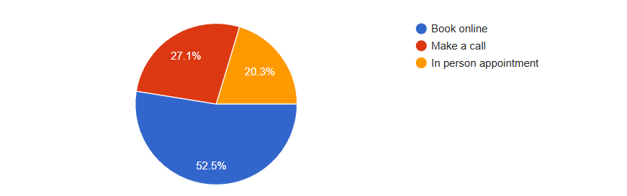
Fig 1: Preference for online appointment management

Figure 2 shows that when searching for a new doctor, most respondents (over 40%) rely on online platforms such as websites and social media. A smaller proportion prefers recommendations from friends and family, while very few start their search directly at hospitals or clinics. This emphasizes the importance of strengthening digital solutions to help patients make quicker, more informed choices
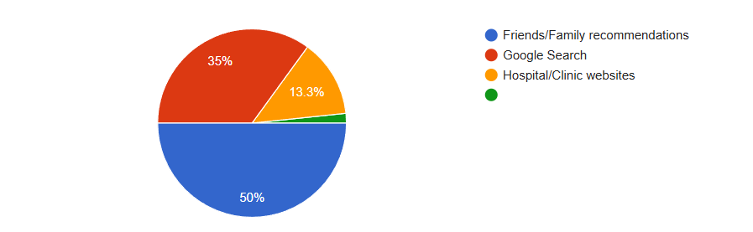
Fig 2: Common sources for finding a new doctor
From Figure 3, it can be observed that one of the biggest challenges respondents face when finding a doctor near their home is the lack of updated information on availability and consultation fees(35%). Another significant issue is the absence of specialization details, which makesdecision-making difficult. This shows the urgent need for a transparent system where patients canaccess verified doctor information
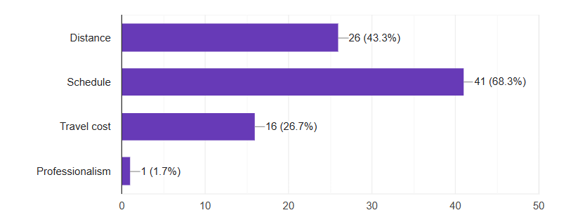
Fig 3: Challenges faced when searching for nearby doctors
As shown in Figure 4, the most important factors patients consider while choosing a doctor are availability (32%), consultation fees (28%), and specialization (25%). A smaller portion also values gender preference and hospital/clinic details. These findings reinforce the necessity of a centralized platform where all this information is accessible in one place.
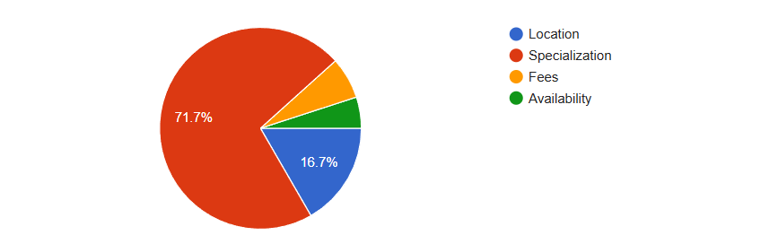
Fig 4: Key factors influencing doctor selection

B. Discussion
The results suggest that HMS can significantly improve healthcare delivery by reducing delays and improving decision-making for patients. By providing accurate and updated information, the system builds trust and ensures
transparency. The inclusion of online booking and payments further modernizes
healthcare access, aligning with Bangladesh’s growing digital ecosystem.

CONCLUS ION

In conclusion, the Health Management System is a promising digital solution for improving healthcare accessibility in Bangladesh. By integrating doctor’s profiles, hospital information, consultation fees, and booking options, the
systemensures patients can make informed healthcare decisions. If implemented widely, this systemcan contribute to better health outcomes and support Bangladesh’s digital health transformation.

Limitations
While the systemprovides transparency and convenience, challenges such as ensuring regular data updates, cybersecurity, and training for doctors/hospitals to use the platform may arise. Without reliable internet access in rural areas, adoption may also be limited.

Suggestions
Regularly update doctor and hospital data for accuracy.
Include patient reviews and ratings for better decision-making.
Ensure strong cybersecurity measures to protect patient data. Extend the system
to rural healthcare centers.
Conduct awareness campaigns to encourage adoption.

REFERENCES

- World Health Organization, “Digital health systems for developing countries,” WHO, 2020. [Online]. Available: https://www.who.int/digital- health. [Accessed: 10-Sep-2025].
- Ministry of Health and Family Welfare, Bangladesh, “Digital Health Strategy 2021–2026,” Govt. of Bangladesh, 2021. [Online]. Available: https://www.mohfw.gov.bd. [Accessed: 10-Sep-2025].
- A. Chowdhury, “Healthcare challenges in Bangladesh: The need for
digitalization,” The Daily Star, 2022. [Online]. Available:
https://www.thedailystar.net. [Accessed: 11-Sep-2025].
- World Bank, “Improving healthcare access through digital platforms,” World Bank Report, 2021. [Online]. Available: https://www.worldbank.org. [Accessed: 11-Sep-2025].
- M. Rahman, “The role of ICT in healthcare modernization in Bangladesh,”
International Journal of Health Systems, vol. 12, no. 2, pp. 45–56, 2020.

ACKNOWLEDGMENT

I would like to express my gratitude to my course instructor for guidance in completing this report. I am also thankful to all survey participants whose responses made this study possible.

- APPENDIX
