# VESPUCCI – Sandra Warren’s Spaces (Visual Guide)

## 🏛️ Sandra’s Private Office – VSI Tower (Top Floor)

This is Sandra's personal command post—not a boardroom. The top floor of VSI Tower is functionally hers, but this particular space is where she processes, plans, and decides. It’s built for silence, control, and obsidian-level focus.

- View: Unobstructed floor-to-ceiling skyline shot of Downtown LA.  
- Lighting: Low-profile, amber wash lighting around the floor base and behind shelves. All lighting is indirect.  
- Furniture: Sculptural modern—white leather wingback, minimalist black desk, chrome-edge guest chairs.  
- Atmosphere: Quiet. Sacred. Computer off unless needed. Feels like a confession box for empires.

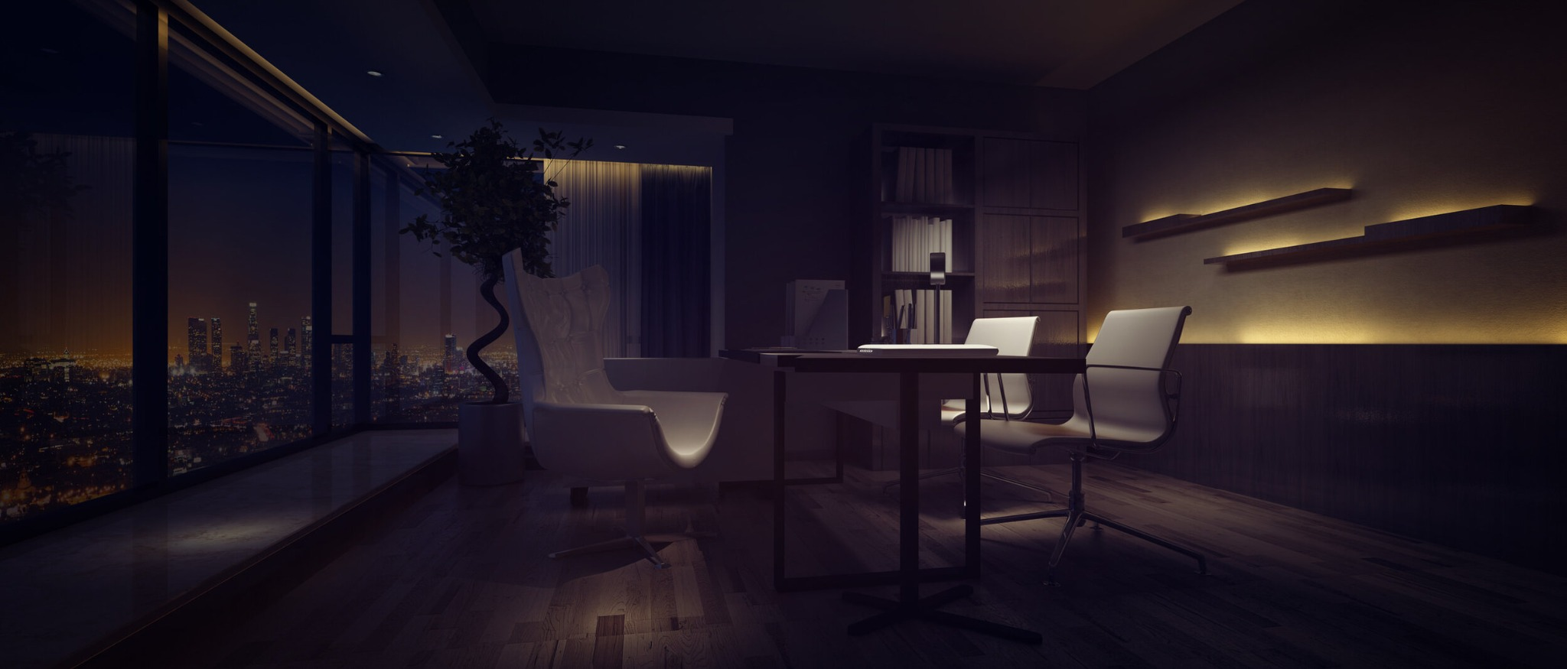

## 🏠 Sandra’s Mansion – Architectural & Lighting Notes

Modernist hillside residence cantilevered over the cliffs of Pacific Palisades.  
  
Defined by sharp black stone geometry and warm interior lighting—it’s meant to feel like a luxury memory palace. She does not entertain here. It is her sanctuary.

- Materials: Charred black wood, dark stone, smoked glass  
- Lighting: Amber and gold-tone indirect lighting only. No overhead fluorescents. Recessed ceiling LEDs, backlit wall panels, and pool reflections provide ambient motion.  
- Architectural Signature: 180° U-deck with a central infinity pool, full city view  
- Vibe: Controlled warmth. Designed detachment. No sentimental clutter.

