# VESPUCCI – Sandra Warren: Industry Visual Bible

Comprehensive visual design and tonal reference for writers, production designers, and costume departments.

## 👤 Sandra Warren – Character Visual Anchor

CEO of Vespucci Solutions International. Known for her austere precision, brutal clarity, and emotionally disciplined presence. This is the internal compass for every department that builds her world.



- Hair: Intentional, structured. Rarely fully loose unless off-duty.  
- Eyes: Always tracking, never darting. High executive control energy.  
- Off-duty vibe: Still composed. Fitted denim, soft white shirt, artisan earrings. Blends into a crowd, but still *reads elite* if you know what to look for.

## 🏢 VSI Tower – Sandra’s Personal Office

Her command center. Reserved for her alone. Dim lighting, minimal objects, and 360° strategic views of Downtown LA.

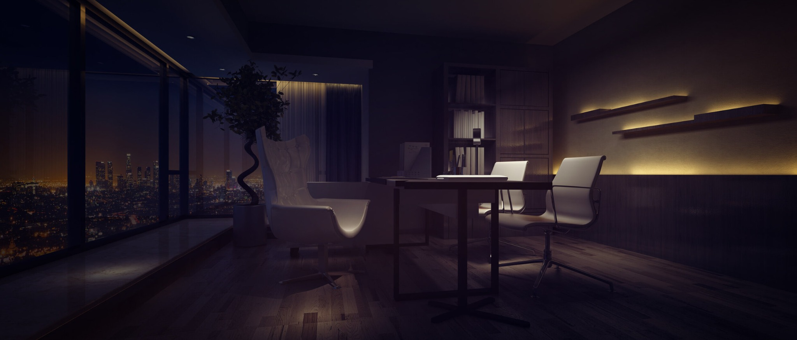

- Materials: Glass, dark matte wood, integrated ambient lighting.  
- Feels: surgical, sacred, silent.  
- Function: For confrontations, decision-making, and emotionally severe beats.

## 🏠 Pacific Clifftop Mansion – Private Residence

Sandra's home is not for hosting—it's for *observation, containment, and self-control*.

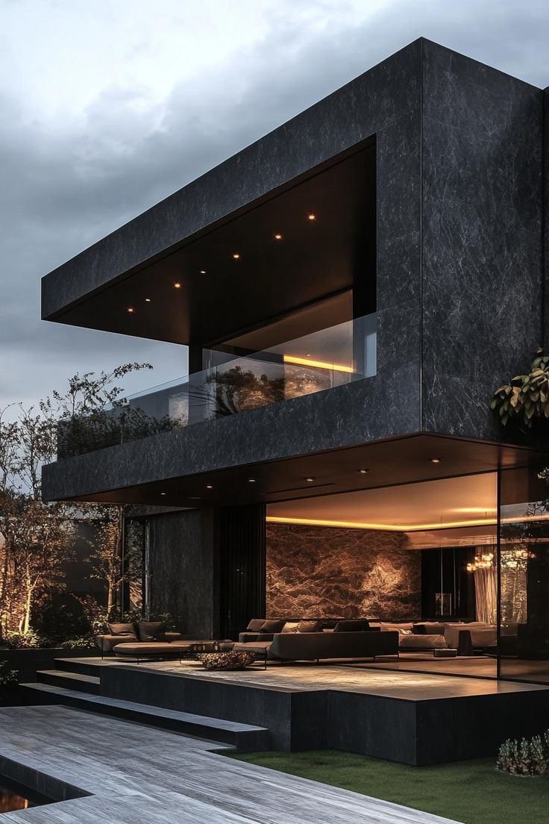

- Architecture: Two-story cantilevered over LA cliffs. Black-stone and charred wood facade.  
- Deck: 180° U-deck with central pool. City view dominant.  
- Lighting: Amber indirect glows, never overhead. Built for reflection—not relaxation.  
- Objects: Bare. One orchid. One chair always pulled slightly away from the others.

## 🌊 Mood Shift Environment – Summer Beach, Solitude

Used for dream sequences, reset moments, or emotional fractures. This is Sandra out of context—not out of character.

- Wide open sky. Minimal people. Coastal wind.  
- Wardrobe: linen blouse, oversized button-up, wide-leg pants or wrap skirt.  
- Always shot at golden hour. Sound design includes wind and breath.  
- Visual motif: her silhouette standing still while the world moves.