Using UniAdmin to create a self-sign sample certificate and define the Security Context Record (Windows system sample)

Creating the certificate repository

You will need to create a directory on the server to store all relate certificate files. The name is your choice. For our example, we will use "c:\certs".

Using UniAdmin to create a self-sign sample certificate

1. Start UniAdmin and connect to the U2 server you are configuring for SSL. You will need to register the server if it has not already been done.

2. Select SSL Configure.

- Select the Certificate Request tab to create a sample certificate request file called “u2sample.req” in the “c:\certs” directory.

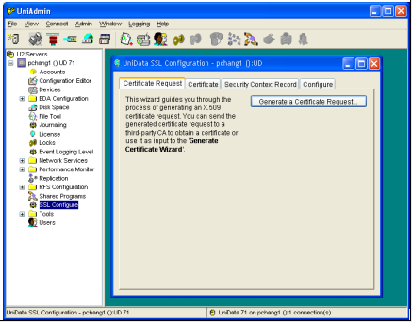

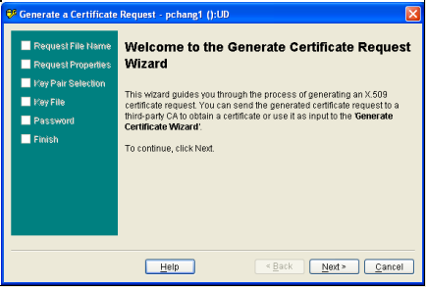

Certificate Request file: “c:\certs\u2sample.req”

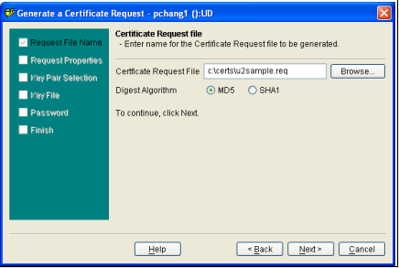

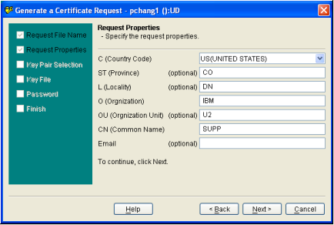

Choose the Generating new key pair option

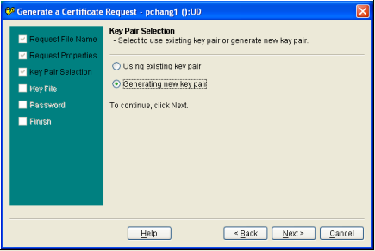

Set the private and public key files

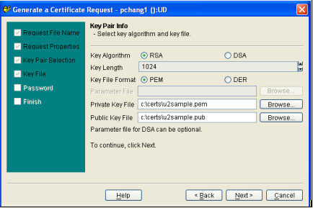

sample password: “my_password”

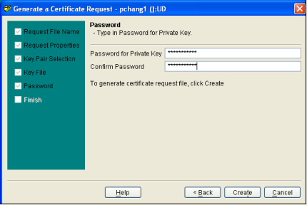

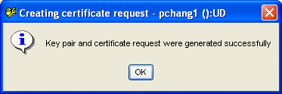

The u2sample.req, u2sample.pem and u2sample.pub files are created in the server c:\certs directory.

4. Select the Certificate tab to create a sample certificate file called “u2sample.crt” in the “c:\certs” directory.

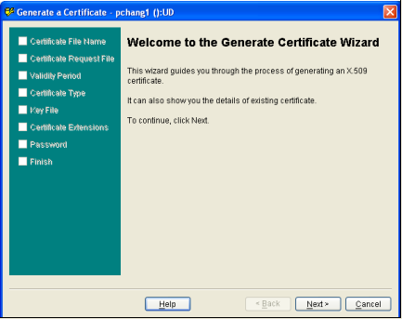

The certificate file: “c:\certs\u2sample.crt”

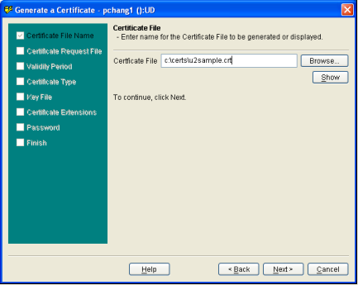

The certificate request file: “c:\certs\u2sample.req” (Created in the previous steps)

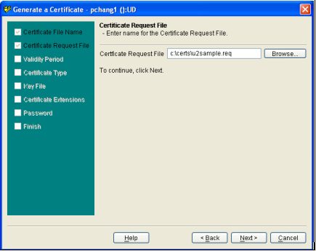

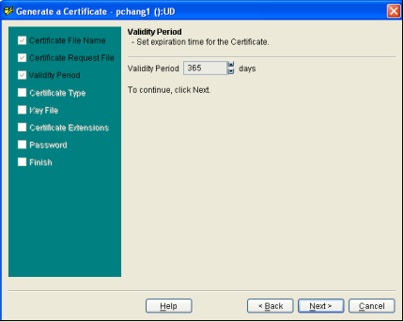

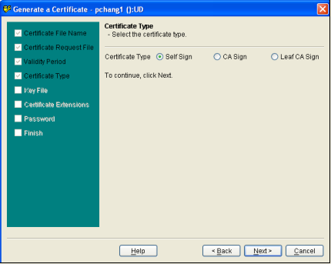

The private key file: “c:\certs\u2sample.pem” (Created in the previous steps)

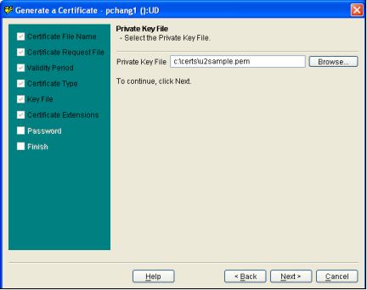

Password: “my_password”

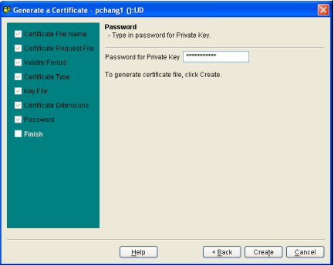

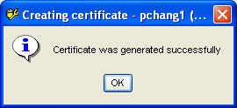

The self-sign u2sample.crt certificate file is created in the server c:\certs directory.

Using UniAdmin to define the Security Context Record

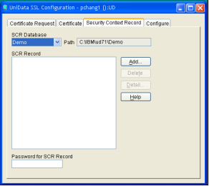

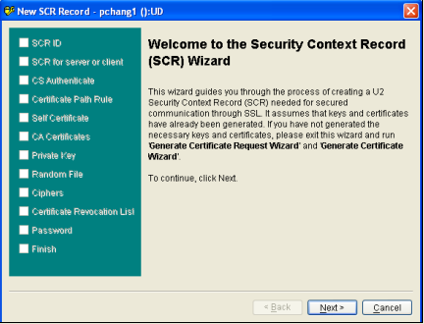

Security Context Record ID: “u2sample.scr”

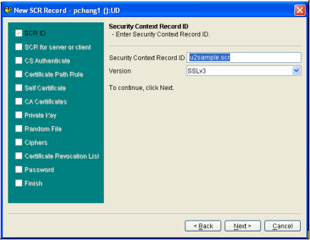

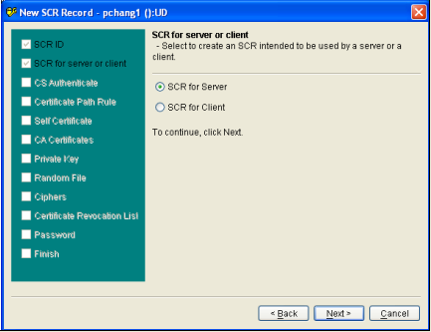

Authentication Strength option: Generous

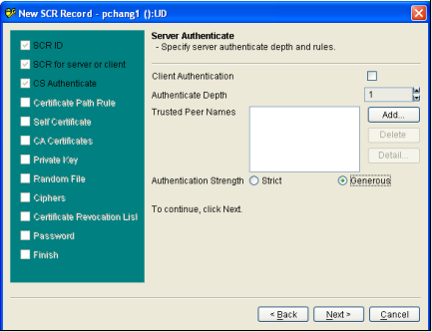

Set default path to “c:\certs”

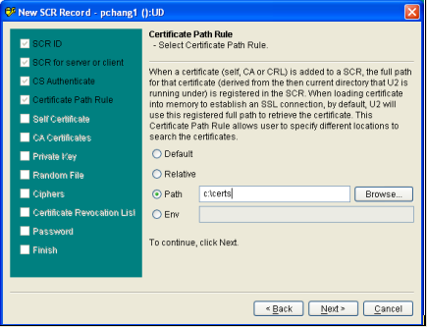

The self certificate file: “c:\certs\u2sample.crt” (Created in the previous steps)

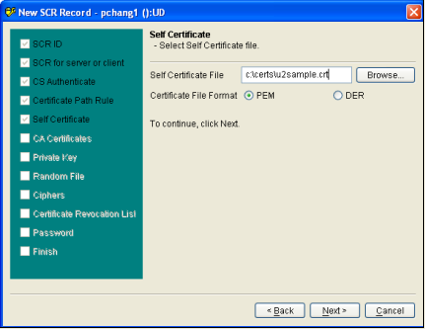

The private key file & password: “c:\certs\u2sample.pem” and “my_password” (Created in the previous steps)

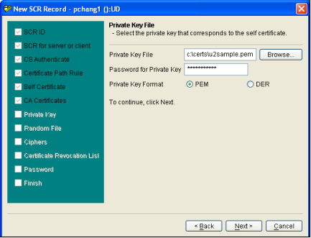

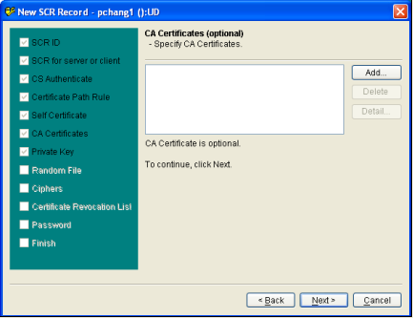

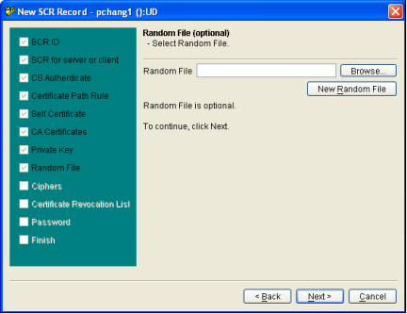

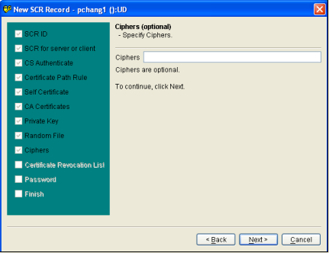

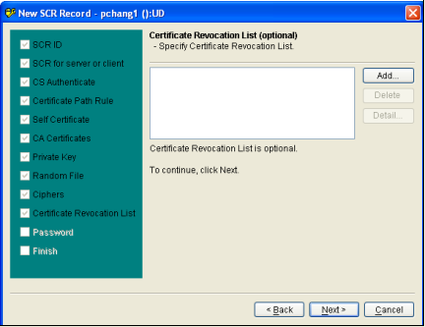

Set the SCR password: “my_password”

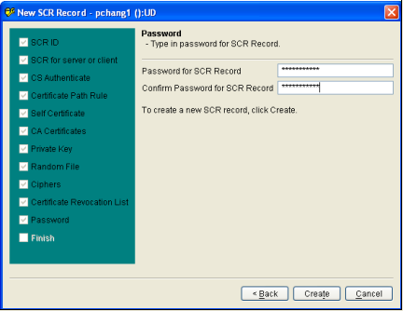

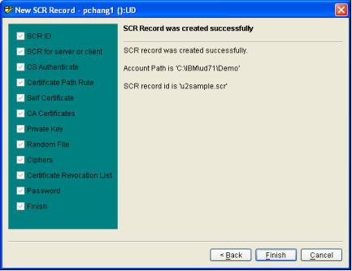

The u2sample.scr record is created in the “_SECUCTX_” file (UniData) or “&SECUCTX&” file (UniVerse).

Using UniAdmin to configure the UniData udtelnetd ssl service

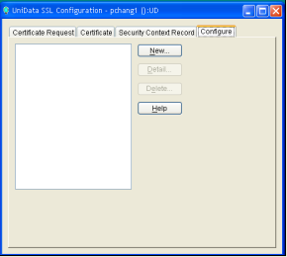

Set SSL for the udtelnetd telnet service using newly created SCR record.

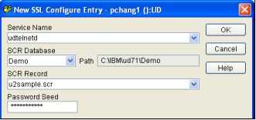

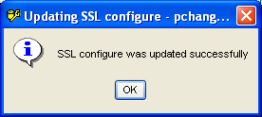

The SSL entry for the udtelnetd service is added to the .unisecurity file, located in the unishared folder (c:\ibm\unishared).

