[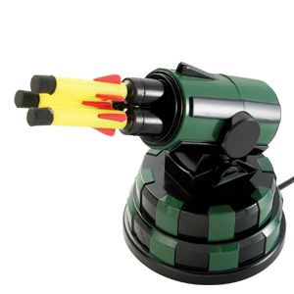](https://www.google.ch/url?sa=i&rct=j&q=&esrc=s&source=images&cd=&cad=rja&uact=8&ved=0ahUKEwiCnPuUroHNAhVM1hoKHdhtB50QjRwIBw&url=https%3A%2F%2Fmauricebutler.wordpress.com%2F2011%2F07%2F12%2Fsharp-launcher-for-dreamcheeky-usb-rocket-launcher-working-on-windows-7-x64%2F&psig=AFQjCNF-m3u73UCa6W9QWu6uZZbLjs0T4Q&ust=1464682582201268)

**Projekt:** Rocket Launcher

Erstellt von: Claudio & Florian Frei, Marco Ackermann

[](http://www.google.ch/url?sa=i&rct=j&q=&esrc=s&source=images&cd=&cad=rja&uact=8&ved=0ahUKEwjB48zEtIHNAhUGPxoKHZsEClsQjRwIBw&url=http%3A%2F%2Fwww.zinnfigur.com%2Fproduct_info.php%3Fproducts_id%3D10214600%26ID%3D1001&psig=AFQjCNEAfXgmsEcILAK8DiFFZO8cDGOoHQ&ust=1464684290019005)

# Einleitung