**“OnePPPM Bookshelf” Job Aid**

The following outlines how to utilize the OnePPPM Bookshelf feature to maintain visibility of Authority Reference Documents (typically used for notifications of updates, etc) –

* **To access your bookshelf:**
  + To access your “My Bookshelf” screen and view your saved documents, simply go to the “**OnePPPM**” homepage (located [here](onepppm.web.boeing.com/onepppm/app/home/browse/) or via a quick Boeing search) and click on the “Bookshelf” tab near the top of the page.



* **To add a document to your bookshelf:**
  + With the desired Document pulled up from the Boeing Web, simply click “**Bookmark**” near the upper right hand side of the document’s browser window.

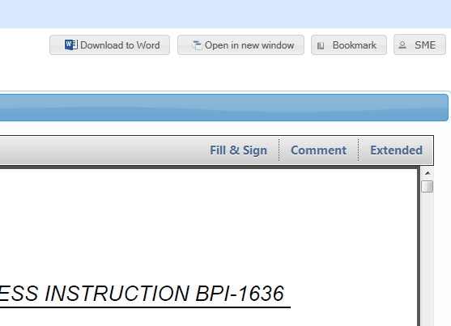

* **To remove a document from your bookshelf:**
  + From your “**My Bookshelf**” screen, check the box(es) of the desired document(s) to remove and select “**Remove**”.

