Low Level Design Template

DMT/AD06/TMP

Project Code | Team 3
Project Name | Order and Invoice Management System

Prepared/Modified by | Role | Date of Preparation
Perakam AnanthaNadh | Analyst | 13-05-2019
Reviewed by | Role | Date of Review
Approved by | Role | Date of Approval
Manish Rajhans | Training Manager
Circulation List | yashwanth.reddy.pasunoori@capgemini.com  ananthanadh.prerakam@capgemini.com  pushpalatha.kommula@capgemini.com  shashank.akula@capgemini.com  jyothi.vadlapudi@capgemini.com  suresh.thaduri@capgemini.com | Version Number of the template:1.0
Version Number | <version No >

Table of Contents

1. Description Of The Unit 3
2. References 4
3. Class Diagrams 6
4. Sequence Diagrams 7
5. Design Components 8
5.1 List Of UI Components 8
5.2 List Of Design Classes 8
6. Re-Usable Routines/Components 9
7. Messages 10
8. Configuration Files 11
9. Crud Matrix Table 12
10. Data Mapping Matrix 13
11. Action Flow Matrix 14

Description Of The Unit

This document outlines a project for the .NET Line of Technology (LOT). The project is to develop an Order and Invoice Management System (OMTBS). This document contains the work flow of the system and gives guidelines on how to build the functionality gradually in each of the course modules of the .NET LOT.

This project is aimed at developing an Order and Invoice Management System (OIMS).

For Example an organization which manufactures stationary items like books, pen, printing paper etc. They receive order from all over the country for their stationary product.
So we created a Web application for all the activities like inventory management to maintain product and customer record as well as maintain the details of the order place and creating invoices for the same.

The System will have Two Users: - Admin and Clerk

Role of Admin:-
1. Managing Category Information
2. Managing Product Information
3. Managing Customer Information
4. Managing User Details
5. Generation of reports like Sales based on category and Product

Role of Clerk:-
1. Creating new order
2. Generating Invoices
3. Printing of Invoices

References

- https://getbootstrap.com/ (For Boot Strap)
- https://www.draw.io/ (For UML Diagrams)
- https://portal.azure.com / (For Deploying the Project)

Class Diagrams
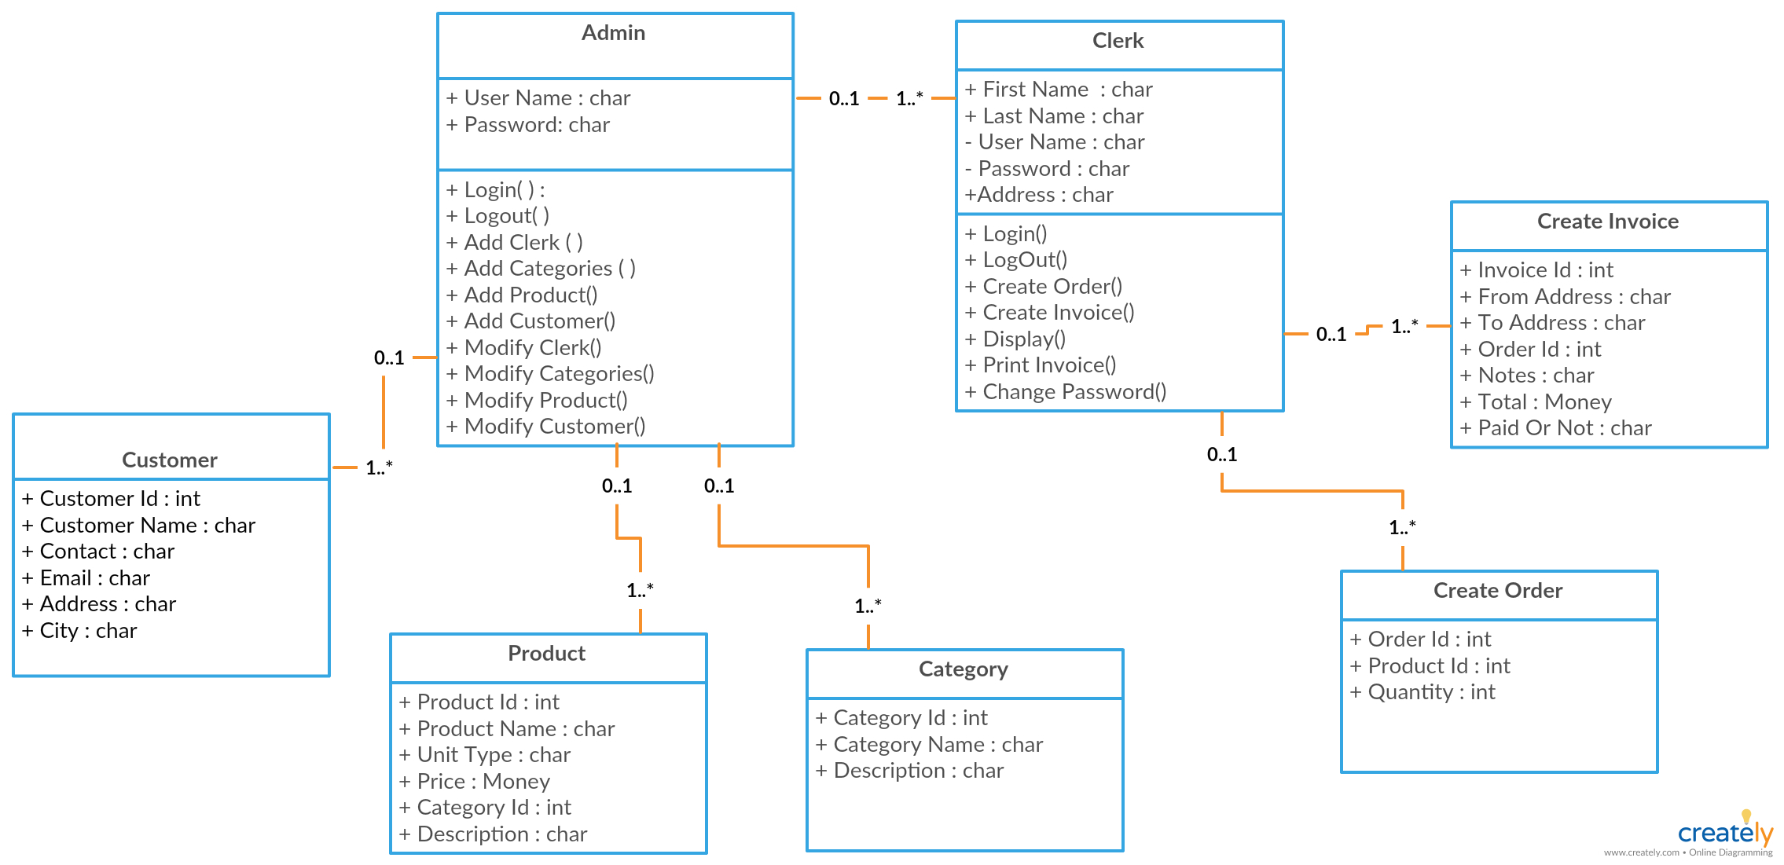

Sequence Diagrams For Admin and Clerk
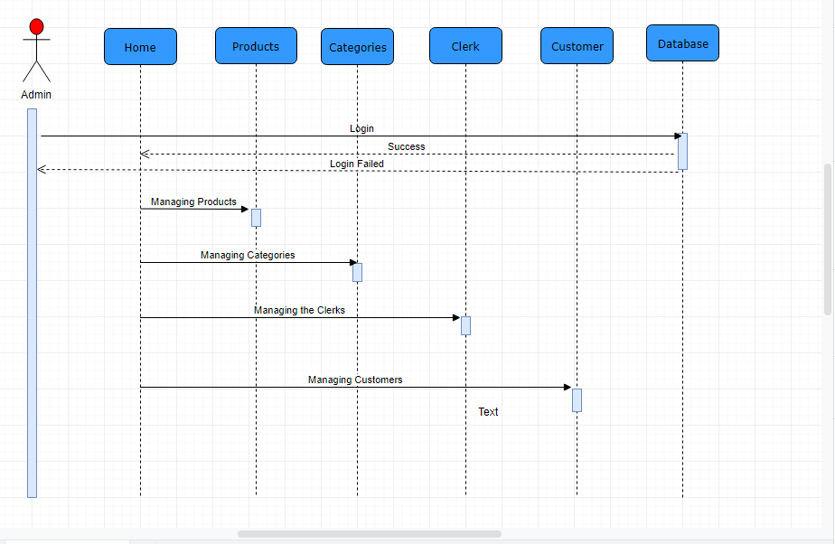
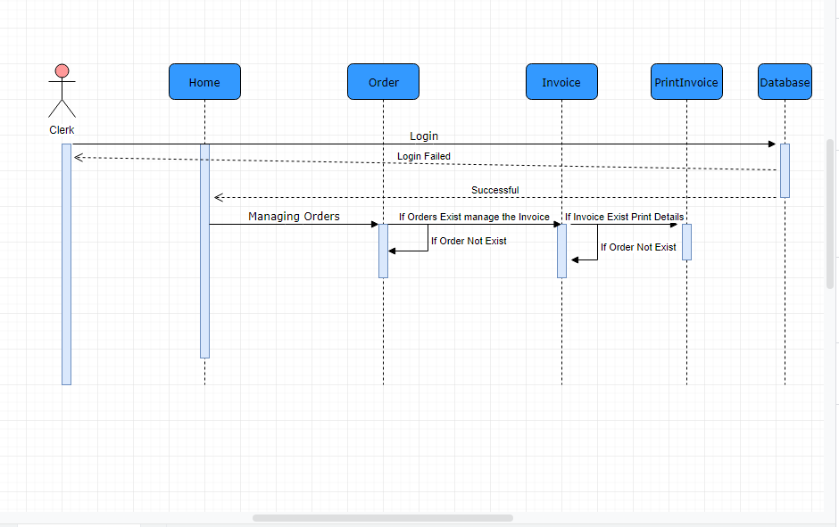

Design Components

List Of UI Components

- Drop down List
- Buttons
- Labels
- Icons
- Textboxes
- Message Boxes
- Search Field
- Tables

List Of Design Classes

- Category Class:- This class/entity will hold Category Information
- Product Class:- This class/entity will hold Product Information
- Customer Class:- This class/entity will hold Customer Information
- Orders Class:- This class/entity will hold Orders Information
- Order Details Class:- This class/entity will hold Orderdetails Information
- Invoice Class:- This class/entity will hold Invoice information
- Users Class:- This class/entity will hold Users Information

Re-Usable Routines/Components

- Layouts
- Models
- Controllers

Messages

#. | Type | Message Text
1. | Required Field Validator | Please Enter Customer name, City, Phone Number, Address, Email, Pin code.
2. | Regular Expression | Phone Number 10 digit only, Pincode 6 digit only.

Configuration Files

File Name | Path | Description
test | C:\Users\aperakam\Downloads\test\test | Development of Order and Invoice Management System

Crud Matrix Table

# | Table Name | Create | Read | Update | Delete
1 | User | Yes | Yes | Yes | Yes
2 | Categories | Yes | Yes | Yes | Yes
3 | CreateInvoice | Yes | Yes | Yes | Yes
4 | Customer | Yes | Yes | Yes | Yes
5 | Display | Yes | Yes | Yes | Yes
6 | Order | Yes | Yes | Yes | Yes
7 | Products | Yes | Yes | Yes | Yes

Data Mapping Matrix
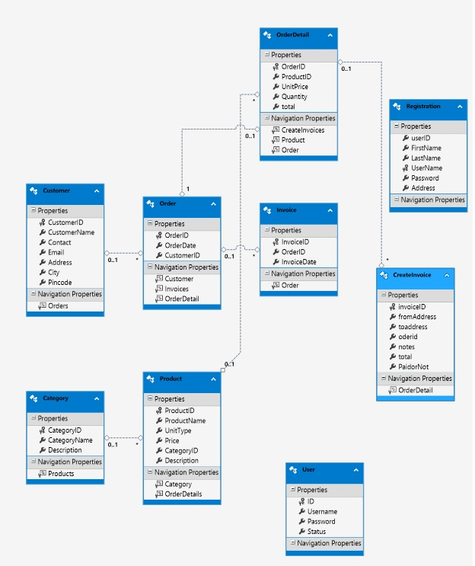

The Above Diagram show Pertinent to screen or report data Items. Provided the Details of base tables

Action Flow Matrix

The below Diagram Flow of Actions happened in the

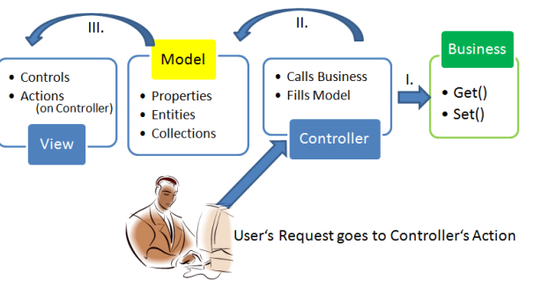

The Below Diagram Authorized Admin and Clerk Following Actions.
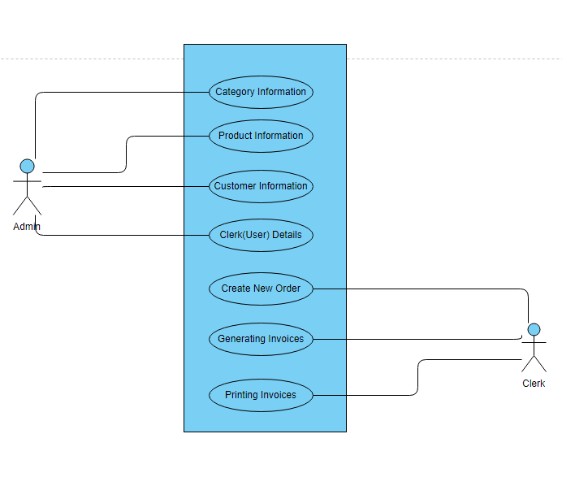

Program Specification / Pseudo Code

Program Specification:
- Visual Studio 2017
- .NET Framework 4.6.1
- MVC 5
- SQL Server 2014 Management Studio
- Bootstrap
- CSS

THE END
THANK YOU

