**Created environment:**

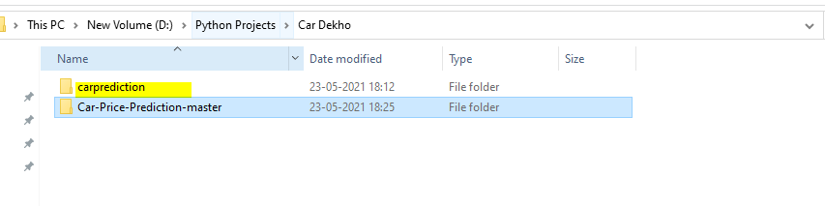

Python 3.7

D:\Python Projects\Car Dekho>carprediction\Scripts\activate

**Go to your folder:**

Cd D:\Python Projects\Car Dekho\Car-Price-Prediction-master

