Demonstration of the use of event driven tools and techniques.

# Screenshots of the Calculater program running.

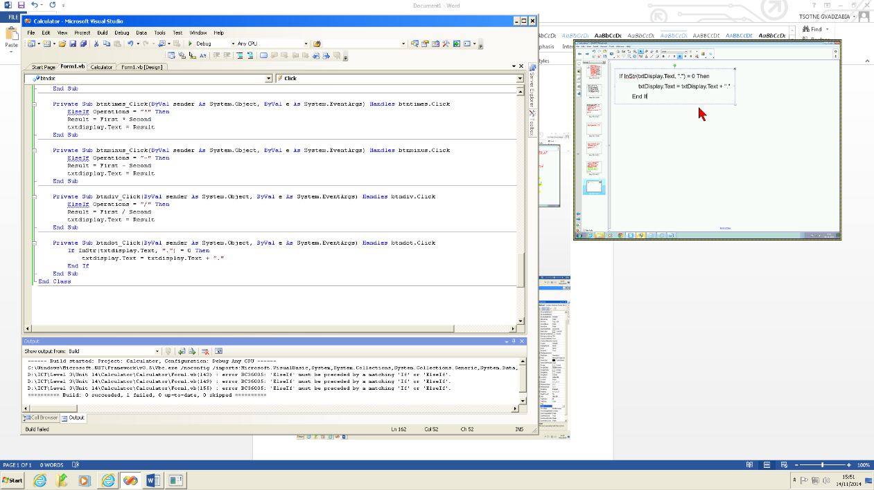

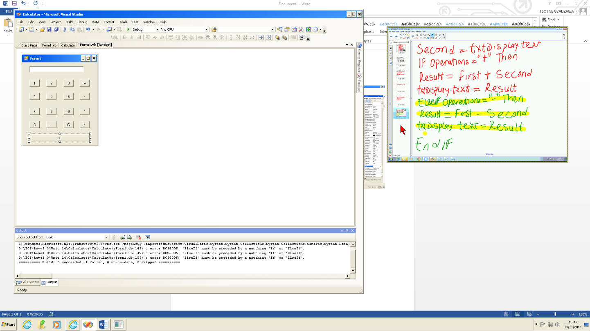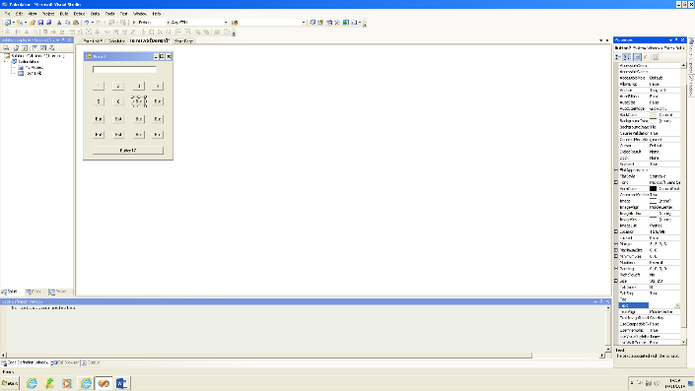

# Tools used

**Buttons**- Each button would represent a number or symbol (plus, divide, etc.) and the user would use these buttons to create calculations of their own.

**Text box**- This was used to display the numbers selected during the process of the calculation as well as the final result when the calculation is complete.

# Code used for the calculator program

Public Class Form1

Dim First As Decimal

Dim Second As Decimal

Dim Result As Decimal

Dim Operations As String

Private Sub btnone_Click(ByVal sender As System.Object, ByVal e As System.EventArgs) Handles btnone.Click

If txtdisplay.Text = "0" Then

txtdisplay.Text = "1"

Else

txtdisplay.Text = txtdisplay.Text + "1"

End If

End Sub

Private Sub btntwo_Click(ByVal sender As System.Object, ByVal e As System.EventArgs) Handles btntwo.Click

If txtdisplay.Text = "0" Then

txtdisplay.Text = "2"

Else

txtdisplay.Text = txtdisplay.Text + "2"

End If

End Sub

Private Sub btnthree_Click(ByVal sender As System.Object, ByVal e As System.EventArgs) Handles btnthree.Click

If txtdisplay.Text = "0" Then

txtdisplay.Text = "3"

Else

txtdisplay.Text = txtdisplay.Text + "3"

End If

End Sub

Private Sub btnfour_Click(ByVal sender As System.Object, ByVal e As System.EventArgs) Handles btnfour.Click

If txtdisplay.Text = "0" Then

txtdisplay.Text = "4"

Else

txtdisplay.Text = txtdisplay.Text + "4"

End If

End Sub

Private Sub btnfive_Click(ByVal sender As System.Object, ByVal e As System.EventArgs) Handles btnfive.Click

If txtdisplay.Text = "0" Then

txtdisplay.Text = "5"

Else

txtdisplay.Text = txtdisplay.Text + "5"

End If

End Sub

Private Sub btnsix_Click(ByVal sender As System.Object, ByVal e As System.EventArgs) Handles btnsix.Click

If txtdisplay.Text = "0" Then

txtdisplay.Text = "6"

Else

txtdisplay.Text = txtdisplay.Text + "6"

End If

End Sub

Private Sub btnseven_Click(ByVal sender As System.Object, ByVal e As System.EventArgs) Handles btnseven.Click

If txtdisplay.Text - "0" Then

txtdisplay.Text = "7"

Else

txtdisplay.Text = txtdisplay.Text + "7"

End If

End Sub

Private Sub btneight_Click(ByVal sender As System.Object, ByVal e As System.EventArgs) Handles btneight.Click

If txtdisplay.Text = "0" Then

txtdisplay.Text = "8"

Else

txtdisplay.Text = txtdisplay.Text + "8"

End If

End Sub

Private Sub btnnine_Click(ByVal sender As System.Object, ByVal e As System.EventArgs) Handles btnnine.Click

If txtdisplay.Text = "0" Then

txtdisplay.Text = "9"

Else

txtdisplay.Text = txtdisplay.Text + "9"

End If

End Sub

Private Sub btnzero_Click(ByVal sender As System.Object, ByVal e As System.EventArgs) Handles btnzero.Click

If txtdisplay.Text = "0" Then

txtdisplay.Text = "0"

Else

txtdisplay.Text = txtdisplay.Text + "0"

End If

End Sub

Private Sub btnequals_Click(ByVal sender As System.Object, ByVal e As System.EventArgs) Handles btnequals.Click

Second = txtdisplay.Text

If Operations = "+" Then

Result = First + Second

txtdisplay.Text = Result

ElseIf Operations = "-" Then

Result = First - Second

txtdisplay.Text = Result

ElseIf Operations = "*" Then

Result = First * Second

txtdisplay.Text = Result

ElseIf Operations = "/" Then

Result = First / Second

txtdisplay.Text = Result

End If

End Sub

Private Sub btnc_Click(ByVal sender As System.Object, ByVal e As System.EventArgs) Handles btnc.Click

txtdisplay.Text = "0"

End Sub

Private Sub btntimes_Click(ByVal sender As System.Object, ByVal e As System.EventArgs) Handles btntimes.Click

First = txtdisplay.Text

txtdisplay.Text = ""

Operations = "*"

End Sub

Private Sub btnminus_Click(ByVal sender As System.Object, ByVal e As System.EventArgs) Handles btnminus.Click

First = txtdisplay.Text

txtdisplay.Text = ""

Operations = "-"

End Sub

Private Sub btndiv_Click(ByVal sender As System.Object, ByVal e As System.EventArgs) Handles btndiv.Click

First = txtdisplay.Text

txtdisplay.Text = ""

Operations = "/"

End Sub

Private Sub btndot_Click(ByVal sender As System.Object, ByVal e As System.EventArgs) Handles btndot.Click

If InStr(txtdisplay.Text, ".") = 0 Then

txtdisplay.Text = txtdisplay.Text + "."

End If

End Sub

Private Sub Form1_Load(ByVal sender As System.Object, ByVal e As System.EventArgs) Handles MyBase.Load

End Sub

Private Sub btnplus_Click(ByVal sender As System.Object, ByVal e As System.EventArgs) Handles btnplus.Click

First = txtdisplay.Text

txtdisplay.Text = "0"

Operations = "+"

End Sub

End Class