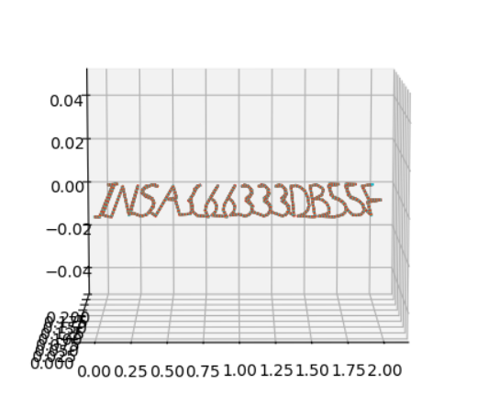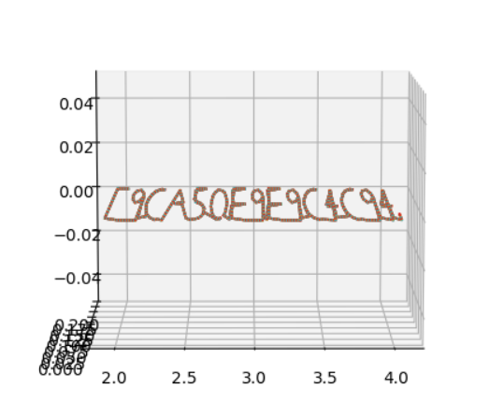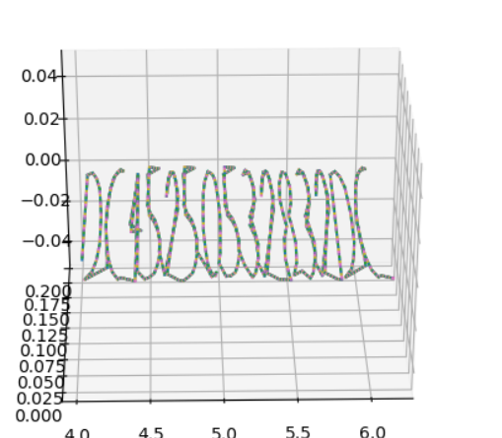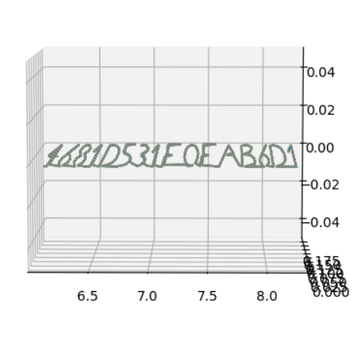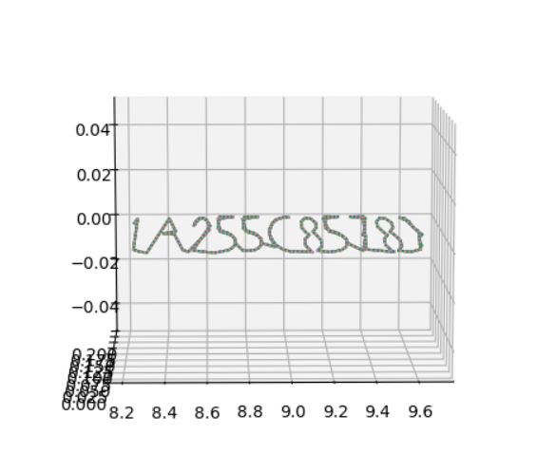

INSA{66333DB55E9CA50E9E9C4C94DC45250532832DC4681D531F0FAB6D1A255C8578}

INSA{66333db55e9ca50e9e9c4c94dc45250532832dc4681d531f0fab6d1a255c8578}