1.程序主体要求：
1.1.编写一个猜单词小程序，（单词长度介于6-9个字母之间），根据用户选择的难度（FIXED难度和ARBITARY难度）从已给的单词库中随机抽取。
用户输入s 开始游戏（start game）
用户输入h 输出游戏规则（support文档里有可以直接调）
用户输入q 退出游戏
非法输入（invalid input）输出非法输入警告信息并重新开始游戏（support文档里也有）

1.2用户有八次猜词机会，八次内猜中，返回
"You have guessed the word correctly. Congratulations".
八次未猜中，返回
"Your guess was wrong. The correct word was "{word}""
（注：{word}是用户应该猜中的单词）

1.3游戏得分：
猜中元音字母（aeiou）并且该元音在单词的正确位置得14分，在正确位置的辅音字母（除了元音以外的其他字母）得12分，猜对正确元音或辅音但不在正确位置的得5分，重复猜对正确字母不再重复给分
例如，猜单词crushing：
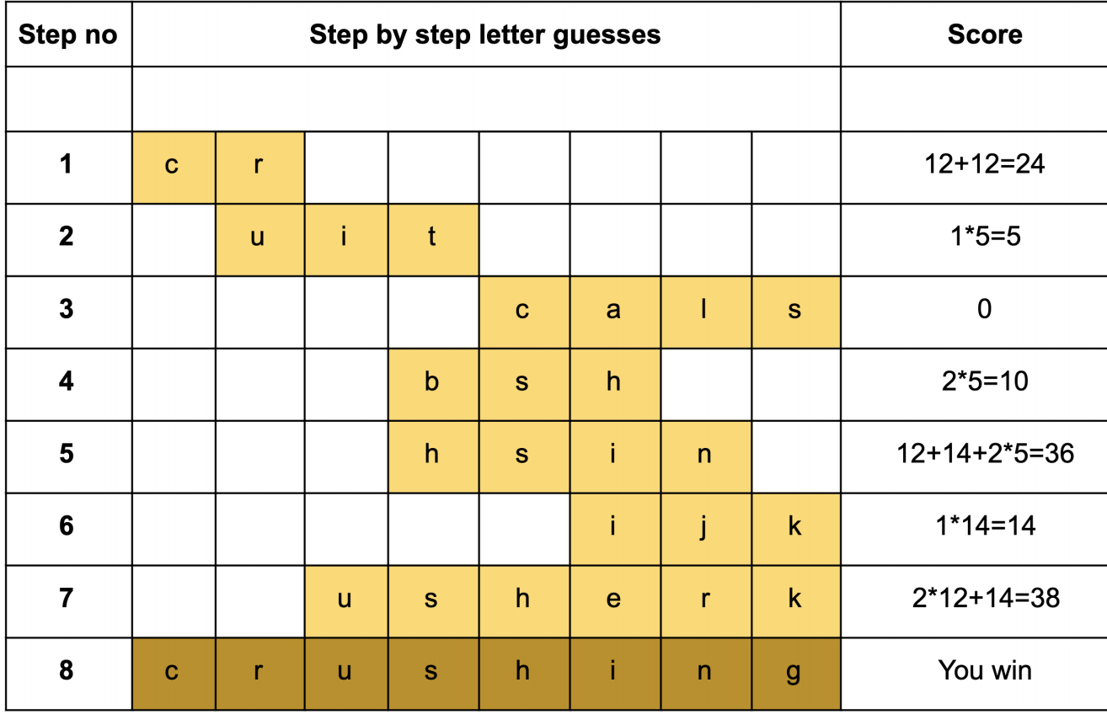
1.4具体变量解释：
• word select: 一个代表从FIXED或者ARBITRARY词库选词的变量（字符串string）
（A string representing a FIXED or ARBITRARY word selection. ）
• guess no: 一个代表猜词次数的变量（整数类型int）
（An integer representing how many guesses the player has made. ）
• word: 一个代表用户猜的单词的变量（字符串string）
（A string representing the word being guessed by the player. ）
• word length: 一个代表用户所猜词长度的变量（整数型int）
（An integer representing the length of the word being guessed by the player）

1.5 必须写入程序的函数
1.5.1
select word at random(word select)-> str:
（注：用户选了FIXED或ARBITRARY后，会对应返回一个从WORDS FIXED.txt 或 WORDS ARBITRARY.txt中随机选择的单词（string类型）
如果选择的单词是这两个词库以外的，函数返回NONE）
可以参考压缩文件中a1.support文件里已有的a1 support.load words() 和 a1 support.random index()两个函数
Given the word select is either “FIXED” or “ARBITRARY” this function will return a string randomly
selected from WORDS FIXED.txt or WORDS ARBITRARY.txt respectively. If word select is anything
other then the expected input then this function should return None.
Hint: see a1 support.load words() and a1 support.random index()
1.5.2
create guess line(guess no, word length)-> str:
（注：这个函数返回一个包含有用户猜词次数和猜词长度的字符串，可参考下面例子）
This function returns the string representing the display corresponding to the guess number integer, guess no.
1.5.3
display guess matrix(guess no, word length, scores)-> None:
（注：这个函数会打印出一个包含有所有猜词次数+猜词内容+对应分数的元组，以及没有得分的猜词过程，参考下面例子）
This function prints the progress of the game. This includes all line strings for guesses up to guess no with their corresponding scores (a tuple containing all previous scores), and the line string for guess no (without a score)
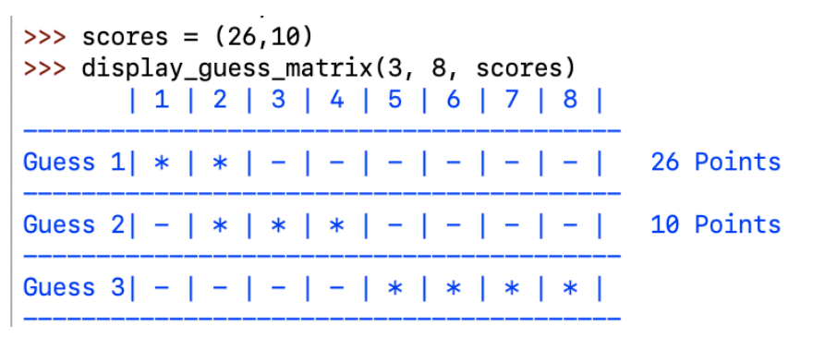

1.5.4
compute value for guess(word, start index, end index, guess)-> int:
（这个函数返回用户的得分(int)； 函数变量一的word代表用户本次游戏过程中所猜的词（例子里是“crushing”）用str类型；这个字符串的子串是一个通过字符串切片，由变量二三（start index开始索引和end index结束索引）决定的子串，最后变量四guess是一个代表用户猜词企图的字符串）
Return the score, an integer, the player is awarded for a specifific guess. The word is a string representing the word the player has to guess. The substring to be guessed is determined by the start index and end index.
The substring is created by slicing the word from the start index up to and including the end index. The guess is a string representing the guess attempt the player has made.
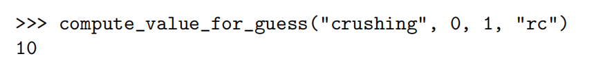

1.5.5
main()-> None:
（注：主函数，在程序开始时输出欢迎信息（a1.support里有），游戏开始时应该循环用户的游戏轮数，直到用户猜对赢了游戏或者猜错输掉
提示：应该从主函数开始入手写，同时它也应该是最后完成的）
This function handles player interaction. At the start of the game the player should be greeted with the Welcome message. Once the guessing sequence commences the game should loop for the correct number of rounds until either the player wins by guessing the correct word or loses by guessing the incorrect word.
Hint: the main function should be your starting point but also the last function you finish implementing

- 游戏示例
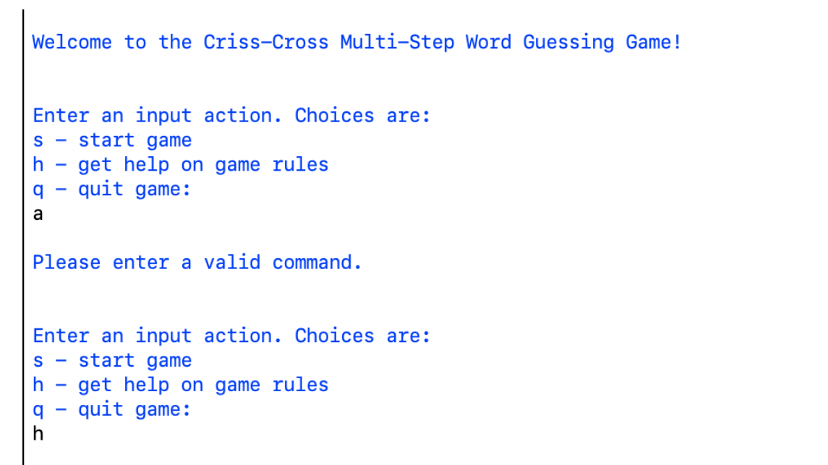
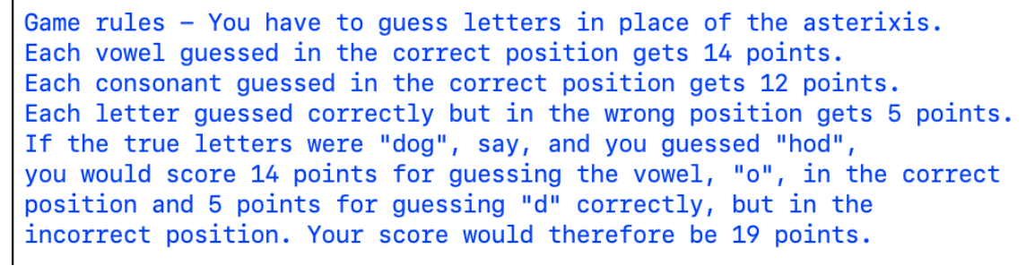
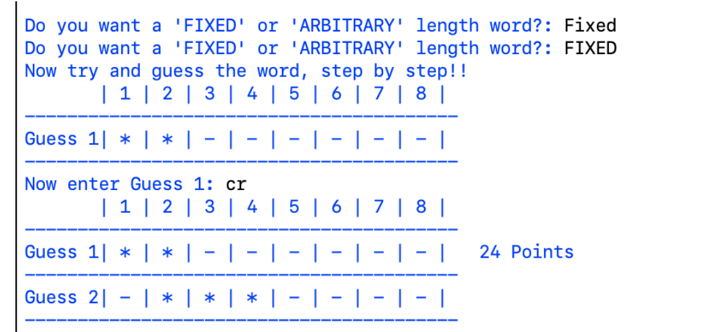
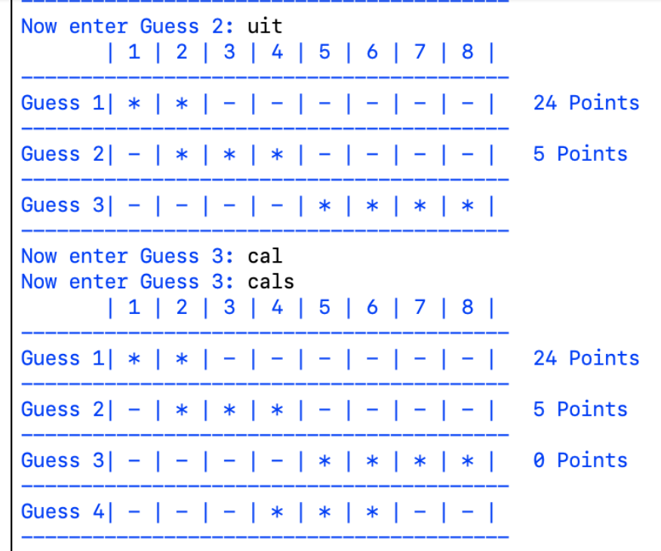
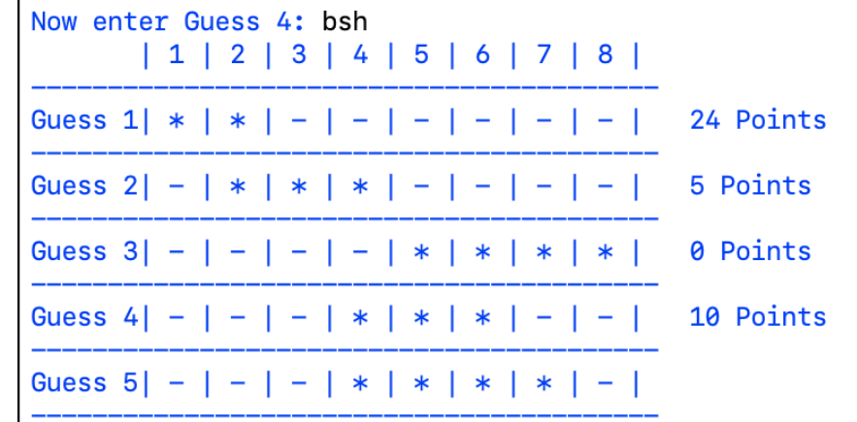
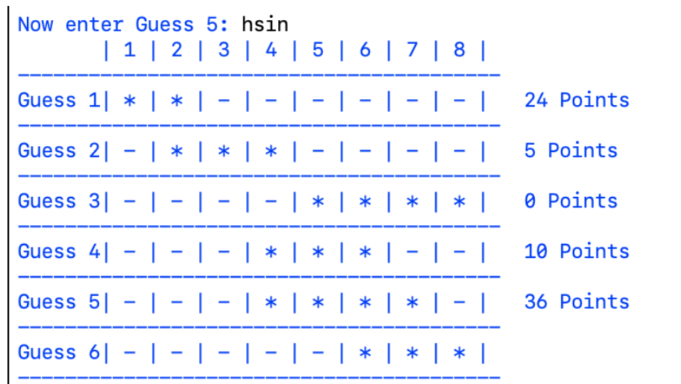
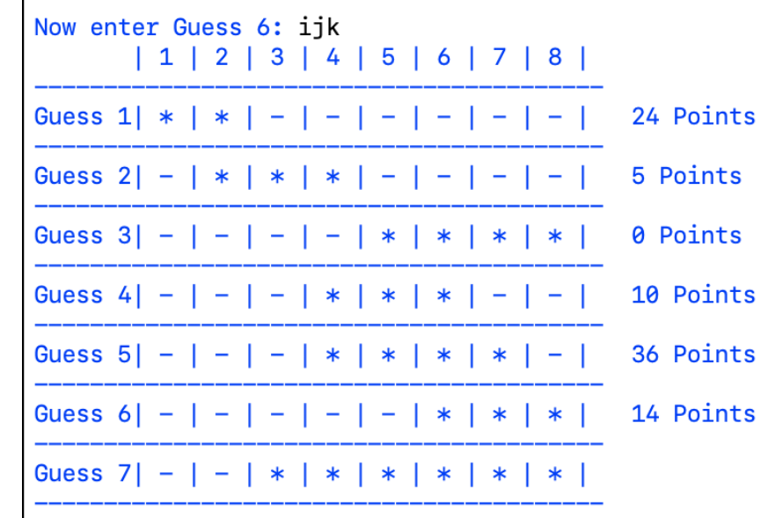
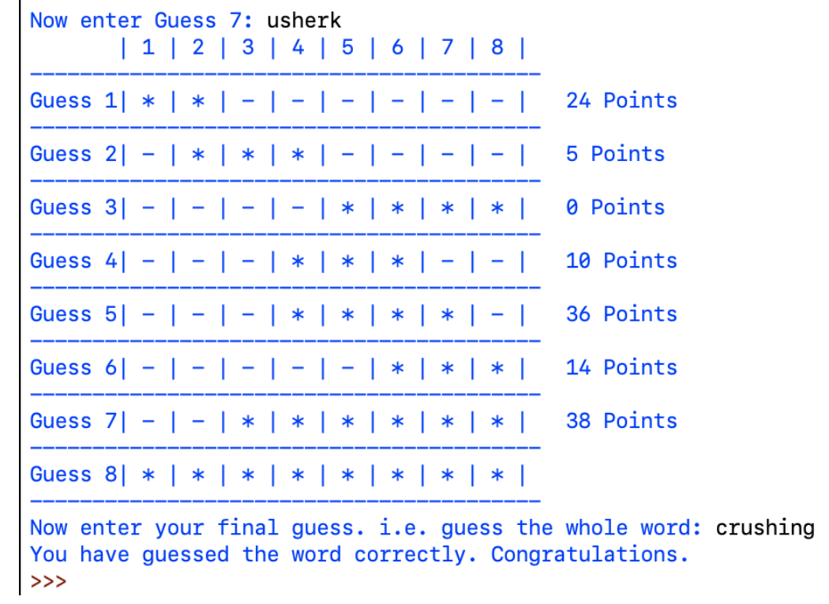

- 帮助信息
  - 欢迎信息（可以直接复制粘贴输入）
"Welcome to the Criss-Cross Multi-Step Word Guessing Game!
Enter an input action. Choices are:
s - start game
h - get help on game rules
q - quit game:
"
  - 帮助信息
"Game rules - You have to guess letters in place of the asterixis.
Each vowel guessed in the correct position gets 14 points.
Each consonant guessed in the correct position gets 12 points.
Each letter guessed correctly but in the wrong position gets 5 points.
If the true letters were "dog", say, and you guessed "hod",
you would score 14 points for guessing the vowel, "o", in the
8correct position and 5 points for guessing "d" correctly, but in the
incorrect position. Your score would therefore be 19 points.”

- 输出示例
