- 功能简介
1.1 游戏内容
钥匙洞冒险游戏是一个单人玩家探索地牢的游戏，主要功能是让玩家找到钥匙并且从地牢的门逃出。该游戏使用键盘WSAD输入上下左右的移动指令；游戏中物体的位置由(row, col)来显示，游戏的区域必须一直保持是一个长方形。
玩家可以在地牢内以规定的WSAD四个任意方向移动，必须在规定步数内走到钥匙所在的位置，拿到钥匙才能打开门锁，从而通过门离开地牢。

1.2 游戏过程内命令解释
输入指令 | 具体解释
‘-DIRECTION-’ | 物体的移动方向
‘I -DIRECTION-’ | ‘I W’ 会调查在给定方向的物体
‘H’ | 帮助信息（详见结尾的例子）
‘Q’ | 退出游戏

移动指令 | 具体解释
‘W’ | 上
‘S’ | 下
‘A’ | 左
‘D’ | 右

字符 | 具体解释
‘#’ | 墙
‘O’ | 玩家
‘K’ | 钥匙
‘D’ | 门
‘ ’ | 空格

1.3 游戏结束
玩家拿到钥匙并通过门后视为完成游戏，如果顺利完成，游戏显示：
You have won the game with your strength and honour!
如果玩家在拿到钥匙并开门前已经走完了步数，则视为游戏失败，游戏显示：
You have lost all your strength and honour.
以下行动会使玩家的步数减少：
1.玩家成功移动到一个新位置
2.未成功移动到一个新位置（例如新位置是墙的位置）
3.在给定的方向调查物体（详见游戏展示部分）

- 类
  - 代码中必须包含的类及解释
下图中，实心箭头所指向的类表明该类存储有另一个类的实例，例如GameApp类指向 Display类，表明GameApp类包含Display类的实例。
空心箭头所指向的类表明该类是另一个类的子类。例如，Item类是Entity类的子类。
可以添加类以减少代码冗余，但下图所包含的类必须在代码中使用。
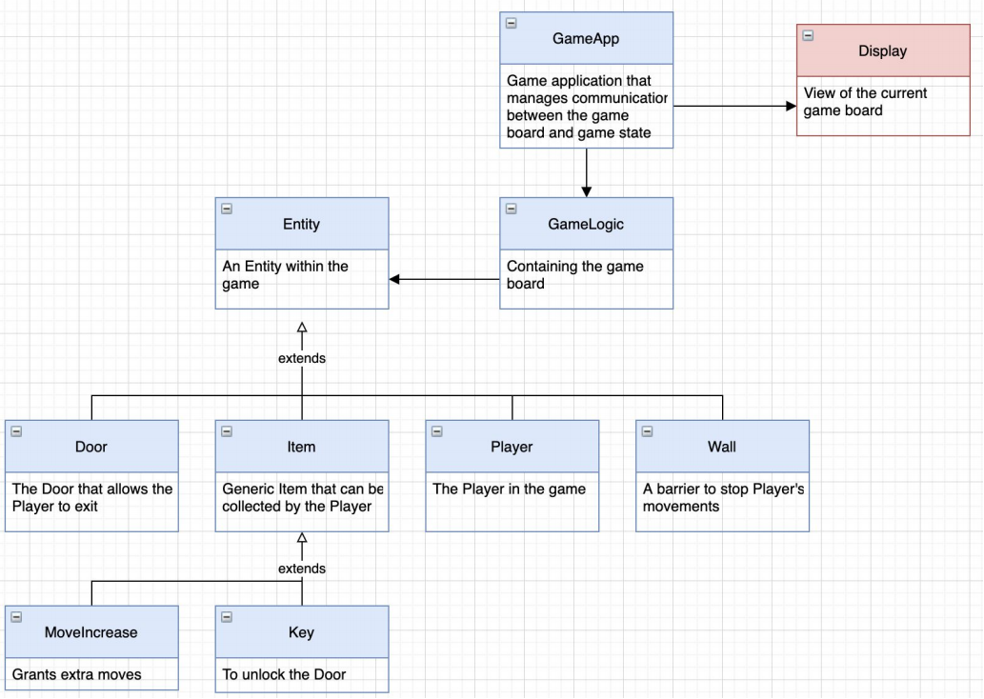
GameApp类
管理游戏和游戏状态之间通信的类
Display类
展示当前游戏界面的类
GameLogic类
包含游戏界面的类
Entity类
游戏中的一个实体
Wall类
阻止玩家移动的障碍
Player类
游戏中的玩家
Door类
允许玩家离开的门
Item类 产生能被玩家收集的物品（详见游戏展示）
MoveIncrease类
允许步数增加
Key类
解锁门

  - 类的具体解释
2.2.1 Entity类
游戏中的实体，每个实体有一个id，两个实体不能同时出现在同一个位置（不能相撞）， Entity类中的collidable属性需要在类创建时就被设置为True。
Entity类应创建为Entity()，并包含以下方法：

1.get_id(self) -> str:
返回一个代表实体id的字符串(Returns a string that represents the Entity’s ID. )
2.set_collide(self, collidable: bool):
设置collidable属性为True (Set the collision state for the Entity to be True. )
3.can_collide(self) -> bool:
当实体可以相冲突时返回True，反之返回False (Returns True if the Entity can be collided with (another Entity can share the position that this one is in) and False otherwise. )
4.__str__(self) -> str:
返回一个代表实体的字符串，详见代码示例(Returns the string representation of the Entity. See example output below. )
5.__repr__(self) -> str:
与str(self)相同(Same as str(self).)

代码示例：
>>> entity = Entity()
>>> entity.get_id()
'Entity'
>>> entity.can_collide()
True
>>> str(entity)
"Entity('Entity')"
>>> repr(entity)
"Entity('Entity')"
>>> entity = Entity()
>>> entity.can_collide()
True
>>> entity.set_collide(False)
>>> entity.can_collide()
False
（注：entity.set_collide不能被设置为False，这里只是举例 (Note that Entity should never be set to False, this is just an example)）

2.2.2 Wall类
Wall是游戏中比较特殊的一个实体，它不能被碰撞（与其他实体冲突），并包含以下方法：

1.get_id(self) -> str:
返回一个代表wall的id的字符串(Returns a string that represents the Wall’s ID. )
2.set_collide(self, collidable: bool):
设置wall的冲突状态为False(Set the collision state for the Wall to be False.)
3.can_collide(self) -> bool:
Wall可以和其他实体冲突时返回True，反之返回False(Returns True if the Wall can be collided with and False otherwise.)
4.__str__(self) -> str:
返回代表wall的字符串，详见代码示例(Returns the string representation of the Wall. See example output below. )
5.__repr__(self) -> str:
与str(self)相同(Same as str(self).)

代码示例：
>>> wall = Wall()
>>> wall.get_id()
'#'
>>> can_collide()
False
>>> str(wall)
"Wall('#')"
>>> repr(wall)
"Wall('#')"
>>> set_collide(True)
>>> can_collide()
True
（注：wall.can_collide不能被设定为True，这里只是示例说明）
(Note that Wall should never be set to True, this is just an example)

2.2.3 Item类
Item类是一个抽象类，在默认情况下可以与实体相撞，Item类应被创建为Item()，并包含以下方法：

1.get_id(self) -> str:
返回一个代表item的id的字符串(Returns a string that represents the Item’s ID.)
2.set_collide(self, collidable: bool):
设置item的相撞状态为True(Set the collision state for the Item to be True.)
3.can_collide(self) -> bool:
当可以相撞时返回True，反之返回False(Returns True if the Item can be collided with and False otherwise. )
4.on_hit(self, game: GameLogic):
这个方法应该抛出NotImplementedError异常
(This function should raise the NotImplementedError. )

代码示例：
>>> game = GameLogic()
>>> item = Item()
>>> item.can_collide()
True
>>> item.on_hit(game)
Traceback (most recent call last):
File "<pyshell#30>", line 1, in <module>
item.on_hit(game)
File "/Users/.../a2.py", line 75, in on_hit
class Item(Entity):
NotImplementedError
>>> str(item)
"Item('Entity')"
>>> repr(item)
"Item('Entity')"

2.2.4 Key类
Key实体可以被碰撞，key类应被创建为Key()并包含以下方法：

1.get_id(self) -> str:
返回一个代表key的id的字符串(Returns a string that represents the Key’s ID. )
2.set_collide(self, collidable: bool):
设置key的碰撞状态为True(Set the collision state for the Key to be True. )
3.can_collide(self) -> bool:
当可以碰撞时返回True，反之返回False(Returns True if the Key can be collided with and False )
4.otherwise.on_hit(self, game: GameLogic) -> None:
当玩家拿到钥匙时，钥匙应该被加到玩家的存货中，并且从地牢中移除
(When the player takes the Key the Key should be added to the Player’s inventory. The Key should then be removed from the dungeon once it’s in the Player’s inventory. )
提示：当Player类和GameLogic类完成一部分后可用来作为参考
(hint: Move onto the Player and GameLogic class and come back to this when they are partly
implemented.)
5.__str__(self) -> str:
返回一个代表字符串的类，详见代码示例(Returns the string representation of the Key. See example output below. )
6.__repr__(self) -> str:
与str(self)相同 (Same as str(self). )

代码示例：
>>> key = Key()
>>> key.get_id()
'K'
>>> key.can_collide()
True
>>> str(key)
"Key('K')"
>>> repr(key)
"Key('K')"
(below are example of the on_hit() method)
>>> game = GameLogic()
>>> game.get_game_information()
{(1, 3): Key('K'), (3, 2): Door('D'), (0, 0): Wall('#'), (0, 1):
Wall('#'), (0, 2): Wall('#'), (0, 3): Wall('#'), (0, 4): Wall('#'),
(1, 0): Wall('#'), (1, 2): Wall('#'), (1, 4): Wall('#'), (2, 0):
Wall('#'), (2, 4): Wall('#'), (3, 0): Wall('#'), (3, 4): Wall('#'),
(4, 0): Wall('#'), (4, 1): Wall('#'), (4, 2): Wall('#'), (4, 3):
Wall('#'), (4, 4): Wall('#')}
>>> player = game.get_player()
>>> player.get_inventory()
[]
>>> player.set_position((1,3))
>>> key.on_hit(game)
>>> player.get_inventory()
[Key('K')]
>>> game.get_game_information()
{(3, 2): Door('D'), (0, 0): Wall('#'), (0, 1): Wall('#'), (0, 2):
Wall('#'), (0, 3): Wall('#'), (0, 4): Wall('#'), (1, 0): Wall('#'),
(1, 2): Wall('#'), (1, 4): Wall('#'), (2, 0): Wall('#'), (2, 4):Wall('#'), (3, 0): Wall('#'), (3, 4): Wall('#'), (4, 0): Wall('#'),
(4, 1): Wall('#'), (4, 2): Wall('#'), (4, 3): Wall('#'), (4, 4):
Wall('#')}

2.2.5 MoveIncrease类
MoveIncrease可以被碰撞，应被设置成：MoveIncrease(int: moves=5) ，其中moves表示玩家在收集当前物品时被允许拥有的额外步数，默认数值是5。该类应包含以下方法：

1.get_id(self) -> str:
返回一个代表MoveIncrease的id的字符串(Returns a string that represents the MoveIncrease’s ID. )
2.set_collide(self, collidable: bool):
设置MoveIncrease的相撞状态为True(Set the collision state for the MoveIncrease to be True. )
3.can_collide(self) -> bool:
当可以相撞时返回True，反之返回False(Returns True if the MoveIncrease can be collided with and False otherwise. )
4.on_hit(self, game: GameLogic) -> None:
当玩家碰到MoveIncrease (M)时，玩家增加的步数和M物品都应该从游戏中移除，这些都应由on_hit方法来完成。特别说明的是，额外步数应该被给予玩家，M物品也应该被移除
(When the player hits the MoveIncrease (M) item the number of moves for the player increases and the M item is removed from the game. These actions are implemented via the on_hit method. Specifically, extra moves should be granted to the Player and the M item should be removed from the game. )
提示：当Player类和GameLogic类完成一部分后可用来作为参考
(hint: Move onto the Player and GameLogic class and come back to this when they are partly
implemented.)
5.__str__(self) -> str:
返回一个代表MoveIncrease的字符串，详见代码示例(Returns the string representation of the MoveIncrease. See example output below. )
6.__repr__(self) -> str:
与str(self)相同(Same as str(self).)

代码示例：
>>> move_increase = MoveIncrease()
>>> move_increase.get_id()
'M'
>>> move_increase.can_collide()
True
>>> str(move_increase)
"MoveIncrease('M')"
>>> repr(move_increase)"MoveIncrease('M')"
(below are example of the on_hit() method)
>>> game = GameLogic()
>>> game.get_game_information()
{(1, 6): Key('K'), (6, 3): Door('D'), (0, 0): Wall('#'), (0, 1):
Wall('#'), (0, 2): Wall('#'), (0, 3): Wall('#'), (0, 4): Wall('#'),
(0, 5): Wall('#'), (0, 6): Wall('#'), (0, 7): Wall('#'), (1, 0):
Wall('#'), (1, 4): Wall('#'), (1, 7): Wall('#'), (2, 0): Wall('#'),
(2, 7): Wall('#'), (3, 0): Wall('#'), (3, 7): Wall('#'), (4, 0):
Wall('#'), (4, 1): Wall('#'), (4, 2): Wall('#'), (4, 7): Wall('#'),
(5, 0): Wall('#'), (5, 7): Wall('#'), (6, 0): Wall('#'), (6, 7):
Wall('#'), (7, 0): Wall('#'), (7, 1): Wall('#'), (7, 2): Wall('#'),
(7, 3): Wall('#'), (7, 4): Wall('#'), (7, 5): Wall('#'), (7, 6):
Wall('#'), (7, 7): Wall('#'), (6, 6): MoveIncrease('M')}
>>> player = game.get_player()
>>> player.set_position((6,6))
>>> player.moves_remaining()
12
>>> move_increase.on_hit(game)
>>> player.moves_remaining()
17
>>> game.get_game_information()
{(1, 6): Key('K'), (6, 3): Door('D'), (0, 0): Wall('#'), (0, 1):
Wall('#'), (0, 2): Wall('#'), (0, 3): Wall('#'), (0, 4): Wall('#'),
(0, 5): Wall('#'), (0, 6): Wall('#'), (0, 7): Wall('#'), (1, 0):
Wall('#'), (1, 4): Wall('#'), (1, 7): Wall('#'), (2, 0): Wall('#'),
(2, 7): Wall('#'), (3, 0): Wall('#'), (3, 7): Wall('#'), (4, 0):
Wall('#'), (4, 1): Wall('#'), (4, 2): Wall('#'), (4, 7): Wall('#'),
(5, 0): Wall('#'), (5, 7): Wall('#'), (6, 0): Wall('#'), (6, 7):
Wall('#'), (7, 0): Wall('#'), (7, 1): Wall('#'), (7, 2): Wall('#'),
(7, 3): Wall('#'), (7, 4): Wall('#'), (7, 5): Wall('#'), (7, 6):
Wall('#'), (7, 7): Wall('#')}

2.2.6 Door类
Door类可以被碰撞(当玩家通过门的时候，玩家应该可以和门共享位置) ，该类应被创建为Door()，并包含以下方法:

1.get_id(self) -> str:
返回一个代表Door的ID的字符串(Returns a string that represents the Door’s ID.)
2.set_collide(self, collidable: bool):
设置Door的相撞状态为True(Set the collision state for the Door to be True. )
3.can_collide(self) -> bool:
当Door可以被碰撞时返回True，否则返回False(Returns True if the Door can be collided with and False otherwise. )
4.on_hit(self, game: GameLogic) -> None:
当玩家的库存中有Key实体时本方法应设置’game over’状态为True(If the Player’s inventory contains a Key Entity then this method should set the ‘game over’state to be True.)
提示：当Player类和GameLogic类完成一部分后可用来作为参考
(hint: Move onto the Player and GameLogic class and come back to this when they are partly
implemented.)
5.__str__(self) -> str:
返回一个代表Door的字符串，详见代码示例(Returns the string representation of the Door. See example output below.)
6.__repr__(self) -> str:
与str(self)相同(Same as str(self). )

注：当玩家的库存里并不包含Key实体的时候，应显示以下内容：
“You don’t have the key!”

代码示例：
>>> door = Door()
>>> door.get_id()
'D'
>>> door.can_collide()
True
>>> str(door)
"Door('D')"
>>> repr(door)
"Door('D')"
(below are example of the on_hit() method)
>>> key = Key()
>>> game = GameLogic()
>>> game.get_game_information()
{(1, 3): Key('K'), (3, 2): Door('D'), (0, 0): Wall('#'), (0, 1):
Wall('#'), (0, 2): Wall('#'), (0, 3): Wall('#'), (0, 4): Wall('#'),
(1, 0): Wall('#'), (1, 2): Wall('#'), (1, 4): Wall('#'), (2, 0):
Wall('#'), (2, 4): Wall('#'), (3, 0): Wall('#'), (3, 4): Wall('#'),
(4, 0): Wall('#'), (4, 1): Wall('#'), (4, 2): Wall('#'), (4, 3):
Wall('#'), (4, 4): Wall('#')}
>>> player = game.get_player()
>>> game.won()
False
>>> player.set_position((3,2))>>> door.on_hit(game)
You don't have the key!
>>> player.get_inventory()
[]
>>> player.set_position((1,3))
>>> key = Key()
>>> key.on_hit(game)
>>> player.get_inventory()
[Key('K')]
>>> player.set_position((3,2))
>>> door.on_hit(game)
>>> game.won()
True

2.2.7 Player类
Player实体可以被碰撞，该类应被创建为Player(move_count: int) ，其中move_count代表玩家在当前所在的地牢所拥有的的移动步数，详见GAME_LEVELS。应包含以下方法：

1.get_id(self) -> str:
返回一个代表Player的ID的字符串(Returns a string that represents the Player’s ID.)
2.set_collide(self, collidable: bool):
设置Player的碰撞状态为True(Set the collision state for the Player to be True.)
3.can_collide(self) -> bool:
当Player可以相撞时返回True，否则返回False(Returns True if the Player can be collided with and False otherwise.)
4.set_position(self, position: tuple<int, int>):
设置Player的位置(Sets the position of the Player. )
5.get_position(self) -> tuple<int, int>:
返回一个代表Player位置的元组，如果Player的位置没有被设置，该方法应返回None
(Returns a tuple of ints representing the position of the Player. If the Player’s position hasn’t been set yet then this method should return None.)
6.change_move_count(self, number: int):
玩家增加的步数(number to be added to the Player’s move)
7.count.moves_remaining(self) -> int:
返回代表玩家达到最大允许步数前的剩余步数(Returns an int representing how many moves the Player has left before they reach the maximum move count. )
8.add_item(self, item: Entity):
给玩家的库存添加物品(Adds the item to the Player’s Inventory. )
9.get_inventory (self) -> list<Entity>:
返回一个代表玩家库存的列表，如果玩家库存为空，返回一个空列表(Returns a list that represents the Player’s inventory. If the Player has nothing in their inventory then an empty list should be returned. )
10.__str__(self) -> str:
返回一个代表玩家的字符串，详见代码示例(Returns the string representation of the Player. See example output below. )
11.__repr__(self) -> str:
与str(self)相同 (Same as str(self).)

代码示例：
>>> player = Player(5)
>>> print(player.get_position())
None
>>> player.set_position((1,2))
>>> player.get_position()
(1, 2)
>>> player.moves_remaining()
5
>>> player.change_move_count(2)
>>> player.moves_remaining()
7
>>> player.get_inventory()
[]
>>> key = Key()
>>> player.add_item(key)
>>> player.get_inventory()
[Key('K')]
>>> str(player)
"Player('O')"
>>> repr(player)
"Player('O')"

提示：你可以指定例如move_count, inventory和position这样的类中的属性，创建后可以把他们的值初始化为None
(Hint: you might want to specify some attributes for this class including: move_count, inventory and position. You can create and initialise the values to be None if you wish.)

2.2.8 GameLogic类
GameLogic类包含所有的游戏信息和游戏该怎么玩，这个类应该被创建为BGameLogic(dungeon_name=”game1.txt”)，并包含以下方法：

1.get_dungeon_size(self) -> int:
返回地牢的宽的整型数值(Returns the width of the dungeon as an integer.)
2.init_game_information(self) -> dict<tuple<int, int>: Entity>:
返回一个包含位置和对应实体作为键值对的字典，这个方法也将设定玩家的位置，游戏开始时这个方法会被调用来寻找当前地牢里所有实体的位置
(This method should return a dictionary containing the position and the corresponding Entity as the keys and values respectively. This method also sets the Player’s position. At the start of the
game this method should be called to find the position of all entities within the current dungeon.)
3.get_game_information(self) -> dict<tuple<int, int>: Entity>:
返回一个包含位置和对应实体作为键值对的字典(Returns a dictionary containing the position and the corresponding Entity, as the keys and values, for the current dungeon. )
4.get_player(self) -> Player:
返回游戏的Player对象(This method returns the Player object within the game. )
提示：此时所有的类和类对象都应该已经完成
(hint: you should now be able to finish off all the Entity classes/subclasses.)
5.get_entity(self, position: tuple<int,int>) -> Entity:
返回实体在当前地牢的给定位置，实体在给定方向或者位置在地牢外这个方法应该返回None
(Returns an Entity at a given position in the dungeon. Entity in the given direction or if the position is off map then this function should return None. )
6.get_entity_in_direction(self, direction: str) -> Entity:
返回一个包含用户给定位置的实体，如果给定方向没有实体或在地牢外这个方法应返回None
(Returns an Entity in the given direction of the Player’s position. If there is no Entity in the given direction or if the direction is off map then this function should return None. )
7.collision_check(self, direction: str) -> bool:
当用户沿给定方向前进并不会碰到实体时返回False，否则返回True
(Returns False if a player can travel in the given direction, they won’t collide. True, they will collide, otherwise )
8.new_position(self, direction: str) -> tuple<int,int>:
返回一个包含沿给定方向的新位置的元组(Returns a tuple of integers that represents the new position given the direction. )
9.move_player(self, direction: str) -> None:
根据给定的方向更新玩家的位置(Update the Player’s position to place them one position in the given direction.)
10.check_game_over(self) -> bool:
当游戏赢了的时候返回True，否则返回False
(Return True if the game has been won and False otherwise.)
提示：以下操作会使玩家丢失步数：
- 玩家成功移动到新位置
- Successfully moving to a new position.
2.玩家未成功移动到新位置，例如：新位置是墙
Unsuccessfully moving to a new position. E.g. The new position is a Wall.
3.调查给定方向的实体
Investigating an Entity in a given direction

11.set_win(self, win: bool) -> None:
设置游戏胜利状态为True或者False(Set the game’s win state to be True or False. )
12.won(self) -> bool:
返回游戏是否胜利，详见代码示例(Return game’s win state. See example outputs below. )

代码示例：
>>> game = GameLogic()
>>> game.get_positions(PLAYER)
[(2, 1)]
>>> game.get_positions(WALL)
[(0, 0), (0, 1), (0, 2), (0, 3), (0, 4), (1, 0), (1, 2), (1, 4), (2,
0), (2, 4), (3, 0), (3, 4), (4, 0), (4, 1), (4, 2), (4, 3), (4, 4)]
>>> game.init_game_information()
{(1, 3): Key('K'), (3, 2): Door('D'), (0, 0): Wall('#'), (0, 1):
Wall('#'), (0, 2): Wall('#'), (0, 3): Wall('#'), (0, 4): Wall('#'),
(1, 0): Wall('#'), (1, 2): Wall('#'), (1, 4): Wall('#'), (2, 0):
Wall('#'), (2, 4): Wall('#'), (3, 0): Wall('#'), (3, 4): Wall('#'),
(4, 0): Wall('#'), (4, 1): Wall('#'), (4, 2): Wall('#'), (4, 3):
Wall('#'), (4, 4): Wall('#')}
>>> game.get_player()
Player('O')
>>> game.get_positions(KEY)
[(1, 3)]
>>> game.get_entity((2,1))
>>> game.get_entity((1,3))
Key('K')
>>> game.get_entity_in_direction("W")
>>> game.get_entity_in_direction("D")
>>> game.get_entity_in_direction("A")
Wall('#')
>>> game.get_game_information()
{(1, 3): Key('K'), (3, 2): Door('D'), (0, 0): Wall('#'), (0, 1):
Wall('#'), (0, 2): Wall('#'), (0, 3): Wall('#'), (0, 4): Wall('#'),
(1, 0): Wall('#'), (1, 2): Wall('#'), (1, 4): Wall('#'), (2, 0):
Wall('#'), (2, 4): Wall('#'), (3, 0): Wall('#'), (3, 4): Wall('#'),
(4, 0): Wall('#'), (4, 1): Wall('#'), (4, 2): Wall('#'), (4, 3):
Wall('#'), (4, 4): Wall('#')}
>>> game.get_dungeon_size()
5>>> game.get_player().get_position()
(2, 1)
>>> game.move_player("W")
>>> game.get_player().get_position()
(1, 1)
>>> game.collision_check("W")
True
>>> game.collision_check("S")
False
>>> game.new_position("W")
(0, 1)
>>> game.new_position("S")
(2, 1)
>>> game.check_game_over()
False
>>> game.won()
False
>>> game.set_win(True)
>>> game.won()
True

2.2.9 GameApp类
GameApp类作为传递GameLogic类和Display类之间通信的类，应该被创建为GameApp()，并包含以下方法：

1.play(self) -> None:
处理玩家的交互(Handles the player interaction. )
2.entity_in_direction(self, direction) -> Entity:
返回在给定方向上的实体(Returns the Entity in a given direction.)
3.draw(self) -> None:
展示包含所有地牢中实体及其所在位置，同时也应展示玩家剩余的步数，可参考at a2_support.py
(Displays the dungeon with all Entities in their positions. This method should also display the player’s remaining move count.) (hint: Look at a2_support.py)

示例：
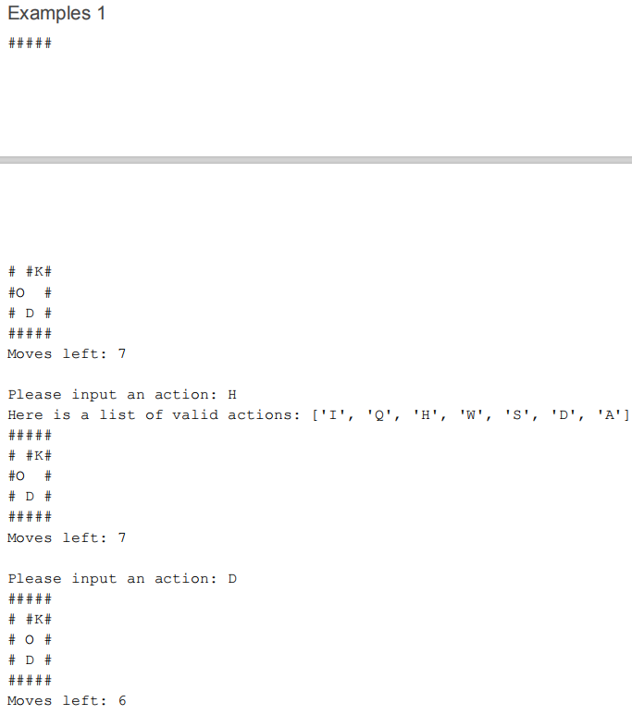
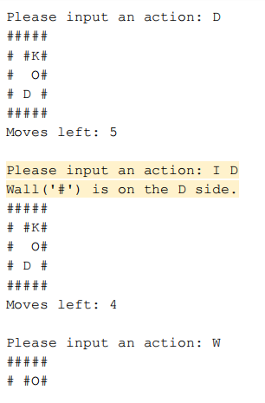
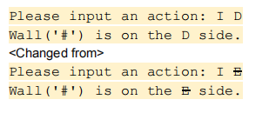

（红色部分有改变，以上图为准）
