DSS
Introduction
This page gives a basic description of DSS (Display SubSystem) hardware, the Linux kernel drivers (tidss) and various TI boards that use DSS. The technical reference manual (TRM) for the SoC in question, and the board documentation give more detailed descriptions.
Supported Devices
There are many DSS IP versions, all of which support slightly different set of features. DSS versions up to 5 are supported by the omapdrm driver, and DSS versions 6 and up are supported by the tidss driver. This document covers DSS6, DSS7-L, and DSS7-UL which are used on the following TI SoCs or SoC families: K2G, AM65x, AM62x, AM62Ax, AM62Px, J721E, J721S2, J784S4.
Hardware Architecture
The Display Subsystem (DSS) is a hardware block responsible for fetching pixel data from memory and sending it to a display peripheral like an LCD panel or an DisplayPort monitor. DSS hardware can be divided into two major parts:
Display Controller (DISPC), which handles fetching the pixel data, doing color conversions, composition, and other pixel manipulation
Peripherals, which encode the raw pixel data to standard display signals, like MIPI DPI or DP.
In addition to the SoC’s DSS, boards often contain external display bridges (for example, DPI-to-HDMI bridge) and display panels.
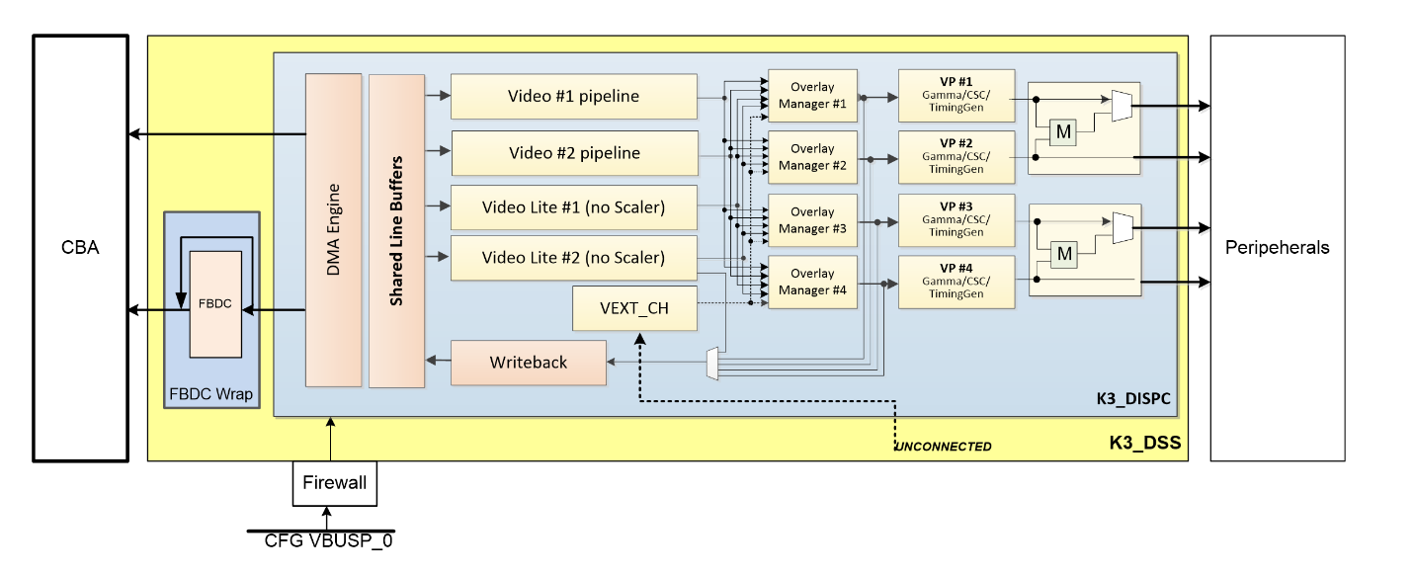
The above image gives an overview of the DSS hardware.
The arrows show how pipelines are connected to overlay managers, which are further connected to video-ports, which finally create an encoded pixel stream for display on the LCD or monitor.
Display Controller (DISPC)
DISPC is the block which is responsible for fetching pixel data from the memory through DMA pipelines, and then create a pixel stream for the peripheral. The pixel stream comprises of a composition of one or more image layers which we finally want to present on the display. DISPC can be split into 3 major sub-blocks:
Pipelines
Overlay Managers (Compositors)
Video Ports (Timing generators)
The next three sub-sections provide details on these sub-blocks.
Pipelines
Pipelines (or DMA channels) consist of the HW block which performs DMA to fetch image pixels (of different color formats) from RAM. Besides performing DMA, pipelines perform other functions like replication, ARGB expansion, scaling, color conversion, VC1 range mapping on the input pixels before it’s passed on to the overlay manager. An overlay manager receives pixel data from one or more such pipelines, and performs the task of composing them and passing it on to the video-port.
There are two types of pipelines: VIDL and VID. The difference between the two is that VID pipelines support scaling, and VIDL does not. The number of pipelines within DSS varies with the DSS IP version used in the SoC.
Overlay Managers (Compositors)
Overlay managers are the blocks which take pixel data from one or more pipelines, layer them to form a composition, and create a pixel stream for the video-ports to consume.
The compositor part takes pixel data from multiple pipelines, composing them on the basis of their position with respect to the complete overlay manager size. Tasks like alpha blending, color-keying and z-order are also performed by the compositor in the overlay manager.
Video Ports (Timing generators)
Video ports take a pixel stream from an overlay manager and encode it into a standard video signal which is understood by the LCD panel/monitor or an internal peripheral (like eDP). These video standards are specified by MIPI or general video/display bodies.
The timing generator part of the video port is responsible for providing the pixel stream generated by the compositor above according to the timings desired by the peripheral. The timing generator is a state machine which provides RGB data along with control signals like pixel clock, hsync, vsync and data enable. This timing info is used by the panel / peripheral to display the composited frame on the screen.
DSS and CRC operations play crucial roles in ensuring data integrity and display accuracy, especially in automotive systems. DSS efficiently manages video data and ensures it is displayed correctly, while CRC operations verify memory integrity, combining DMA and CPU resources to balance performance and reliability. This combination enhances the overall safety and reliability of vehicle electronic systems.
Features need to be considered for MISR [DSS0, DSS1]
- One Video Pipeline (VID)
- One Video Lite Pipeline (VIDL1)
- Two Video Port outputs (VP1 and VP2)
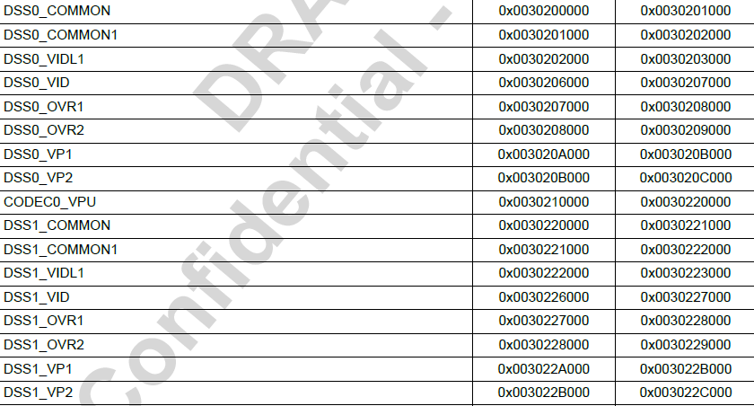
Register base address:
DSS0:
VIDL1, DSS0_VIDL1 Registers, Base Address=3020 2000H, Length=4096
VID, DSS0_VID Registers, Base Address=3020 6000H, Length=4096
VP1, DSS0_VP1 Registers, Base Address=3020 A000H, Length=4096
VP2, DSS0_VP2 Registers, Base Address=3020 B000H, Length=4096
DSS1:
VIDL1, DSS1_VIDL1 Registers, Base Address=3022 2000H, Length=4096
VID, DSS1_VID Registers, Base Address=3022 6000H, Length=4096
VP1, DSS1_VP1 Registers, Base Address=3022 A000H, Length=4096
VP2, DSS1_VP2 Registers, Base Address=3022 B000H, Length=4096
Register to be handled:
DSS_SAFETY_POSITION
DSS_SAFETY_SIZE
DSS_SAFETY_ATTRIBUTES
DSS_SAFETY_LFSR_SEED
DSS_SAFETY_REF_SIGNATURE
DSS_SAFETY_CAPT_SIGNATURE
VIDL1, DSS0_VIDL1 Registers, Base Address=3020 2000H, Length=4096
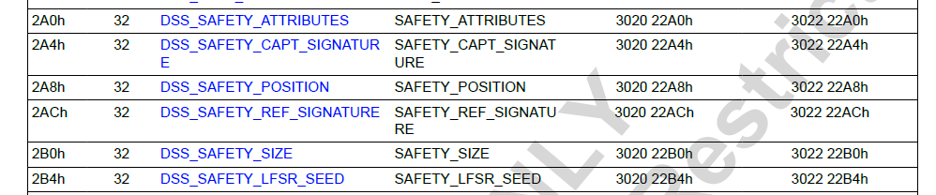
VID, DSS0_VID Registers, Base Address=3020 6000H, Length=4096 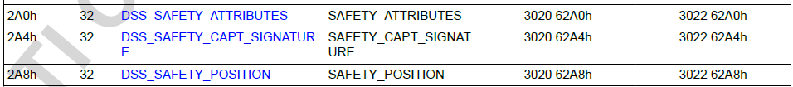 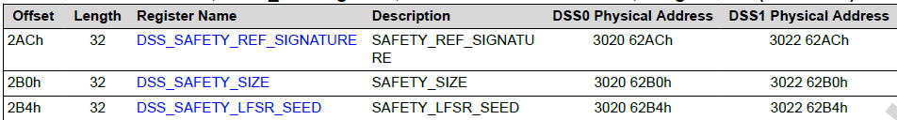
VP1, DSS0_VP1 Registers, Base Address=3020 A000H, Length=4096
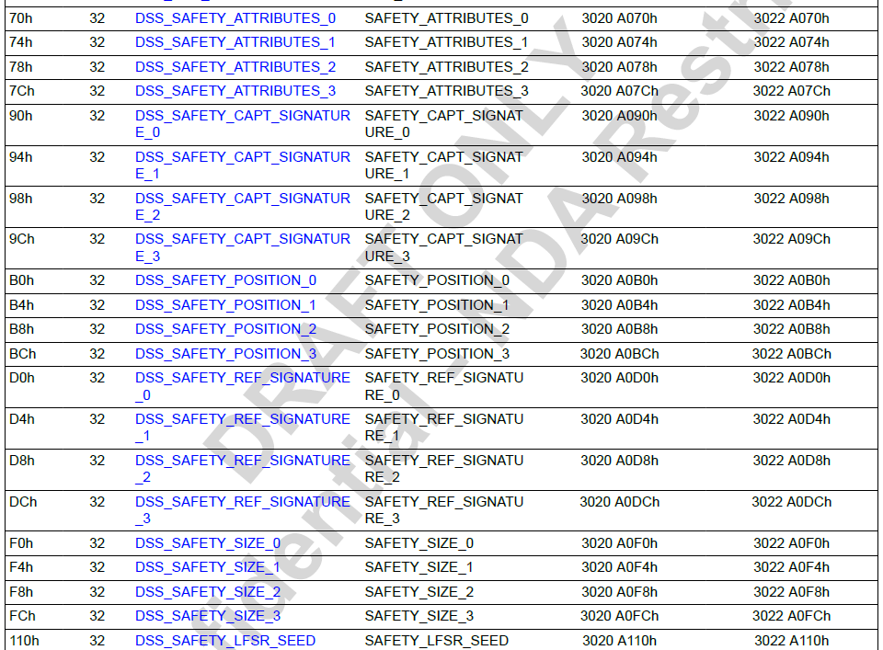
VP2, DSS0_VP2 Registers, Base Address=3020 B000H, Length=4096
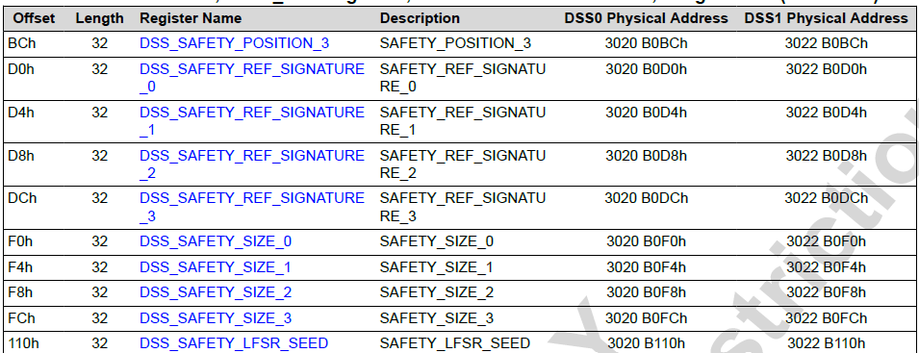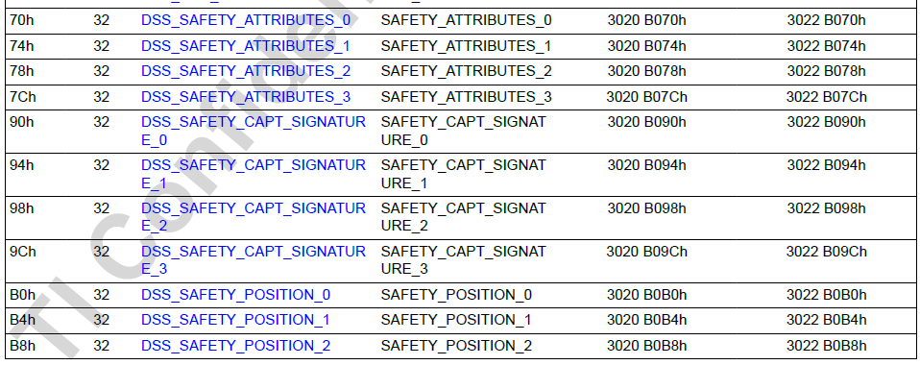
VIDL1, DSS1_VIDL1 Registers, Base Address=3022 2000H, Length=4096
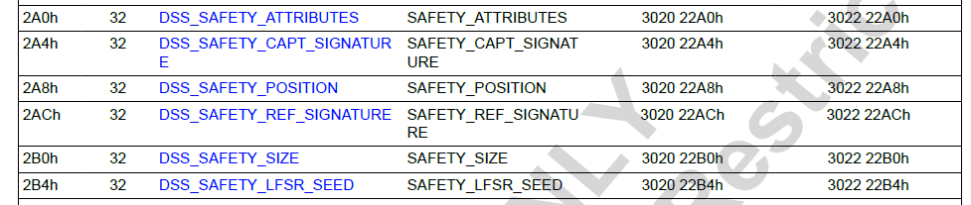
VID, DSS1_VID Registers, Base Address=3022 6000H, Length=4096
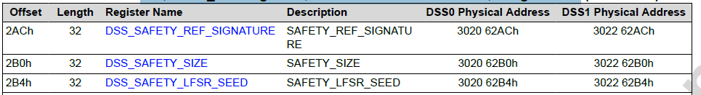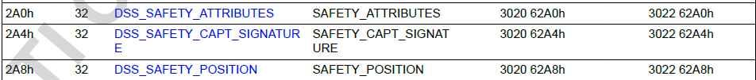
VP1, DSS1_VP1 Registers, Base Address=3022 A000H, Length=4096
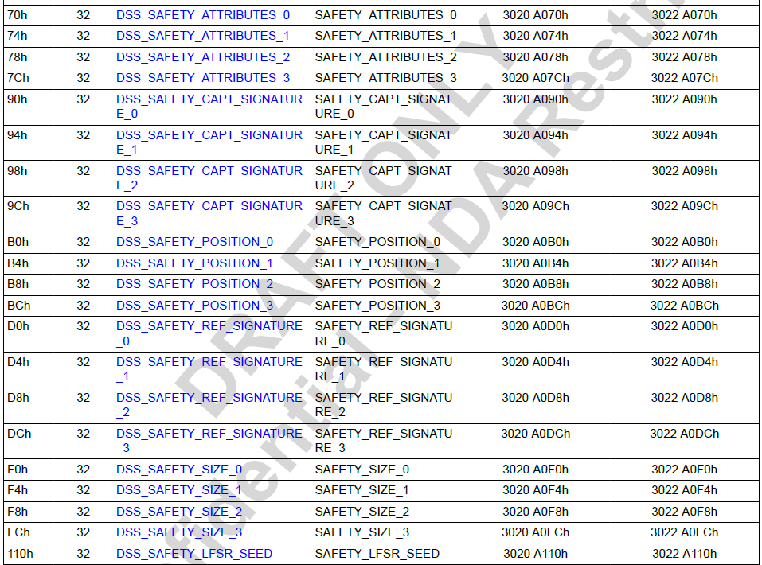
VP2, DSS1_VP2 Registers, Base Address=3022 B000H, Length=4096
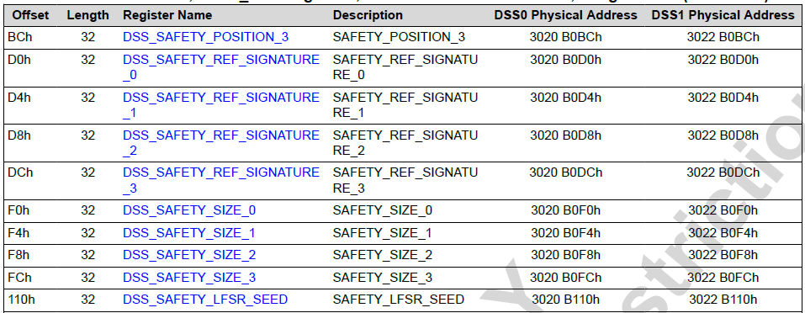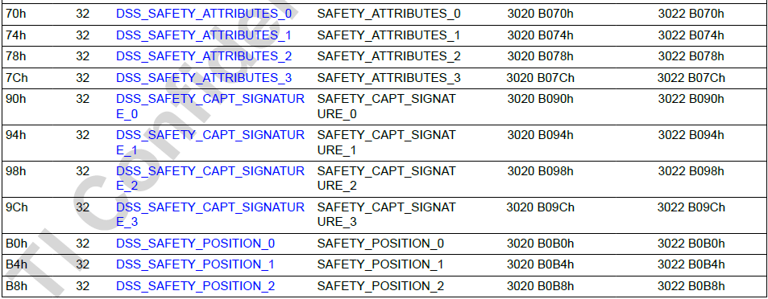
Register to be handled:
DSS_SAFETY_POSITION
DSS_SAFETY_SIZE
DSS_SAFETY_ATTRIBUTES
DSS_SAFETY_LFSR_SEED
DSS_SAFETY_REF_SIGNATURE
DSS_SAFETY_CAPT_SIGNATURE
DSS0:
VIDL1, DSS0_VIDL1 Registers, Base Address=3020 2000H, Length=4096
VID, DSS0_VID Registers, Base Address=3020 6000H, Length=4096
VP1, DSS0_VP1 Registers, Base Address=3020 A000H, Length=4096
VP2, DSS0_VP2 Registers, Base Address=3020 B000H, Length=4096
DSS1:
VIDL1, DSS1_VIDL1 Registers, Base Address=3022 2000H, Length=4096
VID, DSS1_VID Registers, Base Address=3022 6000H, Length=4096
VP1, DSS1_VP1 Registers, Base Address=3022 A000H, Length=4096
VP2, DSS1_VP2 Registers, Base Address=3022 B000H, Length=4096
Register to be handled:
DSS_SAFETY_POSITION
DSS_SAFETY_SIZE
DSS_SAFETY_ATTRIBUTES
DSS_SAFETY_LFSR_SEED
DSS_SAFETY_REF_SIGNATURE
DSS_SAFETY_CAPT_SIGNATURE
Register name | Offset | Description [TI]
DSS_SAFETY_ATTRIBUTES Registers  DSS1_ATTRIBUTES Register (Offset = 2A0h) [reset = 0h ]  In sigunit  [sig_EvalControl] | 2A0h  [DSS_SAFETY_ATTRIBUTES] | Indicates which frames to be skipped while doing FRAMEFREEZE  or DATACHECK [Useful for interlaced displays]. 0x0: No frames are  skipped, 0x1: Even Frames are skipped starting from second frame  after ENABLE, 0x2: Odd Frames are skipped starting from first frame  after ENABLE, 0x3: Reserved  3 | RESERVED | Reserved  2 | ODD | Odd Frames are skipped starting from first frame after  ENABLE  1 | EVEN | Even Frames are skipped starting from second frame  after ENABLE  0 | DISABLE | No frames are skipped
VIDL1_DSS_SAFETY_POSITION Registers  DSS1_POSITION Register (Offset = 2A8h) [reset = 0h ] | 2A8h | Y position of the safety sub-region. Encoded value [from 0 to 4095]  to specify the Y position of the sub-region on the screen. The first  line on the top of the screen has the Y-position 0  X position of the safety sub-region. Encoded value [from 0 to 4095]  to specify the X position of the sub-region on the screen. The first  pixel on the left of the screen has the X-position 0
VIDL1_DSS_SAFETY_SIZE Registers  DSS1_SIZE Register (Offset = 2B0h) [reset = 0h ] | 2B0h | Height of the safety sub-region. Encoded value [from 0 to 4095] to  specify the height of the sub-region on the screen. One line height  region has value of 0  Width of the safety sub-region. Encoded value [from 0 to 4095] to  specify the width of the sub-region on the screen. One pixel wide  region has value of 0
DSS_SAFETY_REF_SIGNATURE Registers  DSS1_REF_SIGNATURE Register (Offset = 2ACh) [reset = 0h ] | 2ACh | The register configures the reference signature of the safety subregion.  Shadow register
DSS_SAFETY_LFSR_SEED Registers  DSS1_LFSR_SEED Register (Offset = 2B4h) [reset = 0h ] | 2B4h | The register configures the seed [initial value] of the MISR. Otherwise, the MISR is initialized  with 0xFFFF_FFFF. Shadow register
VIDL1_DSS_SAFETY_CAPT_SIGNATURE Registers  DSS1_CAPT_SIGNATURE Register (Offset = 2A4h) [reset = 0h ] | 2A4h  [DSS_SAFETY_CAPT_SIGNATUR  E] | The register configures the reference signature of the safety subregion.  Shadow register

