

VMF Trace Framework

1.4

Issue Date: 10 December 2009

J. Becker

Table of Contents

VMF Trace Framework 1
Introduction 3
Purpose 3
Definitions 3
Acronyms 3
References 3
VMF Trace Framework 4
Message Flow 5
VMF-Trace API 6
Macro layer 7
Examples: 8
Trace API and Windows Viewer – “VMF-Tracer” 9
VMF-Trace Severities 10
Predefined VMF Tracer severities 11
Make options 13
VMF-OTF Wrapper 14
Wrapping the OTF severities 14
Arrangement of the VMF-Trace severities: 14
Mapping of OTF severities: 14

Figures

Figure 1 - VMF trace framework 4
Figure 2 - message flow 5
Figure 3 - Macros 7
Figure 4 - Trace API and trace messages shown in the viewer 9
Figure 5 - predefined errors 11
Figure 6 - predefined warnings 11
Figure 7 - predefined info’s 12

Introduction

Purpose
This document discusses the implementation of the VMF-Trace Framework. The VMF Trace Framework is a replacement for the BMW OTF.
The goal is to implement a trace framework that is more efficient less resource hungry than OTF.
A wrapper to the old OTF API will be implemented so that no change in existing code is necessary.

Definitions
Term | Definition
VMF | Visteon Message Framework.
OTF | BMW Trace Framework
BASIC message | This message is send to specific message groups

Acronyms
Acronym | Term

References
The locations identified as Clear Case in the table below are under version control using the specified tool at the time this document was released.

 | Reference | Version | Location

VMF Trace Framework

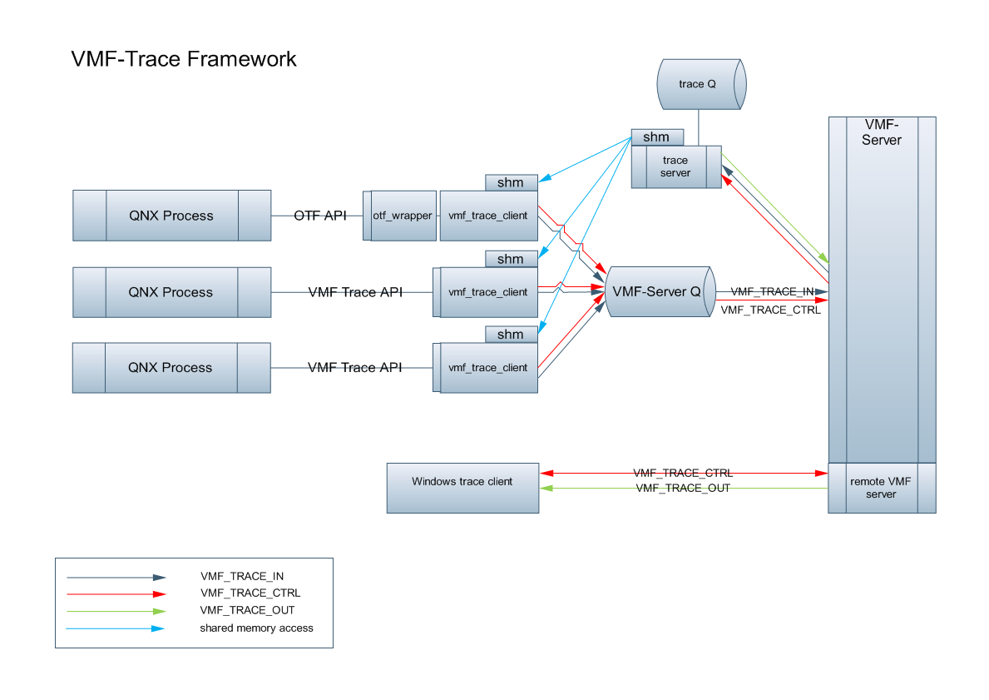
Figure 1 - VMF trace framework

Message Flow

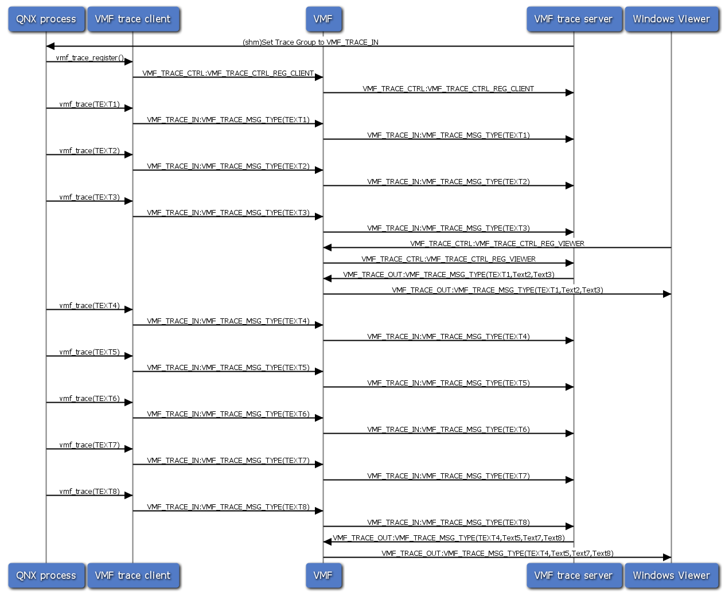

Figure 2 - message flow

Flow of trace messages from QNX process via trace-server to windows client.
Trace messages are collected in the trace-server and forwarded to the client after the buffer is full of after 500ms. This does reduce the load of the ip-stack enormous.

VMF-Trace API

The VMF Trace API consists of a simple set of functions.

All functions are returning a vmf_ret_t. If the return value is not VMF_OK then an error occurred.
All possible return values can be found in nw_vmf_types.h

vmf_ret_t vmf_trace_register(unsigned8 *trid, const char * trid_name);

The function vmf_trace_register is used to register a trace client to the trace server.
The argument *trid is used to return a trace-id signature.
Unique_trid_name is a zero terminated string that identifies this connection – example “nw”
If the function is called multiple times with the same “trid name” the output to this trid will show up in the same tab.

vmf_ret_t vmf_trace (unsigned8 trid,unsigned8 severity,char *task, char *scope,char *message);

The function vmf_trace() can be used to send trace messages to the trace-client.

The first argument is the trid (trace id) that was delivered by the vmf_trace_register() function. Every trid has its own Tab on the viewer.
The second argument is the message severity. The highest severity is 0. A trace message with severity 0 is the highest severity and means an error.
Severities are allowed from 0..127.
The third argument is the trace Task. Every Task has its own Sub-Tab on the Trace client.
An example for a trace Task is “network”

The next Argument is the scope.. The scope can be used to identify the place where the trace message origins.
An example for a trace Scope is “gateway”
The last argument is the trace text (zero terminated). The maximum size of the text is 255 bytes (254 + zero).

vmf_trace_printf (unsigned8 trid,unsigned8 severity,char *task,char *scope,char *format, ... )

The function vmf_trace_printf() is very similar to the vmf_trace() function.
Instead of fixed buffer - variable arguments can be used (like printf()).

vmf_ret_t vmf_trace_hex (unsigned8 trid,unsigned8 severity,char *task, char *scope,unsigned8 len,unsigned8 *data);

The vmf_trace_hex() function can be used to send binary data to the trace client. Instead of a text message a data buffer with a specific length is send to the trace client. The maximum size of the buffer is 65 bytes.

Macro layer

To allow a compilation of target code without any debug functionality a Macro layer was added.
If the make option VMF_TRACE is not set to TRUE the macros are empty!

Every subsystem should use this macros and not the trace functions itself

Macros:

#define VMF_TRACE_REGISTER(a,b) vmf_trace_register(a,b)
#define VMF_TRACE_PRINT(a,b,c,d,e) vmf_trace(a,b,c,d,e)
#define VMF_TRACE_PRINTF(a,b,c,d,e,args...) vmf_trace_printf(a,b,c,d,e,args)
#define VMF_TRACE_HEX(a,b,c,d,e,f) vmf_trace_hex(a,b,c,d,e,f)
Figure 3 - Macros

Examples:

include <nw_vmf_trace.h>

{
vmf_ret_t ret_val;
unsigned8 my_trid;
unsigned8 data[]={0,1,2,3,4,5,6,7,8,9};
unsigned8 my_sev= VMF_TRACE_SEVERITY_INFO;

/* connect to trace server */
ret_val = VMF_TRACE_REGISTER(&my_trid,"test_cli");
if (ret_val < 0)
{
VMF_TRACE_ERROR_PRINT("vmf_trace_register failed - ret=%d\n",ret_val);
}

/* these two messages are displayed in the tab “test1” */
VMF_TRACE_HEX(my_trid, VMF_TRACE_SEV_STD_HEX,"test1","hex",sizeof(data),data);
VMF_TRACE_PRINTF(my_trid, VMF_TRACE_SEV_STD_ERROR,"test1","printf","%s,%d","severity=", my_sev);

/* the following messages is displayed in the tab “test2” */
VMF_TRACE_PRINT(my_trid, VMF_TRACE_SEV_STD_INFO,"test2","vmf_trace"," test message");
}

Remark: instead of using the trace functions - macros where used.
See chapter “Macro layer”

Trace API and Windows Viewer – “VMF-Tracer”

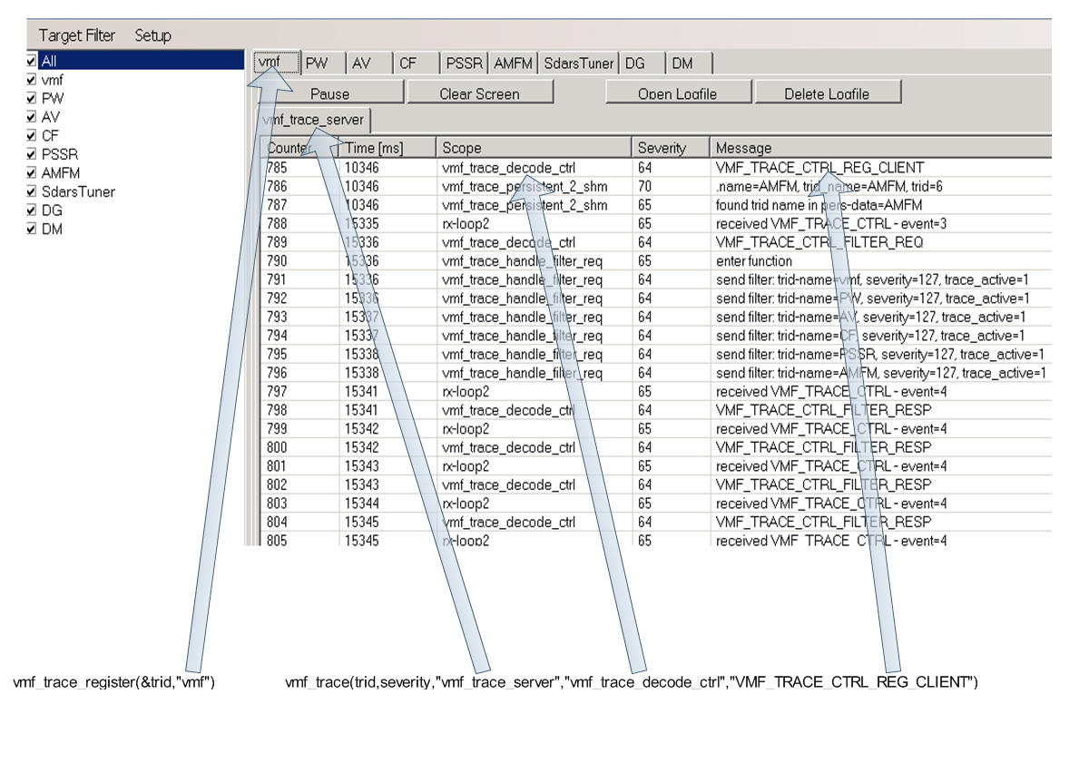
Figure 4 - Trace API and trace messages shown in the viewer

This graphic shows where a parameter of the trace API can be found at the “VMF-Tracer”

vmf_ret_t vmf_trace_register(unsigned8 *trid,char *trid_name);
vmf_ret_t vmf_trace (unsigned8 trid,unsigned8 severity,char *task,char *scope,char *message);

VMF-Trace Severities

VMF Trace does support severities from 0..127.
The highest (most important) severity is 0 == error

The severities are divided into three groups:
errors, warnings and infos.

Ranges
Error: range 0..29
Error messages

Warning: range: 30..59
Warning messages

Info: range: 60..127
Status or information messages.

Predefined VMF Tracer severities

Do prevent the usage of “magic” numbers and to allow the adoptions of severities in the future we added predefined severities.

We added some predefined default severities that should be used!

VMF_TRACE_SEV_STD_ERROR (19)
VMF_TRACE_SEV_STD_WARNING (49)
VMF_TRACE_SEV_STD_INFO (79)
VMF_TRACE_SEV_STD_HEX (80)

List of all predefined severities

enum
{ /* errors */
VMF_TRACE_SEVERITY_ERROR = 0,
VMF_TRACE_SEVERITY_ERROR_1,
VMF_TRACE_SEVERITY_ERROR_2,
VMF_TRACE_SEVERITY_ERROR_3,
VMF_TRACE_SEVERITY_ERROR_4,
VMF_TRACE_SEVERITY_ERROR_5,
VMF_TRACE_SEVERITY_ERROR_6,
VMF_TRACE_SEVERITY_ERROR_7,
VMF_TRACE_SEVERITY_ERROR_8,
VMF_TRACE_SEVERITY_ERROR_9,
VMF_TRACE_SEVERITY_ERROR_10,
VMF_TRACE_SEVERITY_ERROR_11,
VMF_TRACE_SEVERITY_ERROR_12,
VMF_TRACE_SEVERITY_ERROR_13,
VMF_TRACE_SEVERITY_ERROR_14,
VMF_TRACE_SEVERITY_ERROR_15,
VMF_TRACE_SEVERITY_ERROR_16,
VMF_TRACE_SEVERITY_ERROR_17,
VMF_TRACE_SEVERITY_ERROR_18,
VMF_TRACE_SEVERITY_ERROR_19, /* OTF_error */
Figure 5 - predefined errors

The errors 0-5 should be reserved for severe errors that will end a process.
Errors are interesting for everyone and should be reported!

/* warnings */
VMF_TRACE_SEVERITY_WARNING = 30,
VMF_TRACE_SEVERITY_WARNING_1,
VMF_TRACE_SEVERITY_WARNING_2,
VMF_TRACE_SEVERITY_WARNING_3,
VMF_TRACE_SEVERITY_WARNING_4,
VMF_TRACE_SEVERITY_WARNING_5,
VMF_TRACE_SEVERITY_WARNING_6,
VMF_TRACE_SEVERITY_WARNING_7,
VMF_TRACE_SEVERITY_WARNING_8,
VMF_TRACE_SEVERITY_WARNING_9,
VMF_TRACE_SEVERITY_WARNING_10,
VMF_TRACE_SEVERITY_WARNING_11,
VMF_TRACE_SEVERITY_WARNING_12,
VMF_TRACE_SEVERITY_WARNING_13,
VMF_TRACE_SEVERITY_WARNING_14,
VMF_TRACE_SEVERITY_WARNING_15,
VMF_TRACE_SEVERITY_WARNING_16,
VMF_TRACE_SEVERITY_WARNING_17,
VMF_TRACE_SEVERITY_WARNING_18,
VMF_TRACE_SEVERITY_WARNING_19, /* OTF_warning */
Figure 6 - predefined warnings
Warning should be used for non severe problems that the process can recover from.
Warning may be interesting for integration and code owner

/* trace messages */
VMF_TRACE_SEVERITY_INFO = 60,
VMF_TRACE_SEVERITY_INFO_1,
VMF_TRACE_SEVERITY_INFO_2,
VMF_TRACE_SEVERITY_INFO_3,
VMF_TRACE_SEVERITY_INFO_4,
VMF_TRACE_SEVERITY_INFO_5,
VMF_TRACE_SEVERITY_INFO_6,
VMF_TRACE_SEVERITY_INFO_7,
VMF_TRACE_SEVERITY_INFO_8,
VMF_TRACE_SEVERITY_INFO_9,
VMF_TRACE_SEVERITY_INFO_10,
VMF_TRACE_SEVERITY_INFO_11,
VMF_TRACE_SEVERITY_INFO_12,
VMF_TRACE_SEVERITY_INFO_13,
VMF_TRACE_SEVERITY_INFO_14,
VMF_TRACE_SEVERITY_INFO_15,
VMF_TRACE_SEVERITY_INFO_16,
VMF_TRACE_SEVERITY_INFO_17,
VMF_TRACE_SEVERITY_INFO_18,
VMF_TRACE_SEVERITY_INFO_19, /* OTF_trace */
VMF_TRACE_SEVERITY_INFO_20 /* OTF_hex */
}
Figure 7 - predefined info’s

Info’s are just for debug information and are only relevant for the code owner.

The definitions are taken from nw_vmf_trace.h

Make options

To enable the VMF-Trace framework you have to add the make option:
VMF_TRACE=YES

VMF-OTF Wrapper

To simplify the porting of existing code to the new trace API a wrapper was created.
The wrapper will support the following OTF functions.

OTF_trace()
OTF_hex ()
OTF_error()
OTF_warning()
OTF_open()
OTF_close ()
OTF_registerEntry()

The Wrapper is part of the vmf_trace library. To replace OTF it should be sufficient to link against the new lib.

Wrapping the OTF severities

OTF does not support severities as an attribute like the VMF-Trace API.
The severity is given implicit by the used API.
This means that three severities need to be mapped to the 255 severities of VMF-Trace API.

Arrangement of the VMF-Trace severities:
Severity Meaning
0..29 Error messages – 0 = most important
30..59 Warnings
60..127 Trace messages

Mapping of OTF severities:
Severity OTF mapped to VMF-Trace Severity
OTF_error 19
OTF_warning 49
OTF_trace 79
OTF_hex 80

The three severities are mapped to four fixed values: 0, 30, 60 and 61.

Appendix

Sequence Chart Source

participant "QNX process" as Q
participant "VMF trace client" as C
participant VMF
participant "VMF trace server" as S
participant "Windows Viewer" as V

participant "QNX process" as Q
participant "VMF trace client" as C
participant VMF
participant "VMF trace server" as S
participant "Windows Viewer" as V

S->Q: (shm)Set Trace Group to VMF_TRACE_IN

Q->C: vmf_trace_register()
C->VMF: VMF_TRACE_CTRL:VMF_TRACE_CTRL_REG_CLIENT
VMF->S: VMF_TRACE_CTRL:VMF_TRACE_CTRL_REG_CLIENT

Q->C: vmf_trace(TEXT1)
C->VMF: VMF_TRACE_IN:VMF_TRACE_MSG_TYPE(TEXT1)
VMF->S: VMF_TRACE_IN:VMF_TRACE_MSG_TYPE(TEXT1)

Q->C: vmf_trace(TEXT2)
C->VMF: VMF_TRACE_IN:VMF_TRACE_MSG_TYPE(TEXT2)
VMF->S: VMF_TRACE_IN:VMF_TRACE_MSG_TYPE(TEXT2)

Q->C: vmf_trace(TEXT3)
C->VMF: VMF_TRACE_IN:VMF_TRACE_MSG_TYPE(TEXT3)
VMF->S: VMF_TRACE_IN:VMF_TRACE_MSG_TYPE(TEXT3)

V->VMF: VMF_TRACE_CTRL:VMF_TRACE_CTRL_REG_VIEWER
VMF->S: VMF_TRACE_CTRL:VMF_TRACE_CTRL_REG_VIEWER

S->VMF: VMF_TRACE_OUT:VMF_TRACE_MSG_TYPE(TEXT1,Text2,Text3)
VMF->V: VMF_TRACE_OUT:VMF_TRACE_MSG_TYPE(TEXT1,Text2,Text3)

Q->C: vmf_trace(TEXT4)
C->VMF: VMF_TRACE_IN:VMF_TRACE_MSG_TYPE(TEXT4)
VMF->S: VMF_TRACE_IN:VMF_TRACE_MSG_TYPE(TEXT4)

Q->C: vmf_trace(TEXT5)
C->VMF: VMF_TRACE_IN:VMF_TRACE_MSG_TYPE(TEXT5)
VMF->S: VMF_TRACE_IN:VMF_TRACE_MSG_TYPE(TEXT5)

Q->C: vmf_trace(TEXT6)
C->VMF: VMF_TRACE_IN:VMF_TRACE_MSG_TYPE(TEXT6)
VMF->S: VMF_TRACE_IN:VMF_TRACE_MSG_TYPE(TEXT6)

Q->C: vmf_trace(TEXT7)
C->VMF: VMF_TRACE_IN:VMF_TRACE_MSG_TYPE(TEXT7)
VMF->S: VMF_TRACE_IN:VMF_TRACE_MSG_TYPE(TEXT7)

Q->C: vmf_trace(TEXT8)
C->VMF: VMF_TRACE_IN:VMF_TRACE_MSG_TYPE(TEXT8)
VMF->S: VMF_TRACE_IN:VMF_TRACE_MSG_TYPE(TEXT8)

S->VMF: VMF_TRACE_OUT:VMF_TRACE_MSG_TYPE(TEXT4,Text5,Text7,Text8)
VMF->V: VMF_TRACE_OUT:VMF_TRACE_MSG_TYPE(TEXT4,Text5,Text7,Text8)

