

Health Manager Service

User Guide

September 18, 2020



Copyright
This document is property of Visteon Corporation.
The information in this document is confidential!
Copyright © 2020, Visteon. All rights reserved.

Revision
Date | Author(s) | Changes
18-Sept-2020 | Shreya Singh | Initial Version

Reference Document
Document Type | Name
SRS | 543516- Watchdog Proxy Software Requirements Specification

Contents
1. Terminology 1
2. Overview 3
Introduction 3
3. Configuration 4
3.1 Overview 4
3.2 Configurable Items 4
4. HB Miss Low/High 6
4.1.1 Example 6
5. Dependencies 7
6. Watchdog Client Library 8
6.1.1 Overview 8
6.1.2 Connect Function 8
6.1.3 Disconnect Function 9
6.1.4 Start Function 9
6.1.5 Pet Function 10
6.1.6 Pause Function 10
6.1.7 Resume Function 11
6.1.8 Stop Function 11
Appendix A 13
A-1 List of Figures 13
Appendix B 14
B-1 List of Tables 14

Terminology
Acronym / Abbreviation | Description
VIP | Vehicle Interface Processor
GP | Graphical Processor
HAM | High Availability Manager
HB | Heartbeat
SLM | System Launch and Monitor

Overview

Introduction
Watchdog Proxy is a process that subscribes to HAM events and takes appropriate recovery action when the monitored process behaves errantly and notifies the VIP if error condition persists.
Watchdog client is a library which provides APIs to monitor the threads within a process and report the consolidated health status to HAM.
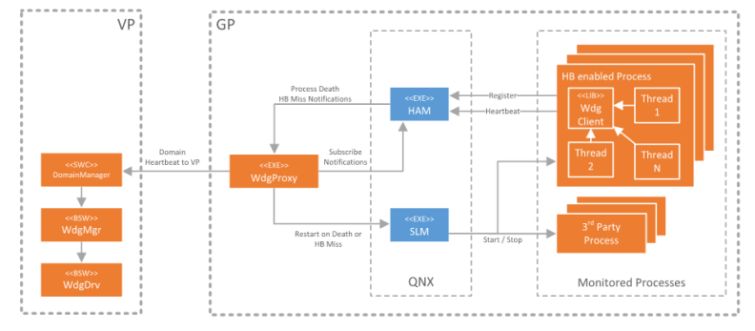
Figure 1 Health Management Concept

Configuration

Overview
The processes being monitored need to be specified in wdg_proxy_cfg.h header file. There is a configuration template wdg_proxy_cfg$.h present under wdg_proxy directory.
A copy of this configuration file shall be placed under a variant specific directory and renamed to wdg_proxy_cfg.h
Example:
${path_to_prebuilt}/prebuilt_xx/usr/include/wdg_proxy_cfg.h for ford_bx755 project.
${PROJECT_BUILD_DIR}/prebuilt_xx/usr/include/wdg_proxy_cfg.h for Honda project.

Configurable Items
1) Watchdog Proxy Dijkstra Component ID - WDG_COMP_ID
2) VMF Message Heartbeat periodicity for the VP in milliseconds - WDG_VMF_MSG_PERIODICITY. Floored internally to 200ms.
3) VMF Group and Event IDs - WDG_VMF_GID, WDG_VMF_HEALTHY_EID and WDG_VMF_FATAL_ERROR_EID
4) The process list and specific recovery actions for the processes.
Process Monitor List shall be specified in following format:
Entity Name | HB Enabled | HB Low Miss Action | HB Low Miss Action | Restart Count

Entity Name: Name of process to be monitored.
HB Enabled: FALSE for processes that does not support process heartbeat monitoring such as drivers and QNX services.
HB Low Miss Action is the expected action to be performed when the watchdog low watermark is missed by the process.
HB High Miss Action is the expected action to be performed when the watchdog high watermark is missed by the process.
Death Action is the expected action to be performed when the process crashes
Restart Count is the number of times the process to be restarted before raising a FATAL error to the VP.
HB Low/High Miss and Death Action can be one of following:
1) None
2) Restart
3) Fatal

Due to an implementation limitation if either HB Low/High Miss actions are set to restart the corresponding death action shall also be set to restart.
Health Manager Components depends on SLM to start and stop processes. So, the processes being monitored by watchdog proxy, mentioned in wdg_proxy_cfg.h, shall be mentioned in SLM configuration file and shall all be started before wdg_proxy starts.
Entity names specified in wdg_proxy_cfg.h shall match the corresponding component name specified in SLM configuration file. Usually component name is the same as the process name and is specified the same by convention but it can be different too and that will still be valid. But for HB enabled processes the entity name, slm component name and the process shall all match.

HB Miss Low/High

HB Miss Low: The number of permissible missed heartbeats before a heartbeat low miss action is triggered and refers to a condition of “low” severity.
HB Miss High: The number of permissible missed heartbeats before a heartbeat high miss action is triggered and refers to a condition of “high” severity.

Example
int32_t connect (const char *pProcessName = __progname,
uint32_t reqTimeoutPeriodMs = 1000U,
int32_t wdgLowMark = 1,
int32_t wdgHighMark = 2);

Here, the connect() connects the process to watchdog for monitoring.
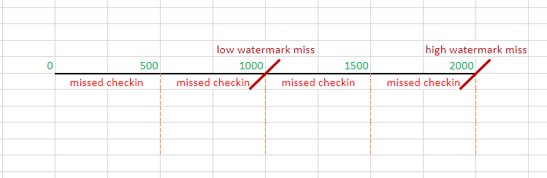
Figure 2 Low and High watermark miss
PeriodicTask() executes 0.5 * every reqTimeoutPeriodMs milliseconds. By default, reqTimeoutPeriodMs is set to 1000ms so, the periodic task will be triggered every 500ms. So, every 500ms it will report missed check-in.
HAM expects heartbeat at interval of reqTimeoutPeriodMs(1000 ms). So, at end of 1000ms, HAM will miss a heartbeat and since value of HB Miss Low is set to 1, HB Miss Low Condition will be triggered (specified in wdg_proxy_cfg.h). HB Miss Low Condition is triggered when HAM has missed number of permissible heartbeats, which is passed as argument wdgLowMark to connect() function.
When the total number of missed heartbeats reaches to wdgHighMark value, HB Miss High Condition will be triggered. In default case value of wdgHighMark is set to 2 so, HB Miss High Condition will be triggered once 2 heartbeats has been missed I.e., after 2000 ms.

Dependencies

ham: wdg_proxy and wdg_client both connects to the HAM process and HAM in turn monitors the registered processes. So, HAM process shall be running before wdg_proxy starts.
dk_logger: wdg_proxy and wdg_client both use the dk_logger library APIs for logging.
vmf: vmf_client library needs to be linked as to send periodic HB and fatal messages over vmf.
mq: To use message queue implementation as required by vmf.

System libraries to link against:
1) mq
2) ham

Dependency libraries to add:
1) vmf_client
2) dk_logger

Watchdog Client Library

Overview
The Watchdog client provides a set of APIs to connect application to health monitoring system and to monitor threads within the process.
APIs provided by wdg_client library are:
- connect
- disconnect
- start
- stop
- pause
- resume
- pet

Connect Function
The connect function connects the process to the watchdog for monitoring. When connect() is called without any arguments then it takes default values as shown below.
The prototype of the function is as follows:
int32_t connect ( const char *pProcessName = __progname,
uint32_t reqTimeoutPeriodMs = 1000U,
int32_t wdgLowMark = 1,
int32_t wdgHighMark = 2 );

Arguments:
pProcessName: Name of the process/entity (default value: base name of program).
reqTimeoutPeriodMs: Requested watchdog petting period. (default value: 1000 milliseconds).
wdgLowMark: Watchdog miss low watermark (default value: 1).
wdgHighMark: Watchdog miss high watermark (default value: 2).

Return:
It returns granted watchdog petting period. By granted, this is minimum petting period any thread in that process can be set to.

Disconnect Function
Disconnects the process from the Watchdog for monitoring. This basically closes the connection to HAM and HAM no longer monitors the process.
The prototype of the function is as follows:
int32_t disconnect ( void );

Arguments:
none
Return:
WDG_OK - Success
WDG_ERR - Failure

Start Function
To start the monitoring of the caller thread. It adds the caller thread into the watchdog thread list which is being monitored. This function shall be invoked from the context of the thread to be monitored.

The prototype of the function is as follows:
int32_t start ( int32_t timeoutMs );

Arguments:
timeoutMs: Watchdog petting period for the thread. It is recommended to have value of timeoutMs in multiple of 500 or precisely half of connect()’s reqTimeoutPeriodMs value.
Return:
WDG_OK - Success
WDG_ERR - Failure

Pet Function
To pet the watchdog for the monitored thread. Shall be invoked from the context of the thread being monitored. If the thread is not petted at the expected interval, HAM will miss the HB.
The prototype of the function is as follows:
int32_t pet ( void );

Arguments:
none
Return:
WDG_OK - Success
WDG_ERR – Failure

Pause Function
To pause the monitoring of the monitored thread. Shall be invoked from the context of the thread being monitored.
The prototype of the function is as follows:
int32_t pause ( void );

Arguments:
none
Return:
WDG_OK - Success
WDG_ERR - Failure

Resume Function
Resumes monitoring of a previously paused thread. Shall be invoked from the context of the thread being monitored.
The prototype of the function is as follows:
int32_t resume ( void );

Arguments:
none
Return:
WDG_OK - Success
WDG_ERR - Failure

Stop Function
Stop monitoring of a monitored thread. Shall be invoked from the context of the thread being monitored.
The prototype of the function is as follows:
int32_t stop ( void );

Arguments:
none
Return:
WDG_OK - Success
WDG_ERR – Failure

- List of Figures

Figure | Description
Figure 1 | Health Management Concept
Figure 2 | Low and High watermark miss

- List of Tables

