

Watchdog proxy configuration (wdg_proxy_cfg.h) Generator

User Guide

December 14, 2023



Copyright
This document is property of Visteon Corporation.
The information in this document is confidential!
Copyright © 2020, Visteon. All rights reserved.

Revision
Date | Author(s) | Changes
14-Dec-2023 | Alleni Sai Siddartha | Initial Version

Contents
1 Overview 1
2 wdg_proxy_cfg_gen Wrokflow 1
3 JSON file generation 1
4 Script generation 1
5 Integration of Script in a project 1
5.1 Variables 1
5.2 Defining Variables 1
5.3 Triggering the script in gp_build 2
6 Script Output

1 Overview
'Wdg_proxy_cfg_gen is a python script that generates wdg_proxy_cfg.h file from wdg_proxy_cfg.json file. The script uses Jinja2 template for generating the header file. The wdg_proxy_cfg.json file is verified by schema defined in wdg_proxy_cfg_gen.

2 wdg_proxy_cfg_gen Workflow
‘wdg_proxy_cfg_gen’ has three files.
- Gen.py
- Schema.json
- Tmpl.j2
Gen.py has the python script for validation of wdg_proxy_cfg.json and generating of wdg_proxy_cfg.h header file. Schema.json contains the schema to validate the wdg_proxy_cfg.json file. Tmpl.j2 has the template to generate the header file.
On triggering the script, wdg_proxy_cfg.json file is parsed and validated using schema.json as schema. On successful validation, the data from the .json file is rendered using Jinja2 with tmpl.j2 as the template. The rendered output is then written to wdg_proxy_cfg.h.
In case of validation failure, a error message is produced by the script accordingly.

3 JSON file generation
In case there is a need to create wdg_proxy_cfg.json file from scratch, use slm_cfg_analyze tool to generate wdg_proxy_cfg.json file. The output file has all the components defined inside slm files and needs to be edited to fit the existing wdg_proxy_cfg. For further information on how to use this tool please refer here.

4 Script Usage
The script takes two arguments. First, the path to the wdg_proxy_cfg.json file and second, the destination path of the header file.
python3 gen.py <path to wdg_proxy_cfg.json> <destination path of the wdg_proxy_cfg.h>

5 Integration of Script in a project

5.1 Variables
DK_HEALTH_CFG_GEN_INPUT | File path variable to wdg_proxy_cfg.json file
DK_HEALTH_CFG_GEN | Option to enable or disable wdg_proxy_cfg_gen

5.2 Defining Variables
The variables are defined in `gp_program.cmake` as shown below.
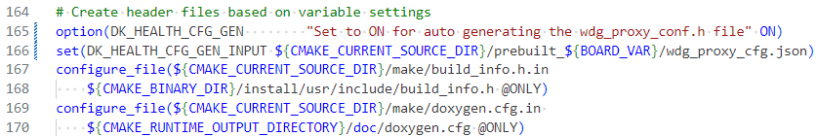

5.3 Triggering the script in gp_build
The below code snipped is added to wdg_proxy.cmake to trigger the script when wdg_proxy is built. This step can be enabled or disabled by configuring DK_HEALTH_CFG_GEN
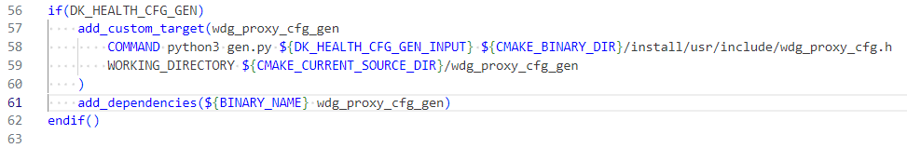

6 Script Output
