Visteon Platform
Technical Reference Manual
Abstract
Platform Technical Reference Manual

Table of Contents
Table of Contents 1
1 AUTOSAR GUIDELINES 6
1.1 INTRODUCTION 6
1.2 BSW GUIDELINES 6
1.2.1 List of BSW Modules 7
1.2.2 IMPLEMENTATION GUIDELINES 11
1.3 CDD GUIDELINES 12
1.3.1 OVERVIEW 12
1.3.2 IMPLEMENTATION GUIDELINES 12
2 BACKUP RAM MANAGER (BURAM) 14
2.1 INTRODUCTION 14
2.2 ARCHITECTURE OVERVIEW 14
2.3 FUNCTIONAL DESCRIPTION 14
2.4 API DESCRIPTION 14
2.5 INTEGRATION GUIDELINES 14
2.6 CONFIGURATION OVERVIEW 14
2.7 CONTACT 14
3 ECU APPLICATION MANAGER (EcuAppM) 15
3.1 INTRODUCTION 15
3.2 ARCHITECTURE OVERVIEW 15
3.3 FUNCTIONAL DESCRIPTION 15
3.3.1 SUPPORTED FUNCTIONALITIES 15
3.3.2 ECUAPPM GROUPS CONTAINERS AND ITS PROPERTIES 16
3.3.3 ECUAPPM GROUPS PROPERTIES 16
3.3.4 ECUAPPM COMPONENT CONTAINERS 18
3.3.5 ECUAPPM STATE MACHINE 19
3.3.5.1 EcuAppM_InitState 20
3.3.5.2 EcuAppM_StartRunState 20
3.3.5.3 EcuAppM_PreGroupActivationState 20
3.3.5.4 EcuAppM_WakeupValidationState 20
3.3.5.5 EcuAppM_StartPowerUpSequenceState 20
3.3.5.6 EcuAppM_ReadDataState 20
3.3.5.7 EcuAppM_GroupsMgmtState 20
3.3.5.8 EcuAppM_BackupDataState 21
3.3.5.9 EcuAppM_StartPowerDownSequenceState 21
3.3.5.10 EcuAppM_PreGroupDeactivationState 21
3.3.5.11 EcuAppM_SleepTransientState 21
3.3.5.12 EcuAppM_PrepareForSleepState 21
3.3.5.13 EcuAppM_SleepState 21
3.4 API DESCRIPTION 22
3.5 INTEGRATION GUIDELINES 23
3.5.1 ECUAPPM COMPONENT FILE’S STRUCTURE 23
3.5.2 OVERVIEW OF ECUAPPM STATE MACHINE 24
3.5.3 OVERVIEW OF ECUAPPM 24
3.5.4 OVERVIEW OF ECUAPPMEXT 28
3.5.5 OVERVIEW OF ECUAPPMCMD PROCESSING 35
3.5.6 OVERVIEW OF ECUAPPM ERROR HANDLER 35
3.6 CONFIGURATION OVERVIEW 35
3.6.1 USAGE OF CONFIGURATION XML 36
3.7 CONTACT 38
4 ECU POWER MANAGER (EcuPowerM) 39
4.1 INTRODUCTION 39
4.2 ARCHITECTURE OVERVIEW 39
4.3 FUNCTIONAL DESCRIPTION 40
4.3.1 DEVICE 40
4.3.2 SEQUENCE 40
4.3.3 JOB 40
4.3.4 COMMAND 41
4.3.5 CHANNEL 41
4.4 API DESCRIPTION 42
4.5 INTEGRATION GUIDELINES 43
4.6 CONFIGURATION OVERVIEW 43
4.7 CONTACT 43
5 ECU WAKEUP MANAGER (EcuWakeupM) 44
5.1 INTRODUCTION 44
5.2 ARCHITECTURE OVERVIEW 44
5.3 FUNCTIONAL DESCRIPTION 45
5.3.1 WAKEUP MANAGER SERVICES 45
5.4 API DESCRIPTION 46
5.5 INTEGRATION GUIDELINES 48
5.6 CONFIGURATION OVERVIEW 49
5.7 CONTACT 49
6 FIT MANAGER (CDD_FitManager) 50
6.1 INTRODUCTION 50
6.2 ARCHITECTURE OVERVIEW 50
6.3 FUNCTIONAL DESCRIPTION 51
6.4 API DESCRIPTION 53
6.5 MODULE ID 54
6.6 INTEGRATION GUIDELINES 54
6.7 CONFIGURATION OVERVIEW 55
6.8 CONTACT 57
7 LOW POWER MANAGER (lPowerM) 58
7.1 INTRODUCTION 58
7.2 ARCHITECTURE OVERVIEW 58
7.3 FUNCTIONAL DESCRIPTION 59
7.4 API DESCRIPTION 61
7.5 INTEGRATION GUIDELINES 61
7.6 CONFIGURATION OVERVIEW 61
7.7 CONTACT 61
8 Visteon Platform Configurator (vConfigurator) 62
8.1 INTRODUCTION 62
8.2 ARCHITECTURE OVERVIEW 62
8.3 FUNCTIONAL DESCRIPTION 62
8.4 API DESCRIPTION 63
8.5 INTEGRATION GUIDELINES 63
8.6 CONFIGURATION OVERVIEW 63
8.7 CONTACT 63

Document Revision History

Date | Version | Description | Author
01.12.2023 | V1.0 | Initial version | Sevana, Kiran kumar (K.)

Reference Documents

Sno | Source | Document Tittle | Document Version
1 | AUTOSAR | AUTOSAR_SRS_BSWGeneral | R22-11
2 | AUTOSAR | AUTOSAR_TR_BSWModuleList | R20-11
3 | AUTOSAR | AUTOSAR_EXP_CDDDesignAndIntegrationGuideline | R22-11
4 | AUTOSAR | AUTOSAR_EXP_LayeredSoftwareArchitecture | R22-11

AUTOSAR GUIDELINES

INTRODUCTION
This section contains quick references to an Autosar guidelines for developing Complex device drivers (CDD) and Basic software components (BSW).

BSW GUIDELINES
This section describes general information on BSW implementation structure. Its strongly recommended to go through the reference document [1] for complete BSW guidelines.

List of BSW Modules
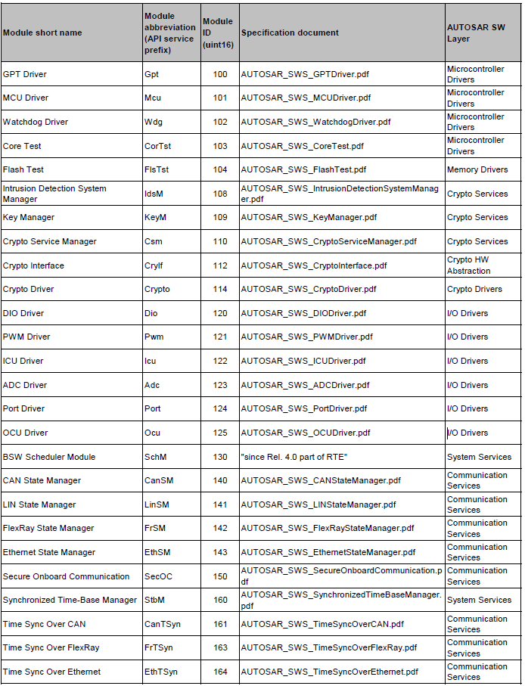
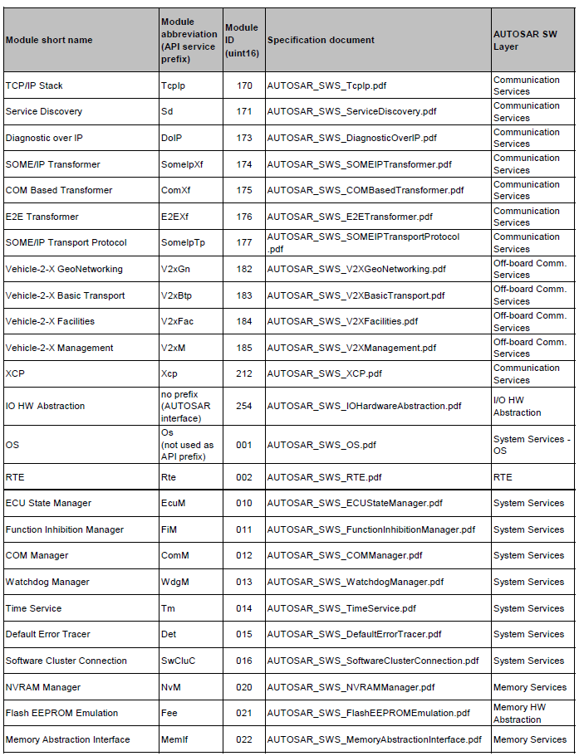

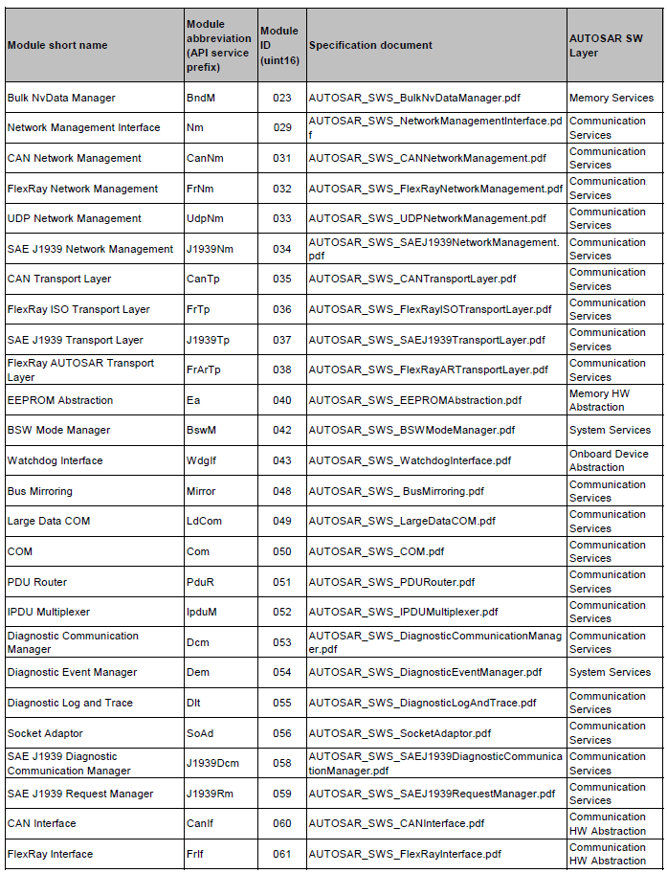

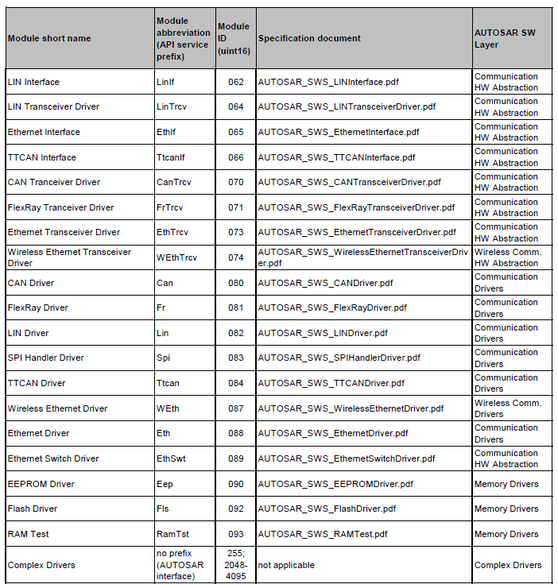
Table 1.0 BSW Modules List

IMPLEMENTATION GUIDELINES
The section provides references to some of the important BSW guidelines as a quick reference. For a detailed list of guidelines please refer document [1]
Naming Conventions
All AUTOSAR Basic Software Modules shall be identified by an unambiguous name.
The module name is always part of related files. Convention for module related files:
<Module name>_*. *
Spelling of module name: First letter of each word upper case, consecutive letters lower case. Module name: 2.8 letters, derived from Table 1.0

Naming convention for type, macro and function’s
All AUTOSAR Basic Software Modules shall label enumeration literals and macro’s
according to the following scheme: <Module Abbreviation>_<Specific name>
<Module Abbreviation> shall be written in UPPERCASE.
<Specific name> shall be written in UPPERCASE.
<Module Abbreviation> and <Specific name> shall be separated by underscore.
If <Specific name> consists of several words, they shall be separated by underscore.

CDD GUIDELINES

This section describes general information on CDD implementation structure. However, its recommended to go through the reference document [3] for complete CDD guidelines.

OVERVIEW
A Complex Driver is a software entity not standardized by AUTOSAR that can access or be accessed via AUTOSAR Interfaces and/or Basic Software Modules APIs. The main goal of the CDD is to implement complex sensor evaluation and actuator control with direct access to the microcontroller using specific interrupts and/or complex microcontroller peripherals, external devices (communication transceivers, ASIC...) to fulfill the special functional and timing requirements.
In addition, it might be used to implement enhanced services / protocols or encapsulates legacy functionality of a non-AUTOSAR system. CDD Implementation might be application, Microcontroller and ECU dependent.
Finally, the CDD can serve as mechanism of migration to introduce existing or new concepts into the AUTOSAR Software Architecture.

IMPLEMENTATION GUIDELINES

The code file structure of the CDD module is not fixed by Autosar. However at least, a CDD_<MODULENAME>.c shall be provided.
Interrupt functions may be placed in a CDD_<MODULENAME>_Irq.c.
Callout functions may be placed in CDD_<MODULENAME>_Callout.c.
Depending on the need, C objects generated at Link time from configuration may be
placed in CDD_<MODULENAME>_Lcfg.c file. If C objects generated at Post Build time from configuration may be placed in CDD_<MODULENAME>_PBcfg.c file.
If an implementation of the CDD module requires additional code files, it is free to
include them.

CDD module shall provide a header file structure, so that users of the CDD module
needs only to include the CDD_<MODULENAME>.h file. CDD module may provide a CDD_<MODULENAME>_Cbk.h header file if some callback functions must be handled by other BSW modules. Depending on the need, C objects declarations generated from configuration may be placed in,
CDD_<MODULENAME>_Cfg.h, CDD_<MODULENAME>_PBcfg.h,
CDD_<MODULENAME>_Lcfg.h files.

If an implementation of the CDD module requires additional header files, it is free to
include them. The header files are self-contained, that means they will include all other
header files which are required by them.
CDD module may include Det.h and/or Dem.h header files to report errors.
CDD module may include <Mip>_MemMap.h header file if some memory mapping
area must be defined where <Mip> is the Module Implementation Prefix.
CDD module may include Rte_CDD_<MODULENAME>.h header file if interfaces to
the Rte are configured.

CDD recommended file structure
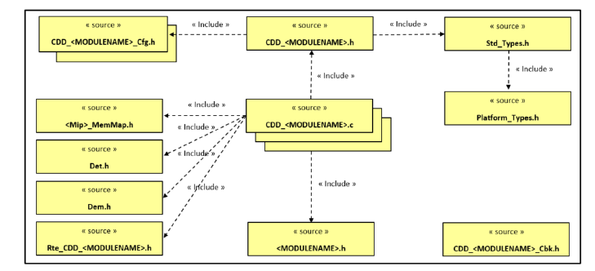
Fig 1.0 File structure of CDD

BACKUP RAM MANAGER (BURAM)

INTRODUCTION

ARCHITECTURE OVERVIEW

FUNCTIONAL DESCRIPTION

API DESCRIPTION

INTEGRATION GUIDELINES

CONFIGURATION OVERVIEW

CONTACT

ECU APPLICATION MANAGER (EcuAppM)

INTRODUCTION
The name “EcuAppM” refers “Ecu Application manager”. A generic manager who manages the sequence of prerequisite functionalities required to run the applications in an ECU. This component manages life cycle of an ECU application starting from powerup sequence, activating application components, and performing shutdown activities. This manager is independent of underlying hardware and the type of the application it is managing.

ARCHITECTURE OVERVIEW
Below figure shows where the EcuAppM component will fall into Autosar architecture.

System Services
Memory services
Communication services
Diagnostic services

Hardware abstraction layer
MCAL abstraction layer
Complex drivers
I/O HW abstraction layer
I/O drivers
Application Layer
Runtime Environment
Microcontroller
EcuM
BswM
ComM
WdgM
EcuAppMM

Fig 3.0 Autosar architecture overview of EcuAppM

FUNCTIONAL DESCRIPTION

SUPPORTED FUNCTIONALITIES
EcuAppM supports below functionalities.
- Validation of the Wakeup’s.
- Triggers powerup and power down sequences.
- Triggers NVM read all sequences.
- Responsible for spawning Power manager and system control applications.
- Activation and deactivation of application components.
- Backing up the application data.
- Supports partial wakeup strategies.

ECUAPPM GROUPS CONTAINERS AND ITS PROPERTIES

EcuAppM manages life cycle of components using “Group Containers”. Each Group container can further contain multiple component Containers. A Component refers to an either SWC’s or CDD’s or any application entity.
A component container will have a data object and/or methods required to manage the respective component.
EcuAppM offers great degree of flexibility in configuring the behavior of “Group containers”. This makes it possible to use this component across programs and can be scalable for future needs.
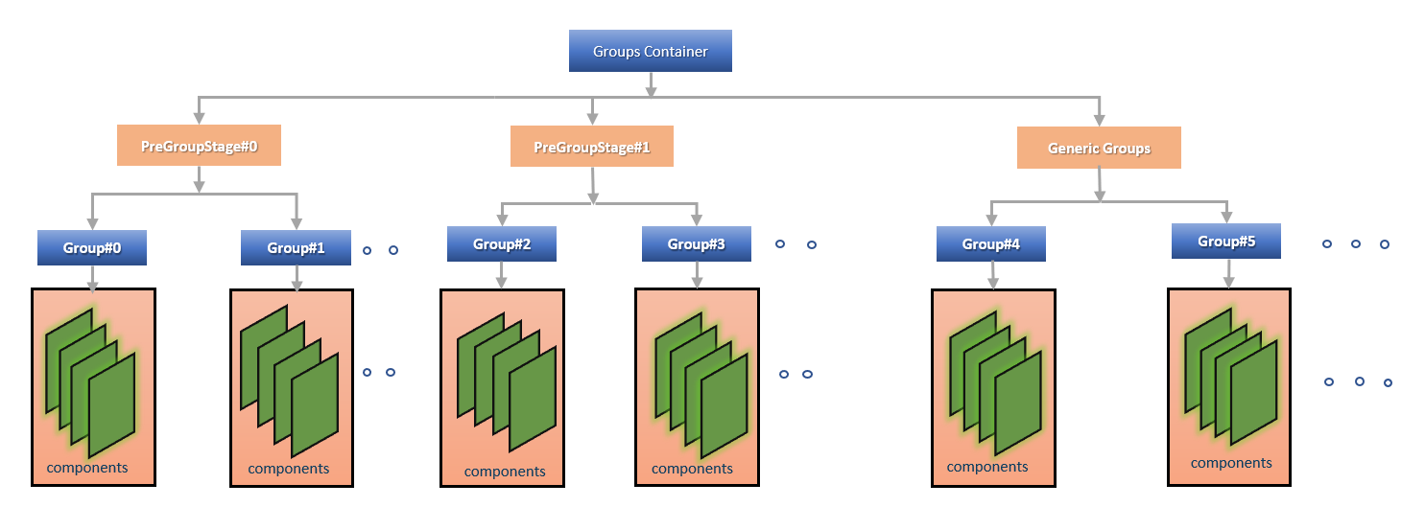
Fig 3.1 Pictorial Representation of EcuAppM Group Container

ECUAPPM GROUPS PROPERTIES

PreGroupStage#0 and PreGroupStage#1 are special stages.
PreGroupStage#0 container will be activated before powering switched supplies and it is meant for activating “Power manager” related components. We can configure multiple groups in this stage based on program needs as shown in the figure [3.1].
PreGroupStage#1 container will be activated in parallel to NVM read all and it is meant for activating “system control” related components like Sleep Wakeup Manager, ComMExt etc. Those components which controls Network and application sleep status. We can configure multiple groups in this stage based on program needs as shown in the figure [3.1].

Generic Groups are the ones they can be used for life cycle management of CDD’s, SWC’s etc.
Following are the currently supported list of Group properties
- Wakeup source mask
- Activation phase
- Deactivation type
- Fail safe mechanism
Wakeup source mask: -
All groups can be subscribed for configured wakeup sources for which group/groups will be activated. This type of configuration allows for efficient partial wakeup strategies like RTC wakeups and MEET mode implementations.
Activation Phase: -
A group “Activation phase” determines which stage the components under particular group will be activated. Following are the list of phases “PRE_GROUP0”, “PRE_GROUP1” and “GENERIC_GROUP” supported. The configuration helps to activate any generic group container in pre group stages. However, the deactivation will remain happens in “GENERIC_GROUP” stage.
Please don’t not change the “PRE_GROUP0” and “PRE_GROUP1” activation phases.

ASYNCHRONUS type groups will be activated in parallel example Group#2, Group#3 etc. will be activated simultaneously.

Inactive
Init
Activation
Active
Deactivation
Group#0
Group#1
Group#2
Group#3
Group#4
Group#5

Fig 3.2 Pictorial Representation of Asynchronous Group Container

SYNCHRONUS groups will be activated in sequential manner example after Group#2 activation confirmation Group#3 will be activated.
Inactive
Init
Activation
Active
Deactivation
Group#0
Group#1
Group#2
Group#3
Group#4
Group#5

Fig 3.3 Pictorial Representation of synchronous Group Container
All groups should fallow either SYNCHRONUS or ASYNCHRONUS only. This is not per group property user should remember this.
Deactivation Type: -
A group “Deactivation Type” can be configured as “SHUTDOWN” or “KEEP ALIVE”. A group will be allowed to deactivate only when its configured as “SHUTDOWN”. A KEEP ALIVE group will never be deactivated.
Failsafe Mechanism: -
A maximum failsafe timer can be configured to ensure that a particular group will be activated within that time after this time a “Failsafe action callout” will be triggered. Users can act based on program’s requirement.

ECUAPPM COMPONENT CONTAINERS
Component Container contains a data member to hold the status, Life cycle API method, status notify API method.
EcuAppM just uses “Life cycle API” to manage life cycle of the components and reads the component status from status notification API if configured.
Activation of a component is independent of its activation library and location.
EcuAppM can manage the life cycle of GIP components. Life cycle API needs to be configured with RTE write calls which can trigger UCL messages and status notify API’s can be configured with RTE read calls which reads the stats received from UCL messages.

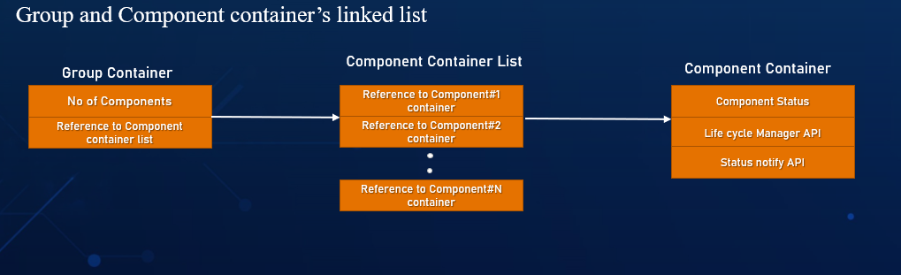
Fig 3.4 ECUAPPM Group and Component Container Structure.

ECUAPPM STATE MACHINE
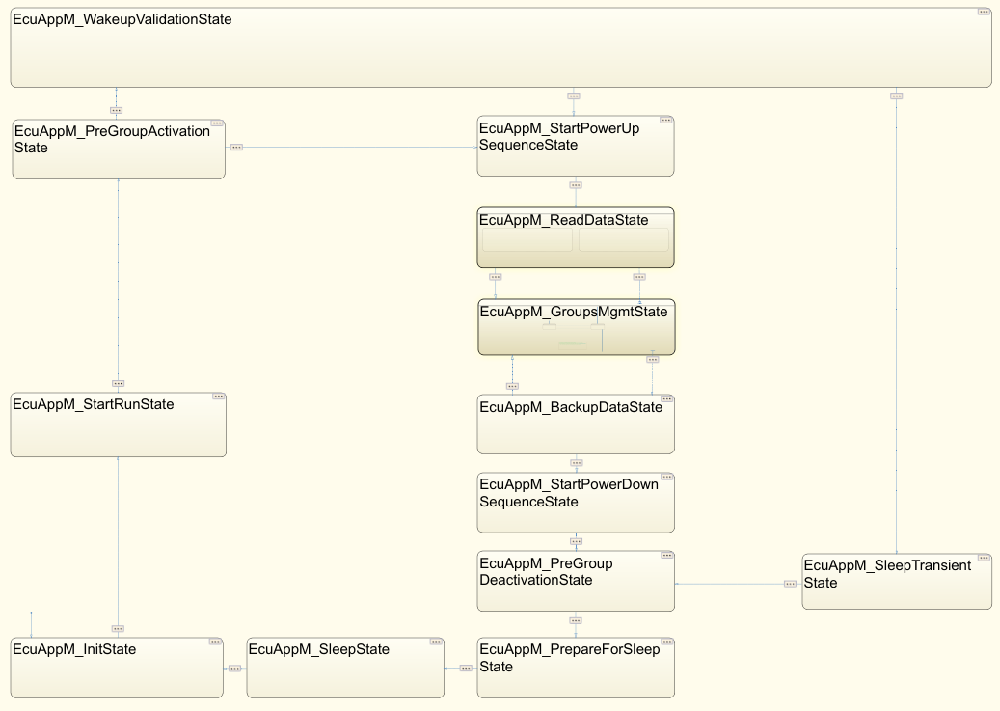
Fig 3.5 State Machine of EcuAppM

EcuAppM_InitState
EcuAppM_InitState is the default state of the EcuAppM State Machine.

EcuAppM_StartRunState
EcuAppM_StartRunState is responsible for powering up the wakeup sources if any and requests RUN(EcuM_RequestRUN) mode for EcuM BSW service component.

EcuAppM_PreGroupActivationState
As the name indicates the components which is responsible for powering switched supplies (Basic power up) example power manager and doesn’t depends on NVM can be activated in this group.

EcuAppM_WakeupValidationState
Any wakeup if it’s configured for Validation, the EcuAppM manager transition to this state and wait for the configured validation time. EcuAppM manager is not responsible for validation algorithm.

EcuAppM_StartPowerUpSequenceState
EcuAppM_StartPowerUpSequenceState is responsible for spanning the power up sequence request to the power CDD.

EcuAppM_ReadDataState
EcuAppM_ReadDataState is responsible for requesting NVM Read all and in parallel with activation of Pre group stage#1 components activation.

EcuAppM_GroupsMgmtState
EcuAppM_GroupsMgmtState is responsible for activation and deactivation of generic groups.
Intern this is state having the two states.
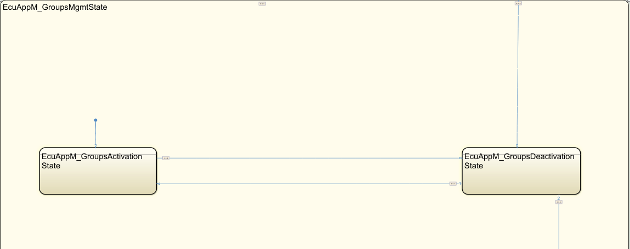
Fig 3.6 EcuAppM Generic groups activation and deactivation states

EcuAppM_GroupsActivationState: -
EcuAppM_GroupsActivationState responsible for activation of generic groups. Based on the sleep request from the application control will jump to EcuAppM_GroupsDeactivationState as shown in the figure [3.7].
EcuAppM_GroupsDeactivationState: -
EcuAppM_GroupsDeactivationState is responsible for deactivation of generic groups. Based on the Early wakeup request control will jump to EcuAppM_GroupsActivationState as shown in the figure [3.7].

EcuAppM_BackupDataState
EcuAppM_BackupDataState is responsible for requesting backing up the data (pushing backup RAM data into NVM).

EcuAppM_StartPowerDownSequenceState
EcuAppM_StartPowerDownSequenceState is responsible for spanning the power down sequence request to the power CDD.

EcuAppM_PreGroupDeactivationState
EcuAppM_PreGroupDeactivationState is responsible for deactivation of Pre group stage#0 groups and Pre group stage#1 groups.

EcuAppM_SleepTransientState
EcuAppM_SleepTransientState is responsible for

EcuAppM_PrepareForSleepState
EcuAppM_PrepareForSleepState is responsible for

EcuAppM_SleepState
EcuAppM_SleepState is responsible for requesting the EcuM_ReleaseRUN.

API DESCRIPTION
EcuAppM module required below input and output api’s as show in below diagram
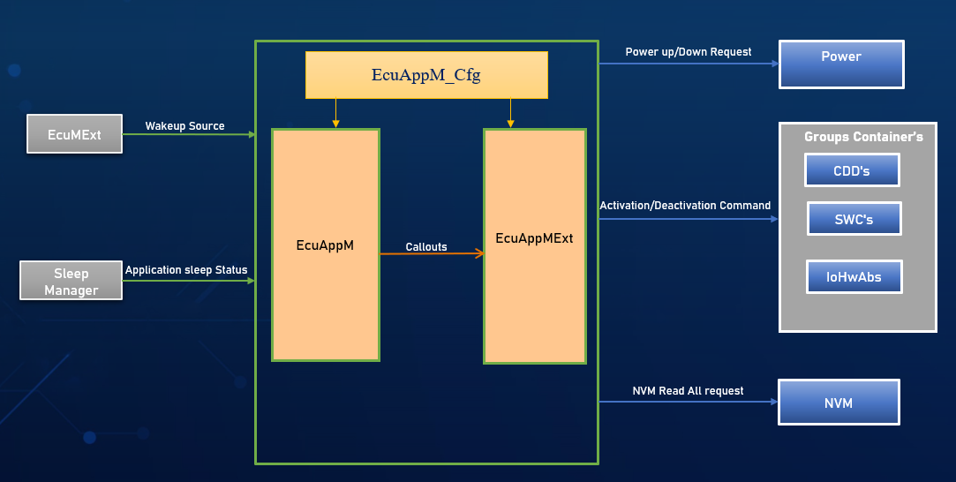
Fig 3.7 EcuAppM interfaces
Wakeup Source api: - Wakeup event should come from EcuMExt, if Wakeup Manger is component Is there in that case it will be coming from WakeupM component.

Application sleep status api: - This one should come from application. Form which component can be decided by user of respective program. Whether it is sleep manager or some other component.

Power up/down request api: - This api should send from extension component respective call outs to power cdd to request power up/down. How to send the api or from which call out you need to send this is there in extension component explanation upcoming section [3.5.4].

Activation/Deactivation command: - These apis of cdds, swc’s, iohwabs should add as components while configuring groups components and its properties.

NVM Read all request: -This api should send from extension component of respective call outs to read the NVM. How to send the api or from which call out you need to send this is there in extension component explanation upcoming section [3.5.4].

It is user responsibility to raise a HLD request before integrating this component.
Along with this if anything required according to the program’s requirement need to analyze by user.

MODULE ID
ECUAPPM_MODULE_ID - 4000

INTEGRATION GUIDELINES

ECUAPPM COMPONENT FILE’S STRUCTURE
EcuAppM component consist of below component structure. Regarding each one in detail explanation fallows below sections.
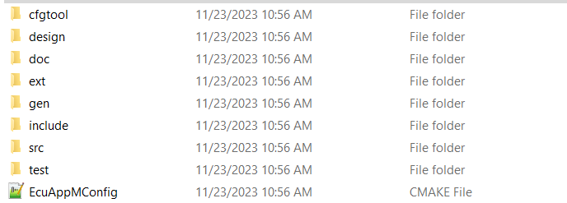
Fig 3.7 EcuAppM Component Files Structure

cfgtoolfolder: -
cfgtool folder consist of xml configuration file and tool which should use to configuring the groups as per the respective program needs.
designfolder: -
design folder consists of EcuAppM MATLAB design files. Which will consist of EcuAppM State Machine.
docfolder: -
doc folder consists of user guide manual (TRM) document and presentation of EcuAppM Component. Which will help you understand complete EcuAppM Component.
extfolder: -
This folder consists of extension component of EcuAppM which should be updated according to the respective program. And should be present program specific path. In detail explanation of EcuAppMExt will be discussed further sections.
genfolder: -
This folder contains cfg files which will be generated from VcoreConfigurator tool. Files having the details of groups configuration and its properties. this folder should present in the respective program specific folder.
Includefolder: -
This folder contains header files which is necessary for EcuAppM Module.
srcfolder: -
This folder consists of EcuAppM, EcuAppM_CmdProcessing, EcuAppM_Errorhandler and EcuAppM_StateMachine files. In detail explanation of each file will be discussed in upcoming sections.
testfolder: -
Test folder contains MATLAB simulation test report of EcuAppM State Machine and different use cases of timing report of EcuAppM module.

OVERVIEW OF ECUAPPM STATEMACHINE
EcuAppM state machine file having the core logic of state machine which we discussed in section [3.3.5].
This is the core logic of EcuAppM module. It is independent of which kind of application you are handling and independent of underlaying hardware. So, this logic will not vary between programs and ECU’S. Below are the files that are having the core logic of EcuAppM State Machine, and these files are generated from MATLAB design.
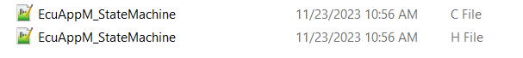
Fig 3.8 EcuAppM State Mahine Files
NOTE: - This logic will not vary between programs. So, when you are integrating should not modify files shown in fig [3.8].

OVERVIEW OF ECUAPPM
EcuAppM file specially designed to handle the interfaces of EcuAppM module. Below are the functions used to get, set, and clear the values from the interfaces.
FUNC (uint8, ECUAPPM_CODE) EcuAppM_GetApplicationSleepStatus(void)
The above function is used to get the application sleep status.
FUNC (uint32, ECUAPPM_CODE) EcuAppM_GetWakeupEventStatus(void)
The above function is used to get wakeup event details.
FUNC (uint32, ECUAPPM_CODE) EcuAppM_GetWakeupSources(void)
The above function is used to get the wakeup source details.
FUNC (void, ECUAPPM_CODE) EcuAppM_SetWakeupSources (uint32 WakeupSource)
The above function is used to set the wakeup event. This call is triggered from the EcuWakeup Manager. Please check in below sequence diagram about how the EcuAppM_SetWakeupSources call is triggered form the EcuWakeupM.
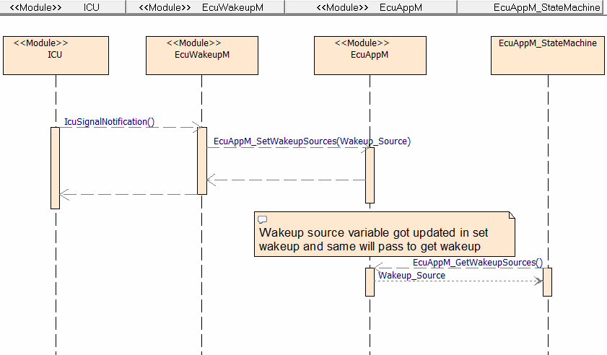
Fig 3.9 EcuAppM_SetWakeupSources Sequence

FUNC (void, ECUAPPM_CODE) EcuAppM_SetEcuAppMState (uint8 state)
The above function is used to set the current state of the EcuAppM state machine. If any other component wants to know the current state of the EcuAppM state machine, we can be able to provide with the help of this function.
FUNC (void, ECUAPPM_CODE) EcuAppM_ClearWakeupSources(void)
The above function is used to clear the wakeup event. This call is triggered by EcuAppM state machine whenever it is necessary.
EcuAppM state machine step function and init functionalities are triggered by using below functions which is present in EcuAppM file.

FUNC (void, ECUAPPM_CODE) EcuAppM_Init(void)
The above function is used to trigger the initialization of EcuAppM state machine. EcuAppM_Init should triggered as like mentioned in the below sequence diagram (figure [3.10]). It is user responsibility to add this function call from the EcuMExt Drive init one.
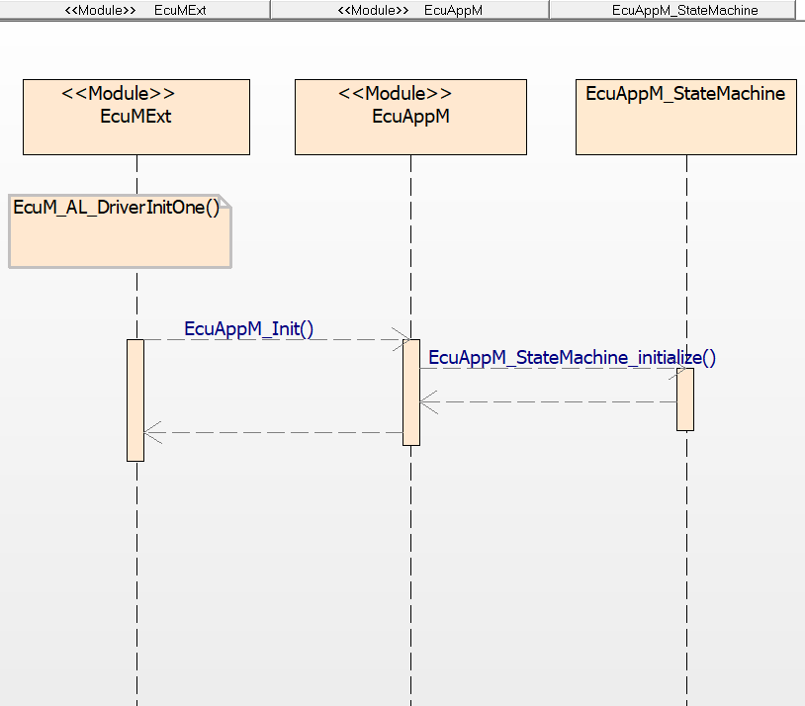
Fig 3.10 EcuAppM_Init Sequence
FUNC (void, ECUAPPM_CODE) EcuAppM_MainFunction(void)
The above function is used to trigger the EcuAppM_StateMachine_step function. EcuAppM_MainFunction should be triggered as like mentioned in the below sequence diagram (figure [3.11]). It is user responsibility to add this function call from the Os.
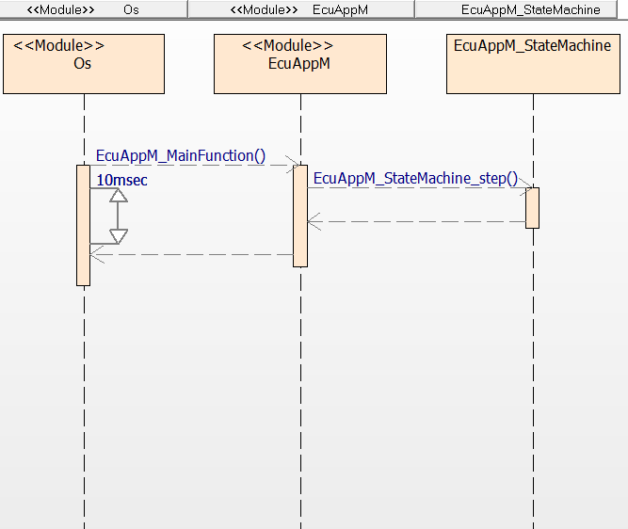
Fig 3.11 EcuAppM_MainFunction Sequence

The below files are having above explained functionalities.
Fig 3.12 EcuAppM Files
NOTE: - This logic will not vary between programs. So, when you are integrating should not modify files in fig [3.12] and should not use the functionalities in file.

OVERVIEW OF ECUAPPMEXT
This is extension component of EcuAppM. This is designed to handle the program specific logic inside the standard callouts which are coming from EcuAppM state machine core logic.
Below are the standard callouts from EcuAppM state machine.
void EcuAppM_OnPowerSeqStart (uint8 State)
This function can be used to trigger the power sequence (powerup/power down) or any necessary activity upon power up sequence and power down sequence from EcuAppM state machine.
This function is triggered from the EcuAppM_StartPowerUpSequenceState and EcuAppM_StartPowerDownSequenceState states from EcuAppM state machine.
Passing Argument: -
State argument is used to know the state of the EcuAppM State machine.
Return Argument: -
void (no return argument).
void EcuAppM_OnNVMReadAll (uint16 WakeupSource)
This function can be used to trigger the NVM read all activity. This is triggered from the EcuAppM_ReadDataState of EcuAppM state machine.
Passing Argument: -
WakeupSource argument is used to know for which wakeup source NVM read is triggered.
Return Argument: -
void (no return argument).
Below is the sequence diagram (figure [3.13]) of triggering NVM read all functionality.
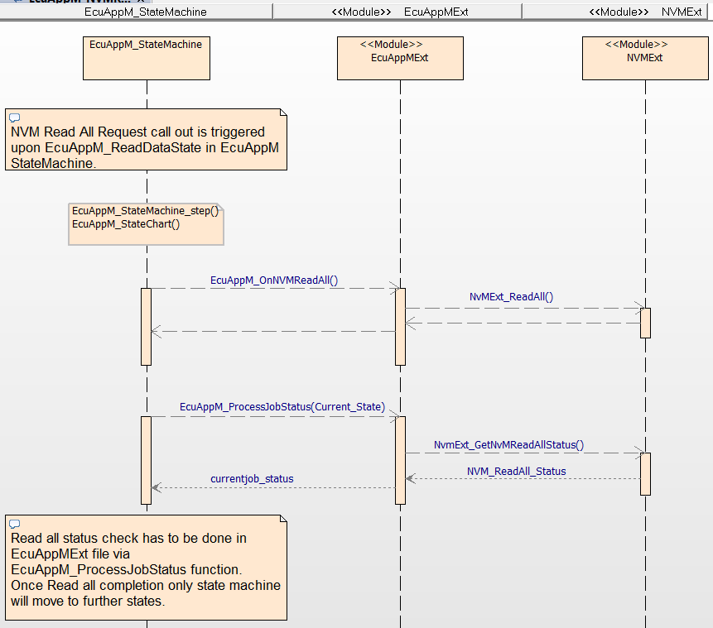
Fig 3.13 EcuAppM_OnNVMReadAll Sequence
void EcuAppM_PowerUpWakeupSources (void)
This function can be used to initiate the powerup sequence to wakeup sources. It is triggered from the EcuAppM_StartRunState state of EcuAppM state machine.
Passing Argument: -
void (no passing argument).
Return Argument: -
void (no return argument).

void EcuAppM_OnWakeupValidation (void)
This function can be used to perform the wakeup validation of wakeup source. It is triggered from the EcuAppM_WakeupValidationState state of the EcuAppM state machine.
Passing Argument: -
void (no passing argument).
Return Argument: -
void (no return argument).
void EcuAppM_FailSafeMechanism (uint8 GroupId, uint8 State)
This function can be used to add failsafe actions upon any of the groups state change is taking more than configured time. Based on program needs which action to be taken need to be decided by the user.
It is triggered from the EcuAppM_GroupsMgmtState of EcuAppM state machine upon groups activation and deactivation.
Passing Argument: -
GroupId and State arguments are passed to know for which group on which state failsafe is triggered from the EcuAppM state machine.
Return Argument: -
void (no return argument).
uint8 EcuAppM_GroupActivationAllowed (uint8 GroupId)
This function can be used to check before activation of individual group whether to allow activation or not. Special condition checks can be added here like low voltage scenario whether to activation of group need to allow or not.
EcuAppM_GroupActivationAllowed is triggered from the EcuAppM_GroupsMgmtState of EcuAppM state machine upon groups activation and deactivation.
Passing Argument: -
GroupId is passed to know for which group this check is required.
Return Argument: -
this return value is used to know group is allowed to activate or not. This function will expect return value as 1 if check is not added. If any special condition is added based on the result of condition return value should be sent.
TRUE (1) -- should sent upon condition met/none of the conditions added.
FALSE (0) -- should sent upon condition not met case.
void EcuAppM_BackupData (void)
This function can be used to write the backup data into NVM. It is triggered from the EcuAppM_BackupDataState of EcuAppM state machine.
Passing Argument: -
void (no passing argument).
Return Argument: -
void (no return argument).
void EcuAppM_GroupStatusChangeCbk (uint8 groupId, uint8 groupState)
This is the function to notify group status change of the individual group. Based on group status change any of the action can be added here according to program needs. It is triggered from the EcuAppM_GroupsMgmtState of EcuAppM state machine.
Passing Argument: -
GroupId and State arguments are passed to know for which group on which state failsafe is triggered from the EcuAppM state machine.
Return Argument: -
void (no return argument).
uint8 EcuAppM_ProcessJobStatus (uint8 Current_State)
This is the function to perform any of the action upon each state of the EcuAppM state machine. Based on the state action completion state machine will move next state. It is triggered from each state of EcuAppM state machine. This function is a periodic polling from the state machine states until respective action completion.
ECUAPPM_JOB_IN_PROGRESS – upon state entry status will change to in progress by the EcuAppM state machine core logic.
ECUAPPM_JOB_DONE – status should be changed to done upon action completion or none of action not there in that state. Job done status should be updated in the extension component.

ECUAPPM_JOB_IDLE – status should be changed to idle, if necessary, action is not completed in that state so that state machine will not move to the next state. Job idle status should be updated in the extension component. Based on this state machine will not take any actions it remains in the same state.
Passing Argument: -
Current_State is used to know about state of the EcuAppM state machine.
Return Argument: -
Return value is to notify about state action progress.
please find EcuAppM_ProcessJobStatus function skeleton (figure [3.14]) in below.
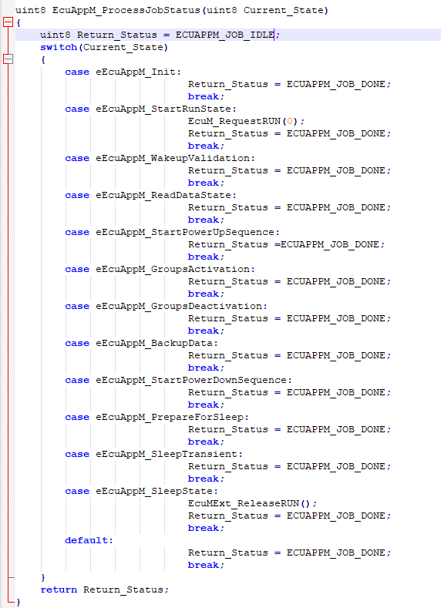
Fig 3.14 EcuAppM_ProcessJobStatus Function Skeleton
Based on program needs user can add the necessary actions on a particular state(case).
void EcuAppM_StartOfGroupsDeactivation (void)
This function can be used perform any necessary activity upon start of the group’s deactivation. It is triggered from the EcuAppM_GroupsMgmtState of EcuAppM state machine.
Passing Argument: -
void (no passing argument).
Return Argument: -
void (no return argument).
uint8 EcuAppM_CheckApplicationSleepStatus (void)
This function can be used to notify about latest application sleep status. It is triggered from the EcuAppM module.
Passing Argument: -
void (no passing argument).
Return Argument: -
Return value should be latest sleep status from the application.
ECUAPPM_READY_TO_SLEEP as value 0 and ECUAPPM_REFUSE_TO_SLEEP as value 1.
Have a look on below sequence of notifying the application sleep status.
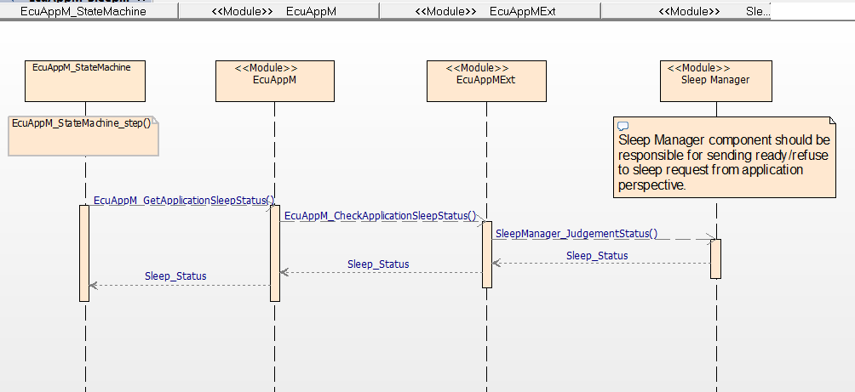
Fig 3.15 Application sleep request notification sequence

OVERVIEW OF ECUAPPMCMD PROCESSING
The command processing is used to process the commands to activate or deactivation of group components. It is responsible for dispatching the commands.
Below are the files having the command processing logic.
Fig 3.15 EcuAppM_CmdProcessing Files
NOTE: - This logic will not vary between programs. So, when you are integrating should not modify files in fig [3.15] and should not use the functionalities in file.

OVERVIEW OF ECUAPPM ERROR HANDLER
The EcuAppM error handler is responsible for notifying the errors occurred in EcuAppM module.
Below are the files for EcuAppM error handling.
Fig 3.16 EcuAppM_Errorhandler Files
NOTE: - This logic will not vary between programs. So, when you are integrating should not modify files in fig [3.16] and should not use the functionalities in file.

CONFIGURATION OVERVIEW
EcuAppM module is unique because of the group’s configuration. Regarding groups configuration and its properties discussed in section [3.3.3]. Configuration of groups properties and its components can be done with the help of VcoreConfigurator tool.
It is user responsibility to analyze about component grouping. Once the component grouping is completed then same need to configure in VcoreConfigurator tool.
The VcoreConfigurator tool looks like below. Currently the XML to Code generator is developed to auto generate the configuration files.
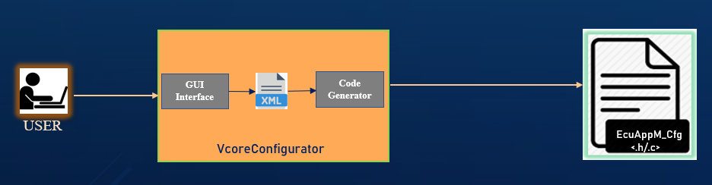
Fig 3.17 VcoreConfigurator tool
XML file looks like below image, and it is in cfgtool folder of EcuAppM folder structure section [3.5.1].
Fig 3.18 XML File

USAGE OF CONFIGURATION XML
To configure the groups user needs to change the xml according program needs. Please investigate below XML file structure to understand how to configure the groups and those properties.
Before configuring the group properties and its groups user should configure the wakeup sources and its properties as shown in the below snippet.
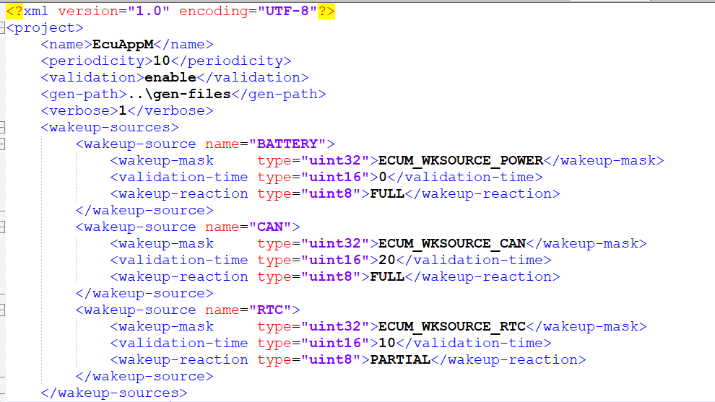
Fig 3.19 wakeup sources configuration form XML
Users need to configure the different wakeup sources based on program requirements as like shown in the above fig [3.19]. For each wakeup source needs to update the below properties.
wakeup-mask: - Needs to mention the wakeup source common macro for that wakeup source.
validation-time: - User need to update the validation time of respective wakeup source, if necessary, otherwise will consider it no validation is required for the wakeup source same user needs to update it as 0.
It is required to validate the respective wakeup source in with in configured time whether it is valid wakeup source or not.
wakeup-reaction: - This property of wakeup source will decide to wakeup FULL system or partial wakeup of the system. This property should be decided based on the program requirement whether to wakeup FULL or PARTIAL as shown in fig [3.19].
For each wakeup source user should configure all above properties. Number of wakeup sources should be decided by the user based on program requirements.

Groups properties and its components should be configured as like below snippet.
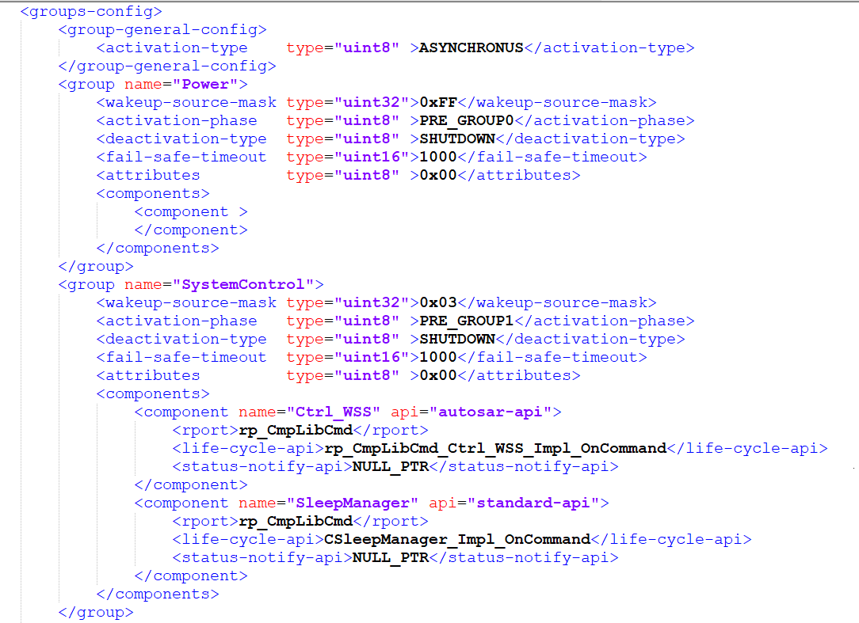
Fig 3.19 Groups properties and its components configuration form XML
Regarding group properties explanation please check in section update all these group properties according to the program needs.
Components needs to be added in each group according to the user analysis on which component should move to which group.

CONTACT
Module Owner Name | CDSID | Module Reviewer Name | CDSID
Anil Kumar K | AKAPPA | Kiran Kumar S | SKIRANKU

ECU POWER MANAGER (EcuPowerM)

INTRODUCTION
A generic manager which performs the power up and power down of any device based on the device sequence configuration.

ARCHITECTURE OVERVIEW

System Services
Memory services
Communication services
Diagnostic services

Hardware abstraction layer
I/O HW abstraction layer
Application Layer
Runtime Environment
I/O drivers
MCAL abstraction layer
Microcontroller
EcuM
BswM
ComM
WdgM
EcuPowerM
Complex drivers

Fig 4.0 EcuPowerM in CDD layer

FUNCTIONAL DESCRIPTION

A generic manager which performs power sequencing of multiple devices. Figure 4.1 depicts blueprint of the EcuPowerM. A device sequence consists of jobs and commands.
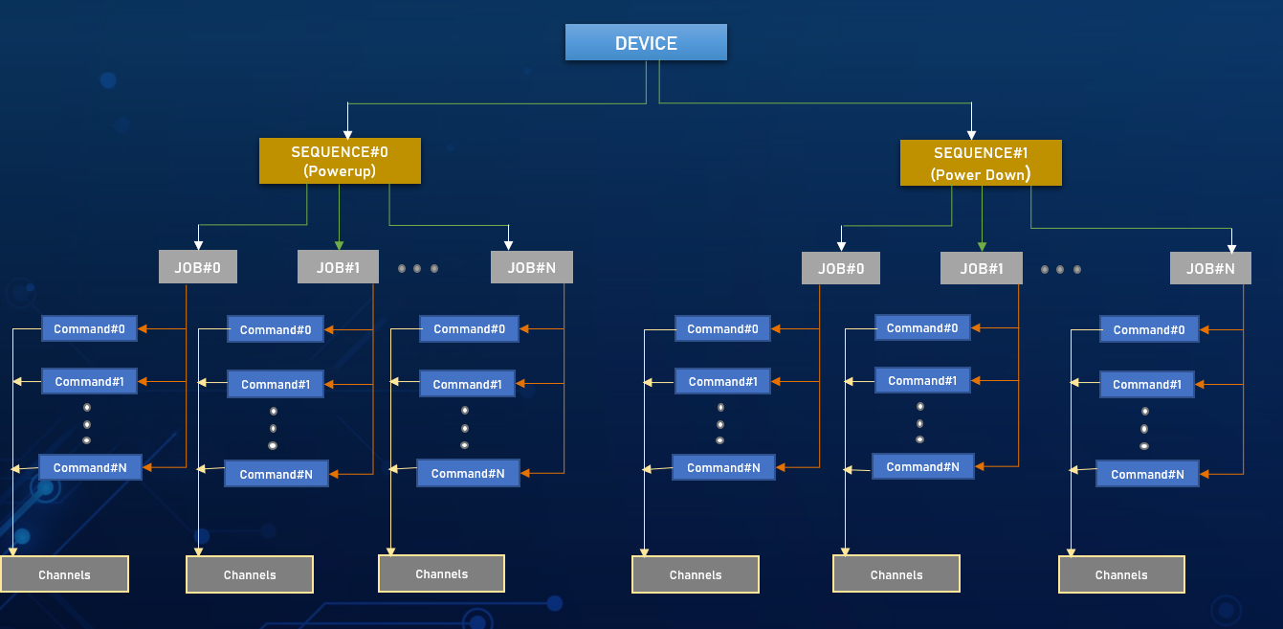
Fig 4.1 EcuPowerM Blueprint

DEVICE
A device nothing but an external IC or any circuit which needs power up and power down sequence. For example, TFT, BACKLIGHT DRIVER IC, BASIC POWER UP like switched supplies etc.

SEQUENCE
A device consists of sequences (Currently two sequences are supported) powerup and power down sequences. A sequence can be INTERRUPTIBLE and NON-INTERRUPTIBLE.
An INTERRUPTIBLE sequence is allowed to interrupt only after completing the current JOB.

JOB
A Job is an atomic operation which performs the series of configured commands.

COMMAND
A command is a specific operation executed on a given channel. Commands are predefined and following are the commands currently supported
/* Read command. */
READ_CHANNEL
/* write command. */
WRITE_CHANNEL
/* wait for channel command. */
WAITON_CHANNEL
/* wait for a given time command. */
WAIT_TIME
/* set duty command. */
SET_DUTY

CHANNEL
A channel refers to underlying hardware channel. Channel will have “low-level-api”
attribute which informs the EcuPowerM to use which low level component to access
the respective channel.

Following Low level API layers are supported

/* driver api type IOHWABS. */
IOHWABS
/* driver api type DIO. */
DIO
/* driver api type ADC. */
ADC
/* driver api type PWM. */
PWM

API DESCRIPTION

Service Name | EcuPowerM_Init
Service ID[HEX] | 0x0
Parameters(in) | None
Parameters(out) | None
Return | None
Description | Initializes Power manager module

Service Name | EcuPoEcuPowerM_DeInit
Service ID[HEX] | 0x0A
Parameters(in) | None
Parameters(out) | None
Return | None
Description | Deinitializes Power manager module

Service Name | EcuPowerM_RequestPower
Service ID[HEX] | 0x03
Parameters(in) | Device - Device ID  Request – Power sequence request
Parameters(out) | None
Return | None
Description | Device power request

Service Name | EcuPowerM_MainFunction
Service ID[HEX] | 0x01
Parameters(in) | None
Parameters(out) | None
Return | None
Description | Periodic function which serves the user requests

Service Name | EcuPowerM_GetDeviceStatus
Service ID[HEX] | 0x09
Parameters(in) | Device - Device ID
Parameters(out) | status - Current device status
Return | None
Description | Get ongoing device power status

MODULE ID

ECUPOWERM_MODULE_ID - 3001U

INTEGRATION GUIDELINES
Please refer EcuAppM_Callout.c file in Common baseline.
Detailed sequence diagram will be released in next phase

CONFIGURATION OVERVIEW

CONTACT

Name | CDSID
Kiran Kumar Sevana | SKIRANKU

ECU WAKEUP MANAGER (EcuWakeupM)

INTRODUCTION
A generic manager which abstracts underlying low level driver and provides generic services to handle wakeups in an ECU like enabling and disabling of wakeup interrupts, scanning underlying driver for wakeup status and notifying the wakeup source to upper layers etc.

ARCHITECTURE OVERVIEW

System Services
Memory services
Communication services
Diagnostic services

Hardware abstraction layer
I/O HW abstraction layer
Application Layer
Runtime Environment
I/O drivers
MCAL abstraction layer
Microcontroller
EcuM
BswM
ComM
WdgM
EcuWakeupM
Complex drivers

Fig 5.0 EcuWakeupM in CDD layer

FUNCTIONAL DESCRIPTION

It’s a part of complex device driver layer in Autosar architecture. This component interacts with all the low-level wakeup drivers and provides services to higher layers via standardized API’s.

EcuWakeupM
EcuM
EcuAppM
ICU
GPT
RTC
EcuMExt

Fig 5.1 EcuWakeupM Component Interactions

WAKEUP MANAGER SERVICES

Wakeup manager provides following services which shall be used by upper layers for enabling and disabling wakeup sources.
EcuWakeupM_EnableAllWakeups

This Service will enable all the configured wakeup sources. It performs all the prerequisites required for underlying wakeup driver. Based on the wakeup type “INTERNAL” or “EXTERNAL” it changes the port mode accordingly.
EcuWakeupM_ManageWakeup
This Service expected to call from the wakeup ISR callback. Upon wakeup this service disables the wakeup interrupt and notifies the upper layer(EcuAppM) about the wakeup source. If configured it will call user callback function.
EcuWakeupM_CheckWakeup
This Service expected to call from the EcuM_CheckWakeup() and this service intern will call underlying low level driver check wakeup function as per Autosar protocol.

API DESCRIPTION

Service Name | EcuWakeupM_Init
Service ID[HEX] | 0x0
Parameters(in) | None
Parameters(out) | None
Return | None
Description | Initializes Wakeup manager module

Service Name | EcuWakeupM_EnableWakeup
Service ID[HEX] | 0x01
Parameters(in) | Channel  NotifyStatus
Parameters(out) | None
Return | None
Description | Enable wakeup channel

Service Name | EcuWakeupM_DisableWakeup
Service ID[HEX] | 0x02
Parameters(in) | Channel
Parameters(out) | None
Return | None
Description | Disable wakeup channel

Service Name | EcuWakeupM_EnableAllWakeups
Service ID[HEX] | 0x03
Parameters(in) | NotifyStatus
Parameters(out) | None
Return | None
Description | Enable all wakeup channels

Service Name | EcuWakeupM_DisableAllWakeups
Service ID[HEX] | 0x04
Parameters(in) | Channel
Parameters(out) | None
Return | None
Description | Disable all wakeup channels

Service Name | EcuWakeupM_SetNotification
Service ID[HEX] | 0x05
Parameters(in) | Channel  NotifyStatus
Parameters(out) | None
Return | None
Description | Enable notification of wakeup channels

Service Name | EcuWakeupM_ManageWakeup
Service ID[HEX] | 0x06
Parameters(in) | Channel
Parameters(out) | None
Return | None
Description | Manges wakeup channel

Service Name | EcuWakeupM_CheckWakeup
Service ID[HEX] | 0x07
Parameters(in) | WakeupSource
Parameters(out) | None
Return | None
Description | Service calls the underlying wakeup driver check wakeup source

Service Name | EcuWakeupM_GetWakeupChannel
Service ID[HEX] | 0x08
Parameters(in) | WakeupSource
Parameters(out) | ChannelData
Return | None
Description | Returns wakeup channel corresponding to wakeup source

Service Name | EcuWakeupM_ScanWakeupChannel
Service ID[HEX] | 0x09
Parameters(in) | Channel
Parameters(out) | None
Return | None
Description | Scans wakeup channel for a wakeup

Service Name | EcuWakeupM_ScanAllWakeupChannels
Service ID[HEX] | 0x0A
Parameters(in) | None
Parameters(out) | None
Return | None
Description | Scans all wakeup channels

Service Name | EcuWakeupM_ReportWakeupSource
Service ID[HEX] | 0x0B
Parameters(in) | Channel
Parameters(out) | None
Return | None
Description | Report wakeup source of a given channel

Service Name | EcuWakeupM_ReportAllWakeupSources
Service ID[HEX] | 0x0C
Parameters(in) | None
Parameters(out) | None
Return | None
Description | Report all wakeup sources

MODULE ID

ECUWAKEUPM_MODULE_ID - 3000U

INTEGRATION GUIDELINES
Refer EcuMExt file in common baseline.
Detailed sequence diagram will be released in next phase

CONFIGURATION OVERVIEW

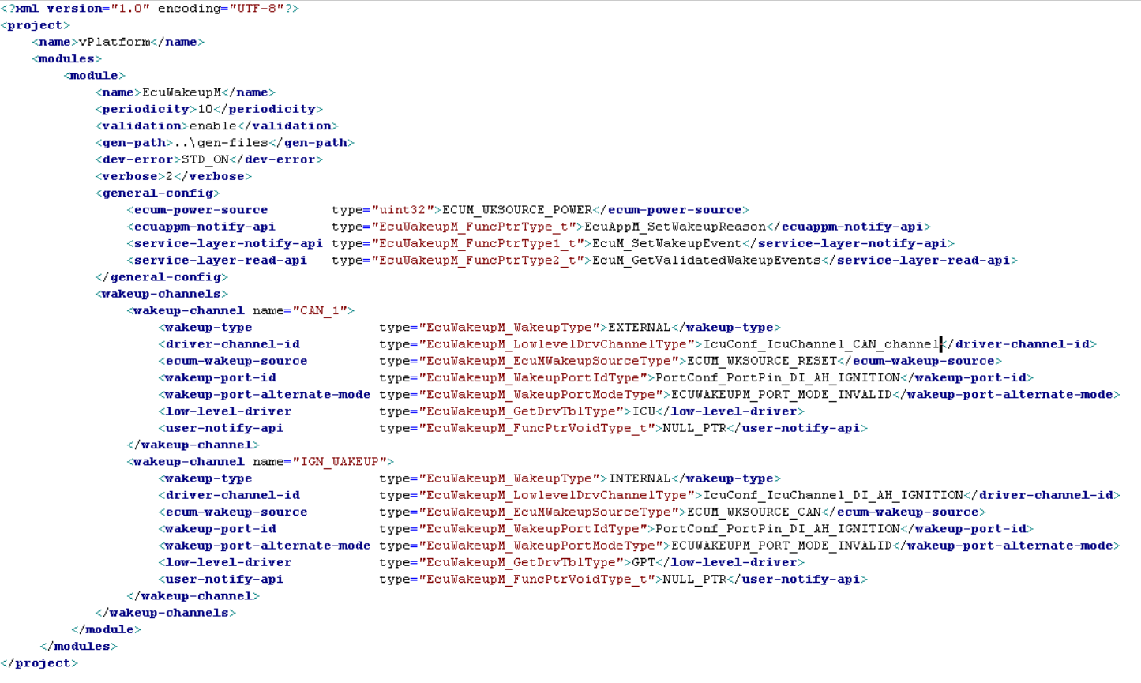

CONTACT

Module Owner Name | CDSID | Module Reviewer Name | CDSID
Kiran Kumar Sevana | skiranku

FIT MANAGER (CDD_FitManager)

INTRODUCTION

The name “FitManager” refers “Fault Injection Test Manager”. A generic manager frame work which manages and perform Fault injection tests for different Modules IDs and its Test IDs which will be invoked through diagnostics service (Diagnostics Tester Tool). This manager Frame work is independent of underlying hardware and the type of the application it is managing.

Additional information:
This framework can be adapted for the following architecture support,
- Traveo 2 micro.
- Architecture supported: E3.5, E4.0 etc.
- Supported Stacks: Visteon and Vector Autosar Stack.

ARCHITECTURE OVERVIEW

Fit Manager will fall under Complex Drivers (CDD) of Autosar Architecture,
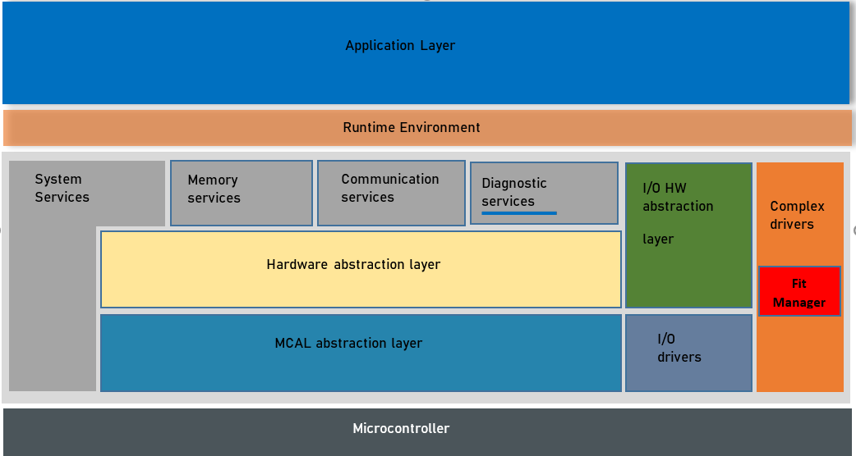

FUNCTIONAL DESCRIPTION

FLOW DIAGRAM:
start

This service (2E) will trigger handler function that will route to FIT manager
Session 10 03

Security access clearance
27 01, 27 02

(Service 2E)

CDD_FitManager_RouteFITDID ()

CDD_FitManager_HandleFaultInjection ()
This function will handle the FIT from FIT manager configuration table based on the input diagnostics data
Diagnostics response handling

Stop

SEQUENCE DIAGRAM:
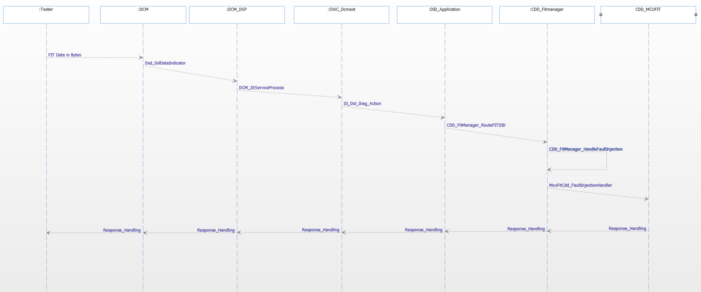

Fault Injection Testing will be triggered from Diagnostics Tester through 2E Service with FIT Data, this Fit Data will be routed to FIT Manager component (CDD_FitManager), in which, incoming Fit Data will be extracted and compared against the Configuration table and invoke the Module Handler and Test Handler function call through Trusted or Non-Trusted calls. This Configuration table will be generated through automated scripts with various FIT Module IDs and Test IDs as part of the program.
Configuration details:
Following elements were part of configuration data.
- FIT Module ID
- FIT Module Handler
- Test count for FIT ID (Total Test IDs)
- FIT Test IDs
- FIT Test Handler

Below is the sample Diagnostics FIT Data that will be send from Diagnostics Tester 2E service.

General format of sending data as below, (B0 is byte 0, B1 is byte 1 etc)
B0 | B1 | B2 | B3 | B4 | B5 | B6 | B7
2E | 4F | 09 | xx | yy | zz | aa | bb
Where,
- 2E – Diagnostic service (Write Data by Identifier)
- 4F 09 is the data identifier for FIT (2 bytes, 4F is higher bytes and 09 is the lower byte of data identifier)
- xx is the FIT module ID (Iohwab, NVM, safety etc)
- yy – is the specific test ID to be performed under FIT module ID
- zz – is to start / stop performing FIT test.
- aa and bb are the FIT Data (2 bytes) , based on the program need , this FIT Data can be updated. As of now, this FIT Data used is in range.
Example:
- 2E – diagnostics service
- 4F 09 - FIT DID number (2bytes)
- 00 – FIT module ID (MCUFit)
- 81 – specific Test ID under FIT module (Trusted call and Test ID is 1)
- 01 – To start the FIT test
- 04 and 05 (FIT Data)

MCUFit Module ID – 0x00
BSWFit Module ID – 0x01

API DESCRIPTION

CDD_FitManager_RouteFITDID (uint8 *Data, uint8 OpStatus, uint8 *pNrc)
CDD_FitManager_HandleFaultInjection(Data);
CDD_FitManager_SupervisorCallFaultInjectionHandler(LoopCount, StartStopData,TestListID,FitData);
CDD_FitManager_NonSupervisorCallFaultInjectionHandler(LoopCount, StartStopData,TestListID,FitData);

CDD_FitManager_CallFaultInjectionHandler(uint8 LoopCount, uint8 StartStopData, uint8 TestListID, uint8 *Data)

MODULE ID

FITMANAGERCDD_MODULE_ID - 3002

INTEGRATION GUIDELINES

- Make sure, along with CDD_Fitmanager component, other dependent components shall also be included in manifest to download and compile without errors. As components like BSWFit, MCUFit is dependent on CDD_Fitmanager component and vice versa.

- Make sure make and Cmake has to be updated accordingly for CDD_FitManager component and for the other dependent components (eg: MCUFit, BSWFit etc).

- Use Macro _FS_FAULT_INJECTION_TEST_ENABLE_ to enable the FIT feature. This macro shall be enabled in production intended software.

- Rhapsody has to be updated accordingly to include the CDD_Fitmanager. Sbsx file and required rp port has to be created either in DCMExt or DIDmdl depend on the diagnostics Stack implemented in the program.

- Davinci configuration has to be updated for the Trusted and NON-Trusted Calls invocation from CDD_Fitmanager file.

- Make sure to update the fitmanger.xml file with required module IDs and Test IDs and its handler functions, so that, CDD_Fitmanager_cfg.c and .h has to be included under Cfg folder under Src folder.
Additional information:
Testing of FIT is done in FORD P708 program for MCUFIT module ID and its Test IDs.
Known Limitation:
- As of now, only Start Handler is proved out. Yet to prove out Stop Handler. Means, FIT test can only be started, it can’t be stopped by diagnostics command.
- Test ID Handler functionality not yet proved out. (Current Module IDs does not have Test Handler)
- Trusted Call invocation not yet updated in Davinci for prove out. Non-Trusted call invocation is proved out.

All the above-mentioned Known Limitations will be addressed in upcoming software iteration.

CONFIGURATION OVERVIEW

- Using VConfigurator Tool Developed by Sevana Kiran Kumar, fitmanager.xml file updated accordingly for various Module IDs and Test IDs and their Handler Function update.
- VConfigurator Tool requires .XML file with which it will auto generate configuration files such as CDD_Fitmanager_cfg.c and .h file.
- Using run.batch file, VConfigurator will auto generate above mentioned configuration files. Which has to be copied to platform_cfg folder under swc_gen component.

Below are the folders available in vConfigurator Tool folder, where,
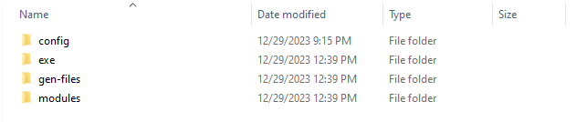

Config – this folder will have the .xml file (fitmanager.xml) which will have the .xml update with modules IDs and Test IDs and its numbers.
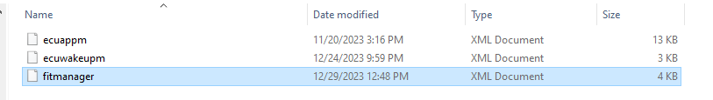

exe - this folder will have executable file - Vconfigurator.exe , and a run.batch file to execute the command.
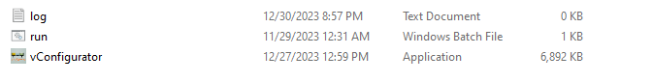
gen_files – Generated output files will be available in exe folder.

modules - this folder will have the template for the autogenerated files.
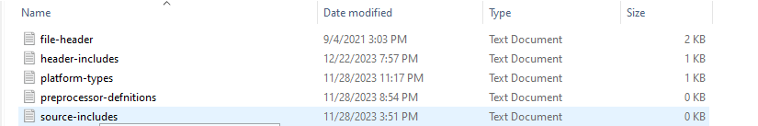

XML file:

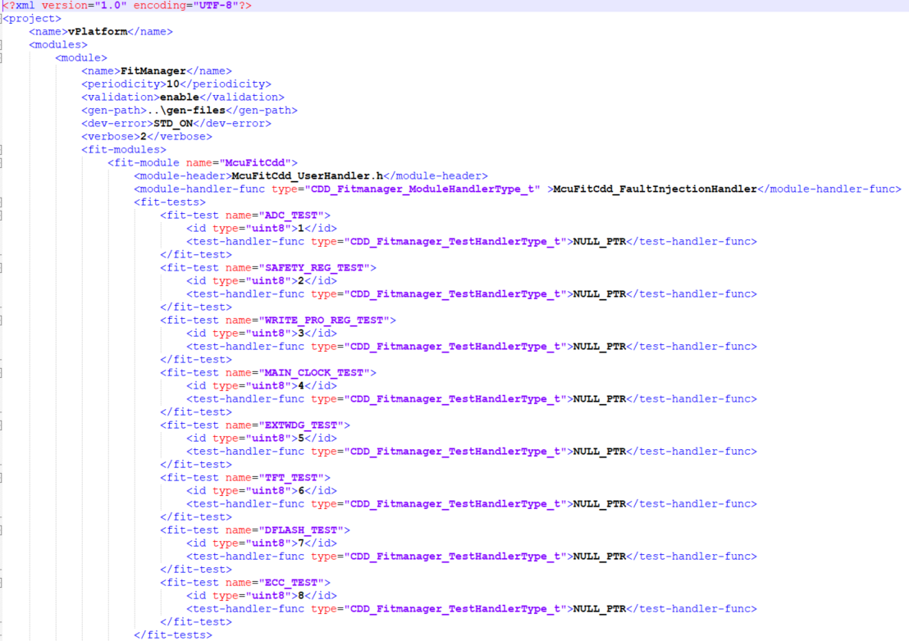
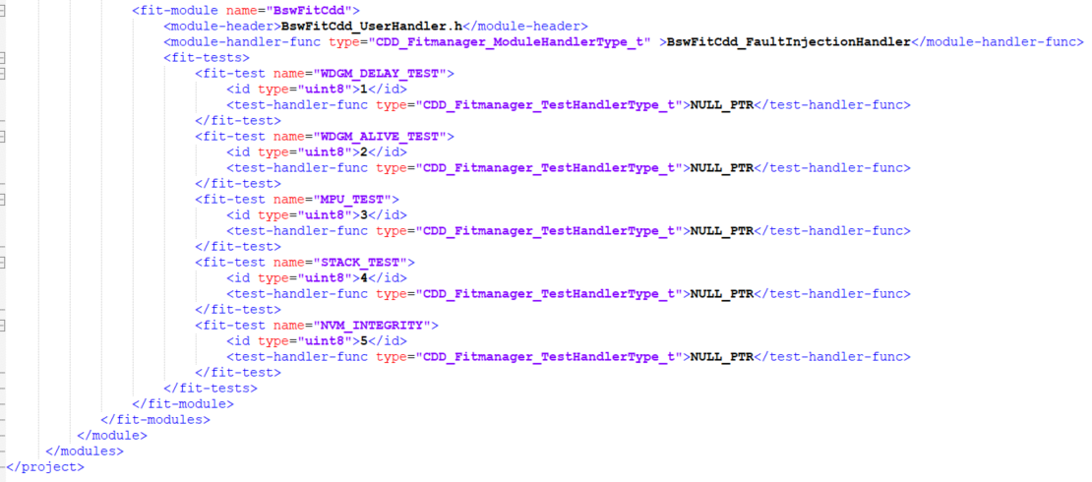

SOFTWARE FILES:
src/src – CDD_FitManager.c and CDD_FitManager_ErrorHandler.c and CDD_FitManagerConfig.cmake
src/cfg - CDD_FitManager_Cfg.c and CDD_FitManager_Cfg.h
src/include - CDD_FitManager_Defines.h, CDD_FitManager_Det.h, CDD_FitManagerTypes.h, CDD_FitManager_Version.h and CDD_FitManager.h

CONTACT
Module Owner Name | CDSID | Module Reviewer Name | CDSID
Rumesh Karan Darshan | RDARSHAN | Kiran Kumar Sevana | SKIRANKU

LOW POWER MANAGER (lPowerM)

INTRODUCTION
Low power manager, a platform dependent module which performs low power mode activities and keeps the ECU in a “Deep Sleep” state. This module is specific to Traveo2.

ARCHITECTURE OVERVIEW

System Services
Memory services
Communication services
Diagnostic services

Hardware abstraction layer
I/O HW abstraction layer
Application Layer
Runtime Environment
I/O drivers
MCAL abstraction layer
Microcontroller
EcuM
BswM
ComM
WdgM
lPowerM
Complex drivers

Fig 7.0 lPowerM in CDD layer

FUNCTIONAL DESCRIPTION
Traveo2 supports Deep sleep and Hibernate modes. The difference between the modes is Hibernate mode cannot retain the SRAM, all clocks are turned off and device resets on wakeup. Supports Wakeup only through “Wakeup pin and RTC alarms”.
Whereas in Deep sleep mode, SRAM can be retained, Low frequency clocks are operating and supports GPIO interrupts, SCB, Watchdog and RTC alarms as wakeup sources. Instead of resetting the device it resumes on wakeup.
Major criteria to select between these two modes is sleep current. Most of the OEM’s requirements is 100-150micro-amps. Which can be achieved by Deep sleep mode.

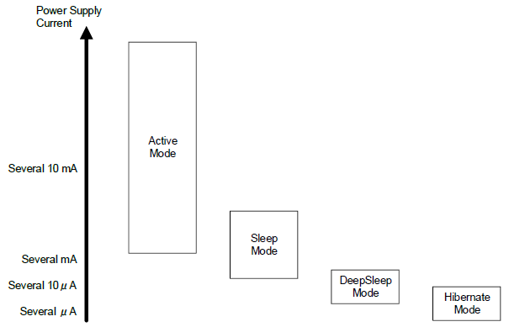
Fig 7.1 Traveo2 low power modes

Most of the programs which uses Deep sleep mode they are storing the wakeup source in backup RAM upon M7 wakeup and performing software reset. Software reset takes control to reset handler of M0+ and wakeup up start like normal battery connect.
Low power manager implemented a different approach instead of reset it tries to wakeup the M0+ core like M7 core without overhead of IPC.
In lPowerM-app context, M7 is master and M0+ is slave. Because M7 responsible for sleep conditions and wakeup factors.

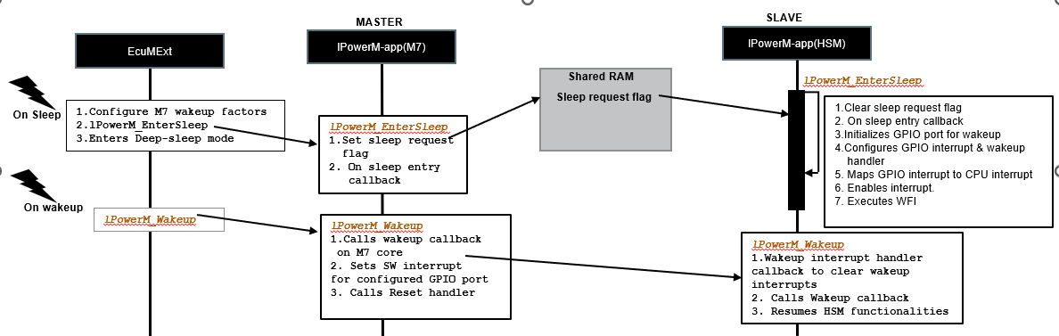

Fig 7.2 Low power mode Sequence diagram

M0+ wakeup from M7 is possible because of the Traveo2 interrupt architecture where NVIC exist per core. Any peripheral interrupt can be individually mapped to both CPU interrupts hence a GPIO can be used in M0+ core to wakeup from deep sleep.
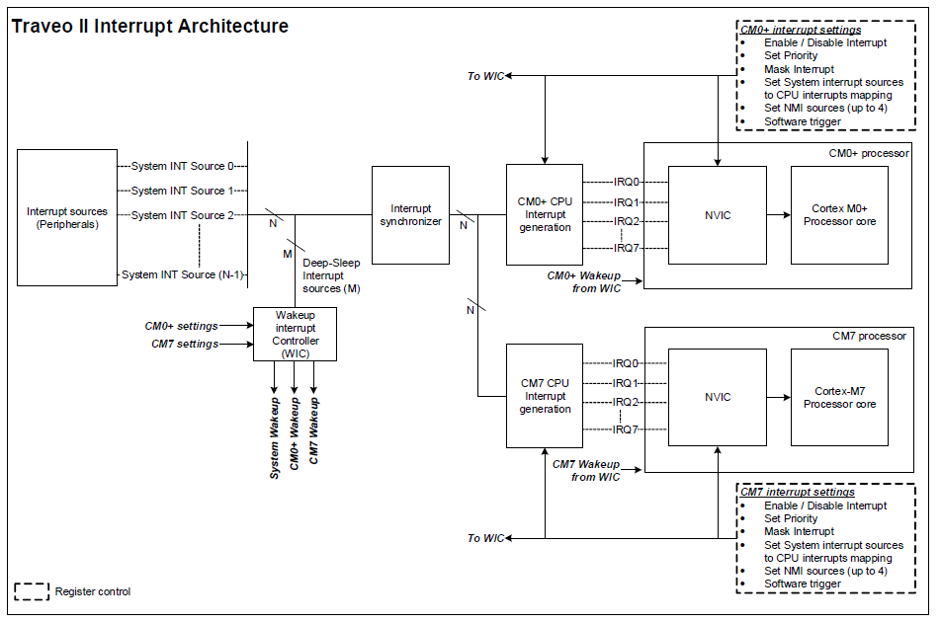
Fig 7.3 TraveoII interrupt architecture

API DESCRIPTION

Service Name | lPowerM_Init
Service ID[HEX] | 0x0
Parameters(in) | None
Parameters(out) | None
Return | None
Description | Initializes low power manager module

Service Name | lPowerM_EnterSleep
Service ID[HEX] | 0x0
Parameters(in) | None
Parameters(out) | None
Return | None
Description | Perform tasks necessary to enter into low power mode

Service Name | lPowerM_Wakeup
Service ID[HEX] | 0x0
Parameters(in) | None
Parameters(out) | None
Return | None
Description | API to be called upon wakeup from low power mode

MODULE ID
None

INTEGRATION GUIDELINES
Please refer the EcuMExt file of the common baseline

CONFIGURATION OVERVIEW

CONTACT

Module Owner Name | CDSID | Module Reviewer Name | CDSID
Kiran Kumar Sevana | skiranku

Visteon Platform Configurator (vConfigurator)

INTRODUCTION
A Python based tool to autogenerate the platform configuration files.

ARCHITECTURE OVERVIEW




USER
GUI
Interface
Code
Generator

Fig 8.0 vConfigurator high level diagram

GUI interface not yet developed, planning to integrate along with DI core tool.

FUNCTIONAL DESCRIPTION
Currently the tool generates the configuration files from the xml configuration file.
Following diagram depicts the workflow.
A generic wrapper which parses the XML files and calls the individual module class files.
Each module class a database generator which is specific to the given XML configurations. From the database the “module-config-generator” will generate the configuration files.

Wrapper
Module-class
Module-database
Module-config-generator

Fig 8.1 vConfigurator workflow

API DESCRIPTION

INTEGRATION GUIDELINES

CONFIGURATION OVERVIEW

CONTACT
Module Owner Name | CDSID | Module Reviewer Name | CDSID
Kiran Kumar Sevana | skiranku

