Turing C Platform - EthIf
User Guide

Version 1.0

ISSUE DATE: 28 Feb, 2024

Prepared by: Parthiban Chinnathambi <pchinnat@visteon.com>
______________________________


COC - OS & BSP

PROPRIETARY AND CONFIDENTIAL
This document contains information that is proprietary to Visteon Corporation. Recipients of the document shall not duplicate, use or disclose information contained herein, in whole or in part, for other than company purposes.

TABLE OF CONTENTS
1 Introduction 4
1.1 Acronyms and abbreviations 4
1.2 References 5
2 Overview 5
2.1 Functional Requirements Satisfied and General Information 5
2.2 Design Information 5
2.2.1 EthIf src and cfg files 5
2.2.2 EthIf doc 5
2.2.3 EthIf test 5
3 Configuration 6
3.1 EthIf_Cfg.h 6
3.2 EthIf_Lcfg.c 6
3.2.1 const EthIf_ControllerType EthIf_Controller[ETHIF_NUM_OF_CONTROLLERS] 6
3.2.2 const EthIf_ControllerType EthIf_Controller[ETHIF_NUM_OF_CONTROLLERS] 7
3.2.3 const EthIf_SwitchType EthIf_Switch[ETHIF_NUM_OF_SWITCHES] 7
3.2.4 const EthIf_ULTxConfirmationFuncType EthIf_ULTxConfirmationFuncArr[ETHIF_NUM_OF_FRAME_OWNERS] 7
3.2.5 const EthIf_ULRxIndicationFuncType EthIf_ULRxIndicationFuncArr[ETHIF_NUM_OF_FRAME_OWNERS] 7
3.2.6 const EthIf_TrcvLinkStateChgFuncType EthIf_TrcvLinkStateChgFuncArr[ETHIF_NUM_OF_FRAME_OWNERS] 7
3.2.7 const EthIf_ConfigType EthIf_Config 8
4 Application Usage 8
5 Target System Requirements 8
5.1 Architecture 8
5.2 System Support 8
5.3 System Resource Requirements 8
6 Integration Checklist 9
7. Revision History 10

1 Introduction

This document describes basic functionality and the configuration of in-house AUTOSAR Basic Software module EthIf (Ethernet Interface ). the main task of the Ethernet Interface:
Provide to upper layers a hardware independent interface to the Ethernet Communication System comprising multiple different wired or wireless Ethernet controllers and transceivers. This interface shall be uniform for all Ethernet controllers and transceivers. Thus, the upper layers (TCP/IP, EthSM, CDD, V2x modules) may access the underlying bus system in a uniform manner

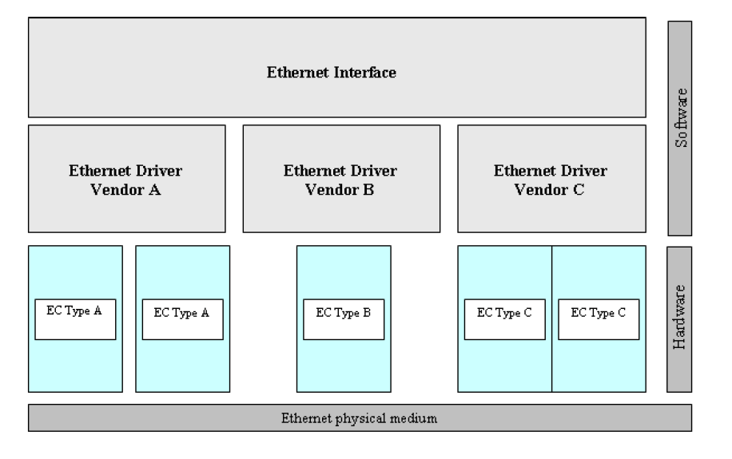

Acronyms and abbreviations
Term | Description
Application Layer | The Application Layer is placed above the RTE. Within the  Application Layer the AUTOSAR Software-Components are placed.
Eth | Ethernet Controller Driver (AUTOSAR BSW module)
EthIf | Ethernet Interface (AUTOSAR BSW module)
EthSM | Ethernet State Manager (AUTOSAR BSW module)
EthTrcv | Ethernet Transceiver Driver (AUTOSAR BSW module)
IP | Internet Protocol
TCP | Transmission Control Protocol
TCP/IP Stack | Ethernet communication stack
VLAN | Virtual Local Area Network
MII | Media Independent Interface (standardized Interface provided by Ethernet controllers to access Ethernet transceivers)

1.2 References
External to the project
- AUTOSAR_SWS_EthernetInterface.pdf (AUTOSAR version 4.3)

Internal to the project

V-Autosar EthIf package is available at:
- Git folder : https://bsp-os.git.visteon.com/platform/bsp-os/turing/vautosar/com/ethernet

2 Overview

2.1 Functional Requirements Satisfied and General Information
AUTOSAR functional requirements satisfied in this EthIf can be find at EthIf_SRS.

2.2 Design Information

2.2.1 EthIf src and cfg files
- EthIf is implemented in here via EthIf.c in “src” folder. The header files are available in “include” folder
- The template of configuration file can be found in “cfg” as EthIf_Cfg.$h, EthIf_Lcfg.$c , EthIf_Lcfg.$h, EthIf_MemMap.$h , SchM_EthIf.$h, SchM_EthIf_Type.$h
- The dollar sign should be removed (like EthIf_Cfg.h,) from above template files and used to configure the EthIf as per the program requirements that are located in program specific private configuration folder.
- The EthIf_MemMap should be included in MemMap.h file and the SchM files to be included from the Rte genearation
Please refer the HLD (.Sbsx) for design information

2.2.2 EthIf doc
- AUTOSAR_SWS_EthIf.xlsx provides the requirement mapping of EthIf
- EthIf.sbsx provides the HLD and DD for EthIf component

2.2.3 EthIf test
- Functional Test Plan and Unit Testing plans are stored in test/plans
- Unit testing reports (Aggregate Coverage Report, Full Report, Metrics Report and Testcase Management Report) are stored test/ result
- Vector Cast tool can be run from ETHIF_VCAST_HT batch file stored in test\test.harness\ethif

3 Configuration

3.1 EthIf_Cfg.h
Configuration items, which used in EthIf_Cfg.h, are listed below:

S.No | Configuration Item | Description
1 | ETHIF_DEV_ERROR_DETECT | Switches the development error detection and notification on or off.
2 | ETHIF_ENABLE_RX_INTERRUPT | Enables / Disables receive interrupt
3 | ETHIF_ENABLE_TX_INTERRUPT | Enables / Disables the transmit interrupt.
4 | ETHIF_GET_BAUDRATE | Enables / Disables GetBaudRate API
5 | ETHIF_GET_COUNTER_STATE | Enables / Disables GetCounterState API.
6 | ETHIF_GET_TRANSCEIVER_WAKEUP_MODE_API | Enables / Disables EthIf_GetTransceiverWakeupMode API
7 | ETHIF_GLOBAL_TIME_SUPPORT | Enables/Disables the Global Time APIs used amongst others by Global Time Synchronization over Ethernet
8 | ETHIF_START_AUTO_NEGOTIATION | Enables / Disables StartAutoNegotiation API.
9 | ETHIF_VERSION_INFO_API | Enables / Disables version info API
10 | ETHIF_VERSION_INFO_API_MACRO | Enables / Disables version info API macro implementation.
11 | ETHIF_WAKEUP_SUPPORT | Configures if wakeup is supported or not
12 | ETHIF_MAIN_FUNCTION_PERIOD | Specifies the period of main function EthIf_MainFunctionRx and EthIf_MainFunctionTx in milliseconds.
13 | ETHIF_MAX_TRCVS_TOTAL | the total number of transceivers supported
14 | ETHIF_RX_INDICATION_ITERATIONS | Maximum number of Ethernet frames per Ethernet controller polled from the Ethernet driver within EthIf_MainFunctionRx
15 | ETHIF_TRCV_LINK_STATE_CHG_MAIN_RELOAD | Specifies the frequency of transceiver link state change checks in each period of main function  EthIf_MainFunctionState
16 | ETHIF_NUM_OF_CONTROLLERS | Defines the number of Eth controllers supported
17 | ETHIF_NUM_OF_TRANSCEIVERS | Defines the number of Eth transceiver supported
18 | ETHIF_NUM_OF_SWITCHES | Defines the number of Eth switch supported
19 | ETHIF_NUM_OF_FRAME_OWNERS | Defines the number of Eth frame owners supported
20 | ETHIF_SWITCH_SUPPORT | Enables/Disables the support of Eth switches
21 | ETHIF_TRCV_SUPPORT | Enables/Disables the support of Eth Trcv
22 | ETHIF_ETHDRV_PHYS_ADRS_FILTER_API | Enables/Disables the support of Eth drv physicall address filter Eth_UpdatePhysAddrFilter api
23 | ETHIF_INVALID_HANDLE | Defines the EthIf invalid handle

3.2 EthIf_Lcfg.c

3.2.1 const EthIf_ControllerType EthIf_Controller[ETHIF_NUM_OF_CONTROLLERS]
Defines the Ethernet controller configuration

S.No | Element | Description
1 | EthIfCtrlId | Index of the Ethernet controller within the context of the EthIf
2 | EthIfMaxTxBufsTotal | Total number of transmit buffers.
3 | EthIfEthCtrlId | Index of Eth controller within the context of the Ethernet Driver
4 | EthIfEthTrcvId | Index of Eth Trcv
5 | EthIfCtrlMtu | maximum Payload size
6 | EthIfVlanId | 12 bit VLAN ID

3.2.2 const EthIf_ControllerType EthIf_Controller[ETHIF_NUM_OF_CONTROLLERS]
Defines the Ethernet Frame configuration

S.No | Element | Description
1 | EthIfFrameType | Frame Type ex: ARP, IPV4
2 | EthIfRxIndicationHandle | Rx Indication function handle.
3 | EthIfTxConfirmationHandle | Tx Confirmation function handle

3.2.3 const EthIf_SwitchType EthIf_Switch[ETHIF_NUM_OF_SWITCHES]
Defines the Ethernet switch configuration

S.No | Element | Description
1 | EthIfEthSwitchId | Index of Switches in context of Eth Interface
2 | EthIfSwitchIdx | Index of Switches in context of Eth Switch module

3.2.4 const EthIf_ULTxConfirmationFuncType EthIf_ULTxConfirmationFuncArr[ETHIF_NUM_OF_FRAME_OWNERS]
Defines the Ethernet tx confirmation callback function of owner

S.No | Element | Description
1 | EthIf_ULTxConfirmationFuncType | tx confirmation callback function of owner

3.2.5 const EthIf_ULRxIndicationFuncType EthIf_ULRxIndicationFuncArr[ETHIF_NUM_OF_FRAME_OWNERS]
Defines the Ethernet Rx Indication callback function of owner

S.No | Element | Description
1 | EthIf_ULRxIndicationFuncType | Rx indication callback function of owner

3.2.6 const EthIf_TrcvLinkStateChgFuncType EthIf_TrcvLinkStateChgFuncArr[ETHIF_NUM_OF_FRAME_OWNERS]
Defines the Ethernet trcv link state callback function of owner

S.No | Element | Description
1 | EthIf_TrcvLinkStateChgFuncType | the Ethernet trcv link state callback function of owner

3.2.7 const EthIf_ConfigType EthIf_Config
Defines the EthIf module configuration

S.No | Element | Description
1 | pEthIfCtrlCfg | pointer to controller config data
2 | pEthIfOwnerCfg | pointer to hold Owner config data
3 | pEthIfSwitchCfg | pointer to hold switches config data
4 | pEthIfULTxConfirmationFunc | pointer to hold Tx confirmation functions list
5 | pEthIfULRxIndicationFunc | pointer to Rx indication function list
6 | pEthIfTrcvLinkStateChgFunc | pointer to hold Trcv Link state functions list
7 | EthIfCtrlCount | Num of Controllers configured
8 | EthIfTrcvCount | Num of Trcv configured
9 | EthIfSwitchCount | Num of Switches configured
10 | EthIfOwnersCount | Num of Owners configured

4 Application Usage

5 Target System Requirements

5.1 Architecture
The EthIf does not require any specific hardware system architecture.

5.2 System Support
None.

5.3 System Resource Requirements

6 Integration Checklist

The following checklist to be used by the package user to help insure correctness of package integration and operation. For each item please check the checkbox upon verification of the item.

And Code
Name and date of persons completing checklist ____________________________________________
Item # | Item | Checkbox
1 | Check EthIf_Init called before scheduling the EthIf_MainFunctionRx(polling), EthIf_MainFunctionTx(polling), EthIf_MainFunctionState
2 | Verify the Eth driver and Trcv are integrated
3 | Check EthIf MainFunction called at desired Task Rate

7. Revision History

Revision Level | Section/page | Date | Description | Author
Version 1.0 | All | 28 Feb 2024 | Initial Release | pchinnat

ORIGINATOR OF THIS DOCUMENT

pchinnat

