Turing C Platform - EthSM
User Guide

Version 1.0

ISSUE DATE: 28 Feb, 2024

Prepared by: Parthiban Chinnathambi <pchinnat@visteon.com>
______________________________


COC - OS & BSP

PROPRIETARY AND CONFIDENTIAL
This document contains information that is proprietary to Visteon Corporation. Recipients of the document shall not duplicate, use or disclose information contained herein, in whole or in part, for other than company purposes.

TABLE OF CONTENTS
1 Introduction 3
1.1 Acronyms and abbreviations 3
1.2 References 4
2 Overview 4
2.1 Functional Requirements Satisfied and General Information 4
2.2 Design Information 4
2.2.1 EthSM src and cfg files 4
2.2.2 EthSM doc 5
2.2.3 EthSM test 5
3 Configuration 5
3.1 EthSM_Cfg.h 5
3.2 EthSM_Lcfg.c 5
3.2.1 const EthSM_NetworkConfigType EthSM_NetworkConfig[ETHSM_NUM_OF_NETWORKS] 5
3.2.2 const EthSM_ConfigType EthSM_Config 6
4 Application Usage 6
5 Target System Requirements 6
5.1 Architecture 6
5.2 System Support 6
5.3 System Resource Requirements 6
6 Integration Checklist 7
7. Revision History 8

1 Introduction

This document describes basic functionality and the configuration of in-house AUTOSAR Basic Software module EthSM (Ethernet State Manager). The main task of the Ethernet State Manager: The Ethernet State Manager shall provide an abstract interface to the AUTOSAR Communication Manager to startup or shutdown the communication on an Ethernet cluster . The Ethernet State Manager does not directly access the Ethernet hardware (Ethernet Communication Controller and Ethernet Transceiver), but by means of the Ethernet Interface. The Ethernet Interface redirects the request to the appropriate driver module

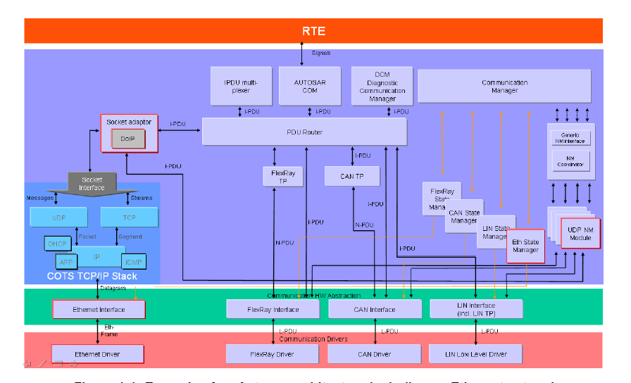

Acronyms and abbreviations
Term | Description
Application Layer | The Application Layer is placed above the RTE. Within the  Application Layer the AUTOSAR Software-Components are placed.
Eth | Ethernet Controller Driver (AUTOSAR BSW module)
EthIf | Ethernet Interface (AUTOSAR BSW module)
EthSM | Ethernet State Manager (AUTOSAR BSW module)
EthTrcv | Ethernet Transceiver Driver (AUTOSAR BSW module)
IP | Internet Protocol
TCP | Transmission Control Protocol
TCP/IP Stack | Ethernet communication stack
VLAN | Virtual Local Area Network
MII | Media Independent Interface (standardized Interface provided by Ethernet controllers to access Ethernet transceivers)
EC | Ethernet controller
ET | Ethernet transceiver
BswM | Basic Software Mode Manager
ComM | Communication Manager
DEM | Diagnostic Event Manager
DET | Default Error Tracer
EcuM | ECU State Manager
SchM | BSW Scheduler
SoAd | Socket Adaptor

1.2 References
External to the project
- AUTOSAR_SWS_EthernetStateManager.pdf (AUTOSAR version 4.3)

Internal to the project

V-Autosar EthSM package is available at:
- Git folder : https://bsp-os.git.visteon.com/platform/bsp-os/turing/vautosar/com/ethernet

2 Overview

2.1 Functional Requirements Satisfied and General Information
AUTOSAR functional requirements satisfied in this EthSM can be find at EthSM_SRS.

2.2 Design Information

2.2.1 EthSM src and cfg files
- EthSM is implemented in here via EthSM.c in “src” folder. The header files are available in “include” folder
- The template of configuration file can be found in “cfg” as EthSM_Cfg.$h, EthSM_Lcfg.$c , EthSM_Lcfg.$h, EthSM_MemMap.$h , SchM_EthSM.$h, SchM_EthSM_Type.$h
- The dollar sign should be removed (like EthSM_Cfg.h,) from above template files and used to configure the EthSM as per the program requirements that are located in program specific private configuration folder.
- The EthSM_MemMap should be included in MemMap.h file and the SchM files to be included from the Rte genearation
Please refer the HLD (.Sbsx) for design information

2.2.2 EthSM doc
- AUTOSAR_SWS_EthSM.xlsx provides the requirement mapping of EthSM
- EthSM.sbsx provides the HLD and DD for EthSM component

2.2.3 EthSM test
- Functional Test Plan and Unit Testing plans are stored in test/plans
- Unit testing reports (Aggregate Coverage Report, Full Report, Metrics Report and Testcase Management Report) are stored test/ result
- Vector Cast tool can be run from ETHSM_VCAST_HT batch file stored in test\test.harness\EthSM

3 Configuration

3.1 EthSM_Cfg.h
Configuration items, which used in EthSM_Cfg.h, are listed below:

S.No | Configuration Item | Description
1 | ETHSM_DEV_ERROR_DETECT | Switches the development error detection and notification on or off.
2 | ETHSM_DUMMY_MODE | Disables the API to the EthIf. The API to the ComM is available but the functionality is deactivated.
3 | ETHSM_MAIN_FUNCTION_PERIOD | Specifies the period in milliseconds that the MainFunction has to be triggered with
4 | ETHSM_VERSION_INFO_API | Enables and disables the version info API.
5 | ETHSM_NUM_OF_NETWORKS | Defines the number of Eth controllers supported
6 | ETHSM_DEM_ERROR_DETECT | Enables/Disables the production error for Link down detection and notification to Dem
7 | ETHSM_ETH_TRCV_SUPPORT | Enables/Disables the Ethernet support

3.2 EthSM_Lcfg.c

3.2.1 const EthSM_NetworkConfigType EthSM_NetworkConfig[ETHSM_NUM_OF_NETWORKS]
Defines the configuration for the Ethernet network-specific parameters of each Ethernet network.

S.No | Element | Description
1 | EthSMEthIfControllerId | This parameter defines the EthIf Controller Id
2 | EthSMComMNetworkHandle | This parameter defines the ComM network handle Id
3 | EthSMIsEthTrcvAvailable | Trcv supported or not
4 | EthSMLinkDownDemEventId | DEM event Id to report bus off errors. Supported if ETHSM_DEM_ERROR_DETECT == STD_ON

3.2.2 const EthSM_ConfigType EthSM_Config
Defines the configuration for the Ethernet SM configuration

S.No | Element | Description
 | NumOfNetworks | Number of configured networks
 | pNetworkConfig | pointer to the configured networks list

4 Application Usage

5 Target System Requirements

5.1 Architecture
The EthSM does not require any specific hardware system architecture.

5.2 System Support
None.

5.3 System Resource Requirements

6 Integration Checklist

The following checklist to be used by the package user to help insure correctness of package integration and operation. For each item please check the checkbox upon verification of the item.

And Code
Name and date of persons completing checklist ____________________________________________
Item # | Item | Checkbox
1 | Check EthSM_Init called before scheduling the EthSM_MainFunction
2 | Verify the Eth driver and EthIf are integrated
3 | Check EthSM MainFunction called at desired Task Rate

7. Revision History

Revision Level | Section/page | Date | Description | Author
Version 1.0 | All | 28 Feb 2024 | Initial Release | pchinnat

ORIGINATOR OF THIS DOCUMENT

pchinnat

