Turing C Platform - EthTrcv
User Guide

Version 1.0

ISSUE DATE: 28 Feb, 2024

Prepared by: Parthiban Chinnathambi <pchinnat@visteon.com>
______________________________


COC - OS & BSP

PROPRIETARY AND CONFIDENTIAL
This document contains information that is proprietary to Visteon Corporation. Recipients of the document shall not duplicate, use or disclose information contained herein, in whole or in part, for other than company purposes.

TABLE OF CONTENTS
1 Introduction 3
1.1 Acronyms and abbreviations 3
1.2 References 4
2 Overview 4
2.1 Functional Requirements Satisfied and General Information 4
2.2 Design Information 4
2.2.1 EthTrcv src and cfg files 4
2.2.2 EthTrcv doc 4
2.2.3 EthTrcv test 4
3 Configuration 5
3.1 EthTrcv_Cfg.h 5
3.2 EthTrcv_Lcfg.c 5
3.2.1 const EthTrcv_WakeupMapType[ETHTRCV_NUM_OF_WAKEUP_SOURCE] 5
3.2.2 const EthTrcv_ConfigType EthTrcv_Config 6
4 Application Usage 6
5 Target System Requirements 6
5.1 Architecture 6
5.2 System Support 6
5.3 System Resource Requirements 6
6 Integration Checklist 7
7. Revision History 8

1 Introduction

This document describes basic functionality and the configuration of in-house AUTOSAR Basic Software module EthTrcv (Ethernet Transceiver ). The main task of the Ethernet Transceiver Driver: Provide to the upper layer (Ethernet Interface) a hardware independent interface comprising multiple equal transceivers. This interface shall be uniform for all transceivers. Thus, the upper layer (Ethernet Interface) may access the underlying bus system in a uniform manner. The configuration of the Ethernet Transceiver Driver however is bus specific, since it considers the specific features of the communication transceiver

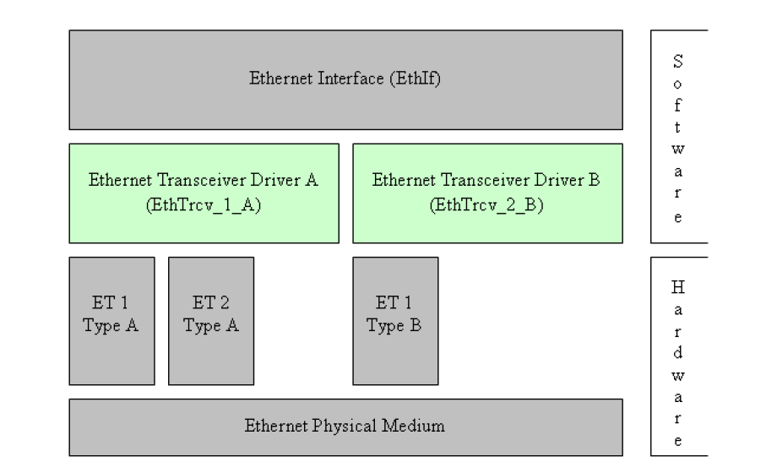

Acronyms and abbreviations
Term | Description
Application Layer | The Application Layer is placed above the RTE. Within the  Application Layer the AUTOSAR Software-Components are placed.
Eth | Ethernet Controller Driver (AUTOSAR BSW module)
EthTrcv | Ethernet Interface (AUTOSAR BSW module)
EthSM | Ethernet State Manager (AUTOSAR BSW module)
EthTrcv | Ethernet Transceiver Driver (AUTOSAR BSW module)
IP | Internet Protocol
TCP | Transmission Control Protocol
TCP/IP Stack | Ethernet communication stack
VLAN | Virtual Local Area Network
MII | Media Independent Interface (standardized Interface provided by Ethernet controllers to access Ethernet transceivers)
EC | Ethernet controller
ET | Ethernet transceiver

1.2 References
External to the project
- AUTOSAR_SWS_EthernetTransceiverDriver.pdf (AUTOSAR version 4.3)

Internal to the project

V-Autosar EthTrcv package is available at:
- Git folder : https://bsp-os.git.visteon.com/platform/bsp-os/turing/vautosar/com/ethernet

2 Overview

2.1 Functional Requirements Satisfied and General Information
AUTOSAR functional requirements satisfied in this EthTrcv can be find at EthTrcv_SRS.

2.2 Design Information

2.2.1 EthTrcv src and cfg files
- EthTrcv is implemented in here via EthTrcv.c in “src” folder. The header files are available in “include” folder
- The template of configuration file can be found in “cfg” as EthTrcv_Cfg.$h, EthTrcv_Lcfg.$c , EthTrcv_Lcfg.$h, EthTrcv_MemMap.$h , SchM_EthTrcv.$h, SchM_EthTrcv_Type.$h
- The dollar sign should be removed (like EthTrcv_Cfg.h,) from above template files and used to configure the EthTrcv as per the program requirements that are located in program specific private configuration folder.
- The EthTrcv_MemMap should be included in MemMap.h file and the SchM files to be included from the Rte genearation
Please refer the HLD (.Sbsx) for design information

2.2.2 EthTrcv doc
- AUTOSAR_SWS_EthTrcv.xlsx provides the requirement mapping of EthTrcv
- EthTrcv.sbsx provides the HLD and DD for EthTrcv component

2.2.3 EthTrcv test
- Functional Test Plan and Unit Testing plans are stored in test/plans
- Unit testing reports (Aggregate Coverage Report, Full Report, Metrics Report and Testcase Management Report) are stored test/ result
- Vector Cast tool can be run from ETHTRCV_VCAST_HT batch file stored in test\test.harness\EthTrcv

3 Configuration

3.1 EthTrcv_Cfg.h
Configuration items, which used in EthTrcv_Cfg.h, are listed below:

S.No | Configuration Item | Description
1 | ETHTRCV_DEV_ERROR_DETECT | Switches the development error detection and notification on or off.
2 | ETHTRCV_GET_BAUD_RATE_API | Enables / Disables EthTrcv_GetBaudRate API
3 | ETHTRCV_GET_DUPLEX_MODE_API | Enables / Disables EthTrcvGetDuplexModeApi API
4 | ETHTRCV_GET_LINK_STATE_API | Enables / Disables EthTrcvGetLinkStateApi API
5 | ETHTRCV_GET_TRANSCEIVER_MODE_API | Enables / Disables EthTrcvGetTransceiverModeApi API
6 | ETHTRCV_GET_TRANSCEIVER_WAKEUP_MODE_API | Enables / Disables EthTrcvGetTransceiverWakeupModeApi API
7 | ETHTRCV_SET_TRANSCEIVER_MODE_API | Enables / Disables EthTrcvSetTransceiverModeApi API
8 | ETHTRCV_START_AUTO_NEGOTIATION_API | Enables / Disables EthTrcvStartAutoNegotiationApi API
9 | ETHTRCV_VERSION_INFO_API | Enables / Disables EthTrcvVersionInfoApi API
10 | ETHTRCV_VERSION_INFO_API_MACRO | Enables / Disables EthTrcvVersionInfoApiMacro API
11 | ETHTRCV_INDEX | Specifies the InstanceId of this module instance. If only one instance is present it shall have the Id 0.
12 | ETHTRCV_MAIN_FUNCTION_PERIOD | Specifies the period of main function EthTrcv_MainFunction in milliseconds
13 | ETHTRCV_MAX_TRCVS_SUPPORTED | Specifies the Maximum number of transecivers supported
14 | ETHTRCV_WAKEUP_SUPPORT | Configures wake-up to polling or interrupt or to not used/not supported
15 | ETHTRCV_DEM_ERROR_DETECT | Enables/Disables the production error detection via DEM

3.2 EthTrcv_Lcfg.c

3.2.1 const EthTrcv_WakeupMapType[ETHTRCV_NUM_OF_WAKEUP_SOURCE]
Defines the mapping of wake up reasons to wake up sources

S.No | Element | Description
1 | EthTrcvWakeupReason | This parameter defines the transceiver wake up reasons.
2 | EcuMWakeupSourceId | This parameter defines the the wake-up source defined in EcuM.

3.2.2 const EthTrcv_ConfigType EthTrcv_Config
Defines the Configuration of the transceiver

S.No | Element | Description
 | EthTrcvAutoNegotiationEnabled | Auto-Negotiation is enabled (TRUE) or disabled (FALSE)
 | EthTrcvCtrlIdx | the controller idx used .
 | EthTrcvIdx | the instance ID of the configured transceiver
 | EthTrcvMiiIdx | the transceiver index used for MII access to the transceiver
 | EthTrcvTotalTrcvCount | Num of Trcv configured
 | EthTrcvConnNegType | the connection negotiation of the Ethernet transceiver link.
 | EthTrcvDuplexMode | the duplex mode of the Ethernet transceiver link
 | EthTrcvPhysLayerType | the physical layer type of the Ethernet transceiver link.
 | EthTrcvSpeed | the speed of the Ethernet transceiver link in [MBit/s].
 | EthTrcvIcuChannelId | Reference to the IcuChannel to enable/disable the interrupts for wakeups. supported if ETHTRCV_WAKEUP_SUPPORT != ETHTRCV_WAKEUP_NOT_SUPPORTED
 | pEthTrcvWakeUpCalloutFunc | the wakeup callout function name supported if ETHTRCV_WAKEUP_SUPPORT != ETHTRCV_WAKEUP_NOT_SUPPORTED
 | pEthTrcvWakeupMap | the mapping of wake up reasons to wake up sources. supported if ETHTRCV_WAKEUP_SUPPORT != ETHTRCV_WAKEUP_NOT_SUPPORTED
 | DemEventParameterId | the references to DemEventParameter Id. supported if ETHTRCV_DEM_ERROR_DETECT == STD_ON

4 Application Usage

5 Target System Requirements

5.1 Architecture
The EthTrcv does not require any specific hardware system architecture.

5.2 System Support
None.

5.3 System Resource Requirements

6 Integration Checklist

The following checklist to be used by the package user to help insure correctness of package integration and operation. For each item please check the checkbox upon verification of the item.

And Code
Name and date of persons completing checklist ____________________________________________
Item # | Item | Checkbox
1 | Check EthTrcv_Init called before scheduling the EthTrcv_MainFunction (polling)
2 | Verify the Eth driver and EthIf are integrated
3 | Check EthTrcv MainFunction called at desired Task Rate

7. Revision History

Revision Level | Section/page | Date | Description | Author
Version 1.0 | All | 28 Feb 2024 | Initial Release | pchinnat

ORIGINATOR OF THIS DOCUMENT

pchinnat

