Turing C Platform - TcpIp
User Guide

Version 1.0

ISSUE DATE: 28 Feb, 2024

Prepared by: Parthiban Chinnathambi <pchinnat@visteon.com>
______________________________


COC - OS & BSP

PROPRIETARY AND CONFIDENTIAL
This document contains information that is proprietary to Visteon Corporation. Recipients of the document shall not duplicate, use or disclose information contained herein, in whole or in part, for other than company purposes.

TABLE OF CONTENTS
1 Introduction 4
1.1 Features of LwIP v2.2.0 5
1.2 System Scalability 5
1.3 Acronyms and abbreviations 6
1.2 References 6
2 Overview 7
2.1 Functional Requirements Satisfied and General Information 7
2.2 Design Information 7
2.2.1 TcpIp src and cfg files 7
2.2.2 TcpIp doc 7
2.2.3 TcpIp test 7
2.2.4 LwIp Cfg 7
3 Configuration 8
3.1 TcpIp_Cfg.h 8
3.2 TcpIp_Lcfg.c 9
3.2.1 const TcpIp_AddrAssignmentConfigType TcpIp_AddrAssignmentConfig[TCPIP_NUM_OF_LOCALADDR] 9
3.2.2 const TcpIp_StaticIpAddressConfigType TcpIp_StaticIpAddressConfig[TCPIP_NUM_OF_LOCALADDR] 9
3.2.3 const TcpIp_LocalAddrConfigType TcpIp_LocalAddrConfig[TCPIP_NUM_OF_LOCALADDR] 10
3.2.4 const TcpIp_SocketOwnerConfigType TcpIp_SocketOwnerConfig[TCPIP_NUM_OF_SOCKETS] 10
3.2.5 const TcpIp_CtrlConfigType TcpIp_CtrlConfig 10
3.2.6 const TcpIp_TcpIpConfigType TcpIp_TcpIpConfig 11
3.2.7 TcpIp_<Socket Owner>GetSocket 11
4 Application Usage 11
5 Target System Requirements 11
5.1 Architecture 11
5.2 System Support 11
5.3 System Resource Requirements 11
6 Integration Checklist 12
7. Revision History 13

1 Introduction

This document describes basic functionality and the configuration of in-house AUTOSAR Basic Software module TcpIp . The AUTOSAR TCP/IP module offers functionality to send and receive Internet Protocol data.

AUTOSAR TcpIp :
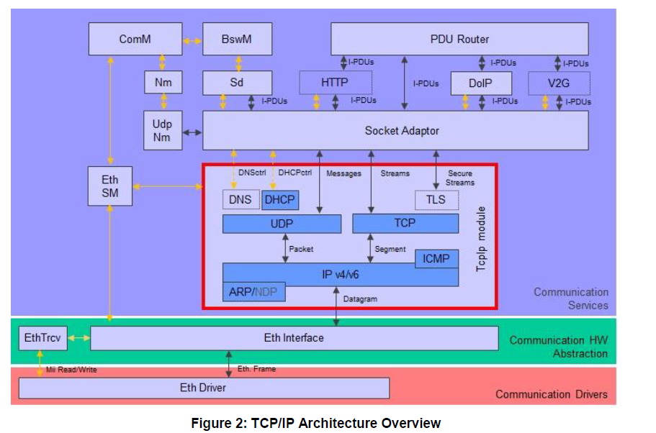

vAUTOSAR TcpIp stack using LWIP :

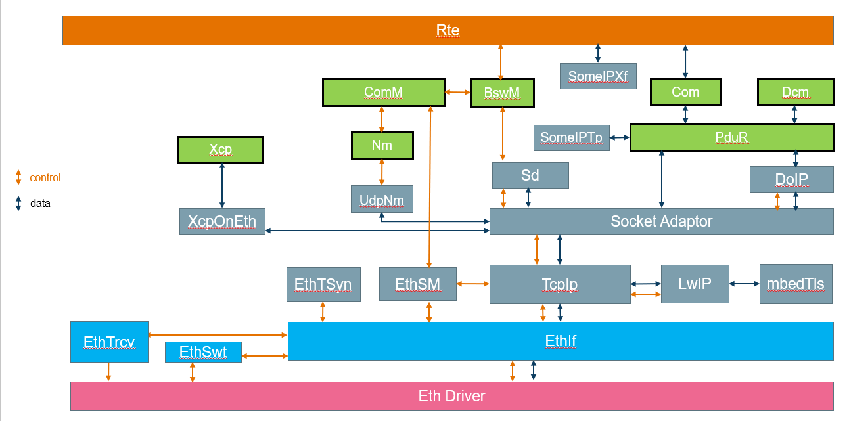

The vAutosar uses LwIp to realize the TcpIp module. LwIP is a small independent implementation of the TCP/IP protocol suite. The focus of the LwIP TCP/IP implementation is to reduce the RAM and ROM usage while still having a full-scale TCP.
LwIP is freely available under a BSD license

Features of LwIP v2.2.0
- IP (Internet Protocol, IPv4 and IPv6) including packet forwarding over multiple network interfaces
- ICMP (Internet Control Message Protocol) for network maintenance and debugging
- IGMP (Internet Group Management Protocol) for multicast traffic management
- MLD (Multicast listener discovery for IPv6). Aims to be compliant with RFC 2710. No support for MLDv2
- ND (Neighbor discovery and stateless address autoconfiguration for IPv6). Aims to be compliant with RFC 4861 (Neighbor discovery) and RFC 4862 (Address autoconfiguration)
- IP (Internet Protocol, IPv4 and IPv6) including packet forwarding over multiple network interfaces
- ICMP (Internet Control Message Protocol) for network maintenance and debugging
- IGMP (Internet Group Management Protocol) for multicast traffic management
- MLD (Multicast listener discovery for IPv6). Aims to be compliant with RFC 2710. No support for MLDv2
- ND (Neighbor discovery and stateless address autoconfiguration for IPv6). Aims to be compliant with RFC 4861 (Neighbor discovery) and RFC 4862 (Address autoconfiguration)

System Scalability
TcpIp Stack the protocols shall be grouped according to the following scalability classes:
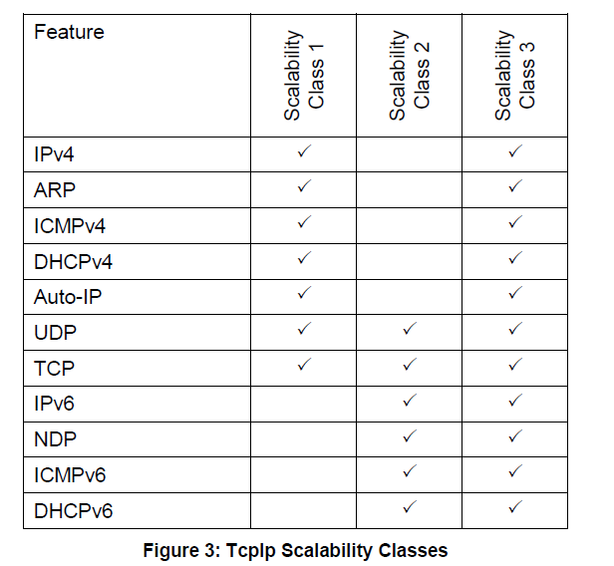
vAutosar LwIp stack supports Scalability class 1

Acronyms and abbreviations
Term | Description
Application Layer | The Application Layer is placed above the RTE. Within the  Application Layer the AUTOSAR Software-Components are placed.
Eth | Ethernet Controller Driver (AUTOSAR BSW module)
EthIf | Ethernet Interface (AUTOSAR BSW module)
TcpIp | Ethernet State Manager (AUTOSAR BSW module)
EthTrcv | Ethernet Transceiver Driver (AUTOSAR BSW module)
IP | Internet Protocol
TCP | Transmission Control Protocol
TCP/IP Stack | Ethernet communication stack
VLAN | Virtual Local Area Network
MII | Media Independent Interface (standardized Interface provided by Ethernet controllers to access Ethernet transceivers)
EC | Ethernet controller
ET | Ethernet transceiver
BswM | Basic Software Mode Manager
ComM | Communication Manager
DEM | Diagnostic Event Manager
DET | Default Error Tracer
EcuM | ECU State Manager
SchM | BSW Scheduler
SoAd | Socket Adaptor
IP | Internet Protocol
IPv4 | Internet Protocol version 4
IPv6 | Internet Protocol version 6
MTU | Maximum Transmission Unit
TCP | Transmission Control Protocol
TCP/IP | A family of communication protocols used in computer networks
UDP | User Datagram Protocol
ICMP | Internet Control Message Protocol
NDP | Neighbor Discovery Protocol
DHCP | Dynamic Host Configuration Protocol
ARP | Address Resolution Protocol
Sd | Service Discovery
IF-PDU | An IF-PDU is a PDU which is sent/received via the IF-API of the SoAd  TP-PDU
TP-PDU | An TP-PDU is a PDU which is send/received via the TP-API of the SoAd

1.2 References
External to the project
- AUTOSAR_SWS_TcpIp.pdf (AUTOSAR version 4.3)

Internal to the project

V-Autosar TcpIp package is available at:
- Git folder :
  - TcpIp https://bsp-os.git.visteon.com/platform/bsp-os/turing/vautosar/com/ethernet
  - LwIp https://bsp-os.git.visteon.com/platform/bsp-os/turing/vautosar/com/lwip

2 Overview

2.1 Functional Requirements Satisfied and General Information
AUTOSAR functional requirements satisfied in this TcpIp can be find at TcpIp_SRS.

2.2 Design Information

2.2.1 TcpIp src and cfg files
- TcpIp is implemented in here via TcpIp.c in “src” folder. The header files are available in “include” folder
- The template of configuration file can be found in “cfg” as TcpIp_Cfg.$h, TcpIp_Lcfg.$c , TcpIp_Lcfg.$h, TcpIp_MemMap.$h , SchM_TcpIp.$h, SchM_TcpIp_Type.$h
- The dollar sign should be removed (like TcpIp_Cfg.h,) from above template files and used to configure the TcpIp as per the program requirements that are located in program specific private configuration folder.
- The TcpIp_MemMap should be included in MemMap.h file and the SchM files to be included from the Rte genearation
Please refer the HLD (.Sbsx) for design information

2.2.2 TcpIp doc
- AUTOSAR_SWS_TcpIp.xlsx provides the requirement mapping of TcpIp
- TcpIp.sbsx provides the HLD and DD for TcpIp component

2.2.3 TcpIp test
- Functional Test Plan and Unit Testing plans are stored in test/plans
- Unit testing reports (Aggregate Coverage Report, Full Report, Metrics Report and Testcase Management Report) are stored test/ result
- Vector Cast tool can be run from TCPIP_VCAST_HT batch file stored in test\test.harness\TcpIp

2.2.4 LwIp Cfg
- LwIp configuration files are lwipopts.h , sys_arch.c which should be placed in the program specific private configuration folder

3 Configuration

3.1 TcpIp_Cfg.h
Configuration items, which used in TcpIp_Cfg.h, are listed below:

S.No | Configuration Item | Description
 | TCPIP_BUFFER_MEMORY | Memory size in bytes reserved for TCP/IP buffers.
 | TCPIP_DEV_ERROR_DETECT | Switches the development error detection and notification on or off.
 | TCPIP_DHCP_SERVER_ENABLED | Enables (TRUE) or disables (FALSE) the DHCP (Dynamic Host Configuration Protocol) Server.
 | TCPIP_GET_AND_RESET_MEASUREMENT_DATA_API | Enables / Disables the Get and Reset Measurement Data API
 | TCPIP_MAINFUNCTIONPERIOD | Period of TcpIp_MainFunction in milliseconds
 | TCPIP_RESET_IP_ASSIGNMENT_API | Enables/disables the API TcpIp_ResetIpAssignment of a DHCP-client
 | TCPIP_SCALABILITY_CLASS | Defines the scalability class of TcpIp stack
 | TCPIP_TCP_ENABLED | Enables (TRUE) or disabled (FALSE) support of TCP (Transmission Control Protocol)
 | TCPIP_TCP_SOCKET_MAX | Maximum number of TCP sockets
 | TCPIP_UDP_ENABLED | Enables (TRUE) or disabled (FALSE) support of UDP (User Datagram Protocol)
 | TCPIP_UDP_SOCKET_MAX | Maximum number of UDP sockets
 | TCPIP_VERSION_INFO_API | If true the TcpIp_GetVersionInfo API is available
 | TCPIP_ARP_ENABLED | Enables (TRUE) or disables (FALSE) support of ARP (Address Resolution Protocol).
 | TCPIP_AUTO_IP_ENABLED | Enables (TRUE) or disables (FALSE) the Auto-IP (automatic private IP addressing) sub-module.
 | TCPIP_DHCP_CLIENT_ENABLED | Enables (TRUE) or disables (FALSE) the DHCP (Dynamic Host Configuration Protocol) Client.
 | TCPIP_ICMP_ENABLED | Enables (TRUE) or disabled (FALSE) support of ICMP (Internet Control Message Protocol).
 | TCPIP_IPV4_ENABLED | Enables (TRUE) or disables (FALSE) support of IPv4 (Internet Protocol version 4)
 | TCPIP_LOCAL_ADDR_IPV4_ENTRIES_MAX | Maximum number of LocalAddr table entries for IPv4
 | TCPIP_PATH_MTU_DISCOVERY_ENABLED | Enables (TRUE) or disables (FALSE) the discovery of the maximum transmission unit on a path according to IETF RfC 1191
 | TCPIP_DHCPV6_CLIENT_ENABLED | Enables (TRUE) or disables (FALSE) the DHCPv6 (Dynamic Host Configuration Protocol for IPv6) Client
 | TCPIP_IPV6_ENABLED | Enables (TRUE) or disables (FALSE) support of IPv6 (Internet Protocol version 6)
 | TCPIP_IPV6_PATH_MTU_DISCOVERY_ENABLED | Enables (TRUE) or disables (FALSE) Path MTU Discovery support for IPv6 according to IETF RFC 1981
 | TCPIP_LOCAL_ADDR_IPV6_ENTRIES_MAX | Maximum number of LocalAddr table entries for IPv6
 | TCPIP_NDP_AR_UNRECHABILITY_DETECTION_ENABLED | Enables (TRUE) or disables (FALSE) support of Address Resoultion and Neighbor Unreachability  Detetion via NDP
 | TCPIP_NDP_PREFIX_AND_ROUTER_DISCOVERY_ENABLED | Enables (TRUE) or disables (FALSE) support of Prefix and Router Discovery via NDP.
 | TCPIP_NUM_OF_CONTROLLERS | Defines the number of controllers supported
 | TCPIP_ADDR_ID_CFG1 | Defines the address configuration id
 | TCPIP_NUM_OF_SOCKETS | Defines the number of sockets supported
 | TCPIP_NUM_OF_LOCALADDR | Defines the number of local addresses supported
 | TCPIP_RX_BUFFER_SIZE | Defines the TcpIP Rx buffer size (not used with LWIP_NO_SYS)
 | ETH_MAC_ADDR | Defines the MAC address of the controller
 | LWIP_TCPIP_INIT_DONE_CALLBACK | Defines whether the TcpIp Init callback to be configured
 | LWIP_NO_SYS | Defines whether the system supports bsd style RTOS api
 | TCPIP_SOCKET_OWNER_ID_SOAD | Defines the socket owner id for SoAd

3.2 TcpIp_Lcfg.c

3.2.1 const TcpIp_AddrAssignmentConfigType TcpIp_AddrAssignmentConfig[TCPIP_NUM_OF_LOCALADDR]
Defines the configuration for the the assignment policy for the IP address.

S.No | Element | Description
1 | AssignmentLifetime | Defines the lifetime of a dynamically fetched IP address.
2 | AssignmentMethod | Method of address assignment
3 | TcpIpAssignmentPriority | Priority of assignment (1 is highest).
4 | TcpIpAssignmentTrigger | Trigger Type of address assignment

3.2.2 const TcpIp_StaticIpAddressConfigType TcpIp_StaticIpAddressConfig[TCPIP_NUM_OF_LOCALADDR]

Defines static IP address including directly related parameters

S.No | Element | Description
 | TcpIpStaticIpAddress | Static IPv4 Address
 | TcpIpDefaultRouter | IPv4 address of default router (gateway)
 | TcpIpNetmask | Network mask of IPv4 address in CIDR Notation

const TcpIp_LocalAddrConfigType TcpIp_LocalAddrConfig[TCPIP_NUM_OF_LOCALADDR]

Defines the local IP (Internet Protocol) addresses configuration.

S.No | Element | Description
 | TcpIpAddrId | IP address table identifier assigned by TCP/IP stack
 | AddressType | Defines the address type
 | DomainType | Address family.
 | CtrlConfigId | Reference to a TcpIpCtrl specifying the EthIf Controller where the IP address shall be assigned
 | pAddrAssignmentConfig | Pointer to the AddrAssignment configuration
 | pStaticIpAddressConfig | Pointer to the Static Ip Address configuration

const TcpIp_SocketOwnerConfigType TcpIp_SocketOwnerConfig[TCPIP_NUM_OF_SOCKETS]

Defines the upper layer configuration of TcpIp that uses the socket API.

S.No | Element | Description
 | SocketOwnerCopyTxDataFunc | Defines the <Up_CopyTxData> function of the TcpIpSocketOwner module
 | SocketOwnerLocalIpAddrAssignmentChgFunc | Defines the name of the <Up_LocalIpAddrAssignmentChg> function of the TcpIpSocketOwner Module
 | SocketOwnerRxIndicationFunc | Defines the name of the <Up_RxIndication> function of the TcpIpSocketOwner module
 | SocketOwnerTcpAcceptedFunc | Defines the name of the <Up_TcpAccepted> function of the TcpIpSocketOwner module
 | SocketOwnerTcpConnectedFunc | defines the name of the <Up_TcpConnected> function of the TcpIpSocketOwner module
 | SocketOwnerTcpIpEventFunc | defines the name of the <Up_TcpIpEvent> function of the TcpIpSocketOwner module
 | SocketOwnerTxConfirmationFunc | defines the name of the <Up_TxConfirmation> function of the TcpIpSocketOwner module
 | SocketOwnerUL | specifies the type of the upper layer module.

const TcpIp_CtrlConfigType TcpIp_CtrlConfig

Defines the configuration of the TcpIp ctrl.

S.No | Element | Description
 | FramePrioDefault | Specifies the default value for the priority for all outgoing frames.
 | EthIfCtrlId | Reference to EthIf controller where the IP address shall be assigned.

const TcpIp_TcpIpConfigType TcpIp_TcpIpConfig

Defines the Configuration data structure of the TcpIp module

S.No | Element | Description
 | pCtrlConfig | pointer to the Controller configuration array.
 | pLocalAddrConfig | pointer to the Local address configuration array
 | pSocketOwnerConfig | pointer to the Controller configuration array

TcpIp_<Socket Owner>GetSocket
Get Socket function should be defined for each Socket owner. Below is an example of SoAd layer

Std_ReturnType TcpIp_SoAdGetSocket
(
TcpIp_DomainType Domain,
TcpIp_ProtocolType Protocol,
P2VAR(TcpIp_SocketIdType,AUTOMATIC,TCPIP_APPL_DATA) SocketIdPtr
)
{
return TcpIp_GetSocket(TCPIP_SOCKET_OWNER_ID_SOAD,Domain,Protocol,SocketIdPtr);
}

4 Application Usage

5 Target System Requirements

5.1 Architecture
The TcpIp does not require any specific hardware system architecture.

5.2 System Support
None.

5.3 System Resource Requirements

6 Integration Checklist

The following checklist to be used by the package user to help insure correctness of package integration and operation. For each item please check the checkbox upon verification of the item.

And Code
Name and date of persons completing checklist ____________________________________________
Item # | Item | Checkbox
1 | Check TcpIp_Init called before scheduling the TcpIp_MainFunction
2 | Verify the Eth driver , EthSM , EthIf and Eth Trcv are integrated
3 | Check TcpIp MainFunction called at desired Task Rate

7. Revision History

Revision Level | Section/page | Date | Description | Author
Version 1.0 | All | 28 Feb 2024 | Initial Release | pchinnat

ORIGINATOR OF THIS DOCUMENT

pchinnat

