Software Detailed Design Specification
1.2

Table of Contents

1 Predesign Review 3
1.1 Purpose 3
1.2 Public interface (Ctrl_Illumination.c) 3
1. External Interface: Rte_Read Interface 3
2. Private Interface: Input_Processing 3
3. Private Interface: Process_Ctrl_Illumination 4
4. Private Interface: Illumination_Data_Handle 4
5. Private Interface: Slicing_control 4
6. Private Interface: Timing_control 4
7. Private Interface: Default_Control 5
8. Private Interface: Off_mode_control 5
1.3 Design choice 5
1.4. File structure 6

References

Reference | Document Name | Version
1
2

Definitions

Term | Abbreviation | Description

Revision History

Version | Date | Author | Description of changes
1.0 | May-05-2025 | AELANGO6 | This document is the detail design of Illumination – Initial Version
1.1 | May-30-2025 | AELANGO6 | Updated the Input and structure to adapt multiple displays
1.2 | June-30-2025 | AELANGO6 | Slew rate control and determination mechanism in slicing is redefined  Illumctrl_Op datatype changed from uint8 to uint16 to handle resolution and slew rates

Predesign Review

Purpose
This document is the detail design methodology for Illumination component.

Public interface (Ctrl_Illumination.c)
Input structure:
typedef struct
typedef struct
{
UInt8 Illumination_Mode;
UInt8 battery_status;
UInt8 Illumination_Sts;
UInt8 power_mode;
UInt8 step_value;
UInt8 step_direction;
UInt8 switch_type;
UInt16 Derating_Value;

} IllumCtrl_Ip;

Output Structure:
typedef struct
{
UInt16 Illumination_Duty_Out [NO_OF_DUTY];
UInt16 Brightness_Out [NO_OF_BGT];
UInt16 RGB_Dimming_Out [NO_OF_RGB];
UInt16 Bulb_PWM_Out [NO_OF_BULB];
UInt16 LED_PWM_Out [NO_OF_LED];
UInt16 Dial_Out [NO_OF_DIAL];
UInt16 Display_Out [NO_OF_DISPLAYS];
UInt16 Telltale_Out [NO_OF_TELLTALES];

} IllumCtrl_Op;

External Interface: Rte_Read Interface

Method | Rte_Read Interface(IllumCtrl_Ip fl_IllumCtrl_Ip)
Reentrant | No
Parameters | IllumCtrl_Ip structure
Return | void
Description | This Rte Read Function Reads the Input data from the Model component

Private Interface: Input_Processing

Method | Static void Input_Processing(void)
Reentrant | No
Parameters | void
Return | void
Description | Function call from CmpActive to read the inputs from the model

Private Interface: Process_Ctrl_Illumination

Method | Static void Process_Ctrl_Illumination(void)
Reentrant | No
Parameters | void
Return | void
Description | This function is act as main function to call the subsequent functions to process the Illumination data such as IlluminationMode check, Switching control,etc

Private Interface: Illumination_Data_Handle

Method | Static void Illumination_Data_Handle(IllumCtrl_Ip l_IllumCtrl_Ip, IllumCtrl_Op_Ptr l_IllumCtrl_Op  )
Reentrant | No
Parameters | IllumCtrl_Ip l_IllumCtrl_Ip, IllumCtrl_Op_Ptr l_IllumCtrl_Op
Return | void
Description | Function used to identify the switching algorithm based on the switch type from Mdl.

Private Interface: Slicing_control

Method | void Slicing_control(IllumCtrl_Ip l_illumctrl_ip,IllumCtrl_Op_Ptr l_illumctrl_op)
Reentrant | No
Parameters | IllumCtrl_Ip l_illumctrl_ip,IllumCtrl_Op_Ptr l_illumctrl_op
Return | void
Description | Function is used to control the Illumination outputs based on the slewrates configured in CFG files

Private Interface: Timing_control

Method | Static void Timing_control (IllumCtrl_Ip fl_IllumCtrl_Ip, IllumCtrl_Op Fl_IllumCtrl_Op)
Reentrant | No
Parameters | IllumCtrl_Ip fl_IllumCtrl_Ip, IllumCtrl_Op Fl_IllumCtrl_Op
Return | void
Description | This function is used to control the timing control of the PWM data.

Private Interface: Default_Control

Method | void Default_control(IllumCtrl_Ip l_illumctrl_ip, IllumCtrl_Op_Ptr l_illumctrl_op)
Reentrant | No
Parameters | IllumCtrl_Ip fl_IllumCtrl_Ip, IllumCtrl_Op Fl_IllumCtrl_Op
Return | void
Description | Function is used to handle default logic of Illumination – extended to core extension area to handle program specific logic

Private Interface: Off_mode_control

Method | void Off_mode(IllumCtrl_Ip l_illumctrl_ip, IllumCtrl_Op_Ptr l_illumctrl_op)
Reentrant | No
Parameters | IllumCtrl_Ip fl_IllumCtrl_Ip, IllumCtrl_Op Fl_IllumCtrl_Op
Return | void
Description | Function is used to handle the Illumination Off feature – extended to core extension area to handle program specific logic

1.3 Design choice

1.3.1 Ctrl-Illumination flow:

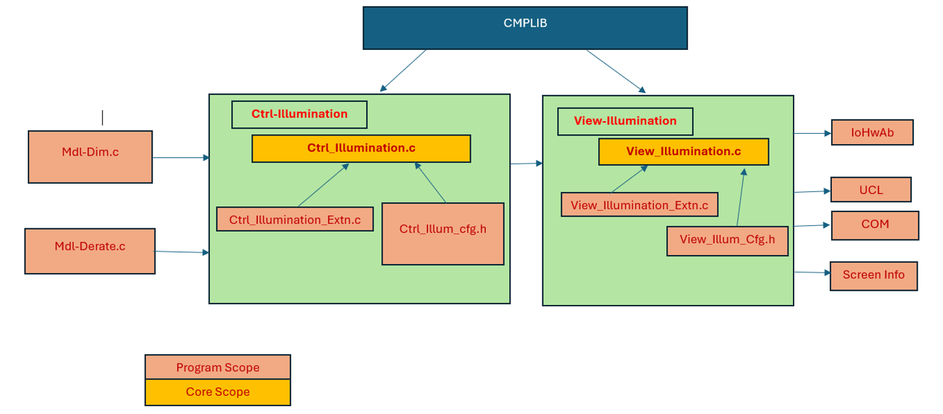

1.3.2. Class Diagram:

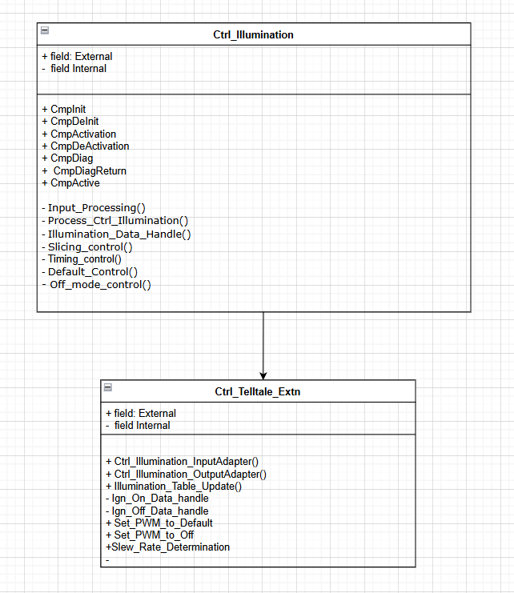

1.4. File structure
Bookshelf:
Ctrl_Illumination.c and Ctrl_Illumination.h

Core-extension:
Ctrl_Illumination_Extn.c and Ctrl_Illumination_Extn.h

