DOMAIN | CLUSTER & DISPLAYS | GROUP | METERS FG

ABSTRACT
This document presents the software architecture design view for the Illumination feature.

It describes the Illumination feature’s core requirements, high level design, Interfaces definition along with data path between Application (Model, Controller) and CDD and UCL components.

It also describes the design limitations and test strategy applicable for this feature implementation.

This deliverable documents approvals for recording in the documentation management database.
 | Author | 1st Review | 2nd Review | Distribution authorized by
Function | Technical Lead | Project Dev. Tech Lead | SW Architect | Tech Team Managers
Name
Date

REVISION SUMMARY
Revision | Date | Author | Modified paragraphs and kind of modification
1.0 | 05-MAY-2025 | AELANGO6 | Initial Version
1.1 | 30-JUN-2025 | AELANGO6 | Design change to adapt slew rate determination and timing control mechanism

CONTENTS
1 INTRODUCTION 4
1.1 Purpose 4
1.2 Scope 4
1.3 Target Audience 4
1.4 Definitions, Acronyms and Abbreviations 4
1.5 Reference Documents 5
2 REQUIREMENTS 6
2.1 IL_R01_Illumination_Data_Handling 6
2.2 IL_R02_Illumination_based_On_Timers 6
2.3 IL_R03_Illumination_based_on_Slew_Rate 6
2.4 IL_R04_Duty_Transition_Default_Control 6
2.5 IL_R05_Derating_Handling 6
3 ARCHITECTURE VIEW 7
3.1.1 SAD - Definitions 7
3.1.1.1 Design Pattern 7
3.1.1.2 High Level Control Algorithm: 8
3.1.1.3 Test Strategy 9
3.1.1.3.1 Unit Test 9
3.1.1.3.1.1 GUIDELINES 9
3.1.1.3.1.2 REFERENCE 9
3.1.1.3.2 Functional Test 9
3.1.1.4 Design Limitations 9

INTRODUCTION

Purpose
The purpose of this document is to describe the software architecture design view for the Illumination feature in the instrument cluster.

Scope
The scope of this document is to describe core feature requirements and standardize the design framework of the chime feature.

Target Audience
The audience of this document include SW Architect, Project Dev Tech Lead, APP tech teams.

Definitions, Acronyms and Abbreviations
Definition | Description
ECU | Electronic Control Unit
SAD | Software Architecture Design
CAN | Controller Area Network
IoHwAb | Input Output Hardware Abstraction

Reference Documents
Reference document and its respective link is shared below. Ref. label may be used across this document.

Ref. | Topics | Reference
[R1]

REQUIREMENTS
REQ_ID | DESCRIPTION | SCOPE

IL_R01_Illumination_Data_Handling
DC_R01 | Applicable Illumination Components can be configurable in Cfg  Illumination Components Available:  1. LED 5. Telltale  2. Bulb 6. RGB  3. Dial  4. Display | APP

IL_R02_Illumination_based_On_Timers
DC_R02 | Based on the configured timer values for each mode and step – corresponding PWM values will switch within the time delay. | APP

IL_R03_Illumination_based_on_Slew_Rate
DC_R03 | Based on the Slew rates configured for transition between each modes and steps – brightness will fade in or fade out within the update frequency configured. | APP

IL_R04_Duty_Transition_Default_Control
DC_R04 | Based on Program specific control mechanism apart from time based or slew based will be handled in the default control mechanism | APP

2.5 IL_R05_Derating_Handling
 | Illumination control based on TFT temperature value.  Whichever Duty is considered applicable – made as configurable in cfg will be sent to view component. | APP

ARCHITECTURE VIEW

SAD - Definitions
SW Architecture design supports high-level design at component level and detailed design at requirement level.

Design Pattern
Architectural design pattern as below.

Use MVC Architectural design pattern as below.
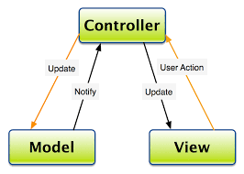
- The overall architecture of the feature follows Model – View – Controller Architecture pattern.
- Components are first classified based on their role in MVC.
- Business logics are implemented in the models (corresponding to M in MVC). They act as clients to a controlling server and use the interfaces provided by the server.
- Controllers are mainly implemented as servers providing a set of defined services to the model and interfacing with View.
- Controller in the example decomposition acts as server, providing a set of defined services to the Model clients.
- Example of services are, controlling the Illumination level based on step, controlling illumination between two different illumination modes, providing to data to the view component to segregate the type of Output.
- Models in the decomposition are a set of instantiated base classes. They do similar functionality and share same interfaces to the controller.
- Any of the individual base class can be removed without affecting other classes in the same model. It does not affect the controller as well.
- This kind of definition allows us to do a plug and play approach where new classes can be added or removed.

High Level Control Algorithm:
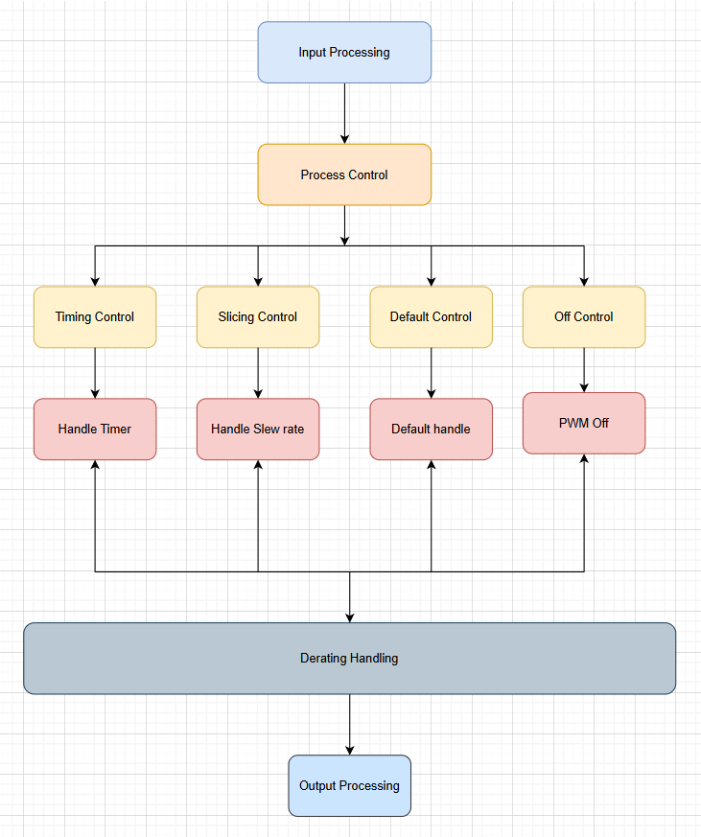

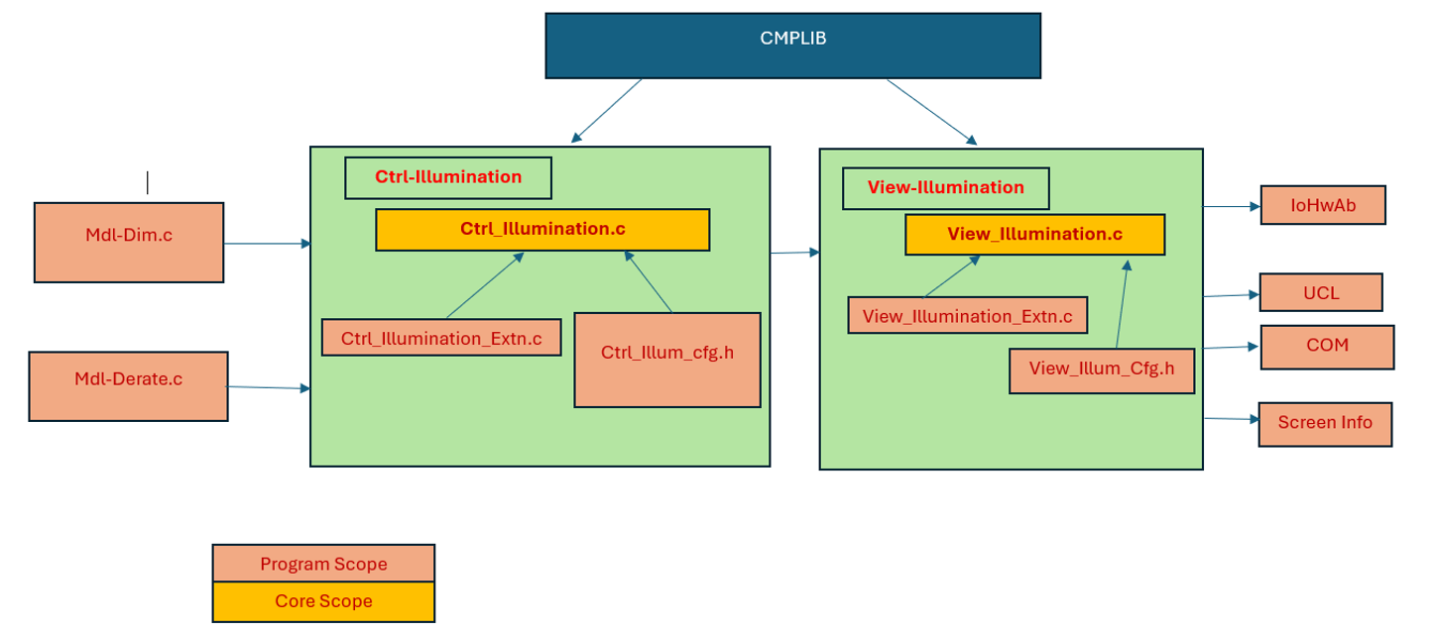

Test Strategy

Unit Test

GUIDELINES
- Scalable design unit with defined inputs and outputs help creating effective test plan and more portable to any SW architecture. Refer below code reference template.
- Create unit test plan design unit-wise for a feature model by also capturing related requirement IDs for each test case.
- For any incoming defects, verify the unit test plan against defect use case and identify escape reason to improve the gaps.

REFERENCE
Refer below example implementation (Not for model-based designs):
RTE inputs and outputs are isolated from the design unit which allows more flexibility to create reusable TP’s.

Functional Test
Will be covered as part of the Illumination model feature functional verification.

Design Limitations

- Initial Design – could be revised in subsequent iterations based on the approvals from Core team leads

