Software Detailed Design Specification
1.0

Table of Contents

1 Preparation for pre-design review 3
1.1 Purpose 3
1.2 Public interface (Ctrl_telltale.c) 3
1. Input Interface: 3
2. Input Interface: 3
1.3 public Interface (Ctrl_telltale.adapter.c) 3
1.4. a Private Interface (Ctrl_telltale.c) 4
1.4. b Private Interface (Ctrl_Telltale_blinkctrl.c) 5
1.4. c Private Interface (Ctrl_Telltale_Extn.c) 9
1.4 Design choice 10
1.5 File structure 13
1.6 Functional blocks (Bookshelf) 15
1.7 Ctrl telltale Functional block (Toyota Specific) 15
1.8 Port Interface details 15
1.8.1 Providing ports 15
1.8.2 Receiving ports 15
1.9 CTRL APP State mapping 15
1.10 Design Assumptions 15
2 Pre-design review conclusions 15
3 Detailed design 16
3.1 Private interfaces 16
3.2 Internal data structures 16
3.3 Algorithms explanation 16
3.4 Component configuration 17
3.4.1 Task period – --25 ms //Project specific 17
3.4.2 Timing constraints 17
3.4.3 NVM access 17
3.5 Registers 18
4 Lessons Learnt 18
4.1 Similar issues/use cases addressed 18
5 Tools 18
6 Traceability 18

References

Reference | Document Name | Version
1 | AppTech_Telltale_Feature_Software_Architecture_Design | Initial Version
2

Definitions

Term | Abbreviation | Description
ms | Milli second | Time unit

Revision History

Version | Date | Author | Description of changes
1.0 | Apr-22-2024 | ABETAGER | This document is the detail design of Ctrl_Telltale
2.0 | Sep -17-2024 | CKULOTHU | This document is the detail design of Ctrl_Telltale

Preparation for pre-design review

Purpose
This document is the detail design methodology for Ctrl_Telltale component.

Public interface (Ctrl_telltale.c)

Input Interface:

Method | Rte_Read_rpTelltlaeStatus_rp_ADAS_TT_Status_CurrentTelltaleStatus(&tt_ip_array_adapter [TT_ADAS_INDEX]);
Sync/Async | Sync
Reentrant | No
Parameters | uint8 tt_ip_array_adapter
Return | void
Description | This Interface updates telltale status in tt_ip_array_adapter in ctrl_telltale_adapter

Input Interface:

Method | Rte_Read_rpIgnSubstate_IgnitionSubstate((&(l_Current_Ignition_state)))
Sync/Async | Sync
Reentrant | No
Parameters | uint8 l_Current_Ignition_state
Return | void
Description | This Interface updates the IGN Status as ON / OFF S

- Output Interface

Method | Rte_Write_ppTelltaleStatusOP_TelltaleOpArray (&(CtrlTTStatus_Array[0]))
Sync/Async | Sync
Reentrant | No
Parameters | uint8 CtrlTTStatus_Array[]
Return | void
Description | This function is used to process the telltale status and send the output status to the UCL interface

public Interface (Ctrl_telltale.adapter.c)

Method | Ctrl_telltale_Adapter_Task(void)
Sync/Async | Sync
Reentrant | No
Parameters | Void
Return | void
Description | This function is used to process the telltale status from app and updates the Telltale status to Ctrl telltale

1.4. a Private Interface (Ctrl_telltale.c)

Method | static void InputProcess(void)
Sync/Async | Sync
Reentrant | No
Parameters | void
Return | void
Description | This function is used to process the IGN status and battery status

Method | static void Process_Ctrl_Telltale(void)
Sync/Async | Sync
Reentrant | No
Parameters | void
Return | void
Description | This function processes the Proveout, battery status and updates the status of each telltale in a array of structure TTInfoTable

Method | static void OutputProcess(void)
Sync/Async | Sync
Reentrant | No
Parameters | void
Return | void
Description | This function process updates the TT output status through RTE INTERFACE

Method | static uint8 CtrlTtGetStateByte(uint8 CtrlTtIgnSts)
Sync/Async | Sync
Reentrant | Yes
Parameters | uint8 CtrlTtIgnSts
Return | void
Description | This function is used to process the Ignition state.

Method | void CtrlTt_CtrlTtUpdateStatus(uint8 index, uint8 tt_status)
Sync/Async | Sync
Reentrant | No
Parameters | uint8 index , uint8 tt_status
Return | void
Description | This function is used to update the Input TT status for all the indexes in the array CtrlTtSts.

Method | void CtrlTt_CtrlTtGetStatus(uint8 index, uint8 *tt_status)
Sync/Async | Sync
Reentrant | No
Parameters | uint8 index , uint8 *tt_status
Return | void
Description | This function is used to check the current input TT Status based on the index.

Method | void CtrlTtStatus_Output_Array(uint8 index, uint8 TT_Phase)
Sync/Async | Sync
Reentrant | No
Parameters | uint8 index , uint8 TT_Phase
Return | void
Description | This function is used to update the Output TT status for all the indexes in the array CtrlTTStatus_Array

1.4. b Private Interface (Ctrl_Telltale_blinkctrl.c)

Method | void BlinkCtrl_Update_Output (void)
Sync/Async | Sync
Reentrant | No
Parameters | void
Return | void
Description | This function is used to process the blinking status of all telltales

Method | static void assignTTStatus(uint8 index, uint8 status)
Sync/Async | Sync
Reentrant | No
Parameters | uint8 index, uint8 status
Return | void
Description | This function updates the Current TT Phase and Previous TT Input Status

Method | Void Process_PrevOFFState_TT(uint8 index)
Sync/Async | Sync
Reentrant | No
Parameters | uint8 index
Return | void
Description | This function is used to process OFF state to On state or other Frequency State or Maintain previous State

Method | Void Process_PrevONState_TT(uint8 index)
Sync/Async | Sync
Reentrant | No
Parameters | uint8 index
Return | void
Description | This function is used to process ON state to OFF state or other Frequency State or Maintain previous State

Method | Void Process_PrevBlinkState_TT(uint8 index)
Sync/Async | Sync
Reentrant | No
Parameters | uint8 index
Return | void
Description | This function is used to process Blink state to OFF state or other Frequency State or Maintain previous State

Method | static void isOnAllowed(uint8 index)
Sync/Async | Sync
Reentrant | No
Parameters | uint8 index
Return | void
Description | This Function is used to update the current TT phase based on the index.

Method | static void BlinkCtrl_Prepare_Flash_Process(uint8 Tt_index, uint8 Tt_target_phase)
Sync/Async | Sync
Reentrant | No
Parameters | uint8 index
Return | void
Description | This Functions prepares to blink the frequency specified of all telltales

Method | static void BlinkCtrl_Same_Flash_Process(uint8 Tt_index)
Sync/Async | Sync
Reentrant | No
Parameters | uint8 index
Return | void
Description | This Function maintains the previous state

Method | static void BlinkCtrl_Different_Flash_Process(uint8 Tt_index)
Sync/Async | Sync
Reentrant | No
Parameters | uint8 index
Return | void
Description | This Function process the Change in blink Frequency of all telltales

Method | static void BlinkCtrl_Asynchronous_Flash_Process(uint8 Tt_index)
Sync/Async | Sync
Reentrant | No
Parameters | uint8 index
Return | void
Description | This Function processes the Counter processing For ON and OFF Cycle of all telltales

Method | static void BlinkCtrl_Flash_Min_Max_Cntr_Process(uint8 Tt_index)
Sync/Async | Sync
Reentrant | No
Parameters | uint8 index
Return | void
Description | This Function process the Min and Max duration of the telltales should play after the input is removed

Method | void BlinkCtrl_TtViewUpdateStatus(uint8 index, uint8 tt_status)
Sync/Async | Sync
Reentrant | No
Parameters | uint8 index, uint8 tt_status
Return | void
Description | This Function updates the current TT status in the TTInfoTable (Array of Structure) based on the index.

1.4. c Private Interface (Ctrl_Telltale_Extn.c)

Method | uint8 CtrlTtVoltageLviHvi(void)
Sync/Async | Sync
Reentrant | No
Parameters | void
Return | void
Description | This Function updates the current battery status (Normal,low Voltage, High voltage)

Method | uint8 CtrlTtCheckBatteryStatus(uint8 index, uint8 l_turn_on_off, uint8 battery_status)
Sync/Async | Sync
Reentrant | No
Parameters | uint8 index
Return | void
Description | This Function process the Voltage Conditions

Method | void CtrlTtCheckProveout()
Sync/Async | Sync
Reentrant | No
Parameters | uint8 index
Return | void
Description | This Function process the prove out condition for the Telltales

Method | uint8 CtrlTt_InitProveout(index, l_turn_on_off, tt_state_byte)
Sync/Async | Sync
Reentrant | No
Parameters | uint8 index
Return | void
Description | This Function defines the initialization of the prove out values

1.4 Design choice

1.4.1 Ctrl telltale Design:

1. TFT Telltales Flow:

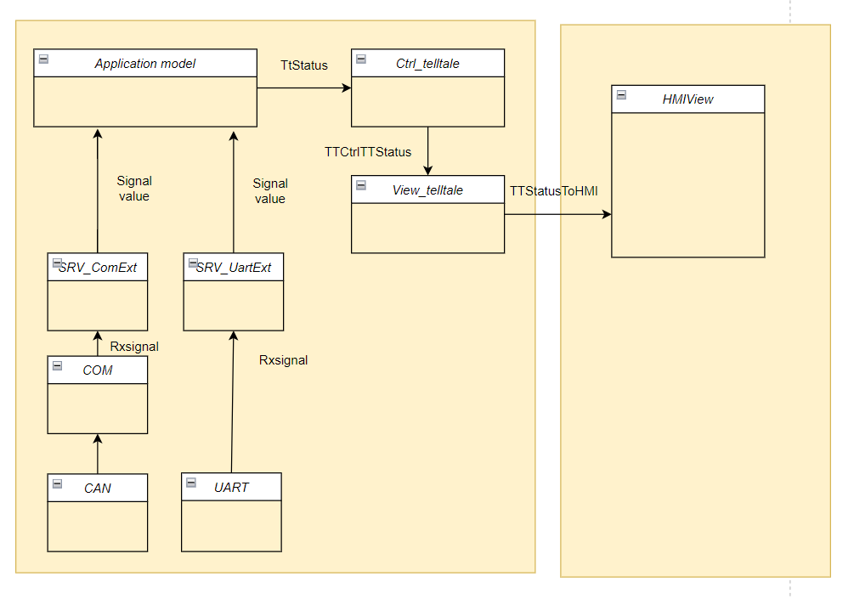

- HW Telltales Flow:

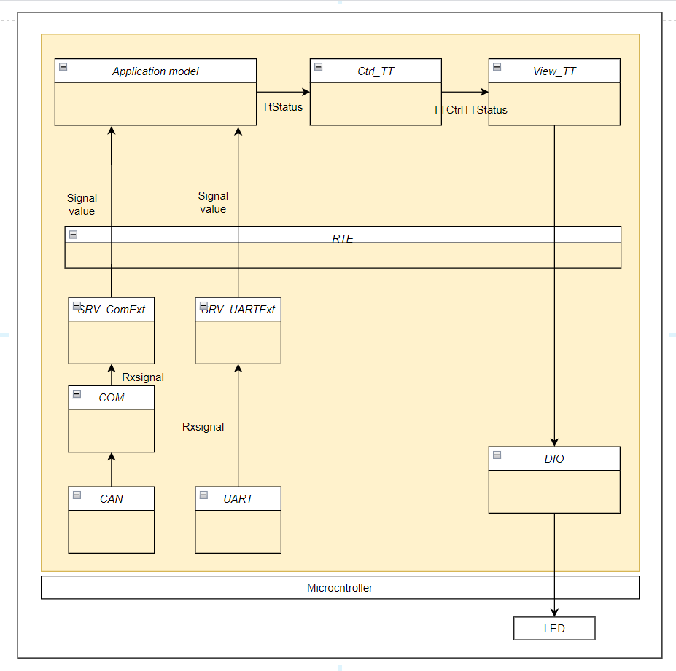

3.Ctrl telltale Sequence Design:

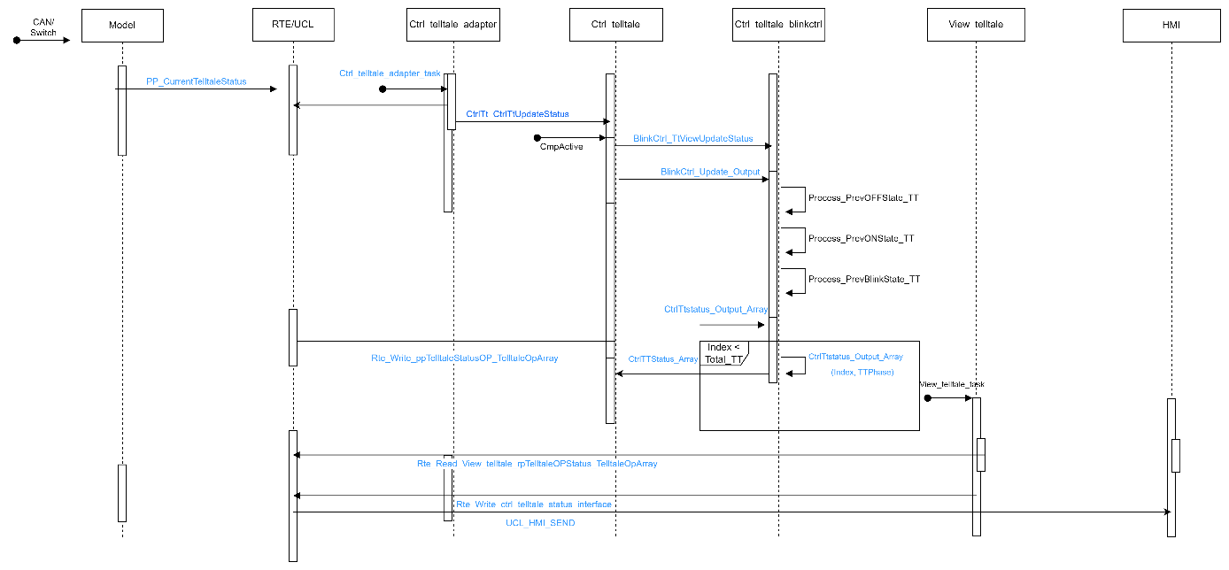

Ctrl telltale Sequence Design

4.Available configurations:

- cIGN_RUN - RUN Bit, if set in attributes, the tt will be enabled in RUN.
- cIGN_OFF - OFF Bit, if set in attributes, the tt will be enabled in OFF.
- cIGN_ACC - ACC Bit, if set in attributes, the tt will be enabled in ACC.
- cIGN_CRANK - CRANK Bit, if set in attributes, the tt will be enabled in CRANK.
- Is_TTProveOut_Enabled – Proveout enabled or NOT
- ProveOut_Ontime – Time in ms
- ProveOut_OFFtime – Time in ms
- ProveOut_StartPhase - cTT_TURN_ON or cTT_TURN_OFF
- LVSD_state – Low Voltage state.
- HVSD_state – High Voltage state.
- TT_CONFIGURED_OFF – If TT is not applicable, TT_Configured_Off will be configured

Below functions are present in the logic of Ctrl telltale model.

- Based on the various IGN state the output of the TT is updated. The TT shall be configured in any of the IGN states like IGN_RUN, IGN_OFF, IGN_ACC, IGN_CRANK.
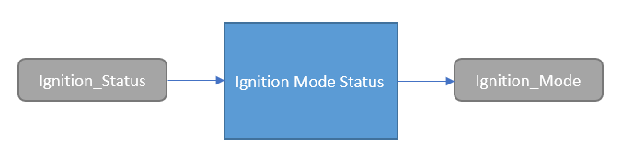

- The following flowchart shows the dynamic state of the component. Here the Telltale status is updated based on the Battery state, TT configured state, Proveout configured etc.

Available Frequency Configurations :

TT_FLASH_QUARTER_HZ (2U) - 2000ms ON , 2000ms OFF
TT_FLASH_HALF_HZ (3U) - 1000ms ON , 1000ms OFF
TT_FLASH_CSNR_HALF_HZ (4U) - 1000ms ON , 1500ms OFF
TT_FLASH_0_83_HZ (5U) - 600ms ON, 600ms OFF
TT_FLASH_1HZ (6U) - 500ms ON , 500ms OFF
TT_FLASH_1_33_HZ (7U) - 375ms ON , 375ms OFF
TT_FLASH_1_66_HZ (8U) - 300ms ON , 300ms OFF
TT_FLASH_2HZ (9U) - 250ms ON , 250ms OFF
TT_FLASH_2_5_HZ (10U) - 200ms ON , 200ms OFF
TT_FLASH_2_66_HZ (11U) - 175ms ON , 175ms OFF
TT_FLASH_TRNHZ_Normal (12U) - 350ms ON , 350ms OFF
TT_FLASH_TRNHZ_Fast (13U) - 100ms ON, 200MS OFF
TT_FLASH_TRNHZ_FHL (14U) - 125ms ON, 175ms OFF
TT_FLASH_4HZ (15U) - 125ms ON, 125 OFF
TT_FLASH_5HZ (16U) - 100ms ON, 100ms OFF

Class Diagram and its Functions :

1.4.2 Justification of the selected option

Based on the applicable/Non-applicable Requirement that initial program which is adopting the Ctrl_Teltlale, this design approach is chosen.

Applicable Requirements:- Update Telltale Status, UCL

Non-Applicable Requirements:- Battery State, Proveout (to be clarified)

File structure
The file structure is as follows:
Ctrl_Telltale contains Ctrl_Telltale.c and Ctrl_Telltale_blinkctrl.c.

The Bookshelf Extension File Contains Ctrl_Telltale_Extn.c, Ctrl_TT_Cfg.h

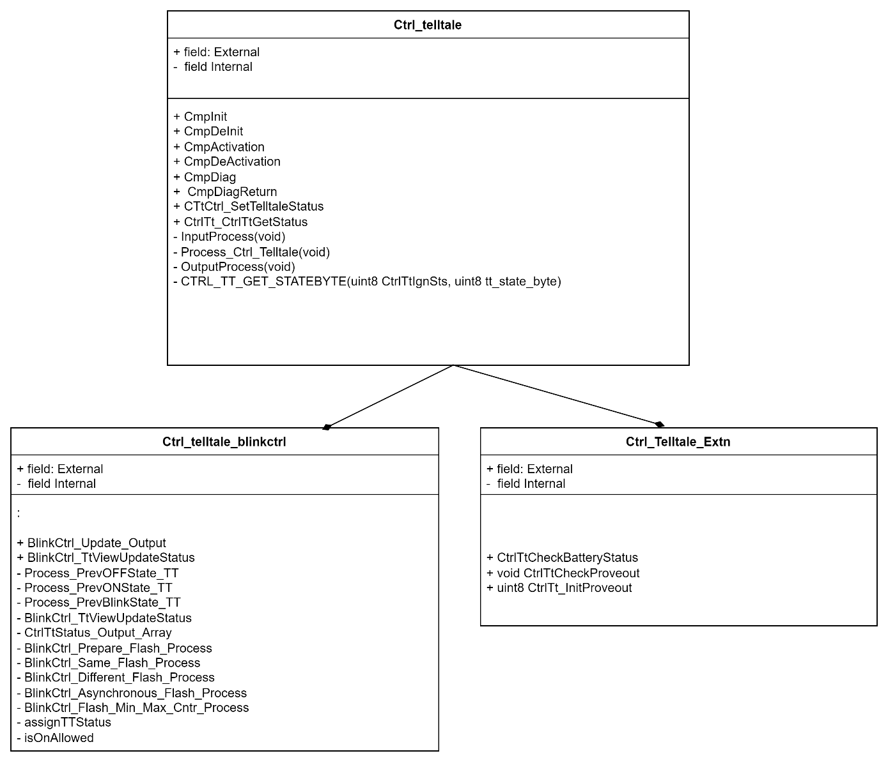

1.6 BLINKING OPERATIONS :

Design Flow of Ctrl Telltale

Functional blocks (Bookshelf)
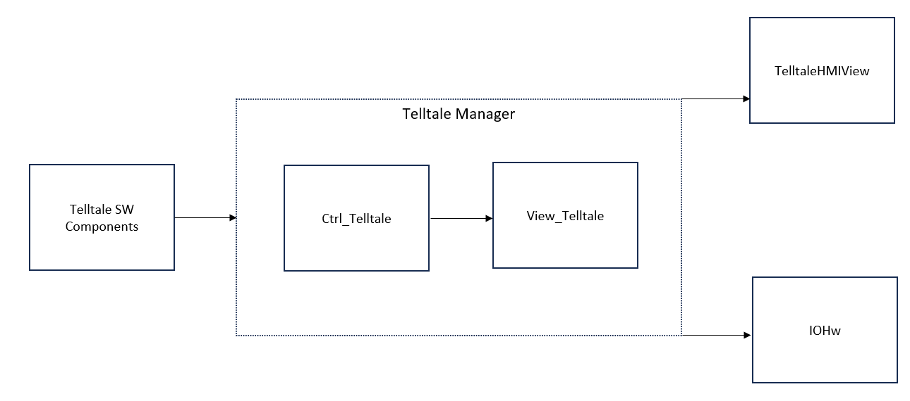

Ctrl telltale Functional block (Toyota Specific)
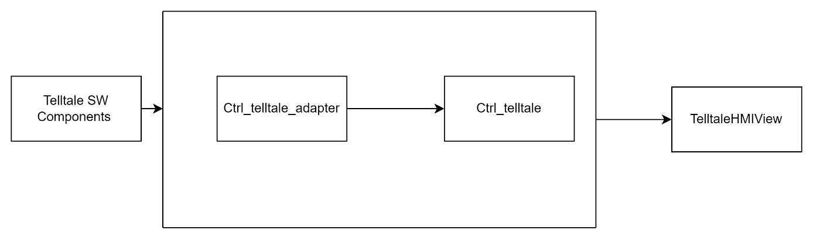

Port Interface details

Providing ports

- Rte_Write_ppTelltaleStatusOP_TelltaleOpArray (&(CtrlTTStatus_Array[0]))

Receiving ports

1.Rte_Read_rpIgnState_IGNState(X)

CTRL APP State mapping

Design Assumptions

Pre-design review conclusions

Detailed design

Private interfaces

Internal data structures
Macros used

Algorithms explanation
Architecture Style – MVC

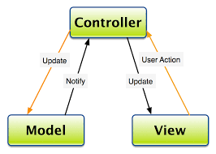

Controllers are mainly implemented as servers providing a set of defined services to the model and interfacing with View.

- The overall architecture of the platform follows Model – View – Controller Architecture pattern.
- Components are first classified based on their role in MVC.
- Business logics are implemented in the models (corresponding to M in MVC). They act as clients to a controlling server and use the interfaces provided by the server.
- Controllers are mainly implemented as servers providing a set of defined services to the model and interface ng with View.
- Controller in the example decomposition acts as server, providing a set of defined services to the Model clients.
- Example of services are, controlling the prove out of a telltale, maintaining the current state of the telltale, providing interface to the models to alter the state of the telltale and giving the current data to tt_view
- Models in the decomposition are a set of instantiated base classes. They do similar functionality and share same interfaces to the controller.
- Any of the individual base class can be removed without affecting other classes in the same model. It does not affect the controller as well.
- This kind of definition allows us to do a plug and play approach where new telltale classes can be added or removed.
- ASIL components are not linked with any other functionality even if it falls with the same feature set. For example, turn indicator chime and telltale are not controlled as a part of the same module.

Component configuration

Task period – --25 ms //Project specific

Timing constraints

NVM access

There is a configuration file used for CtrlTelltale:

- Ctrl_Telltale– Ctrl_TT_Cfg.h – This configuration file is used to configure total no of telltale present. Their ON/OFF requirement like in IGN ON or IGN ON/OFF both and low voltage/high voltage.
- Ctrl_Telltale_TypeCfg.h – This Configuration file is used to update the structure contains all the proveout, battery status parameters and a array of structure which includes all Configurations.
- Ctrl_Telltale_data.h – This Configuration File is used for the declarations of the Variables
There are separate C and H files handled for Blinking control alone.
- Ctrl_TT_blinkctrl.c – This File contains the Blinking Control which will be invoked in the Ctrl_telltale.
- Ctrl_TT_blinkctrl.h – This File Contains all the Function Declartions and the Structures.
There are external files used in the Ctrl_telltale.
- Ctrl_TelltaleExtn – will be containing Ctrl_TelltaleExtn.c, Ctrl_Telltale_Cfg, Ctrl_telltaleConfig, Ctrl_TT_Cfg

- Ctrl_TelltaleExtn.c – Containing all the local functions in this File.
- Ctrl_Telltale_Extn.h – Contains all the Function Declarations.
- Ctrl_Telltale_Cfg, - Contains all the macros and function macros will be defined here.
- Ctrl_TT_Cfg – All the configurations like proveout , lvsd, hvsd will be updated here.
- Ctrl_telltaleConfig – includes all the directories of the C files.

Registers

Lessons Learnt

Similar issues/use cases addressed

Tools
CtrlTelltale_configuration.xls

Traceability
For Requirements and HLD, refer the sections of SAD Document.

S.No | Requirement | HLD | DD | Code
1 | ATT_R01_Telltale_Status_Update | ATT_D01_Telltale_Status_Update  (3.1.2.3.1) | Sec 1.4.1  Sec 1.3 (Public Interfaces of Ctrl_telltale_DD) | Ctrl_telltale.c
2 | ATT_R02_Configuration | ATT_D02_D03_D04_Configuration_Vehiclestate_proveout  (3.1.2.3.2) | Sec 1.4.1.4 | Ctrl_telltale.c
3 | ATT_R03_vehicle_State | ATT_D02_D03_D04_Configuration_Vehiclestate_proveout  (3.1.2.3.2) | Sec 1.2 (Public Interfaces of Ctrl_Telltale_DD) | Ctrl_telltale.c
4 | ATT_R04_Proveout | ATT_D02_D03_D04_Configuration_Vehiclestate_proveout  (3.1.2.3.2) | Sec 1.4b (Private interface) | Ctrl_telltale_Extn.c
5 | ATT_R05_Flashing_sync | ATT_D05_D06_Flashing Sync_Flashing_Non_Sync  ((3.1.2.3.3) | Need to be updated | Ctrl_telltale.c
6 | ATT_R06_Flashing_nonsync | ATT_D05_D06_Flashing Sync_Flashing_Non_Sync  ((3.1.2.3.3) | Sec 1.4.1.3  Sec 1.2 (Public Interfaces of Ctrl_telltale_DD) | Ctrl_telltale_blinkctrl.c
7 | ATT_R07_ETM mode | ATT_D07_D08_ETM_MODE_DIAG_CONTROL  (3.1.2.3.4) | updated in the View telltale | View_Telltale.c
8 | ATT_R08_Diag Control | ATT_D07_D08_ETM_MODE_DIAG_CONTROL  (3.1.2.3.4) | updated in the View telltale | View_Telltale.c

