Software Detailed Design Specification
1.0

Table of Contents

1 Preparation for pre-design review 3
• Purpose 3
• Public interface 3
1. Input Interface: 3
• Private Interface 3
• Public interface 4
2. Output Interface: 4
1.4 Design choice 5
1.1.2 Justification of the selected option 7
Based on the applicable/Non-applicable Requirement that initial program which is adopting the View_Telltale, this design approach is chosen. 7
Applicable Requirements:-Battery State, Update Telltale Status, Flashing, UCL 7
Non-Applicable Requirements:-, Proveout (to be clarified) 7
Below flowchart explain the flow of the Telltale 7
• File structure 7
• Functional blocks 8
• Port Interface details 8
1.7.1 Providing ports 8
1.1.2 Receiving ports 8
• CTRL APP State mapping 8
• Design Assumptions 8
2 Pre-design review conclusions 8
3 Detailed design 8
• Private interfaces 8
• Internal data structures 8
• Algorithms explanation 9
• Component configuration 10
3.1.1 Task period – --ms //Project specific 10
3.1.2 Timing constraints 10
3.1.3 NVM access 10
• Registers 10
4 Lessons Learnt 10
• Similar issues/use cases addressed 10
5 Tools 10
6 Precautions 10

References

Reference | Document Name | Version
1
2

Definitions

Term | Abbreviation | Description
ms | Milli second | Time unit

Revision History

Version | Date | Author | Description of changes
1.0 | Apr-22-2024 | ABETAGER | This document is the detail design of Telltale manager
2.0 | SEP-17-2024 | CKULOTHU | This document is the detail design of View Telltale manager

Preparation for pre-design review

Purpose
This document is the detail design methodology for View_Telltale feature.

Public interface

Input Interface:

Method | Rte_Read_View_telltale_rpTelltaleOPStatus_TelltaleOpArray(TelltaleInputStatus)
Sync/Async | Sync
Reentrant | No
Parameters | uint8 TelltaleInputStatus[]
Return | void
Description | This interface updates the Telltale status in a array TelltaleInputStatus based on the index

Private Interface

Method | static void WriteTTStatus (void)
Sync/Async | Sync
Reentrant | No
Parameters | void
Return | void
Description | This function is used to output the telltale status based on the type of the telltale.

Method | void ViewTelltale_SendTelltaleStatus (uint8 index, boolean TT_status)
Sync/Async | Sync
Reentrant | No
Parameters | uint8 index, boolean TT_status
Return | void
Description | This function is used to update the output in a array structure (TelltaleStatusData) bit by bit for Each Telltale index.

Public interface

Output Interface:

Method | Rte_Write_ppTelltaleSts_TT_StatusData(&TelltaleStatusData)
Sync/Async | Sync
Reentrant | No
Parameters | STT_Status TelltaleStatusData
Return | void
Description | This function is used to update the array structure TelltaleStatusData output via UCL to HMI

UCL STRATEGY:

- Read the Telltale Status in array From the Ctrl Telltale through Rte Read Interface and the call the Function WriteTTStatus.
- If the tt_driven_type_U8 member of the structure at the index position in TelltaleOutputList is not equal to the value of cTT_HARDWARE_DRIVEN, then ViewTelltale_SendTelltaleStatus Function is Called.

- If the Telltale Index < TT_TOTAL_NUM_OF_TELLTALES, calculate the Byte Position and Bit Position
- To determine the specific byte position, we should divide each index by 1 byte, The resulting quotient will represent the byte position.
- To determine the specific bit position, we should calculate the remainder of each index by using the modulus operator, followed by right-shifting it by 1u
- If the TT_status is True, Setting a specific bit in the mask array using a calculated byte position (fl_byte_pos) and a bit position (fl_bit_pos).
- If the TT_status is False, Clear the specific bit in the mask array using a calculated byte position (fl_byte_pos) and a bit position (fl_bit_pos).
- UCL data will be sent through this interface Rte_Write_ppAppUclTtSts_TT_StatusData(&TelltaleStatusData).

1.4 Design choice

1.3.1View telltale Design:

1. TFT Telltales Flow:

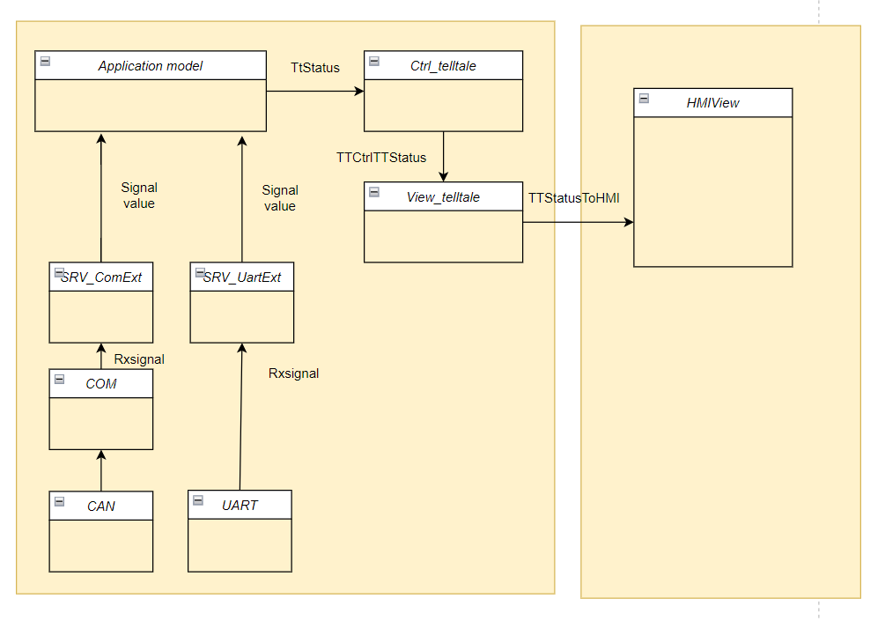

- HW Telltales Flow:

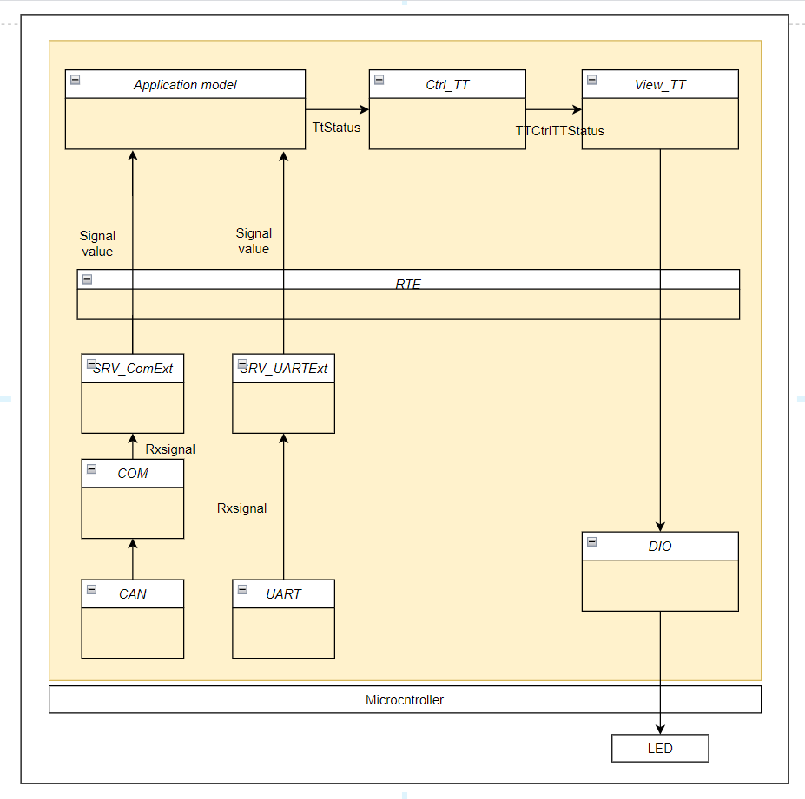

Available configurations:
- cTT_HARDWARE_DRIVEN
- cTT_HARDWARE_DRIVEN_SAFE
- cTT_TFT_DRIVEN
- cTT_NOT_AVAILABLE
- UnusedPin

Justification of the selected option

Based on the applicable/Non-applicable Requirement that initial program which is adopting the View_Telltale, this design approach is chosen.

Applicable Requirements:-Battery State, Update Telltale Status, Flashing, UCL

Non-Applicable Requirements:-, Proveout (to be clarified)

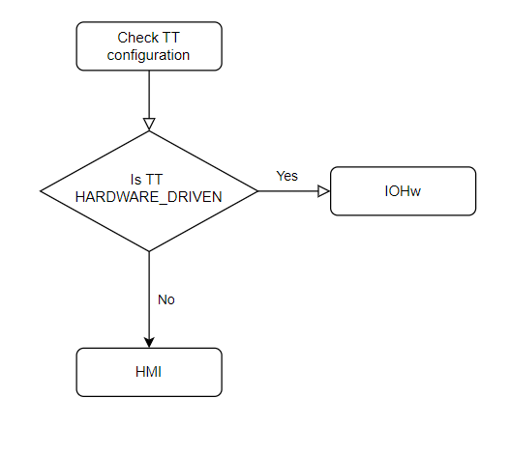
Below flowchart explain the flow of the Telltale

File structure
The file structure is as follows:
View_Telltale contains View_Telltale.c and View_Telltale_Cfg.h

Functional blocks
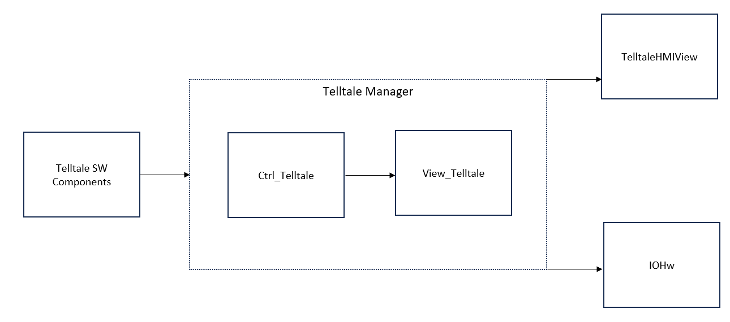

Port Interface details

1.7.1 Providing ports
- Rte_Call_rpIoHwAbSet_Impl_SetPin(Byte_Id,Tt_status)
- Rte_Call_rpIoHwAbSetSafe_SetOutputPin(Byte_Id,Tt_status,Errstatus)
- Rte_Write_ppTTCtrl_TTStatusUpdateHMI(Id, Ttstatusarray)

Receiving ports
- Rte_Call_rpTtStatus_TtViewUpdateStatus
- Rte_Read_rpBattState_BatteryState
- Rte_Read_rpIgnState_IGNState
- (void)Rte_Read_View_telltale_rpTelltaleOPStatus_TelltaleOpArray(TelltaleInputStatus);

CTRL APP State mapping

Design Assumptions

Pre-design review conclusions

Detailed design

Private interfaces

Internal data structures
Macros used

Algorithms explanation
Architecture Style – MVC

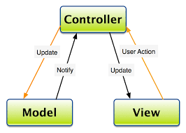

Controllers are mainly implemented as servers providing a set of defined services to the model and interfacing with View.

- The overall architecture of the platform follows Model – View – Controller Architecture pattern.
- Components are first classified based on their role in MVC.
- Business logics are implemented in the models (corresponding to M in MVC). They act as clients to a controlling server and use the interfaces provided by the server.
- Controllers are mainly implemented as servers providing a set of defined services to the model and interface ng with View.
- Controller in the example decomposition acts as server, providing a set of defined services to the Model clients.
- Example of services are, controlling the prove out of a telltale, maintaining the current state of the telltale, providing interface to the models to alter the state of the telltale and giving the current data to tt_view
- Models in the decomposition are a set of instantiated base classes. They do similar functionality and share same interfaces to the controller.
- Any of the individual base class can be removed without affecting other classes in the same model. It does not affect the controller as well.
- This kind of definition allows us to do a plug and play approach where new telltale classes can be added or removed.
- ASIL components are not linked with any other functionality even if it falls with the same feature set. For example, turn indicator chime and telltale are not controlled as a part of the same module.

Component configuration

Task period – --ms //Project specific

Timing constraints

NVM access

There is a configuration file used for ViewTelltale:

- View_Telltale_Cfg.h – This configuration file is used to configure the types of telltale – LED & TFT. If TFT then configure their respective bit position and if LED then configure with their respective pin.
- View_TT_Cfg.h – This Function contains all the Function macros

Registers

Lessons Learnt

Similar issues/use cases addressed

Tools

Precautions

