Software Detailed Design Specification
1.0

Table of Contents

1 Preparation for pre-design review 3
1.1 Purpose 3
1.2 Public interface 3
1.2.1 AW_PublicIf_CtrlWarning_01 3
1.2.2 AW_PublicIf_CtrlWarning_02 3
1.2.3 AW_PublicIf_CtrlWarning_03 4
1.2.4 AW_PublicIf_CtrlWarning_04 4
1.2.5 AW_PublicIf_CtrlWarning_05 4
1.2.6 AW_PublicIf_CtrlWarning_06 5
1.2.7 AW_PublicIf_CtrlWarning_07 5
1.2.1 AW_PublicIf_CtrlWarning_08 5
1.2.1 AW_PublicIf_CtrlWarning_09 5
1.3 Private Interface 6
1.3.1 AW_PrivateIf_CtrlWarning_01 6
1.4 Design Choice 7
1.5 Class Diagram 9
1.6 File structure 9
1.7 Functional blocks 9
1.8 Port Interface details 9
1.7.1 Providing ports - None. 9
1.8.2 Receiving ports - None 9
1.9 CTRL APP State mapping 9
1.10 Design Assumptions 9
2 Pre-design review conclusions 9
3 Detailed design 10
3.1 Private interfaces 10
3.2 Internal data structures 10
3.3 Algorithms explanation 10
3.4 Component configuration 11
3.4.1 Task period – --ms //Project specific 11
3.4.2 Timing constraints 11
3.4.3 NVM access 11
3.5 Registers 11
4 Lessons Learnt 11
4.1 Similar issues/use cases addressed. 11
5 Tools 11
6 Precautions 11
References

Reference | Document Name | Version
1
2

Definitions

Term | Abbreviation | Description
ms | Milli second | Time unit

Revision History

Version | Date | Author | Description of changes
1.0 | Jun-21-2024 | vrk | This document is the detail design of Ctrl_Warning
2.0 | Nov-18-2024 | vrk | Added Public interfaces 07,08,09. Updated the Sequence diagram in 1.4.1

Preparation for pre-design review

Purpose
This document is the detail design methodology for Ctrl_Warning component.

Public interface
Data Types;
typedef uint8 WarningStatus;
typedef uint8 WarningId;
typedef uint8 WarningDisplayedStatus;

typedef struct
{
WarningStatus WarningCurrentStatus;
WarningEvent WarningCurrentEvent;
UInt32 WarningCurrentPayload;
} WarningDataS;

AW_PublicIf_CtrlWarning_01

Interface ID | AW_PublicIf_CtrlWarning_01
Method | FUNC(void, Ctrl_warning_CODE) Ctrl_warning_UpdateWarningStatus(WarningId WarningCurId, WarningStatus WarningCurStatus, WarningEvent WarningCurEvent, UInt32 WarningPayload)
Sync/Async | Sync
Reentrant | No
Parameters | WarningId WarningCurId, WarningStatus WarningCurStatus, WarningEvent WarningCurEvent, UInt32 WarningPayload
Return | void
Description | This function receives the Warning status from application components.

AW_PublicIf_CtrlWarning_02

Interface ID | AW_PublicIf_CtrlWarning_02
Method | FUNC(void, Ctrl_warning_CODE) Ctrl_warning_SetWarningDisplayedStatus(WarningId CurWarningId, WarningDisplayedStatus CurWarningDispStatus)
Sync/Async | Sync
Reentrant | No
Parameters | WarningId CurWarningId, WarningDisplayedStatus CurWarningDispStatus
Return | void
Description | This function receives the Warning displayed status from Message core component.

AW_PublicIf_CtrlWarning_03

Interface ID | AW_PublicIf_CtrlWarning_03
Method | FUNC(void, Ctrl_warning_CODE) Ctrl_warning_GetWarningActiveStatus(WarningId CurrentWarning, P2VAR(WarningDataS, AUTOMATIC, RTE_CTRL_WARNING_APPL_VAR) CurrentWarningStatus)
Sync/Async | Sync
Reentrant | No
Parameters | WarningDataS CurrentWarningStatus
Return | void
Description | This function tells the Actives Warnings to the Message core component.

AW_PublicIf_CtrlWarning_04

Interface ID | AW_PublicIf_CtrlWarning_04
Method | FUNC(void, Ctrl_warning_CODE) Ctrl_warning_GetWarningDisplayedStatus(WarningId CurWarningId, P2VAR(WarningDisplayedStatus, AUTOMATIC, RTE_CTRL_WARNING_APPL_VAR) DisplayedStatus)
Sync/Async | Sync
Reentrant | No
Parameters | WarningId CurWarningId
Return | WarningDisplayedStatus DisplayedStatus
Description | This function shares the Warning displayed status received from Message core component to the application components.

AW_PublicIf_CtrlWarning_05

Interface ID | AW_PublicIf_CtrlWarning_05
Method | FUNC(void, Ctrl_warning_CODE) Ctrl_warning_Get_Red_MasterLamp_Status(P2VAR(UInt8, AUTOMATIC, RTE_CTRL_WARNING_APPL_VAR) LampStatus);
Sync/Async | Sync
Reentrant | No
Parameters | N/A
Return | Uint8 LampStatus
Description | This function returns the Red Master Lamp TT status for the configured warning

AW_PublicIf_CtrlWarning_06

Interface ID | AW_PublicIf_CtrlWarning_06
Method | FUNC(void, Ctrl_warning_CODE) Ctrl_warning_Get_Yellow_MasterLamp_Status(P2VAR(UInt8, AUTOMATIC, RTE_CTRL_WARNING_APPL_VAR) LampStatus)
Sync/Async | Sync
Reentrant | No
Parameters | N/A
Return | Uint8 LampStatus
Description | This function returns the Yellow Master Lamp TT status for the configured warning.

AW_PublicIf_CtrlWarning_07

Interface ID | AW_PublicIf_CtrlWarning_07
Method | FUNC Ctrl_warning_UpdateExtdPayload(WarningId WarningCurId, P2CONST(Rte_DT_PayloadArr_U8_8_0, AUTOMATIC, RTE_CTRL_WARNING_APPL_DATA) WarningPayload);
Sync/Async | Sync
Reentrant | No
Parameters | WarningId WarningCurId, PayloadArr_u8_8_0 WarningPayload
Return | N/A
Description | This function is invoked to send 8 bytes of payload to HMI via UCL for a warning id.

AW_PublicIf_CtrlWarning_08

Interface ID | AW_PublicIf_CtrlWarning_08
Method | FUNC(void, Ctrl_warning_CODE) Ctrl_warning_GetWarningDisplayedPayload(WarningId CurWarningId, P2VAR(Rte_DT_PayloadArr_U8_8_0, AUTOMATIC, RTE_CTRL_WARNING_APPL_VAR) DisplayedPayload
Sync/Async | Sync
Reentrant | No
Parameters | WarningId CurWarningId
Return | Uint8[8] DisplayedPayload
Description | This function returns the displayed payload for the invoked warning id.

AW_PublicIf_CtrlWarning_09

Interface ID | AW_PublicIf_CtrlWarning_09
Method | FUNC(void, Ctrl_warning_CODE) Ctrl_warning_SetWarningDisplayedPayload(WarningId CurWarningId, P2CONST(PayloadArr_U8_8, AUTOMATIC, RTE_CTRL_WARNING_APPL_DATA) CurWarningDispPayload);
Sync/Async | Sync
Reentrant | No
Parameters | CurWarningId , CurWarningDispPayload
Return | N.A
Description | This function updates the payload that is used for the displayed warning id.

Private Interface

AW_PrivateIf_CtrlWarning_01

Interface ID | AW_PrivateIf_CtrlWarning_01
Method | FUNC(void, Ctrl_warning_CODE_LOCAL) update_MasterWarning_Lamp(VAR  (WarningId, AUTOMATIC) rtu_warningID, VAR(WarningStatus, AUTOMATIC)  rtu_WarningStatus)
Sync/Async | Sync
Reentrant
Parameters | WarningId warningID, WarningStatus WarningStatus
Return | None
Description | This function warning that is set has been configured with Yellow or the Red lamp and set the corresponding array of the lamp.

Design Choice

1.4.1 Sequence Diagram – Warning Show/Hide
This highlights the sequence of events from the warning trigger from the model to the ctrl_warning and message core gets the status of all the warnings, gives the callback to the warnmsg_core_observer which sends only the active message to the HMI via UCL. On the removal, the displayed data which goes out from the observer will not have the deactivated warning.

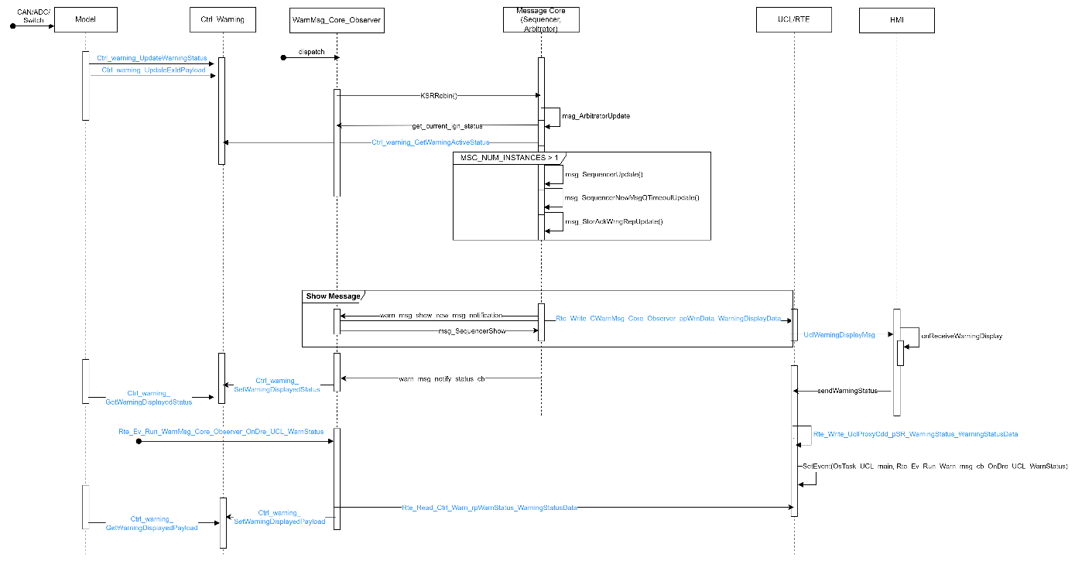

1.4.2 Flow Diagram – Master Lamp Status
Based on the warning configuration specific to Master Warning Lamp, the corresponding Telltale is updated.

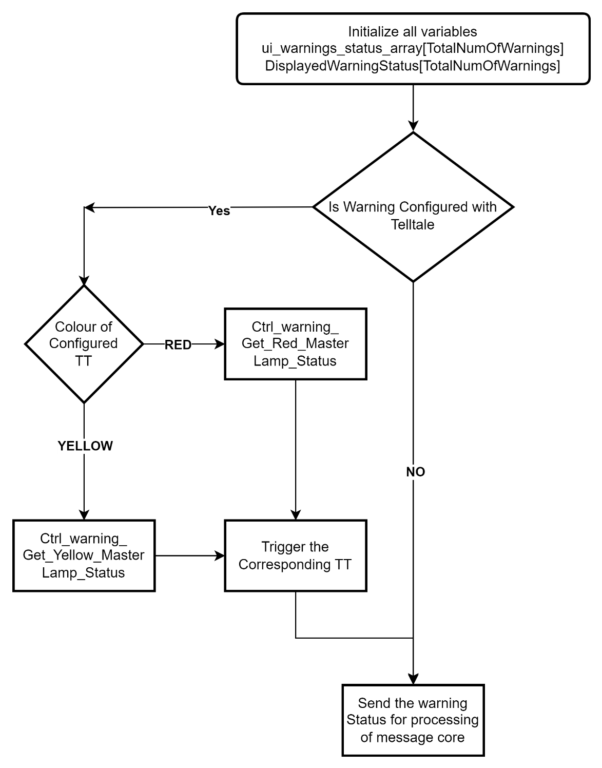

Class Diagram
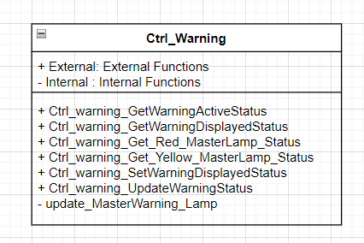

File structure
The file structure is as follows:
Ctrl_Warning contains Ctrl_Warning.c, Ctrl_warning_data and Ctrl_warning_config.cfg

Functional blocks

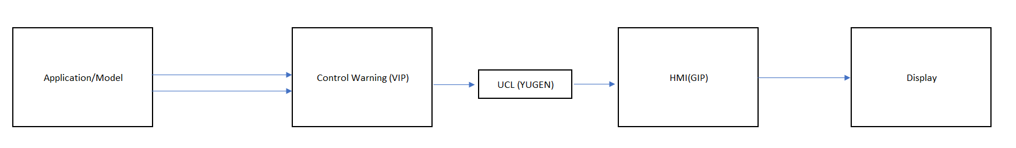

Port Interface details

1.7.1 Providing ports - None.

Receiving ports - None

CTRL APP State mapping

Design Assumptions
Ctrl_Warning_Task is invoked by the OS after the execution of all warning components.

Pre-design review conclusions

Detailed design

Private interfaces

Internal data structures
Macros used

Algorithms explanation
Architecture Style – MVC

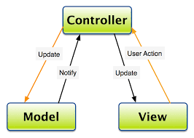

Controllers are mainly implemented as servers providing a set of defined services to the model and interfacing with View.

- The overall architecture of the platform follows Model – View – Controller Architecture pattern.
- Components are first classified based on their role in MVC.
- Business logics are implemented in the models (corresponding to M in MVC). They act as clients to a controlling server and use the interfaces provided by the server.
- Controllers are mainly implemented as servers providing a set of defined services to the model and interface ng with View.
- Controller in the example decomposition acts as server, providing a set of defined services to the Model clients.
- Example of services are, controlling the prove out of a telltale, maintaining the current state of the telltale, providing interface to the models to alter the state of the telltale and giving the current data to tt_view
- Models in the decomposition are a set of instantiated base classes. They do similar functionality and share same interfaces to the controller.
- Any of the individual base class can be removed without affecting other classes in the same model. It does not affect the controller as well.
- This kind of definition allows us to do a plug and play approach where new telltale classes can be added or removed.
- ASIL components are not linked with any other functionality even if it falls with the same feature set. For example, turn indicator chime and telltale are not controlled as a part of the same module.

Component configuration

Task period – --ms //Project specific

Timing constraints
The warning detection time period is 32ms. Since, the CAN reading(Application model runnable) and the warning set to UCL(Controller Runnable) are executed from the same task.

NVM access
None

There is a configuration file used for Ctrl_Warning:

- Ctrl_warning_config.cfg – This configuration file is used to configure the time period of for the Ctrl_Warning.

Registers
None

Lessons Learnt

Similar issues/use cases addressed.

Tools
None

Precautions

