DOMAIN | CLUSTER & DISPLAYS | GROUP | ALERTS FG

ABSTRACT
This document presents the Software architecture design of the Warnings feature.

It describes the Warning feature’s core requirements, high level design, Interfaces definition along with data path between SWC-APPS and other components.

It also describes the design limitations and test strategy applicable for this feature implementation.

This deliverable documents approvals for recording in the documentation management database.
 | Author | 1st Review | 2nd Review | Distribution authorized by
Function | Veeraputhiran Subramanian  R K, Vaidyanath | Project Dev. Tech Lead | SW Architect | Tech Team Managers
Name | ***
Date | ***

REVISION SUMMARY
Revision | Date | Author | Change Summary
1.0 |  | Vsubra11, vrk | Initial version
1.1 | 18/11/24 | vrk | Updated Req AW_R12 and AW_R13. Updated 3.1.2 to accommodate AW_R12 and AW_R13
2.0

CONTENTS
1 INTRODUCTION 4
1.1 Purpose 4
1.2 Scope 4
1.3 Target Audience 4
1.4 Definitions, Acronyms and Abbreviations 4
1.5 Reference Documents 4
2 REQUIREMENTS 5
2.1 AW_R01_Warning_Status_Update 5
2.2 AW_R02_Stored Warnings 5
2.3 AW_R03_LampUpdate 5
2.4 AW_R04_ChimeUpdate 5
2.5 AW_R05_Read Displayed Status 6
2.6 AW_R06_Active Warning Status 6
2.7 AW_R07_Retrigger and Forced Handling 6
2.8 AW_R08_Status Feedback from Message core Handling 7
2.9 AW_R09_HighPriority Warning Display 7
2.10 AW_R10_Hide Warning 7
2.11 AW_R11_Warning_Acknowledgement 7
3 ARCHITECTURE VIEW 9
3.1.1 SAD - Definitions 9
3.1.1.1 Design Pattern 9
3.1.2 SAD – Alerts Warning feature 10
3.1.2.1 SW Arch. Block Diagram 10
3.1.2.2 Data flow diagram 10
3.1.2.3 High Level Design 11
3.1.2.3.1 AW_D01_Warning_Show 11
3.1.2.3.1.1 DETAILED DESIGN 11
3.1.2.3.1.2 KEY CONSIDERATIONS 11
3.1.2.3.2 AW_D02_Warning_Acknowledement 12
3.1.2.3.2.1 DETAILED DESIGN 12
3.1.2.3.2.2 KEY CONSIDERATIONS 12
3.1.2.3.3 AW_D03_Warning_Timeout 13
3.1.2.3.3.1 DETAILED DESIGN 13
3.1.2.3.3.2 KEY CONSIDERATIONS 13
3.1.2.3.4 AW_D04_Warning_MasterLamp 14
3.1.2.3.4.1 DETAILED DESIGN 14
3.1.2.3.4.2 KEY CONSIDERATIONS 14
3.1.2.3.5 AW_D05_Warning_ChimeRequest 14
3.1.2.3.5.1 DETAILED DESIGN 14
3.1.2.3.5.2 KEY CONSIDERATIONS 14
3.1.2.3.6 AW_D06_Warning_Stored 14
3.1.2.3.6.1 DETAILED DESIGN 15
3.1.2.3.6.2 KEY CONSIDERATIONS - Acknowledged 15
3.1.2.3.6.3 KEY CONSIDERATIONS – Timeout 16
3.1.2.3.7 AW_D07_Warning_Hide 17
3.1.2.3.7.1 DETAILED DESIGN 17
3.1.2.3.7.2 KEY CONSIDERATIONS 17
3.1.2.4 Test Strategy 18
3.1.2.4.1 Unit Test 18
3.1.2.4.2 Unit Test 18
3.1.2.4.2.1 GUIDELINES 18
3.1.2.4.2.2 REFERENCE 18
3.1.2.4.3 Functional Test 19
3.1.2.5 Design Limitations 19

INTRODUCTION

Purpose
The purpose of this document is to describe the software architecture design view for the Warning feature in the instrument cluster.

Scope
The scope of this document is to describe core feature requirements and standardize the design framework of the Warning feature.

Target Audience
The audience of this document include SW Architect, Project Dev Tech Lead, APP and HMI tech teams.

Definitions, Acronyms and Abbreviations
Definition | Description
ECU | Electronic Control Unit
SAD | Software Architecture Design
CAN | Controller Area Network
AW | Alerts/Warning
LSH | Logic State Handler
Message Core Observer | Callbacks implemented to get the information from message core and GIP
Stored Warnings | The acknowledged warning which can be retrieved to view in the Warning menu.

Reference Documents
Reference document and its respective link is shared below. Ref. label may be used across this document.

Ref. |  | Topics | Reference
[R1] | Warning message core HLD |  | warn_msg_core_HLD.doc
[R2] | Warning message core DD |  | warn_msg_core_DD.doc
[R3] | Warning Message core  usage Guide |  | Message_core_programmers_guide.doc
[R4] | Yugen Framework |  | YugenLogic (visteon.com)
[R5] | Message Core DD |  | hmi_message_core_DD(v.4.3)

REQUIREMENTS
REQ_ID | DESCRIPTION | SCOPE

AW_R01_Warning_Status_Update
 | Mdl_Warning shall evaluate the Configuration, CAN, UART, ADC, other internal input conditions based on the given requirements and update the status Ctrl_Warning using common interface.  Ctrl_warning_UpdateWarningStatus(WarningId WarningCurId, WarningStatus WarningCurStatus, WarningEvent WarningCurEvent, uint32 WarningPayload)  WarningCurId – Index of the Warning  WarningCurStatus - UI_WARNING_STATUS_OFF, UI_WARNING_STATUS_ON  WarningCurEvent – UI_WARNING_EVENT_NONE, UI_WARNING_EVENT_RETRIGGER, UI_WARNING_EVENT_FORCED  WarningPayload – Standard payload of 4 bytes.  WarningID, Payload Details – Should be common agreement between HMI and APP | APP / HMI

AW_R02_Stored Warnings
 | The WarnMessaageCore_Observer shall provide the list of active stored warnings that need to be shown on the Menu tab to the HMI. The “Store” property of the warnings are identified by the Message core based on the on the configuration of each warning.  Stored warning UCL interface - Should be common agreement between HMI and APP | APP/HMI

AW_R03_LampUpdate
 | Ctrl_Warning shall trigger the Master Lamp (Yellow or Red) based on the warning configuration to telltale that is configured in Ctrl_Warning.cfg. | APP

AW_R04_ChimeUpdate
 | Ctrl_Warning shall trigger the chime that is configured with warning when the corresponding warning is displayed.  Note: The display status is expected to come from the HMI. | APP

AW_R05_Read Displayed Status
 | The Ctrl_Warning enables the model to read the displayed status of the warning for any of its functionality viz. CANTx, Retrigger or turning off the warning.  DisplayedStatus = Ctrl_warning_GetWarningDisplayedStatus(CurWarningId).  CurWarningId – The warning ID for which the displayed status is requested.  DisplayedStatus – The displayed status of the requested warning.  WRNG_NOTIFIED_NONE (0U)  WRNG_NOTIFIED_ACKNOWLEDGED (1U)  WRNG_NOTIFIED_TIMEOUT (2U)  WRNG_NOTIFIED_HIDDEN (4U)  WRNG_NOTIFIED_SHOW (8U)  WRNG_NOTIFIED_ACTIVE (16U)  WRNG_NOTIFIED_INACTIVE (32U)  Note (TBD): This function will call the RTE to get the latest UCL data. | APP

AW_R06_Active Warning Status
 | The Ctrl_Warning shall provide an interface that returns the ON/OFF status of the warning based. This shall be invoked by the model for any of its functionality.  CurrentWarningStatus = Ctrl_warning_GetActiveWarningStatus(CurrentWarning)  CurWarningId – The warning ID for which the warning status is requested.  CurrentWarningStatus - The status of the requested warning. | APP

AW_R07_Retrigger and Forced Handling
 | The Ctrl_Warning shall retrigger/Force the warning based on payload change. Any other conditions that needs the warning event to be forced/Retrigger shall not be handled by Ctrl_Warning.  Strategy For comparing payload <TBD> | APP

AW_R08_Status Feedback from Message core Handling
 | The WarnMsg_Core_Observer shall provide a function to get the feedback from the message core and set the corresponding Display status to Ctrl_Warning.  warn_msg_notify_status_cb(UINT16 *Data, UINT16 Qualifier)  Data – The status of the warning ID after the Priority arbitrator  Qualifier: Current warning ID. | APP
  MSG_EVENT_ACKNOWLEDGED | Acknowledged by User
  MSG_EVENT_TIMEOUT | Message has timed-out
  MSG_EVENT_HIDDEN | Message has been hidden by another
  MSG_EVENT_SHOW | Message has been shown
  MSG_EVENT_ACTIVE | Message is active
  MSG_EVENT_INACTIVE | Message in inactive

AW_R09_HighPriority Warning Display
 | The WarnMsg_Core_Observer shall provide the caller to display a new message. This shall receive a High priority Alert info from Msg Core and send the warning status to HMI  warn_msg_show_new_msg_notification (MSG_VIEWINFO_T * p_msg_info_S)  p_msg_info_S - Holds current active msg information.  MSG_VIEWINFO_T –  Id - Message ID  Position - Position in current list  Count - Number of messages in list  Status - Indicates status of msg ID.  InstanceID  UclWarningDisplayMsg – UCL Warning Message format shall be agreed by HMI and APP | APP/HMI

AW_R10_Hide Warning
 | The WarnMsg_Core_Observer shall provide an interface to process the Message core request to remove/hide message and send the warning status to HMI.  warn_msg_hide_msg_notification (eMessageIdentity p_MsgId_E) | APP

AW_R11_Warning_Acknowledgement
 | On the reception of Warning Status Message, Warning_Msg_observer shall process the incoming message and share the button press event to Warning_Msg_Core to process the Acknowledgement.  HMI – shall send the Button Details on the Acknowledgement of the warning through UCL message (UCLWarnignStatusMsg(WarningId, DynData)  WarningId – Current Warning Id  DynData – The Buttton Press Type (Short_IN, IN)  Note:- Warning_Msg_Core shall be responsible to Notify the WarnMsg_Core_Observer to hide the warning by sending message to HMI | APP/HMI

AW_R12_Warning_Extended Payload
 | The Ctrl_Warning shall provide an interface that enables the application SWCs to update upto 8 bytes of payload data. This is based Einstein 4.0 platform which has the capability to share 8bytes of payload to HMI via UCL.  Ctrl_warning_UpdateExtdPayload(WarningId WarningCurId, P2CONST(Rte_DT_PayloadArr_U8_8_0 WarningPayload);  WarningCurId – The warning ID for which the payload is sent.  WarningPayload - The 8 byte payload data. | APP

AW_R13_ Read Displayed Payload
 | The Ctrl_Warning enables the model to read the displayed payload of the warning for any of its functionality.  Ctrl_warning_UpdateExtdPayload(WarningId WarningCurId, P2CONST(Rte_DT_PayloadArr_U8_8_0 DisplayedPayload);  WarningCurId – The warning ID for which the payload is required.  DisplayedPayload- The 8 byte displayed payload data. | APP

ARCHITECTURE VIEW

SAD - Definitions
SW Architecture design supports high-level design at component level and detailed design at requirement level.

Design Pattern
Use MVC Architectural design pattern as below.
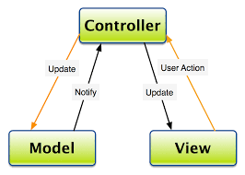
- The overall architecture of the feature follows Model – View – Controller Architecture pattern.
- Components are first classified based on their role in MVC.
- Business logics are implemented in the models (corresponding to M in MVC). They act as clients to a controlling server and use the interfaces provided by the server.
- Controllers are mainly implemented as servers providing a set of defined services to the model and interfacing with View.
- Controller in the example decomposition acts as server, providing a set of defined services to the Model clients.
- Example of services are maintaining the current state of the warning, providing interface to the models to alter the state of the warning and giving the current data to Ctrl_warning
- Models in the decomposition are a set of instantiated base classes. They do similar functionality and share same interfaces to the controller.
- Any of the individual base class can be removed without affecting other classes in the same model. It does not affect the controller as well.
- This kind of definition allows us to do a plug and play approach where new classes can be added or removed.

SAD – Alerts Warning feature

SW Arch. Block Diagram
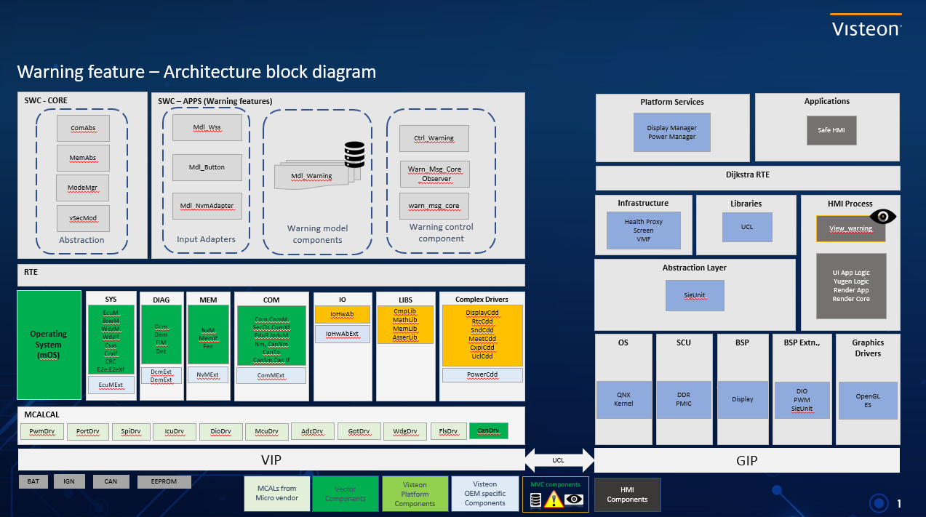

Data flow diagram
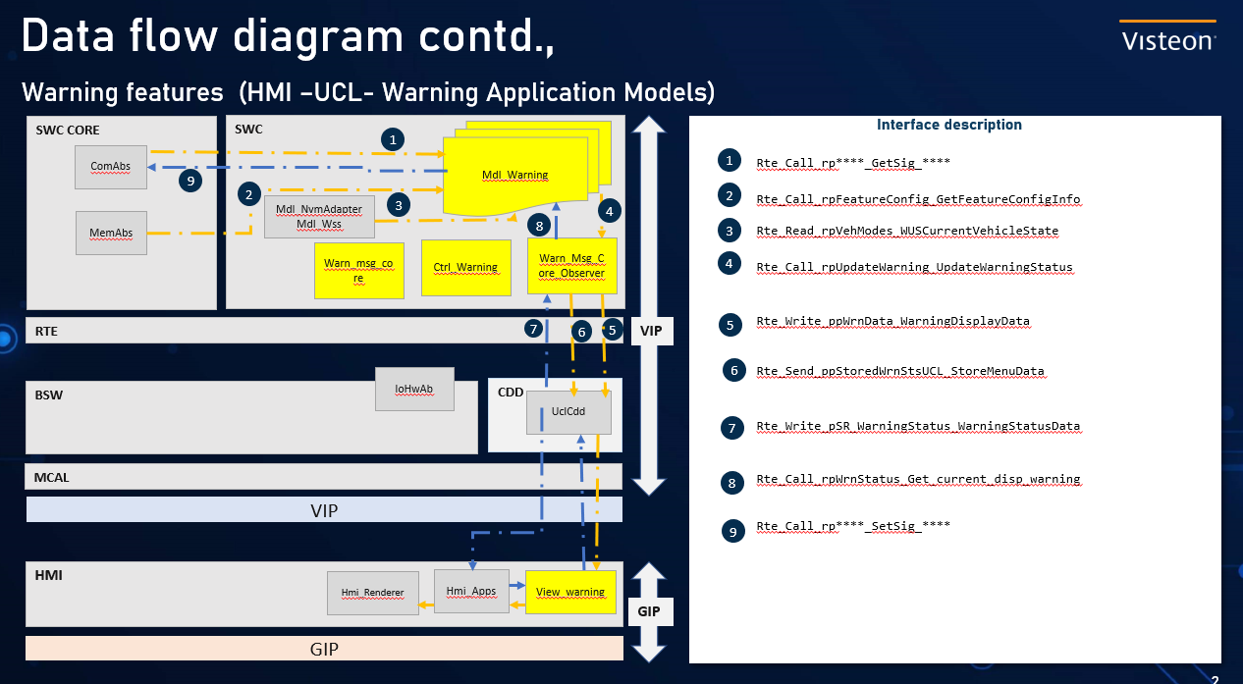

High Level Design
High level design describes the component-level interface and data path definitions to achieve overall core feature requirements.
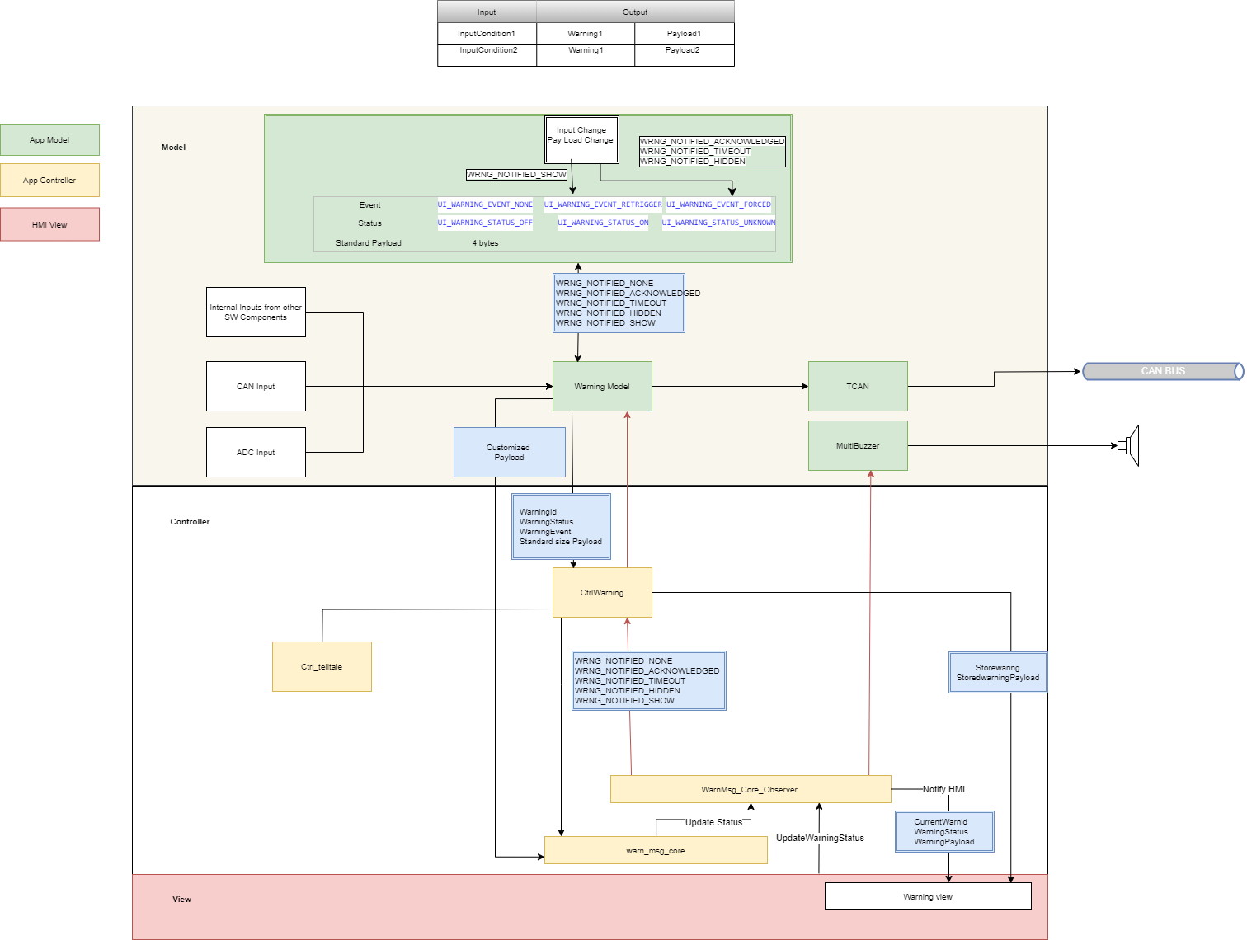

Note:- The notification of warningstatus from HMI shall be going to warn_msg_core, rather than WarnMsg_Core_Observer which needs to be taken care future versions.

AW_D01_Warning_Show

DETAILED DESIGN

KEY CONSIDERATIONS
- The Application shall call the “UpdateWarningStatus” when the condition for the warning is satisfied. This updates the “WarningStatusArray” in the Control Warning.
- The ‘WarningCoreObserver’, on its execution, invokes the Message core. The message core reads the “WarnningStatusArray” and performs the priority arbitration, sequencing and the timeout check.
- Post on the above step, the message core calls the “warn_msg_show_new_msg_notification” in case it has to display a new message.
- The function “warn_msg_show_new_msg_notification” calls the “UclWarningDisplayMsg” to convey what to display to the HMI and also informs the message core about the same.
- The message core will call the “warn_msg_notify_status_cb” and acknowledges the same about the show.
- The HMI on receiving the “UclWarningDisplayMsg” invokes “sendWarningStatus” as an acknowledgement of reception and also sets an Event in the UCL Adapter with the status of display.
- The Application can read the display status and payload by invoking the Ctrl_warning_GetWarningDisplayedStatus(CurWarningId) and Ctrl_warning_UpdateExtdPayload respectively which is updated by the “sendWarningStatus” and “sendWarningPayload”.
- If the warning event is set as Retrigger/Forced, the same warning is sent via the UCL post its sequencing and arbitration.
Requirements covered: AW_R01, AW_R05, AW_R06, AW_R07, AW_R08, AW_R09, AW_R12, AW_R13

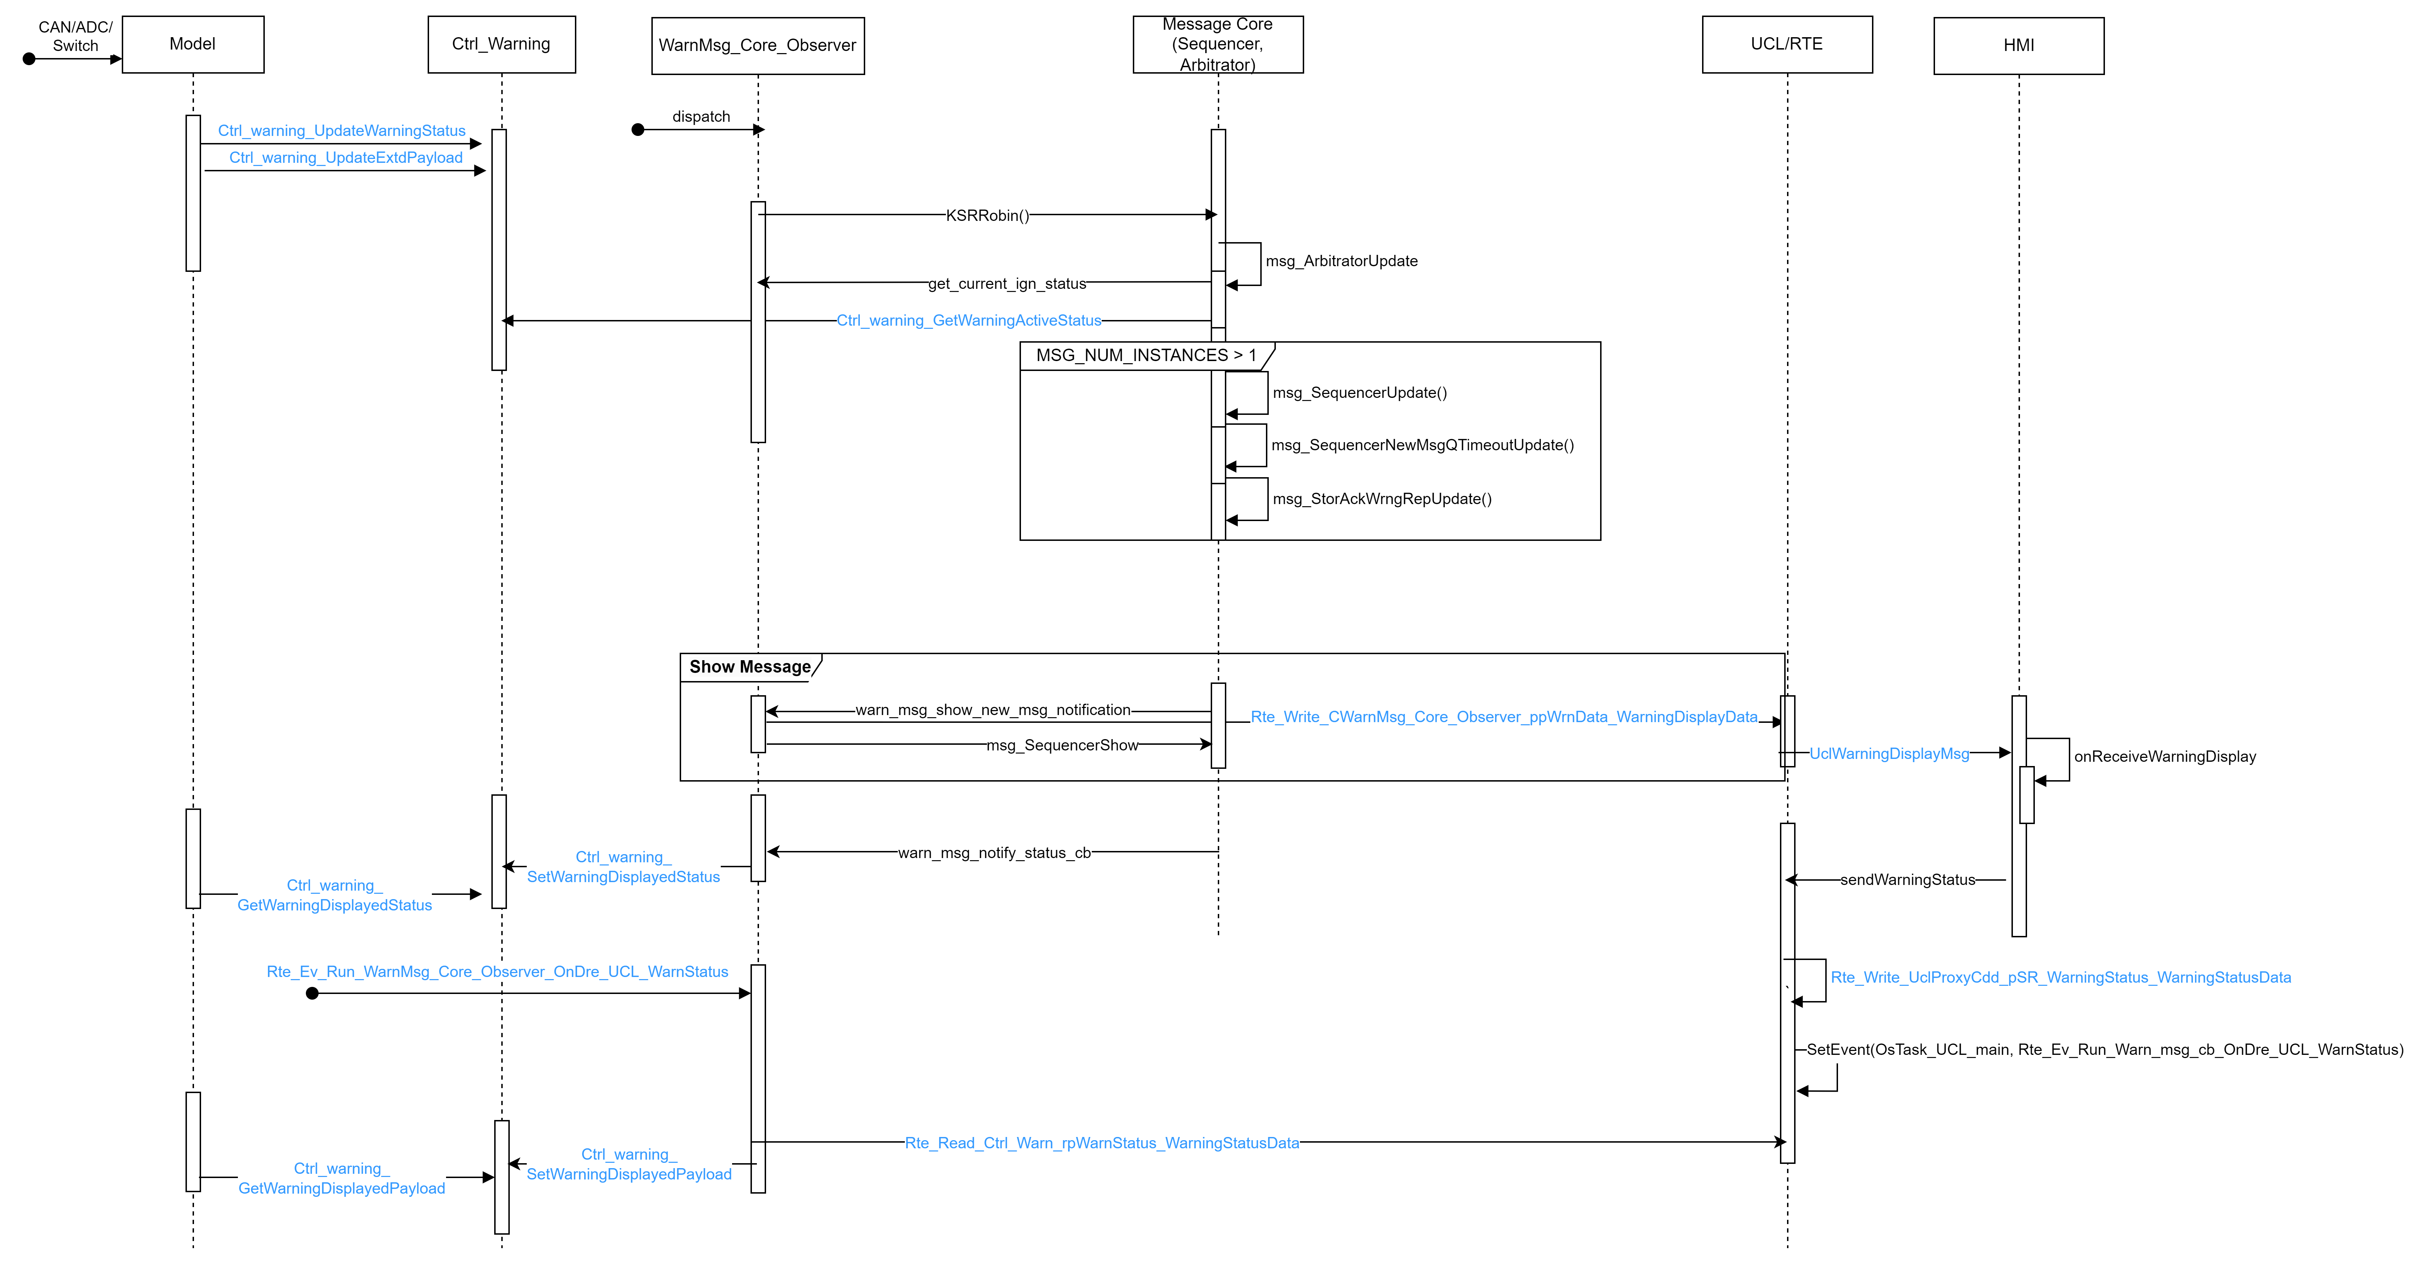

AW_D02_Warning_Acknowledement

DETAILED DESIGN

KEY CONSIDERATIONS
- All steps as above from “AW_D01_Warning_Show”.
- On a acknowledgement (button press - BACK), the “sendWarningStatus” sends this event as a part of the dynamic data.
- The Rte_Write_UclProxyCdd_pSR_WarningStatus_WarningStatusData reads this and invokes the Runnable - OnDre_UCL_WarnStatus that is present in the WarningCoreObserver.
- The ‘WarningCoreObserver’ invokes the msg_SequencerAction(HMI_BTN_EV_OK_SHORT)) that is present in the message core to act on the acknowledgement received.
- The Message core then stops the timer of the warning by warn_msg_stop_timer(WARN_MSG_TIMER_ID_E p_timer_id) and also invokes “warn_msg_hide_msg_notification” to remove the warning from display.
Requirements covered: AW_R01, AW_R05, AW_R06, AW_R08, AW_R09, AW_R10, AW_R11
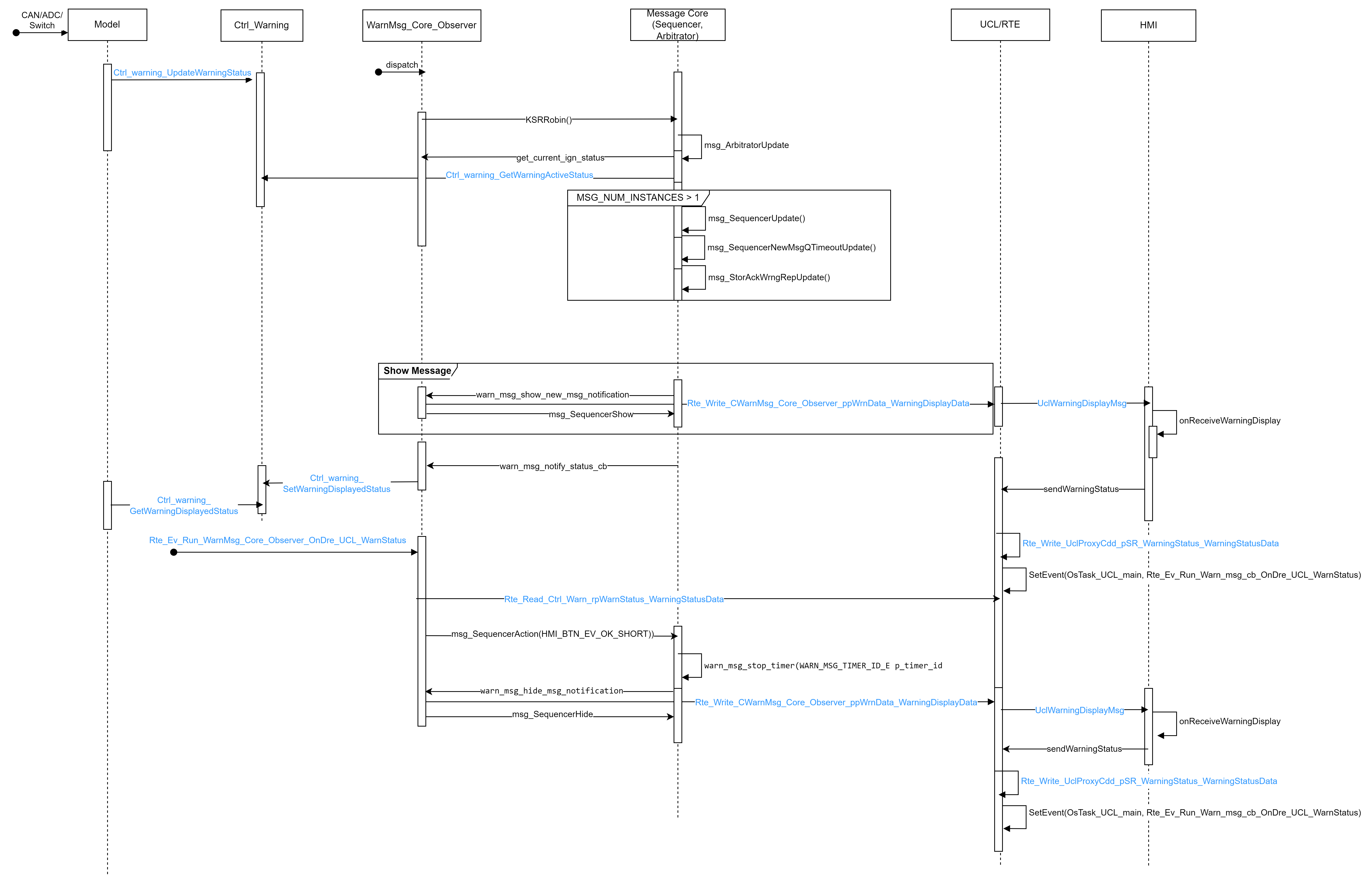

AW_D03_Warning_Timeout

DETAILED DESIGN

KEY CONSIDERATIONS
- All steps as above from “AW_D01_Warning_Show”.
- When the time is elapsed, i.e. time configured for a warning to be displayed on the screen, the message core stops the timer of the warning by warn_msg_stop_timer(WARN_MSG_TIMER_ID_E p_timer_id) and also invokes “warn_msg_hide_msg_notification” to remove the warning from display.
- The function “warn_msg_hide_msg_notification” calls the “UclWarningDisplayMsg” to convey about removing the message to the HMI and also informs the message core about the same.
Requirements covered: AW_R01, AW_R05, AW_R06, AW_R08, AW_R09, AW_R10
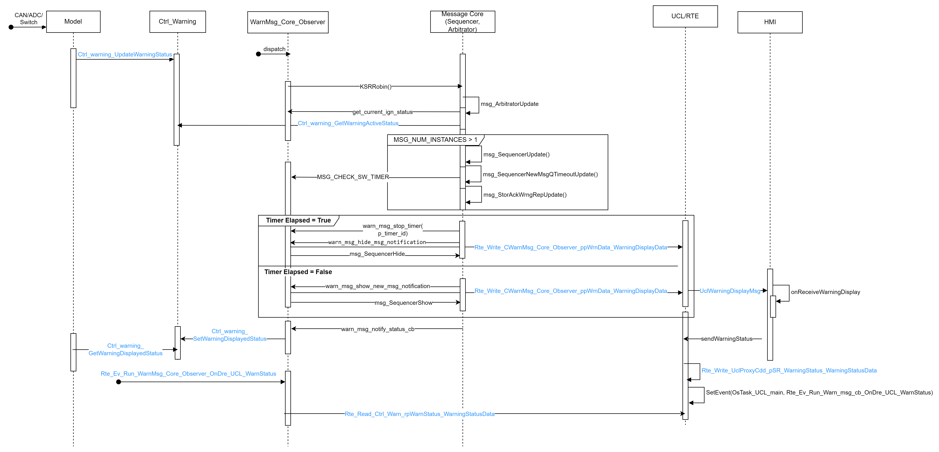

AW_D04_Warning_MasterLamp

DETAILED DESIGN
The Ctrl_Warning will invoke the telltale display function when any warning which is configured with the telltale is set by the application. Similarly, when the warning is reset by the application, the telltale TurnOff request is sent from the Ctrl_Warning. The telltale – Yellow/Red will be configured with its corresponding warning based on the requirements.
Requirements covered: AW_R03

KEY CONSIDERATIONS

AW_D05_Warning_ChimeRequest

DETAILED DESIGN
The Ctrl_Warning will invoke the chime request display function when any warning which is configured with the Chime is set by the application. The chime will be requested only once the HMI sends about the warning being displayed.

Requirements covered: AW_R04

KEY CONSIDERATIONS

AW_D06_Warning_Stored

DETAILED DESIGN

KEY CONSIDERATIONS - Acknowledged

- All steps as above from “AW_D01_Warning_Show”.
- On a acknowledgement (button press - BACK), the “sendWarningStatus” sends this event as a part of the dynamic data.
- The Rte_Write_UclProxyCdd_pSR_WarningStatus_WarningStatusData reads this and invokes the Runnable - OnDre_UCL_WarnStatus that is present in the WarningCoreObserver.
- The ‘WarningCoreObserver’ invokes the msg_SequencerAction(HMI_BTN_EV_OK_SHORT)) that is present in the message core to act on the acknowledgement received.
- The Message core then stops the timer of the warning by warn_msg_stop_timer(WARN_MSG_TIMER_ID_E p_timer_id) and also invokes “warn_msg_hide_msg_notification” to remove the warning from display.
- The WarningCoreObserver checks if the acknowledged warning is stored of not by invoking the local function - CWarnMsg_Core_Observer_SendStoreWarning. If configured as “WRN_STORE”, the warning id is added in the store array and sent to HMI via UCL - Rte_Send_CWarnMsg_Core_Observer_ppStoredWrnStsUCL_StoreWarningData
Requirements covered: AW_R01, AW_R05, AW_R06, AW_R08, AW_R09, AW_R02

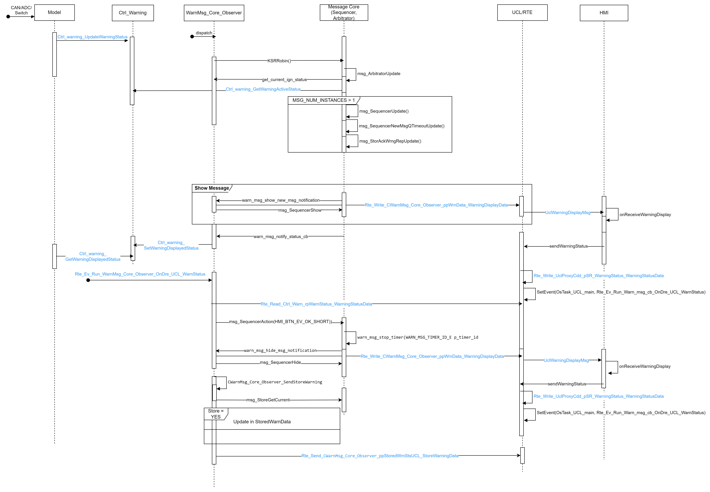

KEY CONSIDERATIONS – Timeout
- All steps as above from “AW_D01_Warning_Show”.
- When the time is elapsed, i.e. time configured for a warning to be displayed on the screen, the message core stops the timer of the warning by warn_msg_stop_timer(WARN_MSG_TIMER_ID_E p_timer_id) and also invokes “warn_msg_hide_msg_notification” to remove the warning from display.
- The function “warn_msg_hide_msg_notification” calls the “UclWarningDisplayMsg” to convey about removing the message to the HMI and also informs the message core about the same.
- The WarningCoreObserver checks if the timed-out warning is stored of not by invoking the local function - CWarnMsg_Core_Observer_SendStoreWarning. If configured as “WRN_STORE”, the warning id is added in the store array and sent to HMI via UCL - Rte_Send_CWarnMsg_Core_Observer_ppStoredWrnStsUCL_StoreWarningData
Requirements covered: AW_R01, AW_R05, AW_R06, AW_R08, AW_R09, AW_R10, AW_R02
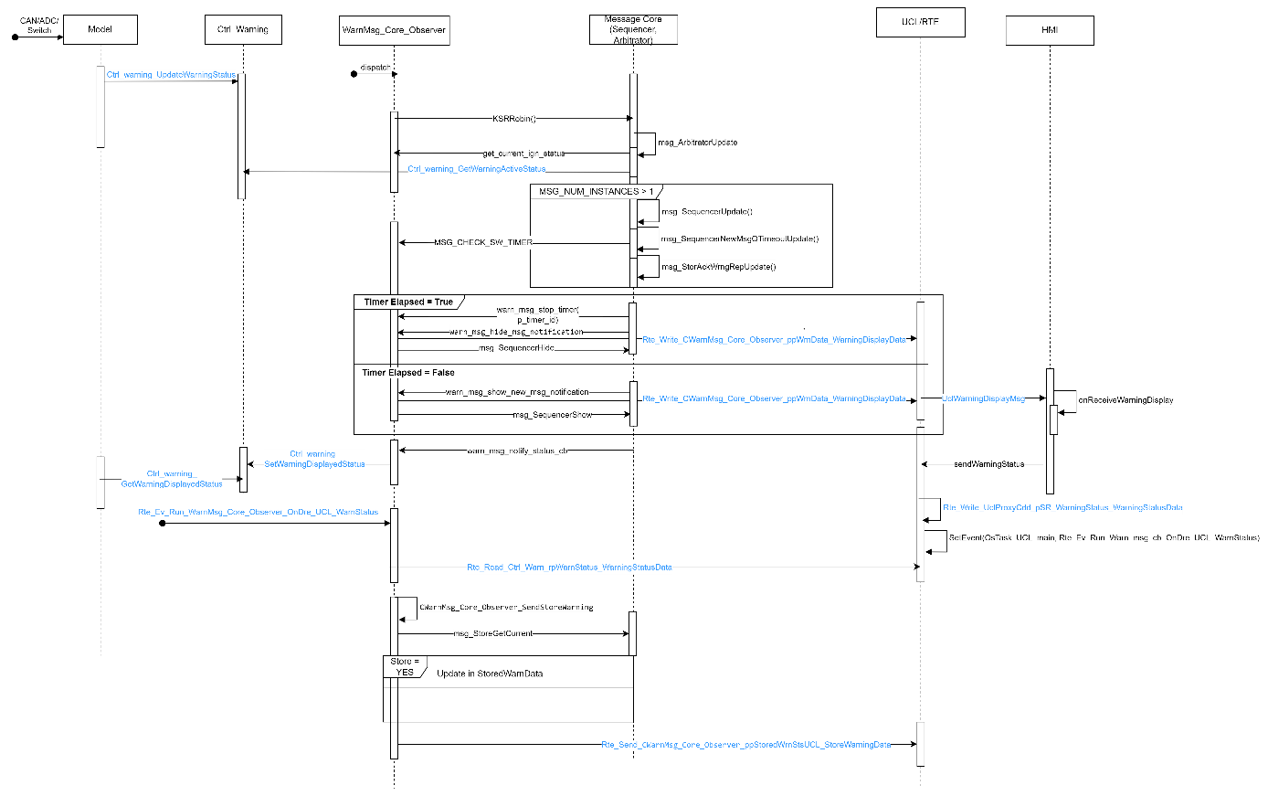

AW_D07_Warning_Hide

DETAILED DESIGN

KEY CONSIDERATIONS
- The Application shall call the “UpdateWarningStatus” when the condition for the warning is not satisfied. This updates the “WarningStatusArray” in the Control Warning.
- The ‘WarningCoreObserver’, on its execution, invokes the Message core. The message core reads the “WarnningStatusArray” and performs the priority arbitration, sequencing and the timeout check.
- Post on the above step, the message core calls the “warn_msg_hide_msg_notification” in case it has to hide the message.
- The function “warn_msg_hide_msg_notification” calls the “UclWarningDisplayMsg” to convey what to display to the HMI.
- The message core will call the “warn_msg_notify_status_cb” and acknowledges the same about the hide.
- The HMI on receiving the “UclWarningDisplayMsg” invokes “sendWarningStatus” as an acknowledgement of reception and also sets an Event in the UCL Adapter with the status of display.
- The Application can read the display status by invoking the Ctrl_warning_GetWarningDisplayedStatus(CurWarningId) which is updated by the “sendWarningStatus”.
Requirements covered: AW_R01, AW_R05, AW_R06, AW_R08, AW_R10
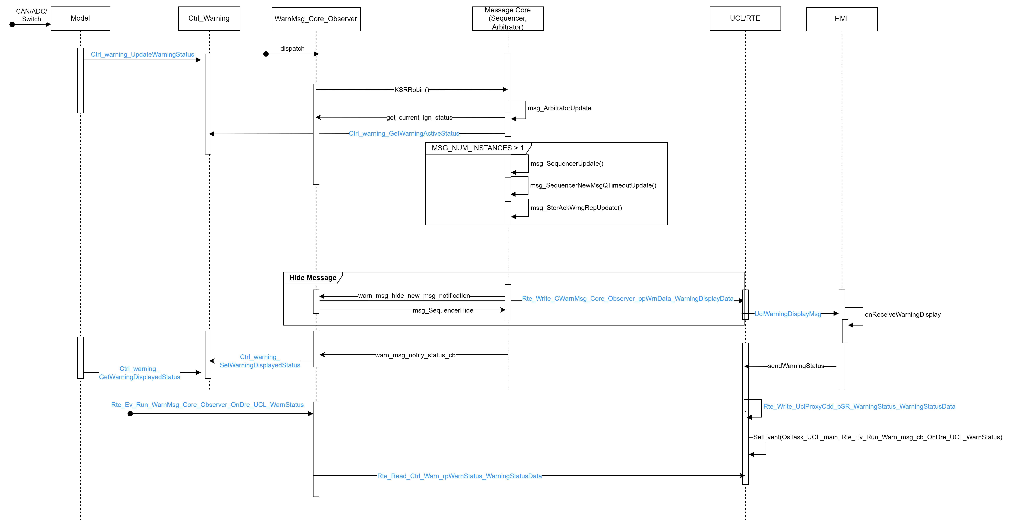

Test Strategy

Unit Test

Unit Test

GUIDELINES
- Scalable design unit with defined inputs and outputs help creating effective test plan and more portable to any SW architecture. Refer below code reference template.
- Create unit test plan design unit-wise for a feature model by also capturing related requirement IDs for each test case.
- For any incoming defects, verify the unit test plan against defect use case and identify escape reason to improve the gaps.

REFERENCE
Refer below example implementation (Not for model-based designs):
RTE inputs and outputs are isolated from the design unit which allows more flexibility to create reusable TP’s.
static Std_ReturnType CmpActive(void)
{
ts_AbsSafeMdl_ip fl_Abs_tt_ip_S;
ts_AbsSafeMdl_op fl_Abs_tt_op_S;
AbsSafeMdl_input_process(&fl_Abs_tt_ip_S);
AbsSafeMdl_process_tt (fl_Abs_tt_ip_S, &fl_Abs_tt_op_S);
AbsSafeMdl_ouput_process(fl_Abs_tt_op_S);
return E_OK;
}
typedef struct {
UInt8 fl_ABS_W_LAMP_val_U8;
UInt8 fl_TCS15_sts_U8;
UInt8 fl_ABS_W_LAMP_1_val_U8;
UInt8 fl_ABS11_sts_U8;
Boolean fl_ESC_variant_sts_bool;
Boolean fl_ABS_variant_sts_bool;
} ts_AbsSafeMdl_ip, *ts_ptr_AbsSafeMdl_ip;
typedef struct {
UInt8 fl_Abs_tt_sts_U8;
} ts_AbsSafeMdl_op, *ts_ptr_AbsSafeMdl_op;

static void AbsSafeMdl_input_process (ts_ptr_AbsSafeMdl_ip p_tt_ip_sts_SP)
{
(void)Rte_Call_rpNvmEOLConfig_GetNvm_EOL_Config_Bit_Status (e_HKMC_ESC, &p_tt_ip_sts_SP->fl_ESC_variant_sts_bool);
(void)Rte_Call_rpNvmEOLConfig_GetNvm_EOL_Config_Bit_Status (e_HKMC_ABS, &p_tt_ip_sts_SP->fl_ABS_variant_sts_bool);
(void)Rte_Call_rpComSafeAbsSignal_RxCan_GetSignalValue (eABS_W_LAMPIn,
&p_tt_ip_sts_SP->fl_ABS_W_LAMP_val_U8, &p_tt_ip_sts_SP->fl_TCS15_sts_U8);
(void)Rte_Call_rpComSafeAbsSignal_RxCan_GetSignalValue (eABS_W_LAMP_1In,
&p_tt_ip_sts_SP->fl_ABS_W_LAMP_1_val_U8, &p_tt_ip_sts_SP->fl_ABS11_sts_U8);
}

static void AbsSafeMdl_process_tt (ts_AbsSafeMdl_ip p_tt_ip_sts_S, ts_ptr_AbsSafeMdl_op p_tt_op_sts_SP)
{
/* p_tt_ip_sts_S – Input structure (Read only) used for processing*/
/* p_tt_op_sts_SP– Output structure (Write) updated after processing*/
}

static void AbsSafeMdl_ouput_process (ts_AbsSafeMdl_op p_tt_op_sts_S)
{
(void)Rte_Call_rpCS_rpTtMdlStatus_TITtMdl_TtMdlUpdateStatus (cTTABS, p_tt_op_sts_S.fl_Abs_tt_sts_U8);
}

Model Based Design
Model Based Design shall use the MIL methodology to test against the requirement for the waring Models and get all the Method and decision coverage as well.

Functional Test
Will be covered as part of the settings model feature functional verification.

Design Limitations
- Strategy that are incomplete.
  - For comparing Custom payload and common handling of Retrigger and Forced
  - Common handling of CAN out on validation/acknowledgement.
  - Handling of MCAN-Popup, Popup.

