 Software Detailed Design Specification
1.0

Table of Contents

1 Preparation for pre-design review 3
1.1 Purpose 3
1.2 Public interface 3
1.3 Private Interface 3
1.4 Design Choice 6
1.5 Class Diagram 11
1.6 File structure 12
1.7 Functional blocks 13
1.8 Port Interface details 13
1.7.1 Providing ports - None. 13
1.8.2 Receiving ports - None 13
1.9 CTRL APP State mapping 13
1.10 Design Assumptions 13
2 Pre-design review conclusions 13
3 Detailed design 13
3.1 Private interfaces 13
3.2 Internal data structures 13
3.3 Algorithms explanation 13
3.4 Component configuration 14
3.4.1 Task period – --ms //Project specific 14
3.4.2 Timing constraints 14
3.4.3 NVM access 14
3.5 Registers 15
4 Lessons Learnt 15
4.1 Similar issues/use cases addressed. 15
5 Tools 15
6 Traceability 15
7 Precautions 16

References

Reference | Document Name | Version
1 | Bookshelf_Ctrl_Warning_Design_Document_Ver1_0 | 1.0
2 | hmi_message_core_DD | 4.3

Definitions

Term | Abbreviation | Description
ms | Milli second | Time unit

Revision History

Version | Date | Author | Description of changes
1.0 | Jun-24-2024 | vrk | This document is the detail design of WarnMsg_Core_Observer
1.1 | Sep-10-2024 | vrk | Updated the Algorithms explanations and incorporate other review comments.

Preparation for pre-design review

Purpose
This document is the detail design methodology for WarnMsg_Core_Observer component. This component executes hm_msg_KSRRobin in message core to achieve arbitration and sequencing of the warnings list (both active and inactive) and get the callback to show/hide the message. The message core takes care of priority, urgency, minimum indication time, storing.

Public interface
Data Types;
typedef uint8 SIF_STATUS;
typedef uint16 eMessageIdentity;

typedef struct
{
eMessageIdentity Id; /* Message ID */
UINT16 Position; /* Position in current list */
UINT16 Count; /* Number of messages in list. */
UINT8 Status; /* Indicates status of msg ID */
UINT8 InstanceID;
} MSG_VIEWINFO_T;

Interface ID | AW_PublicIf_WarnMsgCoreObs_01
Method | void OnDre_UCL_MultiZone_WarnStatus(uint8 inst)
Sync/Async | Sync
Reentrant | No
Parameters | N/A
Return | void
Description | This function is used to process the button acknowledgement of the warning for Multi Instance

Interface ID | AW_PublicIf_WarnMsgCoreObs_01
Method | void OnDre_UCL_SingleZone_WarnStatus(void)
Sync/Async | Sync
Reentrant | No
Parameters | N/A
Return | void
Description | This function is used to process the button acknowledgement of the warning for Single Instance

Private Interface

Interface ID | AW_PrivateIf_WarnMsgCoreObs_01
Method | SIF_STATUS WarnMsg_Core_Observer_Warning_Get_status (UINT16 *Data, UINT16 Qualifier)
Sync/Async | Sync
Reentrant | No
Parameters | Uint16 Data, Uint16 Qualifier
Return | SIF_Status
Description | This function receives the Warning status from Ctrl_Warning

Interface ID | AW_PrivateIf_WarnMsgCoreObs_02
Method | UINT8 CWarnMsg_Core_Observer_Get_Current_IgnSts ( void )
Sync/Async | Sync
Reentrant | No
Parameters | None
Return | Uint8
Description | This function returns the ignition status when invoked by the message core.

Interface ID | AW_PrivateIf_WarnMsgCoreObs_03
Method | CWarnMsg_Core_Observer_Show_New_Msg_Notification (const MSG_VIEWINFO_T * p_msg_info_S )
Sync/Async | Sync
Reentrant | No
Parameters | MSG_VIEWINFO_T
Return | void
Description | This function is invoked by the sequencer of the Message core component to share the data of the warning to be displayed.

Interface ID | AW_PrivateIf_WarnMsgCoreObs_04
Method | void CWarnMsg_Core_Observer_Hide_Msg_Notification (eMessageIdentity p_MsgId_E)
Sync/Async | Sync
Reentrant | No
Parameters | eMessageIdentity p_MsgId_E
Return | None
Description | This function is invoked by the sequencer of the Message core component to share the data of the warning to be removed from the display.

Interface ID | AW_PrivateIf_WarnMsgCoreObs_05
Method | SIF_STATUS CWarnMsg_Core_Observer_Notify_Status_Cb(uint8 *Data, uint8 Qualifier)
Sync/Async | Sync
Reentrant | No
Parameters | uint8 *Data, uint8 Qualifier
Return | SIF_STATUS
Description | This function used to get the msg status from the message core post it’s processing.

Interface ID | AW_PrivateIf_WarnMsgCoreObs_06
Method | void CWarnMsg_Core_Observer_SendStoreWarning(void)
Sync/Async | Sync
Reentrant | None
Parameters | None
Return | None
Description | This function will be used to get actual store warning position and count.

Interface ID | AW_PrivateIf_WarnMsgCoreObs_07
Method | BOOLEAN CWarnMsg_Core_Observer_store_warning_check(eMessageIdentity MessageId)
Sync/Async | Sync
Reentrant | None
Parameters | eMessageIdentity MessageId
Return | Boolean
Description | This function will confirm if the requested warning is configured as store warning or not.

Interface ID | AW_PrivateIf_WarnMsgCoreObs_08
Method | void CWarnMsg_Core_Observer_store_remove_notification(eMessageIdentity p_message_id)
Sync/Async | Sync
Reentrant | None
Parameters | eMessageIdentity MessageId
Return | Boolean
Description | This function is used to remove the store warning and convey the same to HMI.

Design Choice

1.4.1 Sequence Diagram – Warning Show
This highlights the sequence of events from the warning trigger from the model to the ctrl_warning and message core gets the status of all the warnings, gives the callback to the warnmsg_core_observer which sends the active message to the HMI via UCL.

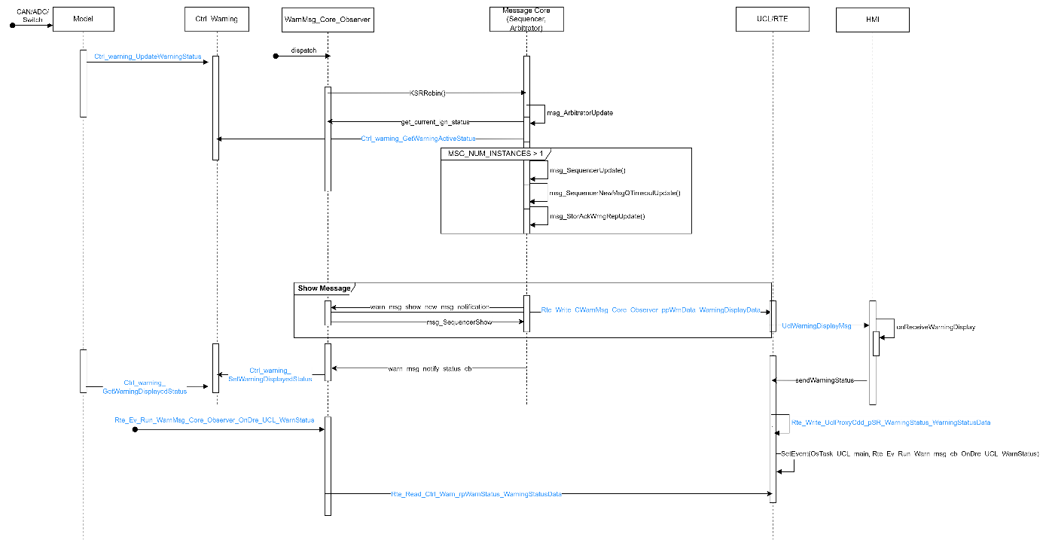

1.4.2 Sequence Diagram – Warning Acknowledge
This highlights the sequence of events from the warning trigger from the model to the ctrl_warning and message core gets the status of all the warnings, gives the callback to the warnmsg_core_observer which sends the active message to the HMI via UCL. On acknowledgement, HMI sends the keypress info to the warnmsgcore_observer which processes it and send the deactivate status to HMI.

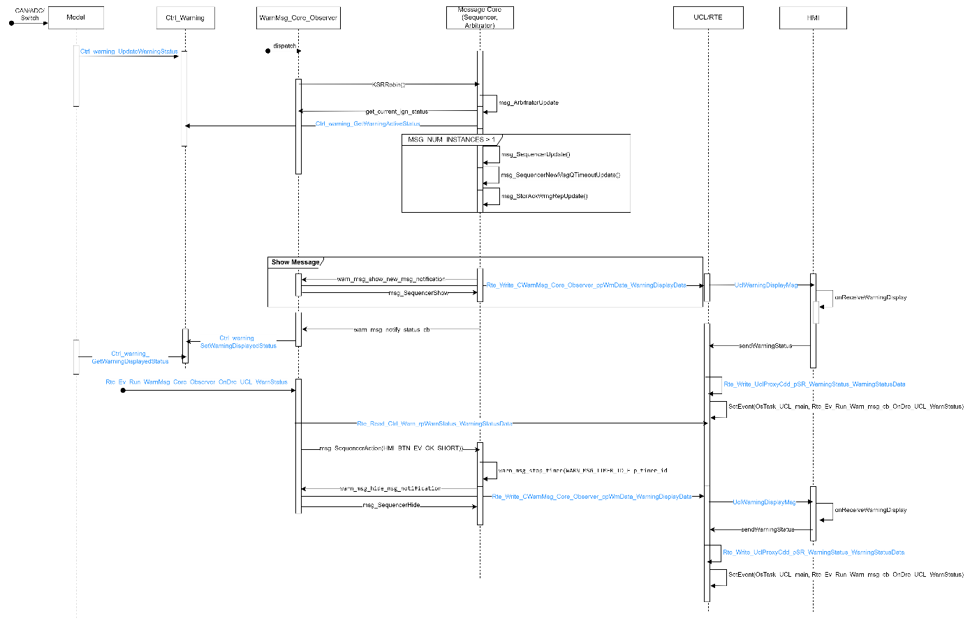

1.4.3 Sequence Diagram – Warning Timeout
This highlights the sequence of events from the warning trigger from the model to the ctrl_warning and message core gets the status of all the warnings, gives the callback to the warnmsgcore_observer which sends the active message to the HMI via UCL. The warnmsgcore processes the configured timeout and post its elapse, it instructs the warnmsgcore_observer to send the deactivate status to HMI.

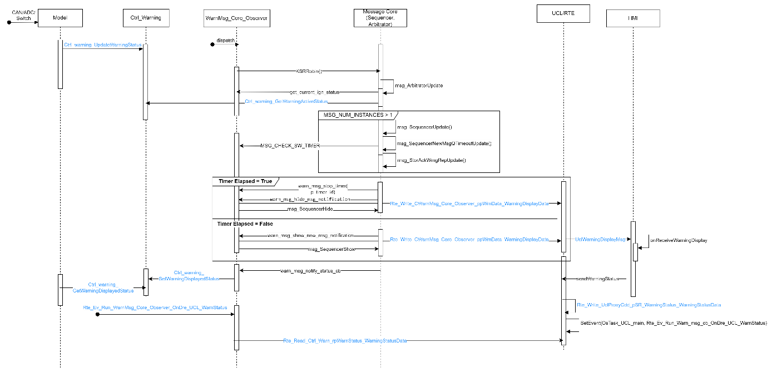

1.4.4 Sequence Diagram – Warning Acknowledge and Store
This highlights the sequence of events from the warning trigger from the model to the ctrl_warning and message core gets the status of all the warnings, gives the callback to the warnmsgcore_observer which sends the active message to the HMI via UCL. On acknowledgement, HMI sends the keypress info to the warnmsgcore_observer which processes it and send the deactivate status to HMI. If the warning is configured as “Stored Warning”, the stored warning array is updated, and the data is shared to HMI to display the stored warnings in the corresponding menu tab.

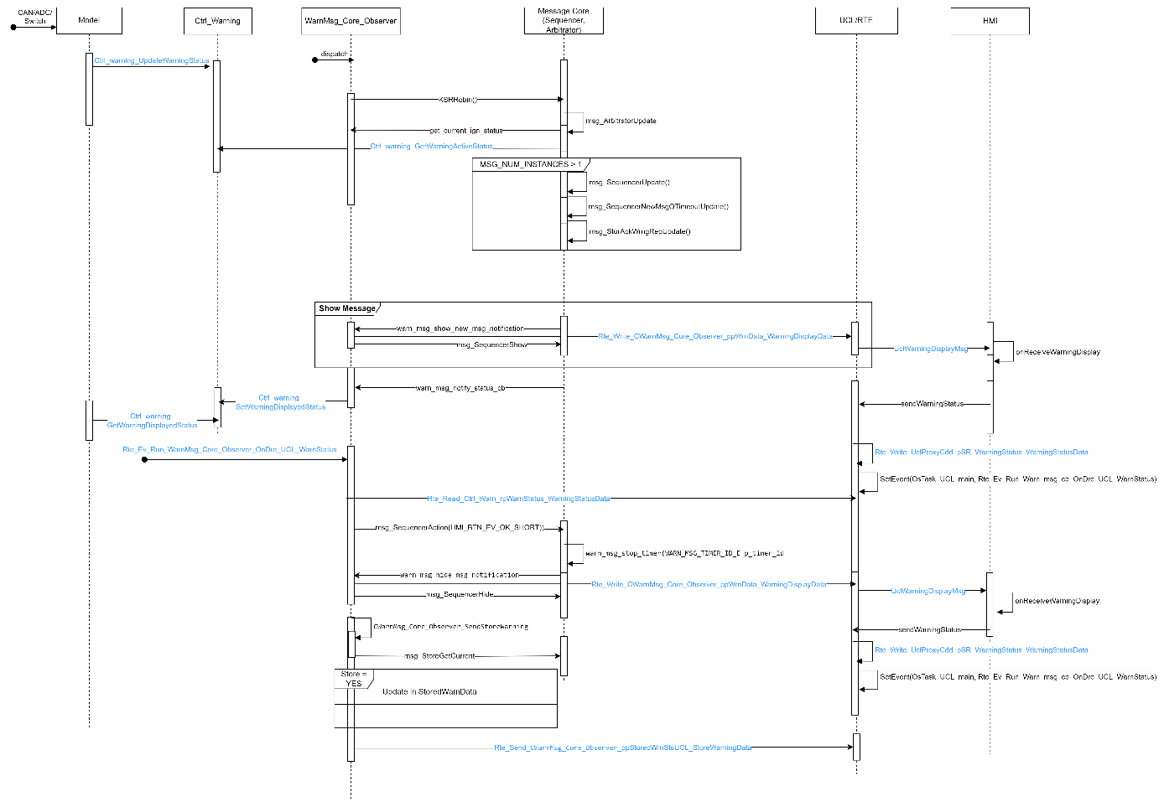

1.4.5 Sequence Diagram – Warning Timeout and Store
This highlights the sequence of events from the warning trigger from the model to the ctrl_warning and message core gets the status of all the warnings, gives the callback to the warnmsgcore_observer which sends the active message to the HMI via UCL. The warnmsgcore processes the configured timeout and post its elapse, it instructs the warnmsgcore_observer to send the deactivate status to HMI. If the warning is configured as “Stored Warning”, the stored warning array is updated, and the data is shared to HMI to display the stored warnings in the corresponding menu tab.

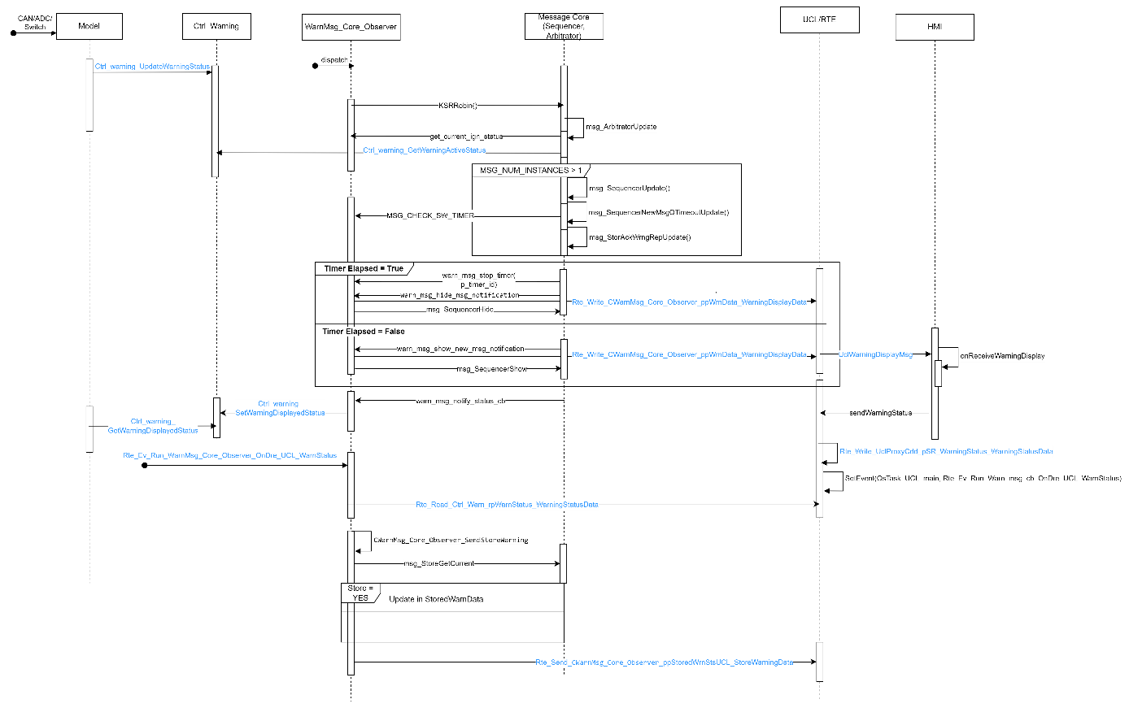

1.4.6 Sequence Diagram – Hide

This highlights the sequence of events from the warning trigger from the model to the ctrl_warning and message core gets the status of all the warnings, gives the callback to the warnmsg_core_observer which sends only the active message to the HMI via UCL. On the removal, the displayed data which goes out from the observer will not have the deactivated warning.

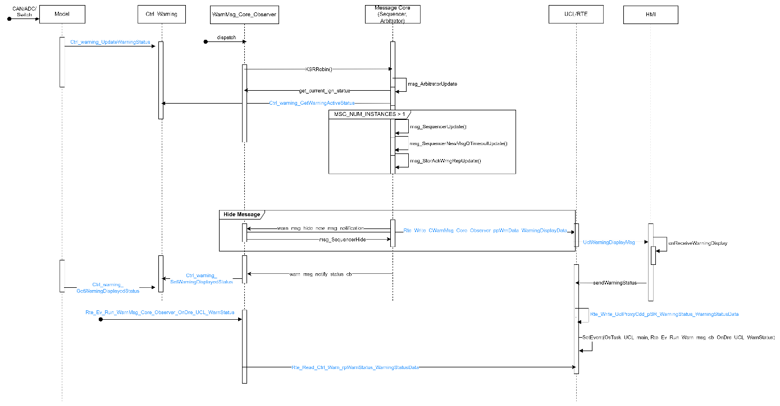

1.4.7 Flow Diagram – Chime Request
This function is implemented in the warnmsgcore_observer_extn. This handles the triggering of chime that is configured for the warning. The triggering happens once the warning comes into display.
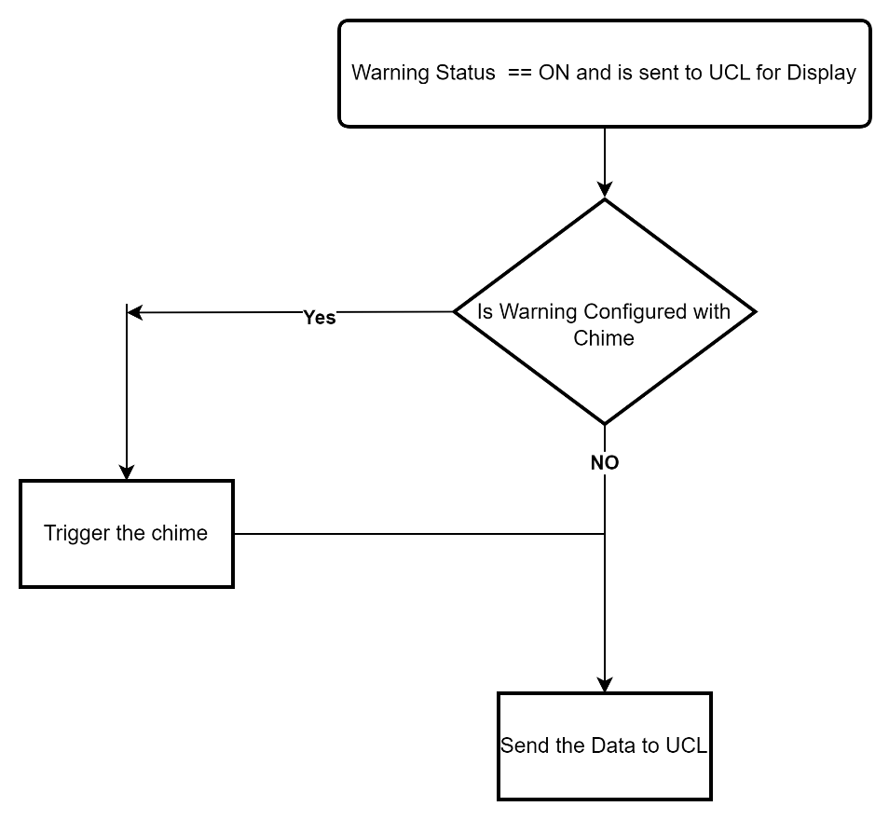

1.4.8 Flow Diagram – Initialization
Based on the type of initialization required for the respective programs, the warminit/coldinit is executed. The conditions to trigger the initialization are present in warnmsgcore_observer_extn based on the program requirements.
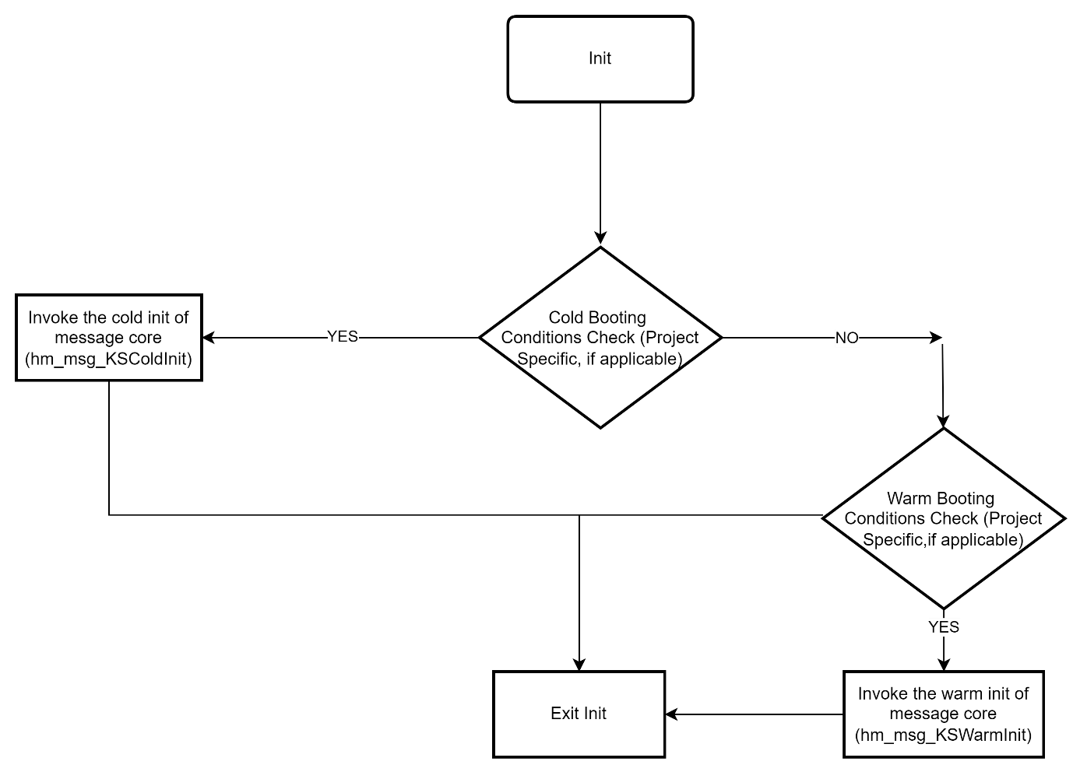

Class Diagram
The WarnMsg_Core_Observer is a single AUTOSAR component which holds warnmsgcore_observer, warnmsgcore_observer_extn and warningcore. The public functions which are shown below, only with respect to the sub-component i.e., warnmsgcore_observer and warning core and not with respect to the AUTOSAR component.

Responsibilities:
warnmsgcore_observer
- Invokes the KSRRobin of message core.
- Receives callback from message core.
- Sends data to HMI.
- Receives feedback from HMI and updates message core accordingly.

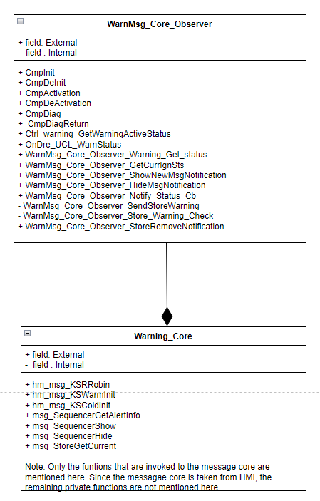

File structure
The file structure is as follows:
WarnMsg_Core_Observer contains WarnMsg_Core_Observer.c, WarnMsg_Core_Observer_Extn.c and their headers.

Functional blocks
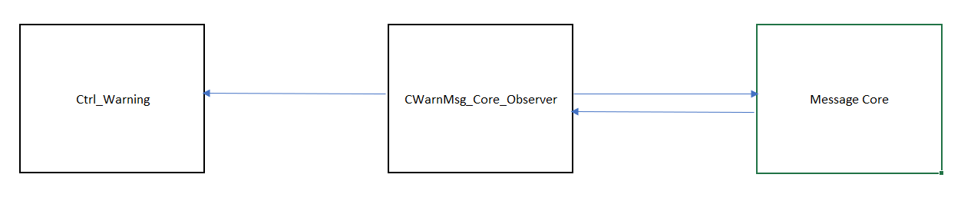

Port Interface details

1.7.1 Providing ports - None.

Receiving ports - None

CTRL APP State mapping

Design Assumptions
- This component – WarnMsg_Core_Observer is invoked after Ctrl_Warning and the feedback from message core is stored in the corresponding array which can be invoked by the application based on the need basis.
- The Warning to be displayed is sent to the HMI via UCL. The platform interface is used and is configured as “On Write”.
- Store Warning data is stored in the “stor_MessageList” of Message Core. This can be used is backup RAM based on the requirements.

Pre-design review conclusions

Detailed design

Private interfaces
Follows Pre-Design decisions.

Internal data structures
Follows Pre-Design data structure defined in Public interface section.

Macros used

Algorithms explanation

CmpInit
Invoked reset the message core based on the OEM requirement. In addition, it initializes all the global variables associated with the WarnMsg_Core_Observer and its extension file.

CmpActive
Invoked every task period by the CmpLib. This triggers the message core that is responsible for priority, urgency, minimum indication time, storing. The stored warning data is shared to the HMI via the UCL in this function. Any OEM/Program specific requirements that needs action periodically (every task period) is handled here.

WarnMsg_Core_Observer_ShowNewMsgNotification
This is invoked by the message core post its arbitration to display the warning. The warning to be displayed is shared to the HMI via the UCL from this function.

WarnMsg_Core_Observer_HideMsgNotification
This is invoked by the message core post its arbitration to remove a warning from the display. The warning to be removed is shared to the HMI via the UCL from this function.

WarnMsg_Core_Observer_Notify_Status_Cb
This is a callback function from the Message core that indicates the current status of all the active warnings (irrespective of timeout/acknowledged etc.) post its processing. This status is updated to the applications via Ctrl_warning.

Component configuration

Task period – --ms //Project specific

Timing constraints

The warning detection time period is 32ms. Since, the CAN reading(Application model runnable) and the warning set to UCL(Controller Runnable) are executed from the same task.

NVM access

Registers
None

Lessons Learnt

Similar issues/use cases addressed.

Tools
None

Traceability
For Requirements and HLD, refer the sections of SAD Document.

S.No | Requirement | HLD | DD | Code
1 | AW_R01_Warning_Status_Update | AW_D01_Warning_Show  (Sec. 3.1.2.3.1)  AW_D02_Warning_Acknowledement  (Sec. 3.1.2.3.2)  AW_D03_Warning_Timeout  (Sec. 3.1.2.3.3) | Sec 1.4.1, Sec 1.4.2 and Sec 1.4.6  Sec 1.2 (Public Interfaces of Ctrl_Warning_DD) | Ctrl_warning.c
2 | AW_R02_Stored Warnings | AW_D06_Warning_Stored  (Sec. 3.1.2.3.6) | Sec 1.4.4 and Sec 1.4.5 | CWarnMsg_Core_Observer.c
3 | AW_R03_LampUpdate | AW_D04_Warning_MasterLamp  (Sec. 3.1.2.3.4) | Sec 1.4.2  (Ctrl_Warning_DD)  Sec 1.2 (Public Interfaces of Ctrl_Warning_DD) | Ctrl_warning.c
4 | AW_R04_ChimeUpdate | AW_D05_Warning_ChimeRequest  (Sec. 3.1.2.3.5) | Sec 1.4.7 | CWarnMsg_Core_Observer.c
5 | AW_R05_Read Displayed Status | AW_D01_Warning_Show  (Sec. 3.1.2.3.1)  AW_D02_Warning_Acknowledement  (Sec. 3.1.2.3.2)  AW_D03_Warning_Timeout  (Sec. 3.1.2.3.3) | Sec 1.4.1, Sec 1.4.2, Sec 1.4.3  Sec 1.2 (Public Interfaces of Ctrl_Warning_DD) | Ctrl_warning.c
6 | AW_R06_Active Warning Status | AW_D01_Warning_Show  (Sec. 3.1.2.3.1)  AW_D02_Warning_Acknowledement  (Sec. 3.1.2.3.2)  AW_D03_Warning_Timeout  (Sec. 3.1.2.3.3) | Sec 1.4.1, Sec 1.4.2, Sec 1.4.3  Sec 1.2 (Public Interfaces of Ctrl_Warning_DD) | Ctrl_warning.c
7 | AW_R07_Retrigger and Forced Handling | AW_D01_Warning_Show  (Sec. 3.1.2.3.1) | Sec 1.4.1  Sec 1.2 (Public Interfaces of Ctrl_Warning_DD) | Ctrl_warning.c
8 | AW_R08_Status Feedback from Message core Handling | AW_D01_Warning_Show  (Sec. 3.1.2.3.1)  AW_D03_Warning_Timeout  (Sec. 3.1.2.3.3) | Sec 1.4.1, Sec 1.4.2, Sec 1.4.3 | WarnMsg_Core_Observer.c
9 | AW_R09_HighPriority Warning Display | AW_D01_Warning_Show  (Sec. 3.1.2.3.1)  AW_D03_Warning_Timeout  (Sec. 3.1.2.3.3) | Sec 1.4.1 | WarnMsg_Core_Observer.c
10 | AW_R10_Hide Warning | AW_D02_Warning_Acknowledement  (Sec. 3.1.2.3.2)  AW_D03_Warning_Timeout  (Sec. 3.1.2.3.3) | Sec 1.4.2, Sec 1.4.3, Sec 1.4.6 | WarnMsg_Core_Observer.c
11 | AW_R11_Warning_Acknowledgement | AW_D02_Warning_Acknowledement  (Sec. 3.1.2.3.2) | Sec 1.4.2, Sec 1.4.4 | WarnMsg_Core_Observer.c

Precautions

