Software Detailed Design Specification
1.0

Table of Contents

1 Preparation for pre-design review 3
1.1 Purpose 3
1.2 Public interface 3
1.3 Private Interface 3
1.4 Design Choice 4
1.5 File structure 6
1.6 Functional blocks 6
1.7 Port Interface details 7
1.7.1 Providing ports - None. 7
1.7.2 Receiving ports - None 7
1.8 CTRL APP State mapping 7
1.9 Design Assumptions 7
2 Pre-design review conclusions 7
3 Detailed design 7
3.1 Private interfaces 7
3.2 Internal data structures 7
3.3 Algorithms explanation 7
3.4 Component configuration 8
3.4.1 Task period – --ms 8
3.4.2 Timing constraints 8
3.4.3 NVM access 8
3.5 Registers 8
4 Lessons Learnt 8
4.1 Similar issues/use cases addressed. 8
5 Tools 8
6 Precautions 8

References

Reference | Document Name | Version
1 | Bookshelf_Ctrl_Warning_Design_Document_Ver1_0 | 1.0
2 | hmi_message_core_DD | 4.3
3 | Bookshelf_CWarnMsg_Core_Observer_Design_Document | 1.0

Definitions

Term | Abbreviation | Description
ms | Milli second | Time unit

Revision History

Version | Date | Author | Description of changes
1.0 | Jun-24-2024 | vrk | This document is the detail design of WarnMsg_Core_Observer_TmrSupport
1.1 | Sep-10-2024 | vrk | Updated Algorithm Explanations and incorporated some additional review comments

Preparation for pre-design review

Purpose
This document is the detail design methodology for WarnMsg_Core_Observer_TmrSupport component. This component is used by Warning core for calculating the time for the following situations.
- Check Elapsed time for displaying a warning.
- Cyclic display of warning.
- Minimum duration to display the warning.

Public interface
None

Private Interface

Method | WarnMsgCore_TmrSupport_Start_Timer(uint16 timer_id, uint32 timeout_count, uint16 event)
Sync/Async | Sync
Reentrant | No
Parameters | uint16 timer_id, uint32 timeout_count, uint16 event
Return | None
Description | This function is used to start the timer that is requested by the message core.

Method | void WarnMsgCore_TmrSupport_Stop_Timer(uint16 timer_id)
Sync/Async | Sync
Reentrant | No
Parameters | Uint16
Return | None
Description | This function is used to stop the timer that is requested by the message core.

Method | uint8 WarnMsgCore_TmrSupport_Check_Timer(uint16 timer_id)
Sync/Async | Sync
Reentrant | No
Parameters | Uint16
Return | Uint8
Description | This function is invoked to check if the timer of a particular warning attribut that is running is elapsed.

Design Choice
The sequences that invoke the WarnMsg_Core_TmrSupport are briefed below.

1.4.1 Timer Macros Description

List of S/W timers invoked by Warning Message Core and their Description.

Timer IDs | Description
WARNING_DISPLAY_TIMER_ID | Total time allowed to display the warning.
WARNING_HOLD_TIMER_ID | Minimum warning display time even if warning is gets deactivated
WARNING_CYCLE_TIMER_ID | Allowable warning display Time during cycling mode
WARNING_DISPLAYHOLD_TIMER_ID | Minimum Warning display time without interruption.
WARNING_ACK_TIMER_ID | Allow the warning acknowledgement after "HMI_MSG_ACK_AFT_MIN_TIME" period
WARNING_MSGTIMEOUT_1SEC_TIMER_ID | Used for 1 second time calculation for warning timeout with cycling mode
WRN_ACK_REDISPLAY_TIMER_ID | Used for 1 second time calculation for message Q timeout check
SUPPORTED_PERIOD | This is the maximum count value that can be handled by TmrExt. The value is 63536U for 16bit timers. Since max time limit required for core is only 6s which is less than 63536U(65s),only 16 bit timers are used by warning core currently.

1.4.2 Sequence Diagram – Warning Acknowledge

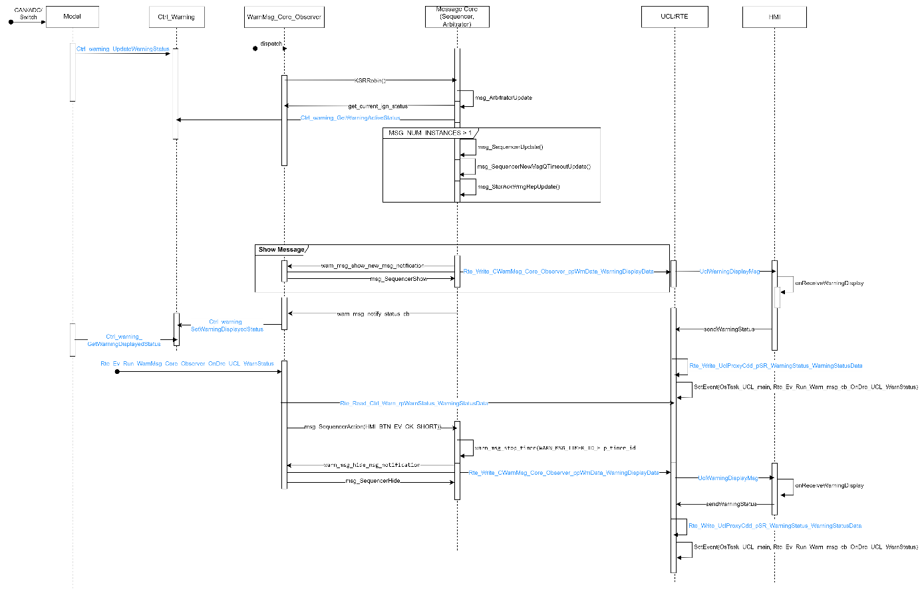

1.4.3 Sequence Diagram – Warning Timeout

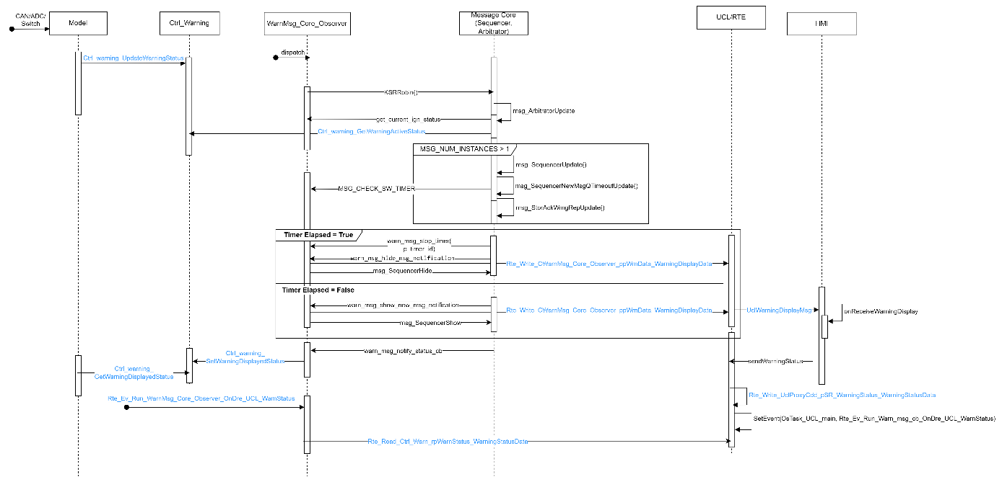

1.4.4 Sequence Diagram – Warning Acknowledge and Store

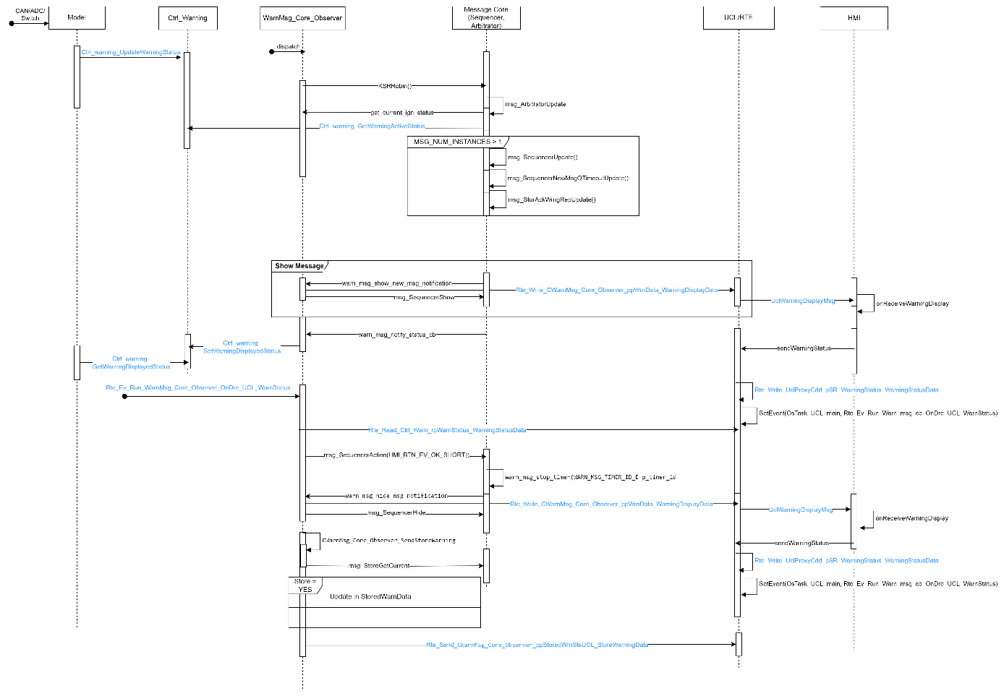

1.4.5 Sequence Diagram – Warning Timeout and Store
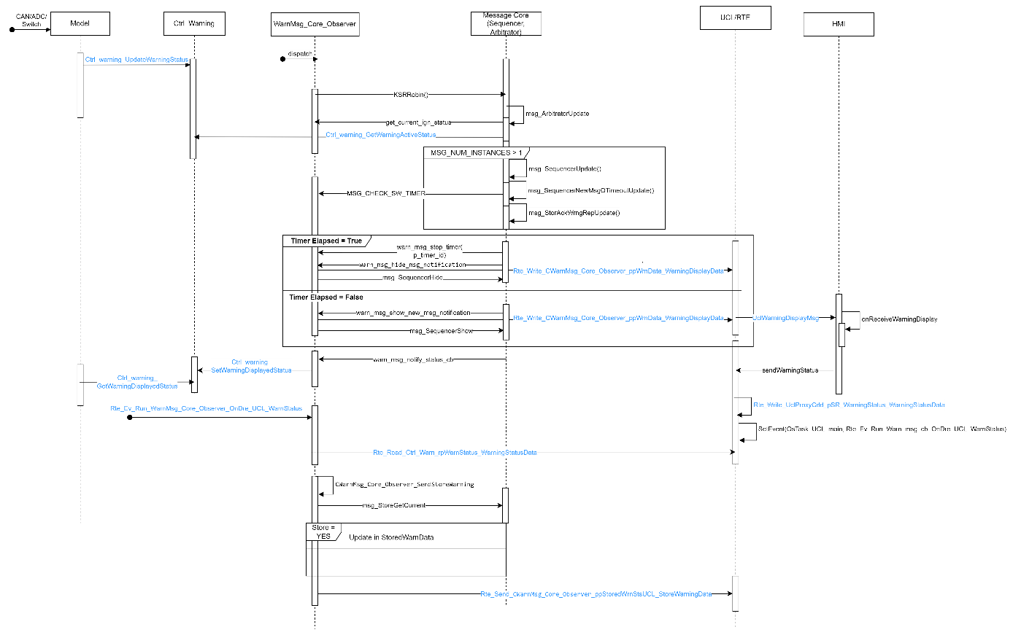

File structure
The file structure is as follows:
CWarnMsgCore_TmrSupport contains CWarnMsg_Core_TmrSuppport.c, and its header.

Functional blocks
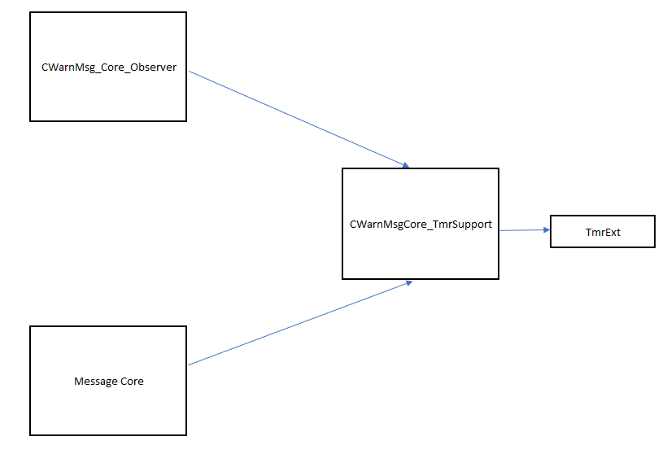

Port Interface details

1.7.1 Providing ports - None.

Receiving ports - None

CTRL APP State mapping

Design Assumptions
None

Pre-design review conclusions

Detailed design

Private interfaces

Internal data structures
Macros used

Algorithms explanation

WarnMsg_Core_TmrSupport_Start_Timer
This is used to start the timer when the requested timer count is less than the max timer.

WarnMsg_Core_TmrSupport_Stop_Timer
On clearing of warnings or elapsing of display/hold timers, this function is used to stop the timer.

WarnMsg_Core_TmrSupport_Check_Timer
This is used to check if the running timer is elapsed past its requested count or not.

Component configuration

Task period – --ms
This is a dummy task as no operation is performed in the task.

Timing constraints

NVM access

Registers
None

Lessons Learnt

Similar issues/use cases addressed.

Tools
None

Precautions

