Software Detailed Design Specification
1.0

Table of Contents

Preparation for pre-design review 3
1 Purpose 3
2 Public interface 3
3 Design choice 3
3.1.1 Design options 3
3.1.2 Justification of the selected option 3
4 File structure 3
5 Functional blocks 3
6 Pre-design review conclusions 3
7 Detailed design 3
8 Private interfaces 3
9 Internal data structures: 3
10 Algorithm’s explanation 3
11 Component configuration 3
• Os Task Configuration 3
• RTE interfaces 3
12 Integration requirements: 3
13 Registers 3
14 Tools 3
15 Precautions 3
16 Limitations 3

References

Reference | Document Name | Version
[R1] | AM62Px Sitara® Processors Technical Reference Manual – SPRUJ83B | <X.X>
[R2] | < > | <X.X>
[R3] | < > | <X.X>

Definitions

Term | Abbreviation | Description

Revision History

Version | Date | Author | Description of changes
1.0 | 13/08/2025 | mchoudha | Updated for TI Sitara DSS drivers’ integration

Preparation for pre-design review

Purpose
To develop a Complex Device Driver for TI Sitara DSS Signature unit to satisfy the ASIL B compliance for Display. To control the correctness of display output, signature values can be computed for each frame and compared against reference golden values. In case of a mismatch (signature violation) a HW event can be triggered.

Signature unit overview:
- There are 2 DSS instances supported in TI Sitara micro.
- Each DSS is equipped with a Video Pipeline, Video Lite Pipeline & Video Port
- Up to 4 Evaluation Windows @ Video Port Output
- One Safety Evaluation Window @ Video Pipeline Output*
- One Safety Evaluation Window @ Video Lite Pipeline Output*
- Windows can be evaluated in parallel for each frame
- Individual windows can be exempt from signature check
- Automatic reaction on Signature mismatch if expected content is not shown --Generation of HW interrupt.

*Note: Currently Safety Evaluation Windows can be configured only @ Video Port Output.
There are some issues with signature generation @ Video Pipeline or Video Lite Pipeline Output

Public interface
void CSigCdd_Impl_sig_get_win_crc_data(SIG_WIN_INFO_T const * p_sw_info, SIG_WIN_CRC_RGB_T * p_sw_crc_rgb)

Design choice

Design options

Justification of the selected option

File structure
SigCdd.c
SigCdd_cfg.$h
SigMgrCdd.c
SigMgrCdd.h
SigMgrCdd_cfg.$h
SigIfCdd.c
SigIfCdd.h
SigIfCdd_cfg.$h

Functional blocks

SigCdd
SigMgrCdd
SigIfCdd
TI DSS Driver
RTE
Config Data
Safety Application SWC

SigCdd :
Live cycle management (CmpInit, CmpDeInit, CmpActive, CmpActivation, CmpDeActivation, CmpWakeUp, CmpDiag and CmpDiagReturn) of the CDD stays here and all the RTE function definitions. It maps RTE interfaces to the Service Layer interfaces.

SigMgrCdd :
This is Service layer. It uses SigIfCdd interfaces to implement the real interfaces of the CDD.

SigIfCdd :
This is hardware abstraction layer of the CDD. This will use the interfaces of TIDSS_SigDrv.

TIDSS_Sig drivers:
The signature unit’s registers are programmed here. This is delivered by TI and maintained in OSBSP git repo (https://bsp-os.git.visteon.com/platform/bsp-os/turing/mcal/ti)

Pre-design review conclusions

Detailed design

Private interfaces

Internal data structures:
typedef struct
{
UINT8 sig_unit; What is signature unit
UINT8 window; What is evaluation window
}SIG_WIN_INFO_T;
typedef struct
{
UINT32 crc; calculated CRC data of red
}SIG_WIN_CRC_RGB_T;
typedef struct
{
UINT32 control; /*!<Bit0 (EnEvalWin)—
1: enable the window for crc calculation,
0: disable */
/*!<Bit8 (AlphaMask0) */
UINT16 winsx; evaluation window start x
UINT16 winsy; evaluation window start y
UINT16 winex; evaluation window end x
UINT16 winey; evaluation window end y
UINT32 crc_ref; evaluation window reference CRC value
}SIG_WIN_SETUP_T;

#define SIG_EV_WIN_DISABLED (0x00U) /* Signature Evaluation window is disabled */
#define SIG_EV_WIN_ENABLED (0x01U) /* Signature Evaluation window is enabled */
#define SIG_EV_WIN_TYPE_MASK (0x30U) /* Signature Evaluation window Type Mask */
#define SIG_EV_WIN_VID (0x10U) /* Signature Evaluation window @ Video Pipeline (Pre Blending)*/
#define SIG_EV_WIN_VIDL (0x20U) /* Signature Evaluation window @ Video Pipeline Lite (Pre Blending) */
#define SIG_EV_WIN_VP (0x30U) /* Signature Evaluation window @ Video Port (Post Blending) */
#define SIG_EV_WIN_INVALID (0x00U) /* Signature Evaluation window type invalid configuration */

Algorithm’s explanation
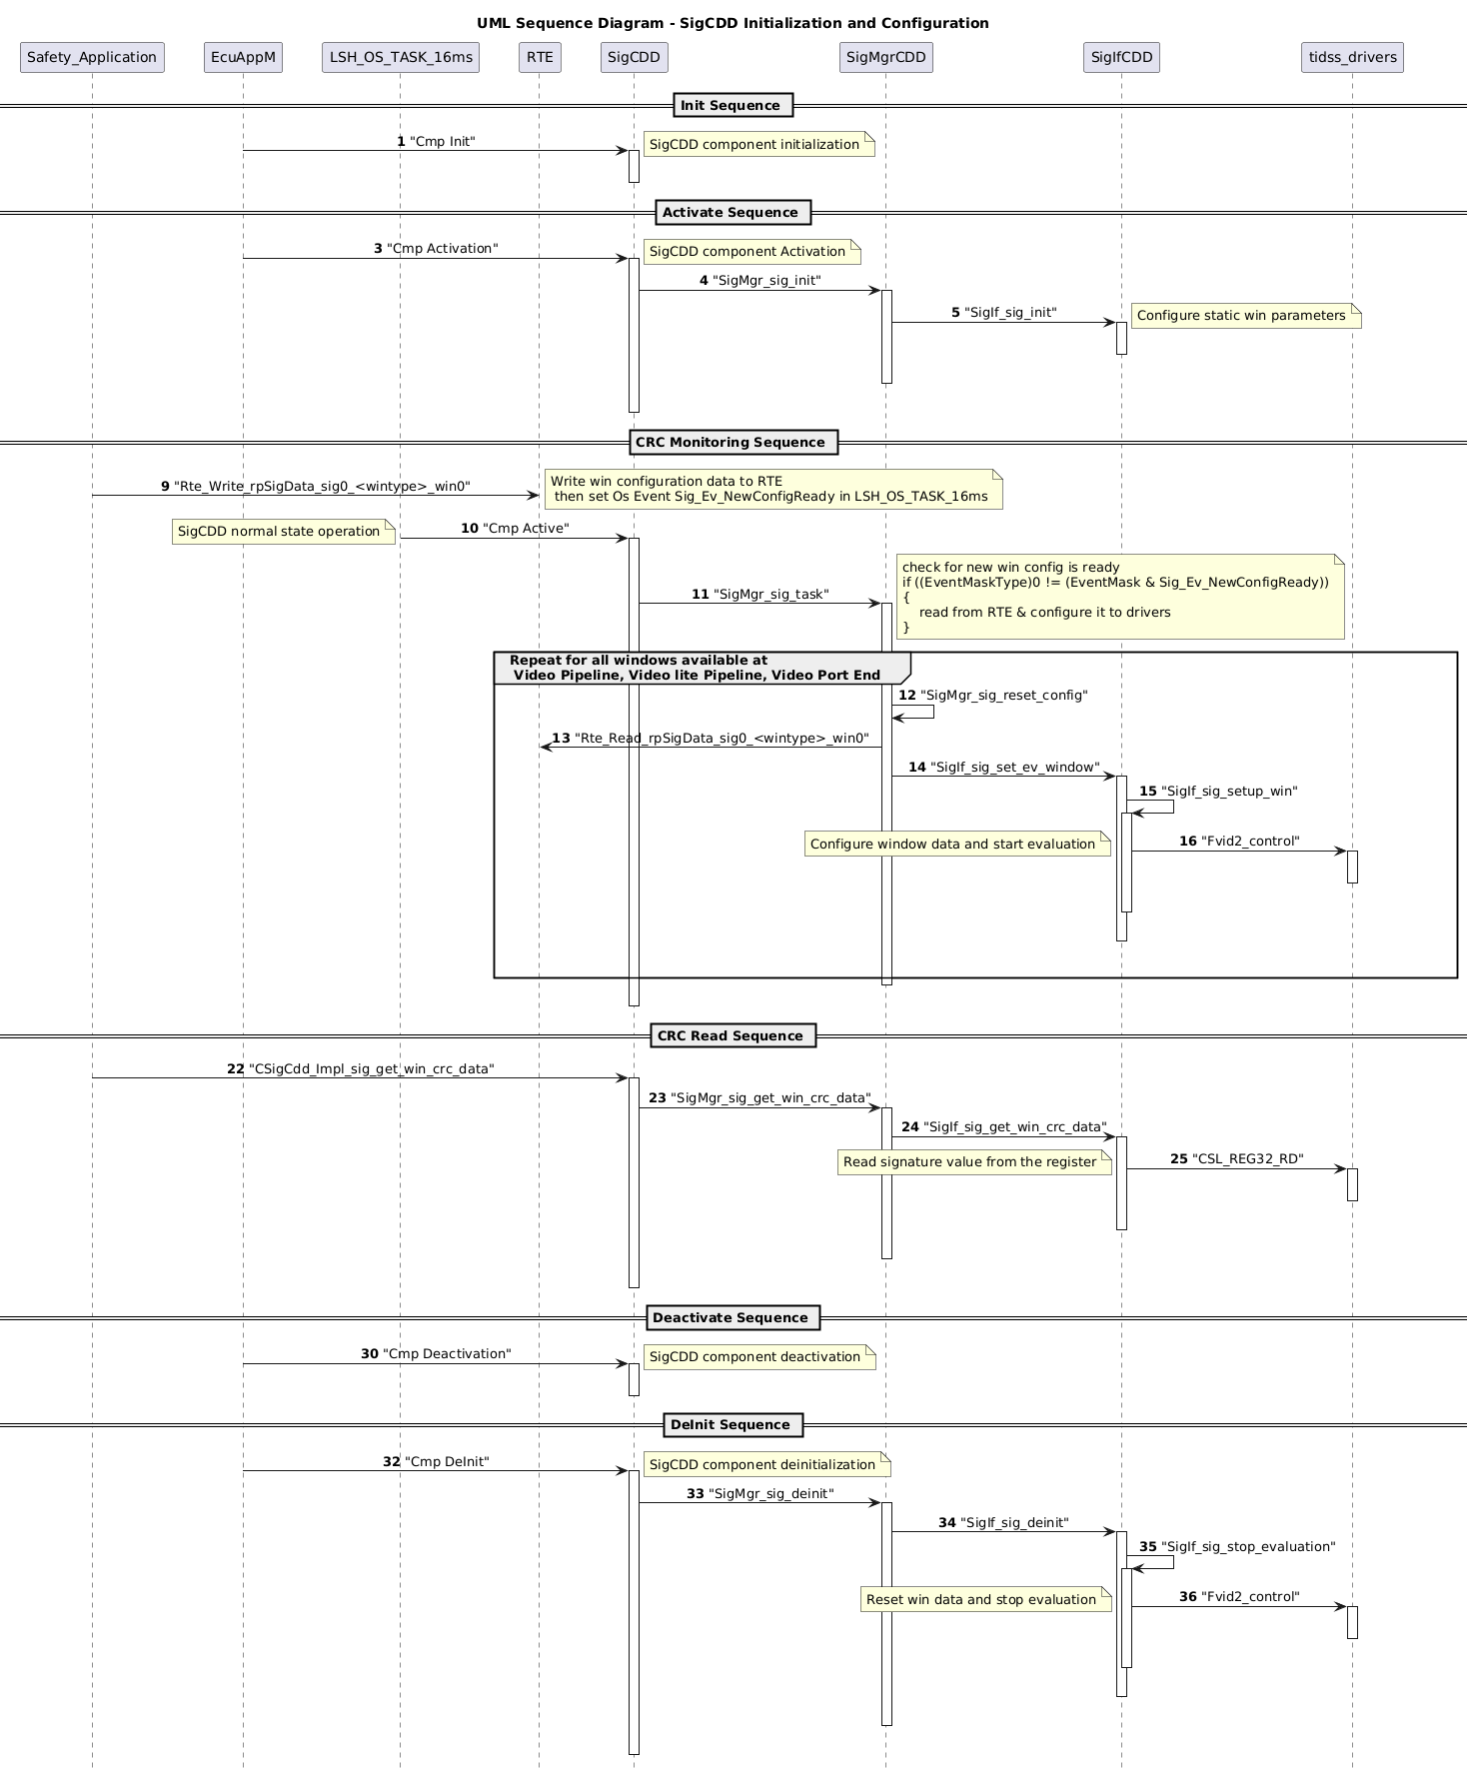

Component configuration
The user can customize the static configurations of the signature unit using SigIfCdd_cfg.$h

- Number of Signature units to use:

TIDSS has 2 Signature Units supported
Configure the macro - SIGNATURE_UNITS_TO_USE as below.

if SigUnit#0 to use,
#define SIGNATURE_UNITS_TO_USE (0U)

if SigUnit#1 to use,
#define SIGNATURE_UNITS_TO_USE (1U)

if both SigUnit#0 and SigUnit#1 to use,
#define SIGNATURE_UNITS_TO_USE (2U)

Os Task Configuration
The OS Events raised by SWC to indicate the new dynamic configurations will be monitored.
So provide the name of the Task. This task should be same as where SigCDD Main Function runnable is mapped to.

#define SIG_OS_TASK Os16msSafetyTask

RTE interfaces

- Read data from RTE when new a configuration is uploaded unto RTE and set an event by application (sender and receiver communication):

GET_SIG_WIN_CONFIG_INPUT(SIG_WIN_SETUP_T * p_sw_config);

Expected data example:
SIG_WIN_SETUP_T l_sig_win_setup[] =
{
{
(SIG_EV_WIN_VP|SIG_EV_WIN_ENABLED), /* controls */
350, /* winsx*/
200, /* winsy*/
450, /* winex*/
300, /* winey*/
0xDEADBEEF /* ref crc*/
}
};
- Once new configuration is updated application can use the below interfaces from “SigCDD” ( server and client communication ):

CSigCdd_Impl_sig_get_win_crc_data(SIG_WIN_INFO_T const * p_sw_info, SIG_WIN_CRC_RGB_T * p_sw_crc_rgb)

This interface can give calculated RGB CRC values of a desired window where p_sw_info desired window for which crc data is requested (input), and p_sw_crc_rgb Calculated CRC values from HW of given window (output)

Integration requirements:
- All below RTE interfaces need to configure in < SigCdd_cfg.$h >

/* RTE read Signature unit-0 interface to be configured */
#define GET_SIG0_VID_WIN0_CONFIG_INPUT(rte_read_data) Rte_Read_rpSigData_sig0_vid_win0(rte_read_data)
#define GET_SIG0_VIDL_WIN0_CONFIG_INPUT(rte_read_data) Rte_Read_rpSigData_sig0_vidl_win0(rte_read_data)
#define GET_SIG0_VP_WIN0_CONFIG_INPUT(rte_read_data) Rte_Read_rpSigData_sig0_vp_win0(rte_read_data)
#define GET_SIG0_VP_WIN1_CONFIG_INPUT(rte_read_data) Rte_Read_rpSigData_sig0_vp_win1(rte_read_data)
#define GET_SIG0_VP_WIN2_CONFIG_INPUT(rte_read_data) Rte_Read_rpSigData_sig0_vp_win2(rte_read_data)
#define GET_SIG0_VP_WIN3_CONFIG_INPUT(rte_read_data) Rte_Read_rpSigData_sig0_vp_win3(rte_read_data)

/* RTE read Signature unit-1 interface to be configured */
#define GET_SIG1_VID_WIN0_CONFIG_INPUT(rte_read_data) Rte_Read_rpSigData_sig1_vid_win0(rte_read_data)
#define GET_SIG1_VIDL_WIN0_CONFIG_INPUT(rte_read_data) Rte_Read_rpSigData_sig1_vidl_win0(rte_read_data)
#define GET_SIG1_VP_WIN0_CONFIG_INPUT(rte_read_data) Rte_Read_rpSigData_sig1_vp_win0(rte_read_data)
#define GET_SIG1_VP_WIN1_CONFIG_INPUT(rte_read_data) Rte_Read_rpSigData_sig1_vp_win1(rte_read_data)
#define GET_SIG1_VP_WIN2_CONFIG_INPUT(rte_read_data) Rte_Read_rpSigData_sig1_vp_win2(rte_read_data)
#define GET_SIG1_VP_WIN3_CONFIG_INPUT(rte_read_data) Rte_Read_rpSigData_sig1_vp_win3(rte_read_data)
- Configure all template files with required configurations - SigCdd_cfg.$h, SigMgrCdd_cfg.$h, SigIfCdd_cfg.$h
- New Os Event “Sig_Ev_NewConfigReady” is required to be added in the Os cfg files.
- To get consistent signature values for static contents across frames, one must configure frame buffer memory region as either “non-cacheable” or “cacheable, non-bufferable”.

Registers

Tools

Precautions

Limitations

- Safety Window configuration at Video Pipeline & Video Lite Pipeline End is not currently supported due to some issues with the drivers which is being discussed with TI. So the application is required to configure safety windows present at Video Port End only.
- Safety Signature Mismatch Violation Interrupt is currently not supported in SigCDD. So there is no RTE write to notify signature violation for any of the windows.

