Software Detailed Design Specification
1.0

Table of Contents

1 Preparation for pre-design review 3
1.1 Purpose 3
1.2 Public interface 3
1.3 Design choice 3
1.3.1 Design options 3
1.3.2 Justification of the selected option 3
1.4 File structure 3
1.5 Functional blocks 3
2 Pre-design review conclusions 3
3 Detailed design 3
3.1 Private interfaces 3
3.2 Internal data structures 3
3.3 Algorithms explanation 3
3.4 Component configuration 3
3.5 Registers 3
4 Tools 3
5 Precautions 3

References

Reference | Document Name | Version
[R1] | <T2G-SignatureDriver_UserGuide.pdf> | <X.X>
[R2] | <Turing_SWA.doc> | <X.X>
[R3] | <Document Name> | <X.X>

Definitions

Term | Abbreviation | Description

Revision History

Version | Date | Author | Description of changes
1.0 | 06/07/2022 | arajase2 | Updated for Infineon driver integration

Preparation for pre-design review

Purpose
SigIfCdd: Complex Device Driver for Signature unit to satisfy the ASIL B compliance for Display.

Signature unit overview:
- There are 2 signature units Traveo2 micro.
- Up to 8 Evaluation Windows per signature unit.
  - Windows checked in parallel for each frame
  - Individual windows can be exempt from check
  - Use of alpha mask for evaluating of arbitrary window shapes, and prioritization of windows
- Input for Signature unit either anyone point of the below units
  - Frame generation output
  - Gamma correction output
  - Dithering output.
- Frame Error Counter with programmable Threshold
- Automatic reaction on mismatch if expected content is not shown
  - Generation of SW interrupt
  - Automatic HW switch to constant color mode or safety graphics stream mode for whole display or individual evaluation windows – Not supported in Infineon driver

Public interface
void CSigCdd_Impl_sig_get_win_crc_data(SIG_WIN_INFO_T const * const p_sw_info, SIG_WIN_CRC_RGB_T * p_sw_crc_rgb)

Design choice

Design options

Justification of the selected option

File structure
SigCdd.c
SigCdd_Cfg.$h
SigMgrCdd.c/h
SigMgrCdd_Cfg.$h
SigIfCdd.c/h
SigIfCdd_Cfg.$h

Functional blocks

SigCdd
SigMgrCdd
SigIfCdd
FsSigDrv (InfineonDriver)
RTE
Data
Sig SWC

SigCdd :
Live cycle management (CmpInit, CmpDeInit, CmpActive, CmpActivation, CmpDeActivation, CmpWakeUp, CmpDiag and CmpDiagReturn) of the CDD stays here and all the RTE function definitions. It maps RTE interfaces to the Service Layer interfaces.
SigMgrCdd:
This is Service layer. It uses SigIfCdd interfaces to implement the real interfaces of the CDD.
SigIfCdd:
This is hardware abstraction layer of the CDD. This will use the interfaces of FsSigDrv

FsSigDrv:
The signature unit’s registers are accessed here. This is delivered by infineon and maintained in OSBSP git repo(https://bsp-os.git.visteon.com/platform/bsp-os/turing/mcal/traveo2FsSigDrv).

Pre-design review conclusions

Detailed design
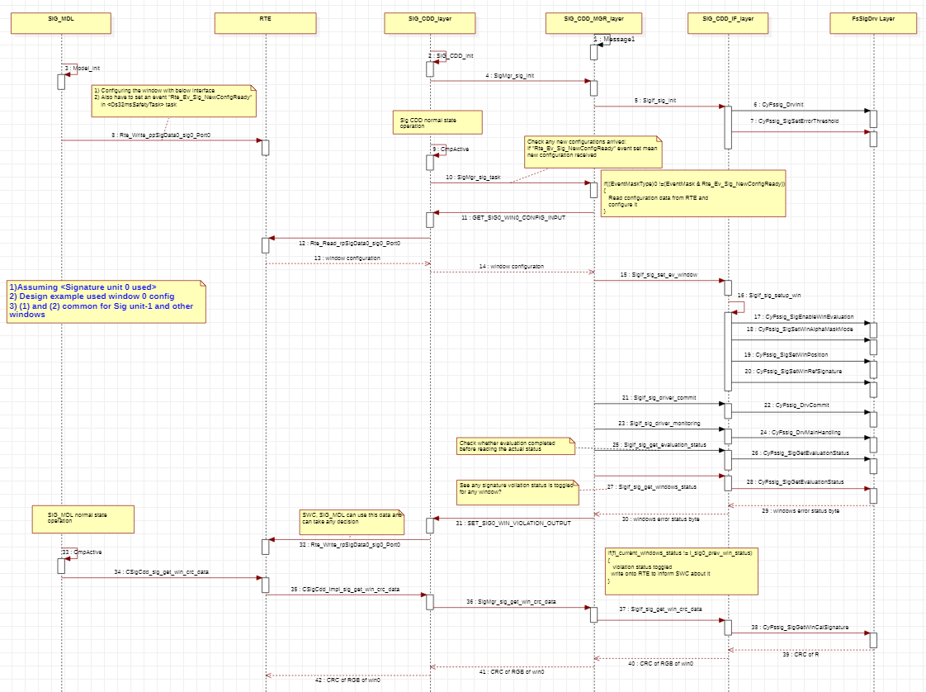

Private interfaces

Internal data structures:

typedef struct
{
UINT8 sig_unit; What is signature unit
UINT8 window; What is evaluation window
}SIG_WIN_INFO_T;
typedef struct
{
UINT32 crc_r; calculated CRC data of red
UINT32 crc_g; calculated CRC data of green
UINT32 crc_b; calculated CRC data of blue
}SIG_WIN_CRC_RGB_T;
typedef struct
{
UINT32 control; /*!<Bit0 (EnEvalWin)—
1: enable the window for crc calculation,
0: disable */
/*!<Bit8 (AlphaMask0) */
UINT16 winsx; evaluation window start x
UINT16 winsy; evaluation window start y
UINT16 winex; evaluation window end x
UINT16 winey; evaluation window end y
UINT32 crc_ref_r; evaluation window reference CRC value of red
UINT32 crc_ref_g; evaluation window reference CRC value of green
UINT32 crc_ref_b; evaluation window reference CRC value of blue
}SIG_WIN_SETUP_T;

Algorithm’s explanation
None

Component configuration
The user can customize the static configurations of the signature unit using SigIfCdd_Cfg.$h.

User should configure the below interrupt for integrating Traveo2 Sig unit

1. Input for Signature units:

/*
Configure the macro-SIGNATURE_UNITS_TO_USE as below.
Define
0 for SIGNATURE_UNITS_TO_USE if SigUnit 0 to use.
1 for SIGNATURE_UNITS_TO_USE if SigUnit 1 to use.
2 for SIGNATURE_UNITS_TO_USE if SigUnit 0 and 1 to use.
*/

#define SIGNATURE_UNITS_TO_USE 0

Signature unit supports the below source for calculating the CRC values
/** Signature source is from the Frame output. */
CYFSSIG_SIG_SOURCE_SELECT_FRAMEGEN = 1,
/** Signature source is from the Gamma output. */
CYFSSIG_SIG_SOURCE_SELECT_GAMMACOR = 2,
/** Signature source is from the Dither output. */
CYFSSIG_SIG_SOURCE_SELECT_DITHER = 3,

By default, FsSigDrv uses the below precompiled configuration which is defined in FsSigDrv\src\config\CyFssig_Cfg.h

#define CYFSSIG_PRE_COMPILE_CFG {\
.tagPcConfig_Pre = CYFSSIG_PC_CFG_PRE_TAG,\
.hardwareDerivative = CYFSSIG_HARDWARE_DERIVATIVE,\
.displaySettings =\
{\
{\
.dispId = CYFSSIG_DISPLAY_STREAM_ID_0,\
.evaluationWindowCount = (uint8)0x08u,\
.registerReadbackPeriod = (uint8)30u,\
.signatureSourceSelect = CYFSSIG_SIG_SOURCE_SELECT_GAMMACOR\
},\
},\
.tagPcConfig_Post = CYFSSIG_PC_CFG_POST_TAG\
}

3. Threshold Value:
Number of frames with signature violation before StsSigError is set for an evaluation window. These frames do not need to be consecutive.
0 means that each frame with violation will set the status.
The internal counter compared against this threshold is reset when 'ErrThreshReset' consecutive frames without signature violation occur.
The valid range is 0-255.
#define SIG0_ERROR_THRESHOLD_VALUE (UINT32)0
#define SIG1_ERROR_THRESHOLD_VALUE (UINT32)0
4. Threshold Reset Value:
Number of consecutive frames without signature violation before StsSigError is reset for an evaluation window.
0 means that each frame without violation will reset the status.
The internal counter compared against this threshold is reset with each frame that has violation.
The valid range is 0-254.
#define SIG0_ERROR_THRESHOLD_RESET_VALUE (UINT32)0
#define SIG1_ERROR_THRESHOLD_RESET_VALUE (UINT32)0

RTE interfaces

- Read data from RTE when new a configuration is uploaded unto RTE and set an event by application (sender and receiver communication):

GET_SIG_WIN_CONFIG_INPUT(SIG_WIN_SETUP_T *fl_sw_config);

Expected data example:
SIG_WIN_SETUP_T l_sig_win_setup[] =
{
{
(SIG_ENABLE_EVWIN|SIG_ENABLE_CRC), /* sing 0 controls */
350, /* winsx*/
200, /* winsy*/
450, /* winex*/
300, /* winey*/
0xA, /* ref r crc*/
0xB, /* ref g crc*/
0xC, /* ref b crc*/
}
};
- Once new configuration is updated application can use the below interfaces from “SignatureCDD” ( server and client communication ):

- CSigCdd_Impl_sig_get_win_crc_data(SIG_WIN_INFO_T const * p_sw_info, SIG_WIN_CRC_RGB_T * p_sw_crc_rgb)

This interface can give calculated RGB CRC values of a desired window
Where p_sw_info desired window crc data (input)
p_sw_crc_rgb Calculated CRC of values of given window (output)

- Write the “SigCDD” onto the RTE when any configured window has violated the signatures (sender and receiver communication):

SET_SIG_WIN_VOILATION_OUTPUT(UINT8 window_error_status_byte);

This byte will contain error/violation status of each window
1 Signature violation
0 No signature violation

Integration requirements:
- All below RTE interfaces need to configure in < SigCdd_cfg.$h >

/* RTE read Signature unit-0 interface to be configured */
#define GET_SIG0_WIN0_CONFIG_INPUT(rte_read_data) Rte_Read_rpSigData0_sig0_Port0(rte_read_data)
#define GET_SIG0_WIN1_CONFIG_INPUT(rte_read_data) Rte_Read_rpSigData0_sig0_Port1(rte_read_data)
#define GET_SIG0_WIN2_CONFIG_INPUT(rte_read_data) Rte_Read_rpSigData0_sig0_Port2(rte_read_data)
#define GET_SIG0_WIN3_CONFIG_INPUT(rte_read_data) Rte_Read_rpSigData0_sig0_Port3(rte_read_data)
#define GET_SIG0_WIN4_CONFIG_INPUT(rte_read_data) Rte_Read_rpSigData0_sig0_Port4(rte_read_data)
#define GET_SIG0_WIN5_CONFIG_INPUT(rte_read_data) Rte_Read_rpSigData0_sig0_Port5(rte_read_data)
#define GET_SIG0_WIN6_CONFIG_INPUT(rte_read_data) Rte_Read_rpSigData0_sig0_Port6(rte_read_data)
#define GET_SIG0_WIN7_CONFIG_INPUT(rte_read_data) Rte_Read_rpSigData0_sig0_Port7(rte_read_data)
/* RTE read Signature unit-1 interface to be configured */
#define GET_SIG1_WIN0_CONFIG_INPUT(rte_read_data) Rte_Read_rpSigData1_sig1_Port0(rte_read_data)
#define GET_SIG1_WIN1_CONFIG_INPUT(rte_read_data) Rte_Read_rpSigData1_sig1_Port1(rte_read_data)
#define GET_SIG1_WIN2_CONFIG_INPUT(rte_read_data) Rte_Read_rpSigData1_sig1_Port2(rte_read_data)
#define GET_SIG1_WIN3_CONFIG_INPUT(rte_read_data) Rte_Read_rpSigData1_sig1_Port3(rte_read_data)
#define GET_SIG1_WIN4_CONFIG_INPUT(rte_read_data) Rte_Read_rpSigData1_sig1_Port4(rte_read_data)
#define GET_SIG1_WIN5_CONFIG_INPUT(rte_read_data) Rte_Read_rpSigData1_sig1_Port5(rte_read_data)
#define GET_SIG1_WIN6_CONFIG_INPUT(rte_read_data) Rte_Read_rpSigData1_sig1_Port6(rte_read_data)
#define GET_SIG1_WIN7_CONFIG_INPUT(rte_read_data) Rte_Read_rpSigData1_sig1_Port7(rte_read_data)
- Configure all template files with required configurations
SigCdd_Cfg.$h
SigMgrCdd_Cfg.$h
SigIfCdd_Cfg.$h

Registers

Tools

Precautions

