SigCDD is a Complex Device Driver designed for the DSS Signature Unit, developed to meet ASIL B compliance requirements. It ensures the correctness of display output by computing signature values for each safety window and comparing them against reference values.

SigCDD Integration and Configuration Guidelines
1. Stub Removal from vp-build/stubs/main.c
The application team must remove the following stub runnables from the main.c file
- void CSigCdd_Impl_MainFunction(void) {}
- Std_ReturnType CSigCdd_Impl_OnCommand(uint8 Cmd) { return E_OK; }
2. Safety Region Configuration
SigCDD requires the macro “CONFIG_DSS_NUM_SAFETY_REGIONS” to be defined with the correct number of safety regions used in the application in MCAL layer.
- The application team should coordinate with the MCAL team to configure the Video Port Safety Region Parameters. These parameters must be added to the SYSconfig-generated files in the mcal-gen.
Example: #define CONFIG_DSS_NUM_SAFETY_REGIONS 1U
3. SigCDD Configuration Files
Application team can modify SigCDD related cfg files as mentioned below to configure SigCDD component and archive these files in their repo itself. They will be responsible for configuring and archiving the following SigCDD-related configuration files into their repo:
a. SigIfCdd_Cfg.h
Location: sigcdd/ui.core.sigcdd/SigIfCdd/cfg/tidss/SigIfCdd_Cfg.$h
- Configure the macro “SIGNATURE_UNITS_TO_USE” based on the number of DSS instances used:
// Use DSS #0 Signature Unit
#define SIGNATURE_UNITS_TO_USE (0U)
// Use DSS #1 Signature Unit
#define SIGNATURE_UNITS_TO_USE (1U)
// Use both DSS #0 and #1 Signature Unit
#define SIGNATURE_UNITS_TO_USE (2U)
b. SigCdd_Cfg.$h
Location: sigcdd/ui.core.sigcdd/SigCdd/cfg/SigCdd_Cfg.$h
- Define macro “SIG_OS_TASK” with correct Auotsar OS task wherever “CSigCdd_Impl_MainFunction” runnable is mapped to,
Example: #define SIG_OS_TASK OsTask_LSH_16ms

- Configure RTE read interfaces for Signature Unit 0. If not applicable, define macros with empty bodies to maintain consistency. Define below macros with correct RTE read interface, wherever applicable. If not required, keep empty definition as definition is necessary for all macros. For example,
#define GET_SIG0_VID_WIN0_CONFIG_INPUT(rte_read_data) Rte_Read_rpSigData_sig0_vid_win0(rte_read_data)
#define GET_SIG0_VIDL_WIN0_CONFIG_INPUT(rte_read_data) Rte_Read_rpSigData_sig0_vidl_win0(rte_read_data)
#define GET_SIG0_VP_WIN0_CONFIG_INPUT(rte_read_data) Rte_Read_rpSigData_sig0_vp_win0(rte_read_data)
#define GET_SIG0_VP_WIN1_CONFIG_INPUT(rte_read_data) Rte_Read_rpSigData_sig0_vp_win1(rte_read_data)
#define GET_SIG0_VP_WIN2_CONFIG_INPUT(rte_read_data) Rte_Read_rpSigData_sig0_vp_win2(rte_read_data)
#define GET_SIG0_VP_WIN3_CONFIG_INPUT(rte_read_data) Rte_Read_rpSigData_sig0_vp_win3(rte_read_data)
c. SigMgrCdd_Cfg.$h
Location: sigcdd/ui.core.sigcdd/SigMgrCdd/cfg/SigMgrCdd_Cfg.$h
- No changes are required currently. Archive the file as-is.
4. SigCDD Integration via cmake
- To integrate the SigCDD component into the workspace, a corresponding CMake file is required. Refer to the provided snapshot for guidance on structure and content.
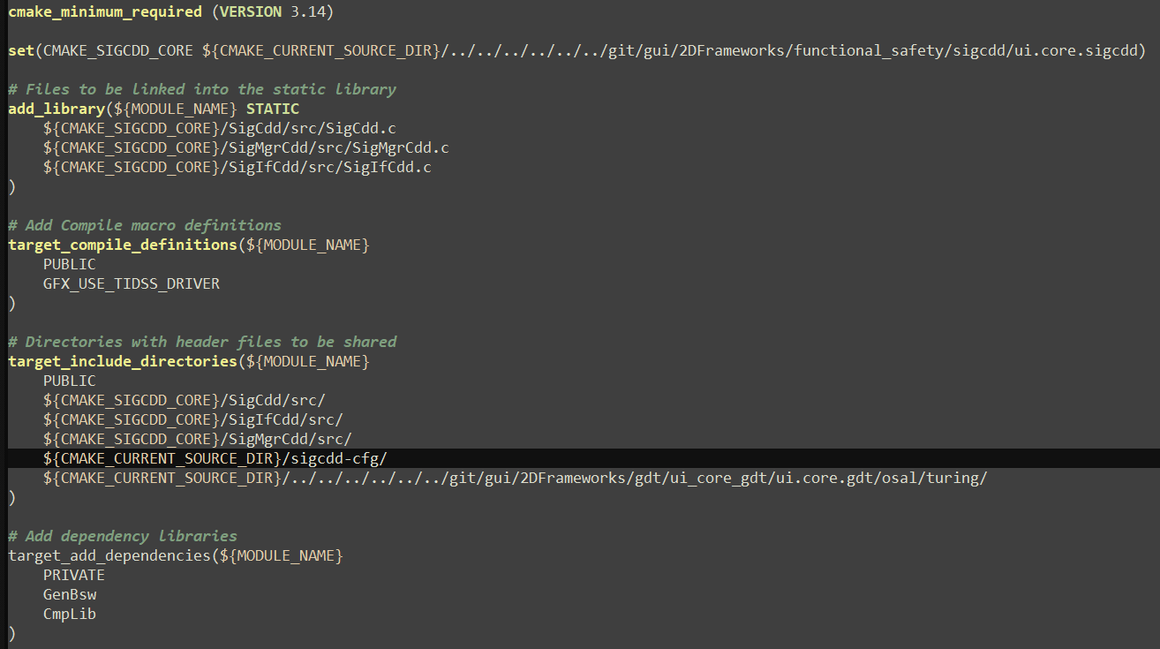

- To enable SigCDD integration with TI Sitara DSS drivers, the compile-time macro definition “GFX_USE_TIDSS_DRIVER” must be added in the SigCDD CMake file as shown in above snapshot.

5. Dynamic Safety Window Configuration via RTE
- To configure safety windows dynamically from the application layer, the window configuration data must be written to the RTE using the following interface: “Rte_Write_pp_SigData_sig0_port”

- After writing the data to the RTE, application must manually set OS event “Sig_Ev_NewConfigReady” to the SIG_OS_TASK.
Example - (void)SetEvent(SIG_OS_TASK, Sig_Ev_NewConfigReady);

- The structure SIG_WIN_SETUP_T should be populated with the appropriate values before invoking the write interface:
typedef struct
{
UINT32 control;
/*!< Bit 0 – Safety Window Enable Status
1: SIG_EV_WIN_ENABLED (Safety window is enabled)
0: SIG_EV_WIN_DISABLED (Safety window is disabled)
Bits 5-4 – Safety Window Type
3: SIG_EV_WIN_VP (Safety window @ Video Port)
2: SIG_EV_WIN_VIDL (Safety window @ Video Lite Pipeline)
1: SIG_EV_WIN_VID (Safety window @ Video Pipeline) */
UINT16 winsx; /*!<CRC window start x */
UINT16 winsy; /*!<CRC window start y */
UINT16 winex; /*!<CRC window end x */
UINT16 winey; /*!<CRC window end y */
UINT32 ref_crc; /*!<Reference CRC */
}SIG_WIN_SETUP_T;
6. Get CRC for Configured Safety Window
- To read the CRC value for the configured window, following client-server rte interface should be used
“Rte_Call_rp_SigCddCrc_Impl_sig_get_win_crc_data (&win_info, &crc_data)”
where:
win_info is of type SIG_WIN_INFO_T
typedef struct
{
UINT8 sig_unit; /* DSS Sig Unit ID */
UINT8 window; /* Video Port Safety Window ID */
} SIG_WIN_INFO_T;
crc_data is of type SIG_WIN_CRC_RGB_T
typedef struct
{
UINT32 crc; /* Calculated crc value for the passed window */
}SIG_WIN_CRC_RGB_T;

