ChecKsum generation User Guide

INDEX

1 INTRODUCTION 2
2 CONFIGURATION 4
3 API USAGE…………………………………………………………………………………………………6

INTRODUCTION
This document provides an overview of the configuration changes that needs to be done to generate the checksum.

Macros:

2. Configuration from TOOL:

Under Project settings, Generate Checksum option provided

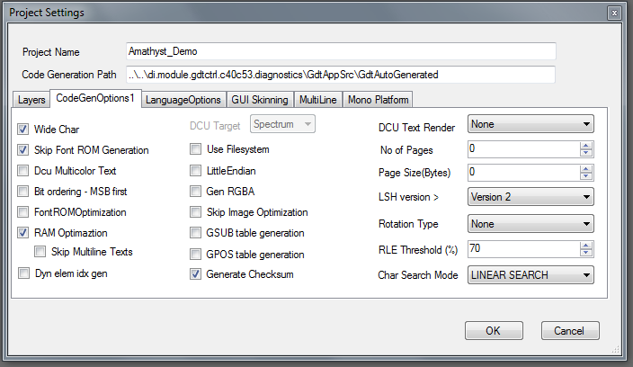

TOOL GENERATED DATA

- By checking this option, GFX_MGR02_CHECKSUM_ENABLED macro will be generated in hmi_gfx_mgr02_cfg.h
- hmi_gfx_mgr02_checksum.dat will also be generated

hmi_gfx_mgr02_cfg.h:
#define GFX_MGR02_CHECKSUM_ENABLED
#define GFX_MGR02_CFG_CHECKSUM (32bit time stamp)

hmi_gfx_mgr02_checksum.dat:
GFX_IMG_DATA_PREFIX const UINT32 gfx_mgr02_dat_checksum = 32bit time stamp

3. API USAGE

The below API needs to be called from the application to check for the checksum status.

UINT8 hmi_gfx_mgr02_layout_initialize(void)

Return value :
GFX_MGR02_CHECKSUM_MATCHED
GFX_MGR02_CHECKSUM_FAILED

If the checksum generated in hmi_gfx_mgr2_cfg.h and hmi_gfx_mgr02_checksum.dat matches, then
GFX_MGR02_CHECKSUM_MATCHED will be returned.

If the checksum generated in hmi_gfx_mgr2_cfg.h and hmi_gfx_mgr02_checksum.dat does not match, then
GFX_MGR02_CHECKSUM_FAILED will be returned.

Decision can be taken in the application based on the return value from the above API.

